­­

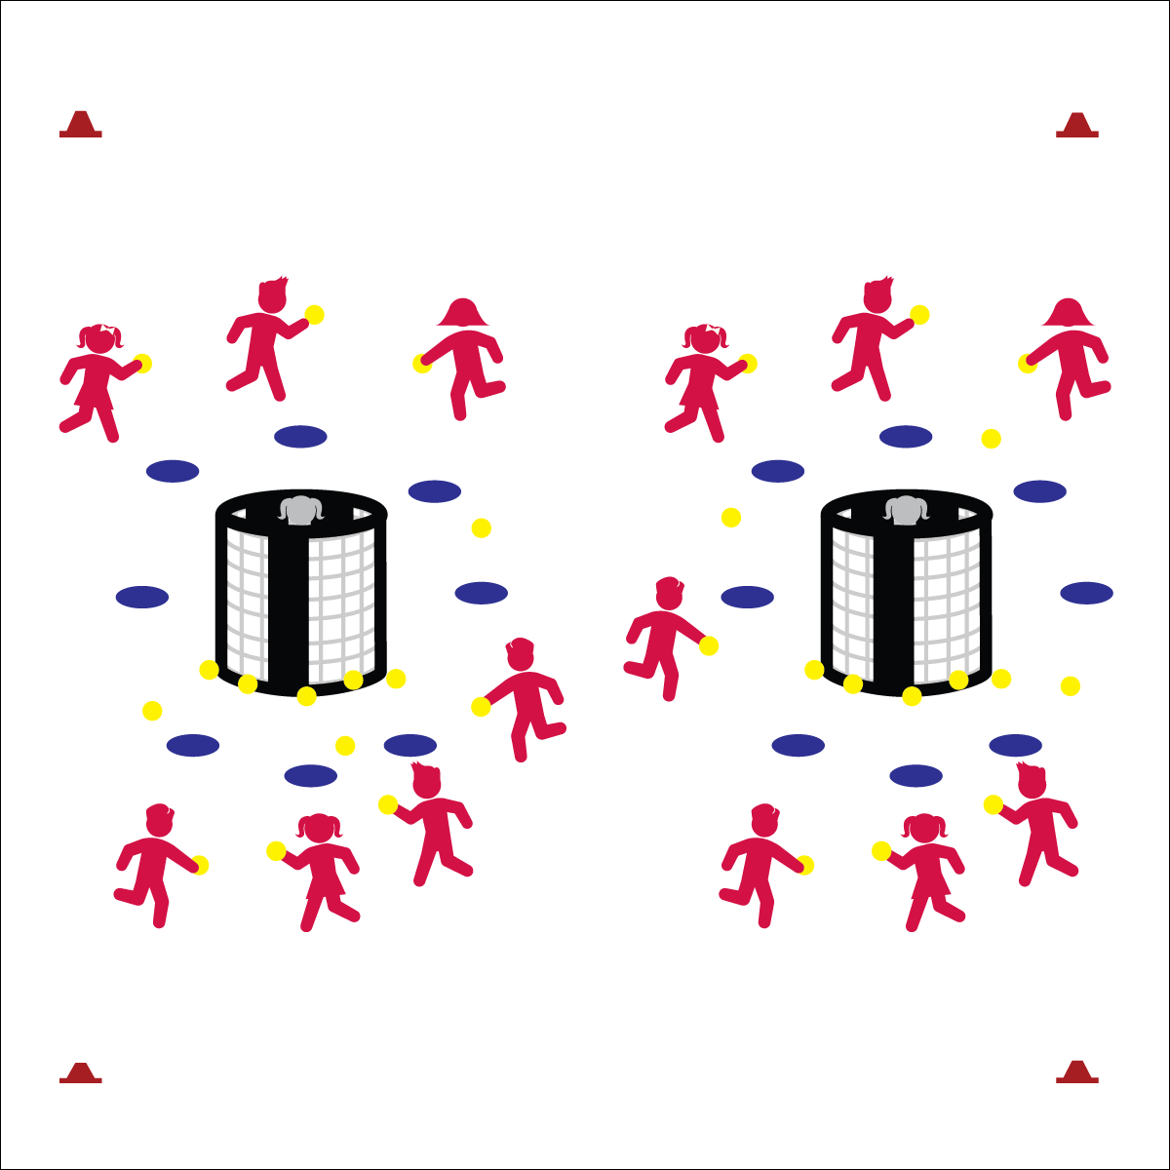

* **Skill:** I will use all of the skill cues for throwing to a target.
* **Cognitive:** I will discuss the reasons why I enjoy different physical activities.
* **Fitness:** I will remain actively engaged in order to accumulate physical activity minutes.
* **Personal & Social Responsibility:** I will maintain control of my actions and throws in order to keep myself and my classmates safe.
* Throwing: Shoulder to Target, Load Back, Opposite Foot to Target, Throw Across
* Catching: Eye/Hands Ready, Reach, Soft Hands

**Equipment:**

* 2 goals
* 1 (or more) yarn balls per student
* 16 spot markers
* 4 large cones
* Throwing and Catching Skill Cue Chart

**Set-Up:**

* Create a large rectangular activity with the 4 large cones.
* Set 2 goals up 5 to 10 paces from each end line.
* Place 8 spot markers in a circle around each goal, approximately 5 paces from the goal.
* Choose 2 students to be “Grouches,” each standing inside one of the goals.
* All other students scattered throughout the activity area with a yarn ball.

**THE GROUCH**

**Activity Procedures:**

1. Today’s activity is called The Grouch. The object is for you to shoot the foam balls into the goal while the Grouch tosses them back out.
2. On the start signal, players with a yarn ball can shoot at either goal from behind the spot markers. If a ball goes inside the goal, it’s the Grouch’s job to toss it back out as quickly as she/he can. If the ball doesn’t go inside the goal, players can move to pick up any ball that’s on the floor.
3. On the stop signal, stop and listen for instructions.

**Grade Level Progression:**

**3rd:** Play the activity as described above.

**4th & 5th:** Divide the class into 2 teams. Each team will shoot on 1 goal only. The grouch will “defend” their team’s goal by tossing yarn balls back out of the goal as quickly as they can. Grouches will work to toss the balls into open space, away from the opposing team.



* Pairs work together with one partner gathering the ball and the other shooting.
* Provide an auditory cue at each goal.
* Use safe passable objects of various sizes, shapes, colors, and textures.

**THE GROUCH**



* **DOK** **1:** What is an activity that you enjoy?
* **DOK 2:** Can you summarize the reasons why you enjoy a particular activity?
* **DOK 3:** Based on the answers you’ve heard in class, what are the top reasons why people choose different physical activities?



* **Standard** **1 [E13&14.3-5b)** Throws underhand to a partner or target with reasonable accuracy (3). Throws overarm to a partner or at a target with accuracy at a reasonable distance (4b). Throws (underhand and overarm) using a mature pattern in non-dynamic environments, with different sizes and types of objects (5a). Throws (both underhand and overarm) to a large target with accuracy (5b).
* **Standard 3 [E2.3-5]** Engages in the activities of physical education class without teacher prompting (3); Actively engages in the activities of physical education class, both teacher-directed and independent (4); Actively engages in all the activities of physical education (5).
* **Standard 4 [E6.3-5]** Works independently and safely in physical activity settings (3); Works safely with peers and equipment in physical activity settings (4); Applies safety principles with age-appropriate physical activities (5).
* **Standard 5 [E3.3-5]** Reflects on the reasons for enjoying selected physical activities (S5.E3.3); Ranks the enjoyment of participating in different physical activities (S5.E3.4); Analyzes different physical activities for enjoyment and challenge, identifying reasons for a positive or negative response (S5.E3.5).



Accuracy, Target, Independent, Safe, Control, Enjoyment, Challenge

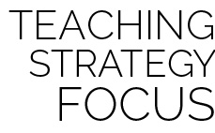

**Review content:** The Grouch is a perfect activity for reviewing underhand and overarm throwing cues while also focusing on the connection between self-control and safety. Passing, catching, and shooting are all important skills required for successful participation in invasion games. Highlight proper form, the importance of skill cues, and the need for safe, controlled play.