­­

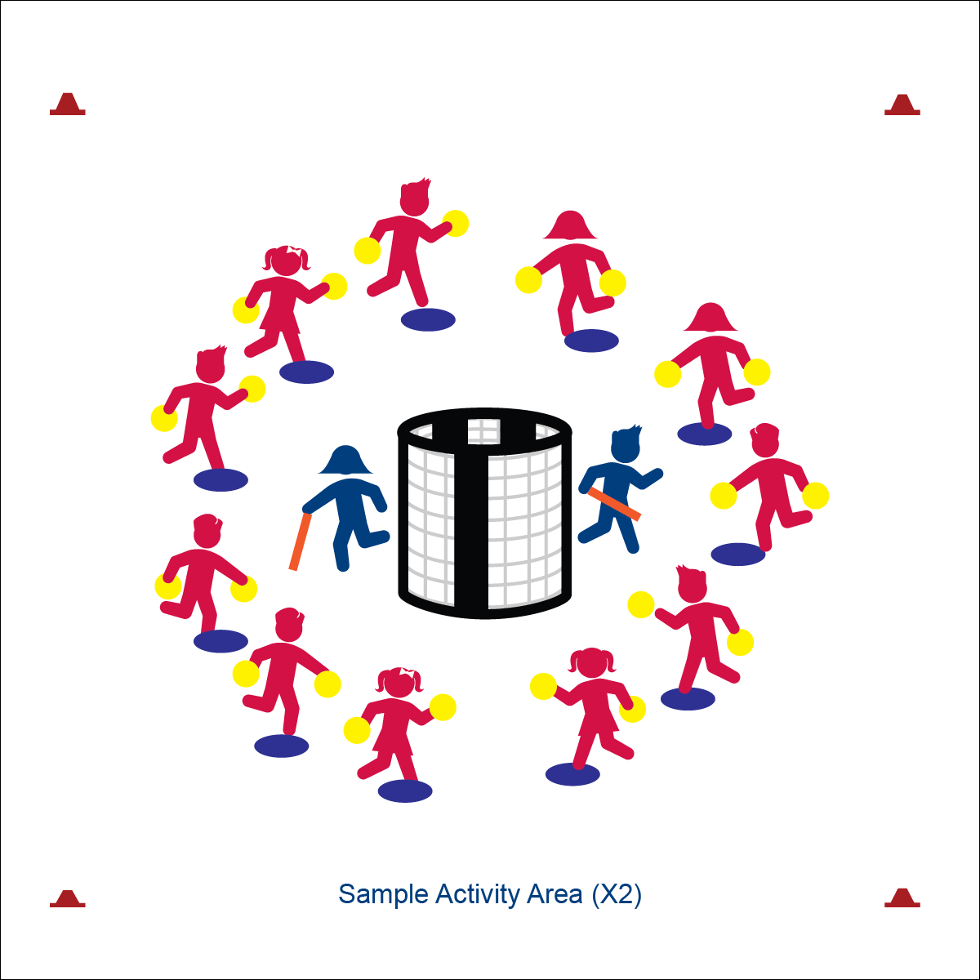

* Relationship: Goal, Ball, Players
* Space Awareness: Open/Closed, Levels, Pathways
* Effort: Move Fast/Slow, Pressure Strong/Light
* **Skill:** I will move thoughtfully in order to position my body to gain an advantage as a goalie.
* **Cognitive:** I will identify movement concepts important to positioning as goalie.
* **Fitness:** I will remain actively engaged in order to accumulate physical activity minutes.
* **Personal & Social Responsibility:** I will recognize and follow all activity rules.

**Equipment:**

* 2 goals
* 11 spot markers
* 2 foam noodles
* 2 (or more) foam balls per student
* Defensive Movement Concept Chart

**Set-Up:**

* Create 2 separate activity areas, each with a goal in the center.
* Place 11 spot markers in a circle around each goal, approximately 5 paces from the goal.
* Choose 2 students to be goalies. Give each goalie a foam noodle and send them to defend separate goals.
* All other students on a spot marker with 2 foam balls. At each goal, number each student consecutively from 1 to 11.

**GOLDEN GOALIE**

**Activity Procedures:**

1. Today’s activity is called Golden Goalie. We’ll take turns practicing our goalie skills. The object of the game is for the goalie to block as many rolling shots as they can using the foam noodle.
2. On the start signal, player number 1 at each goal will roll 1 of their balls and attempt to make a goal. The goalie will attempt to strike it away with the noodle.
3. As soon as the ball is hit by the goalie (or goes into the net), the next player will roll a ball at the goal. We’ll continue in order until everyone has rolled both of their foam balls.
4. Offensive players must keep at least 1 foot on their spot at all times. After both foam balls are rolled, get in plank position and hold until the round is over.
5. After each round, we’ll choose a new goalie and reset the game.

**Grade Level Progression:**

**3rd:** Play the activity as described above.

**4th:** Offensive players may bounce shots in addition to rolling.

**5th:** Stagger spot markers to create a variety of shooting distances.



* **DOK** **1:** Can you make a list of movement concepts that impact invasion games?
* **DOK 2:** Which concepts are important to positioning as a goalie?
* **DOK 3:** How does the concept of levels relate to defensive positioning as a goalie?



* **Standard** **1 [E25.3-4]** Strikes a ball with a long-handled implement, sending it forward, while using proper grip for the implement (e.g., hockey stick) (3); Strikes an object with a long-handled implement (e.g., hockey stick), while demonstrating three of the five critical elements of a mature pattern for the implement (grip, stance, body orientation, swing plane and follow-through) (4).
* **Standard 2 [E3.3&5b]** Combines movement concepts (direction, levels, force, time) with skills as directed by the teacher (3); Applies the concepts of direction and force to strike an object with a long-handled implement. (5b).
* **Standard 4 [E5.3-5]** Recognizes the role of rules and etiquette in physical activity with peers (3); Exhibits etiquette and adherence to rules in a variety of physical activities (4); Critiques the etiquette involved in rules of various game activities (5).

**GOLDEN GOALIE**



* Help the goalie hold the foam noodle using Velcro or other safe fastener.
* Provide 1-on-1 assistance to students needing hand-over-hand support.
* Use equipment that provides auditory cues/signals.



Goalie, Mature Pattern, Rule, Etiquette, Accumulate, Movement Concept, Positioning

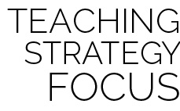

**Help students process content:** While the application of movement concepts may seem instinctual for some students, others will struggle at a very basic level. Students working to defend a goal must also overcome natural apprehension. All of this requires a gentle and observant teacher who is constantly looking for teachable moments within the activity and provides feedback in a positive and meaningful way.