­­

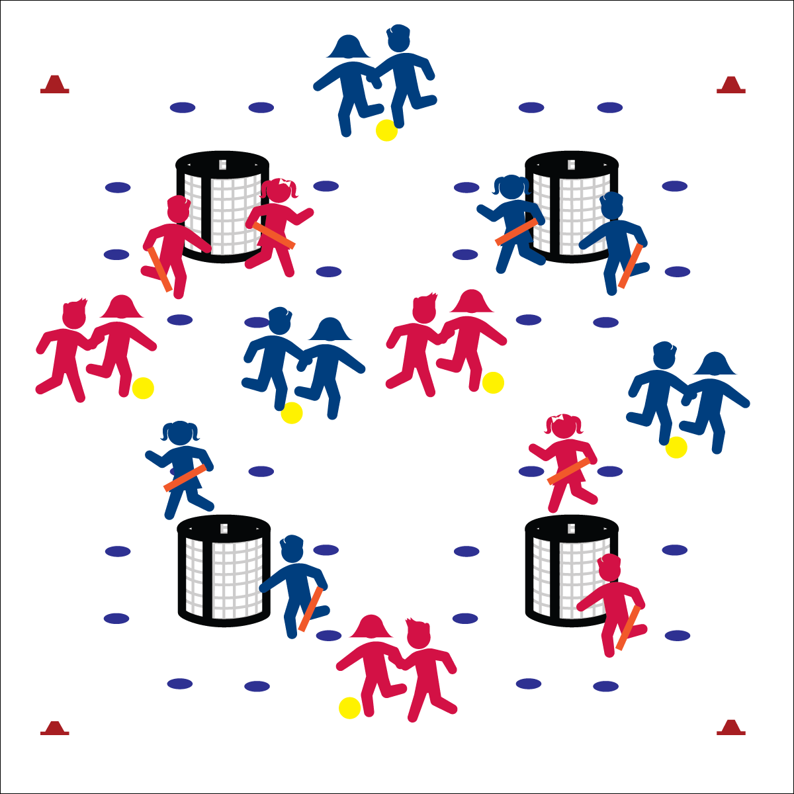

**FOUR CORNERS**

**Activity Procedures:**

1. It’s time to play Four Corners. The object is for you and your partner to work cooperatively to score a goal at any of the 4 goals.
2. The first round of play will be soccer style. You’ll dribble and pass the ball soccer style between you and your partner toward a goal, and then shoot the ball from behind the spot markers.
3. If you score a goal, switch places with the goalies. They’ll lock arms and dribble your ball to a new goal while you and your partner defend the goal you just scored on. Goalies do not have to lock elbows.
4. If goalies block a shot, the shooting team must then go get their ball and dribble to a different goal before taking another shot.
5. We’ll begin on the start signal. When you hear the stop signal, freeze and listen for instructions.

**Grade Level Progression:**

**3rd & 4th:** Play the activity as described above.

**5th:** Offensive players unlock elbows and travel together while staying approximately 6 to 10 feet apart.

* **Skill:** I will combine locomotor skills (walk/jog) with foot dribbling/passing.
* **Cognitive:** I will identify and apply basic offensive and defensive strategies.
* **Fitness:** I will discuss the health benefits of participating in today’s activity.
* **Personal & Social Responsibility:** I will work safely with my partner and classmates.
* Offense: Space, Movement, Pass, Shoot
* Defense: Ball/Opponent, Angles, Space, Force Outside

**Equipment:**

* 4 goals (for up to 24 players)
* 1 ball per pair
* 24 spot markers
* Offense/Defense Strategy Chart

**Set-Up:**

1. Create a large activity area and place a goal in each of the 4 corners of the area.
2. Place 8 spot markers in a circle around each goal, approximately 5 paces from the goal.
3. Pair students. Send 1 pair to each of the 4 goals as goalies. All other pairs scattered in area with locked elbows and a ball at their feet.



Combine, Offense, Defense, Strategy, Health Benefits

**FOUR CORNERS**



* **DOK** **1:** What does offense mean? What does defense mean?
* **DOK 2:** What do you know about playing offense? About playing defense?
* **DOK 3:** How would you apply what you know in order to perform well during Four Corners?



* **Standard** **1 [E1.4 & 5c]** Uses various locomotor skills in a variety of small-sided practice tasks, dance, and educational gymnastics experiences (4); Combines traveling with manipulative skills for execution to a target (e.g., scoring in soccer, hockey, and basketball) (5c).
* **Standard 1[E20.4-5]** Dribbles with hand/feet in combination with other skills (e.g., passing, receiving, shooting) (4). Hand/foot-dribbles with mature patterns in a variety of small-sided game forms (5).
* **Standard 2 [E5.4c-5a]** Recognizes the type of kicks needed for different games/sports situations (4c); Applies basic offensive and defensive strategies/ tactics in invasion small-sided practice tasks (5a).
* **Standard 4 [E6.3-5]** Works independently and safely in physical activity settings (3); Works safely with peers and equipment in physical activity settings (4); Applies safety principles with age-appropriate physical activities (5).
* **Standard 5 [E1.3-5]** Discusses the relationship between physical activity and good health (3); Examines the health benefits of participating in physical activity (4); Compares the health benefits of participating in selected physical activities (5).



* Use auditory signals in goals.
* Play the game without goalies, focusing on traveling with the ball and shooting.
* Utilize brightly colored boundaries and equipment.

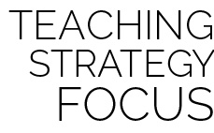

**Organize students to interact with content:** Four Corners organizes students as well as the activity environment to promote purposeful practice with a developmentally appropriate level of challenge for a wide range of skill and ability levels. Students combine locomotor and manipulative skills in an open offensive environment, with defensive pressure increasing as pairs work to execute directly toward a goal.