­­

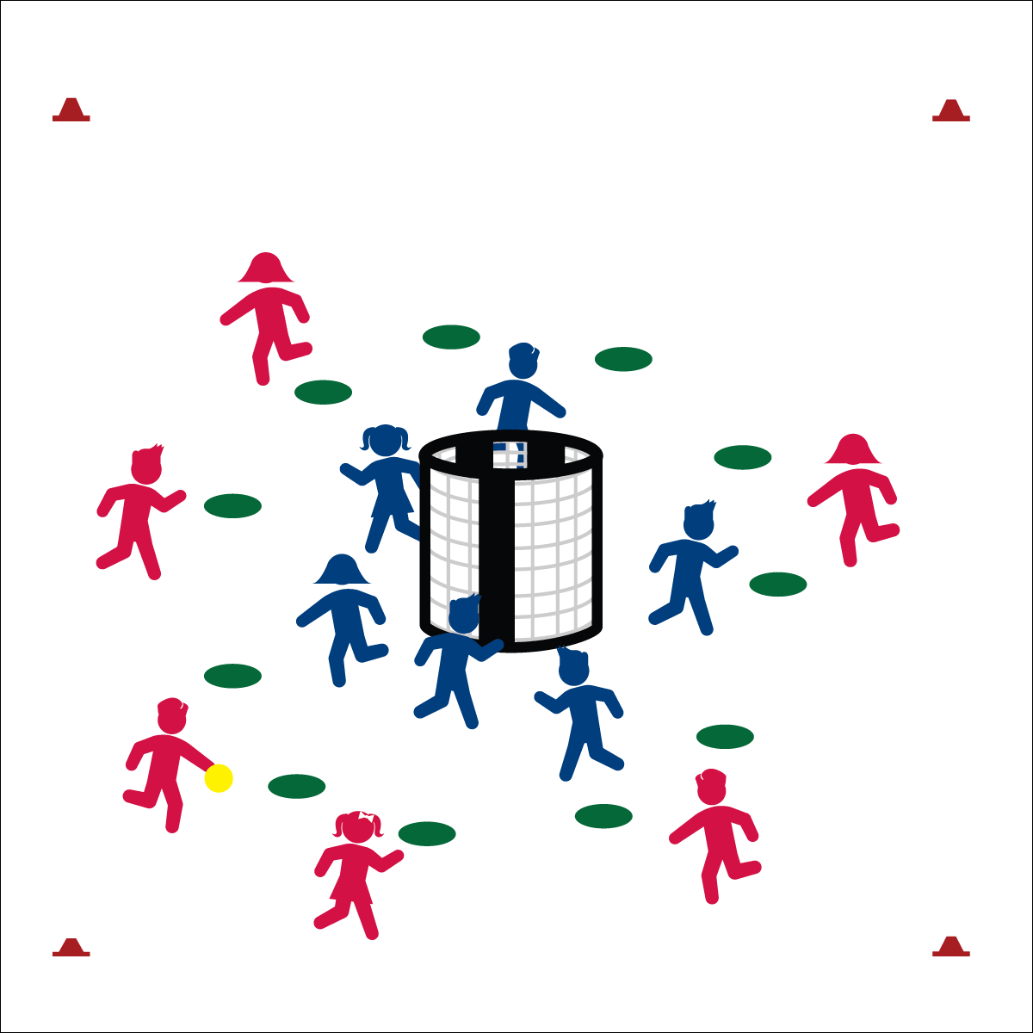

**Activity Procedures:**

1. Today’s activity is called Switch. The object of the game is for the offense to score a goal (teacher’s choice: soccer, handball, or basketball style). Three passes must be made before a shot is taken.
2. When a goal is scored or an interception is made (defense gains possession), players yell, “SWITCH!” On this signal, teams switch; offense becomes defense and defense becomes offense.
3. The new offensive team must complete 10 jumping jacks before the next round begins.
4. Defensive teams must stay inside the cones but may move throughout the defensive area. Offense must stay outside cones but may move throughout the offensive area. If a player breaks this rule 3 times, she/he must sit out for 1 minute while the other team has a Power Play.
5. Continue play until you hear the stop signal.

**Grade Level Progression:**

**3rd:** Play the activity as described above.

**4th & 5th:** Add a second ball to the activity. This could be a different type of ball (e.g., a football).

**Equipment:**

* 1 or 2 goals per 12 students
* 1 ball per 12 students
* 12 spot markers per group of 12 students
* 1 pinnie per 2 students.
* Offense/Defense Strategy Chart
* Throwing and Catching Skill Cue Chart

**Set-Up:**

1. Create 1 activity area per 12 students with 2 stacked goals in the center of each area.
2. Create a shooting circle 8 to 10 paces from the goal using 12 spot markers. This creates a defensive area inside the spots and an offensive area outside the spots.
3. Create teams of 6 students with 1 team inside the circle area (defense) and 1 team outside the circle area (offense). The team starting on offense wears pinnies.

* Offense: Space, Movement, Pass, Shoot
* Defense: Ball/Opponent, Angles, Space, Force Outside
* **Skill:** I will demonstrate throwing and catching cues in order to pass and shoot accurately.
* **Cognitive:** I will identify and discuss basic skills and strategies need to gain an offensive advantage.
* **Fitness:** I will remain actively engaged in order to enhance my fitness.
* **Personal & Social Responsibility:** I will work safely while staying active.

**SWITCH**

**SWITCH**



Skill Cue, Pass, Shoot, Advantage, Accurately



* Allow teams to continue as offense/defense for a set time, followed by an auditory cue to switch roles.
* Teammates must hand the ball off to teammates rather than passing/tossing.
* Vary the number of players on offense and defense to give one an advantage.



* **DOK1:** What does it mean to have an offensive advantage?
* **DOK 2:** What skills and strategies help you gain an offensive advantage?
* **DOK 3:** How is ball movement (passing) related to offensive advantage?



* **Standard** **1 [E13&14.3-5b)** Throws underhand to a partner or target with reasonable accuracy (3); Throws overarm to a partner or at a target with accuracy at a reasonable distance (4b); Throws (underhand and overarm) using a mature pattern in non-dynamic environments, with different sizes and types of objects (5a); Throws (both underhand and overarm) to a large target with accuracy (5b).
* **Standard 1 [E15.4-5b]** Throws to a moving partner with reasonable accuracy in a non-dynamic environment (4). Throws with accuracy, both partners moving (5a). Throws with reasonable accuracy in dynamic, small-sided practice tasks.
* **Standard 1 [E16.4-5c]** Catches a thrown ball above the head, at chest/waist level, and below the waist using a mature pattern in a non-dynamic environment (4); Catches with accuracy, both partners moving (5b); Catches with reasonable accuracy in dynamic, small-sided practice tasks (5c).
* **Standard 2 [E5.3-5]** Applies basic offensive and defensive strategies/ tactics in invasion small-sided practice tasks (5a); Recognizes the type of throw, volley or striking action needed for different games/sports situations (5c).
* **Standard 4 [E6.3-5]** Works independently and safely in physical activity settings (3); Works safely with peers and equipment in physical activity settings (4); Applies safety principles with age-appropriate physical activities (5).



**Help students engage in cognitively complex tasks:** Execution of locomotor and manipulative skill combinations within a dynamic activity environment is both physically and cognitively complex for intermediate school students. Further increasing the complexity of the task is the transition from offense to defense and vice versa. Switch is a perfect game for introducing this level of complexity: play remains focused on 1 goal, there are auditory and visual cues to announce the transitions, and possession changes can be buffered by adjusting the number of exercises the offense must complete before play resumes.