­­

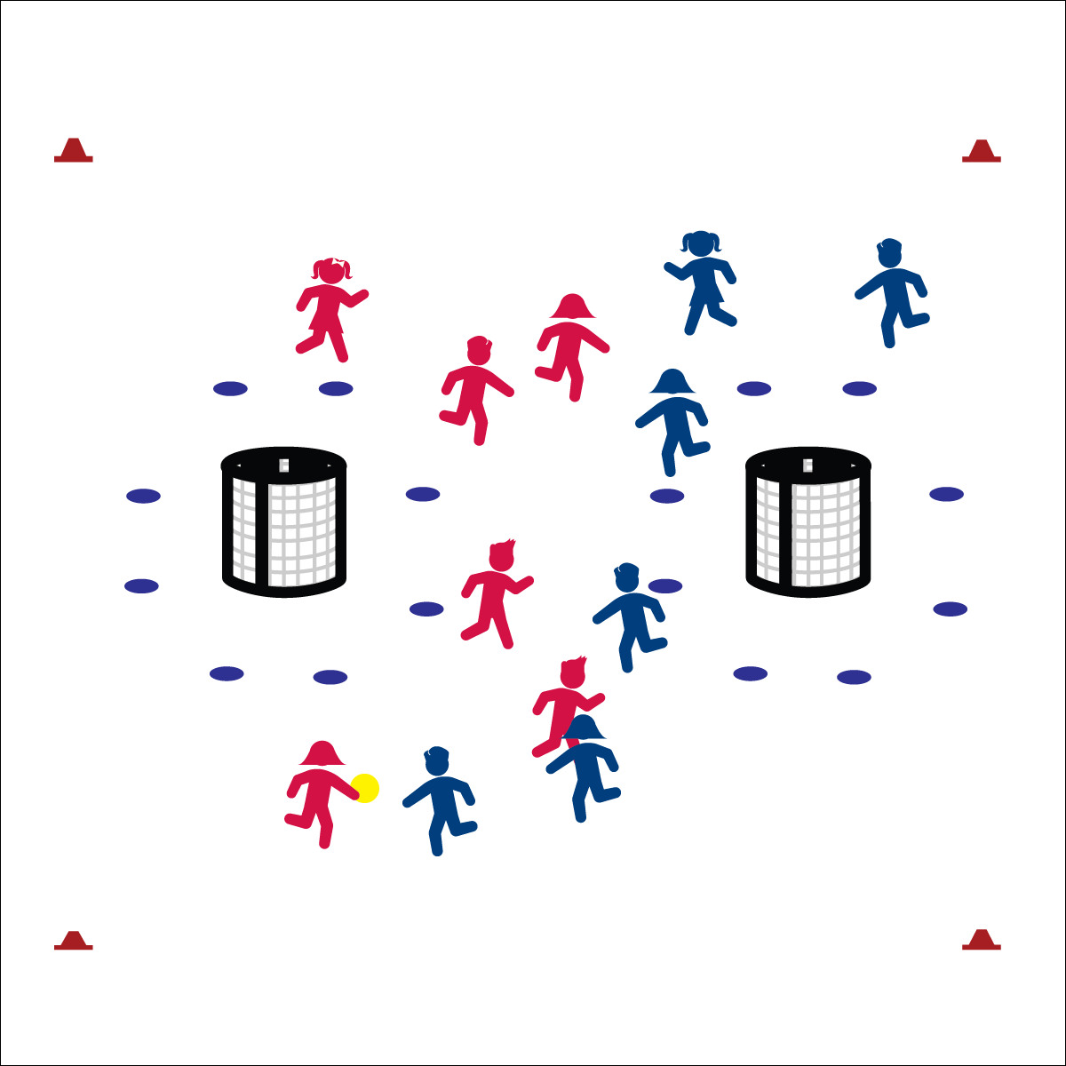

**Equipment:**

1. 2 goals per 12 students
2. 1 ball per 12 students
3. 12 spot markers per goal
4. 4 large cones per court/field
5. Offense/Defense Strategy Chart

**Set-Up:**

* Create a large activity area (the size of a basketball court) using large cones.
* Set up goals 5 to 10 paces from each end line.
* Create a shooting circle (i.e., crease) 6 paces from the goal using spot markers.
* Create two teams per activity area (6 per team is ideal). One team per area wearing pinnies. Pinnies begin with the ball.

**Activity Procedures:**

1. Today we’re going to play Team Handball. The object of the games is for your team to score more points than your opponent scores before the stop signal. You’ll use the skills and strategies we’ve learned in previous activities to work as a team on both offense and defense.
2. There are a few important rules:
3. Play begins with a throw-off from midfield: the starting player stands at midfield and passes to a teammate. This starts the game and is the way players should restart play after each goal.
4. If the ball goes out of bounds, restart with a throw-in: a player standing on the side line or end line throws to a teammate who is in bounds.
5. Defense must be 5 paces away from the player performing every throw-off and throw-in.
6. No contact between players is allowed. Defense must stay an arms-length from the player with the ball.
7. Defense cannot touch the ball when an offensive player has control.
8. Passes and shots can be intercepted/knocked down with hands and arms.
9. Offense can take 3 steps with the ball and/or hold the ball for no more than 3 seconds.
10. Challenge: Change possession if the ball hits the ground after a pass. Shots are not considered passes. Offense may get a rebound from a shot.

* **Skill:** I will use a combination of skills and movement concepts.
* **Cognitive:** I will apply my understanding of open space.
* **Fitness:** I will remain actively engaged in order to enhance my fitness.
* **Personal & Social Responsibility:** I will work safely while staying active.
* Offense: Space, Movement, Pass, Shoot
* Defense: Ball/Opponent, Angles, Space, Force Outside

**TEAM HANDBALL**

**TEAM HANDBALL**



Apply, Skill, Movement Concept, Combination, Open Space



* Use larger, stacked goals to increase opportunities for shooting success.
* Play without goalies. Place auditory signals in goals.
* Use passable objects of various sizes, shapes, colors, and textures.
* Implement a 5-, or 3-second rule for players holding the ball.
* Require a minimum number of passes prior to shooting.

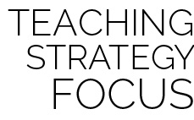

**Help students examine similarities and differences:** Students may not be familiar with Team Handball as a specific invasion sport. However, many students will recognize invasion strategies from prior experience in sports such as basketball, soccer, lacrosse, etc. Examine similarities as well as differences in order to help students connect with prior learning as well as extend learning into future participation in all invasion games. Skill and knowledge transfer will work to enhance both competence and confidence as we encourage students to try a variety of activity options.



* **Standard** **1 [E1.4 & 5c]** Uses various locomotor skills in a variety of small-sided practice tasks, dance, and educational gymnastics experiences (4); Combines traveling with manipulative skills for execution to a target (e.g., scoring in soccer, hockey and basketball) (5c).
* **Standard 1 [E15.4-5b]** Throws to a moving partner with reasonable accuracy in a non-dynamic environment (4). Throws with accuracy, both partners moving (5a). Throws with reasonable accuracy in dynamic, small-sided practice tasks.
* **Standard 1 [E16.4-5c]** Catches a thrown ball above the head, at chest/waist level, and below the waist using a mature pattern in a non-dynamic environment (4); Catches with accuracy, both partners moving (5b); Catches with reasonable accuracy in dynamic, small-sided practice tasks (5c).
* **Standard 2 [E1.3-5]** Recognizes the concept of open spaces in a movement context (3); Applies the concept of open spaces to combination skills involving traveling, (e.g., dribbling and traveling) (4a); Applies the concept of closing spaces in small-sided practice tasks (4b); Combines spatial concepts with locomotor and non-locomotor movements for small groups in gymnastics, dance, and games environments (5).
* **Standard 2 [E5.3-5]** Applies basic offensive and defensive strategies/tactics in invasion small-sided practice tasks (5a); Applies basic offensive and defensive strategies/tactics in net/wall small-sided practice tasks (5b); Recognizes the type of throw, volley or striking action needed for different games/sports situations (5c).



* **DOK1:** What is an open space?
* **DOK 2:** How does open space affect offense? How does it affect defense?
* **DOK 3:** What does the defense have to do to closed space?