­­

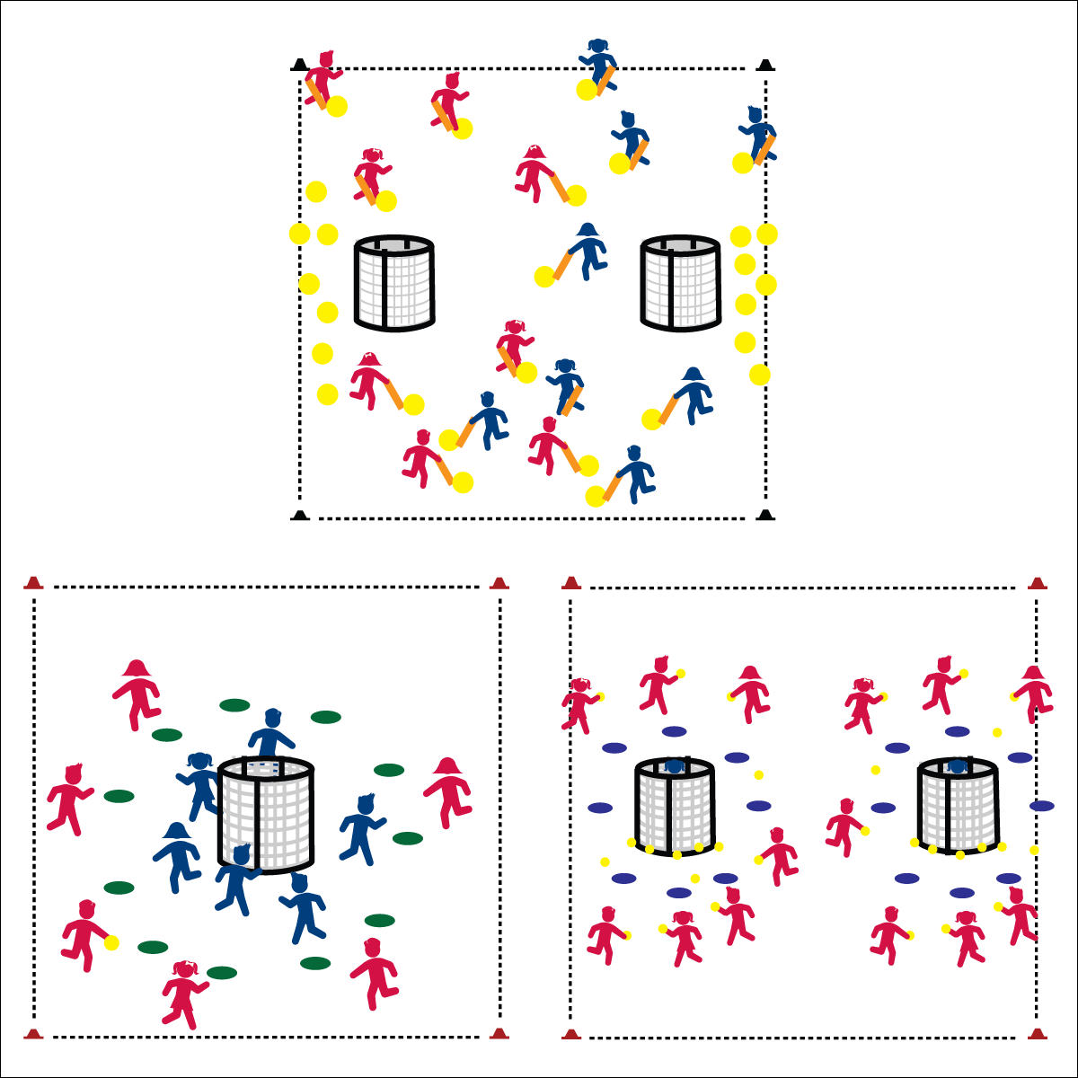

**INVASION TRIATHLON**

* **Skill:** I will use a combination of skills to execute offensive and defensive strategies and tactics.
* **Cognitive:** I will discuss the health benefits of participating in invasion games/sports.
* **Fitness:** I will compare the health benefits of invasion games with other activities that I enjoy.
* **Personal & Social Responsibility:** I will identify the reasons why I enjoy being physically active in a variety of activity choices.
* Offense: Space, Movement, Pass, Shoot
* Defense: Ball/Opponent, Angles, Space, Force Outside

**Equipment:**

* E See equipment needed for selected activities.

**Set-Up:**

1. Set up 3 activity areas according to the set-up instructions for selected activities.
2. Create even teams and number teams as Team 1, Team 2, Team 3, Team 4, etc.
3. Rotate teams through each of the selected activities.
4. Even teams rotate clockwise, odd teams rotate counter-clockwise.

**Activity Procedures:**

1. It’s time for the Invasion Triathlon. Today you’ll work independently with your team, rotate through each activity area, and participate in 3 different invasion activities.
2. While you’re participating in each activity, I’ll be using a rubric to assess your skill level. We’ll review your assessment together when you compete the Invasion Basics Self-Assessment.
3. Teachers, choose 3 activities from this module in order to assess student performance.
4. Suggested Activities:
5. Over There
6. The Grouch
7. Switch (Team Handball for highly skilled groups)

**Grade Level Progression:**

**3rd – 5th:** See grade level progressions for selected activities.



* **DOK1:** How can you recognize an invasion game?
* **DOK 2:** How do invasion games affect personal health?
* **DOK 2:** How would you compare the health benefits of invasion games with other activities that you enjoy?

**INVASION TRIATHLON**



* Choose UDA’s from selected activities.



Choose words from selected activities.



* **Standard** **1 & 2 [Multiple Outcomes:** Select outcomes from the activities chosen for this event.
* **Standard 3 [E3.3-5]** Describes the concept of fitness and provides examples of physical activity to enhance fitness (3); Identifies the components of health-related fitness (4); Differentiates between skill-related and health-related fitness (5).
* **Standard 4 [E5.3-5]** Recognizes the role of rules and etiquette in physical activity with peers (3); Exhibits etiquette and adherence to rules in a variety of physical activities (4); Critiques the etiquette involved in rules of various game activities (5).
* **Standard 5 [E1.3-5]** Discusses the relationship between physical activity and good health (3); Examines the health benefits of participating in physical activity (4); Compares the health benefits of participating in selected physical activities (5).
* **Standard 5 [E3.3-5]** Reflects on the reasons for enjoying selected physical activities (S5.E3.3); Ranks the enjoyment of participating in different physical activities (S5.E3.4); Analyzes different physical activities for enjoyment and challenge, identifying reasons for a positive or negative response (S5.E3.5).



**Review content:** Take an opportunity to review critical skill cues and movement concepts from earlier lessons and activities in order to highlight the cumulative nature of skill and knowledge acquisition. Highlight progress made from the start of the module through the final lessons. This helps to underscore the importance of purposeful practice.