­­

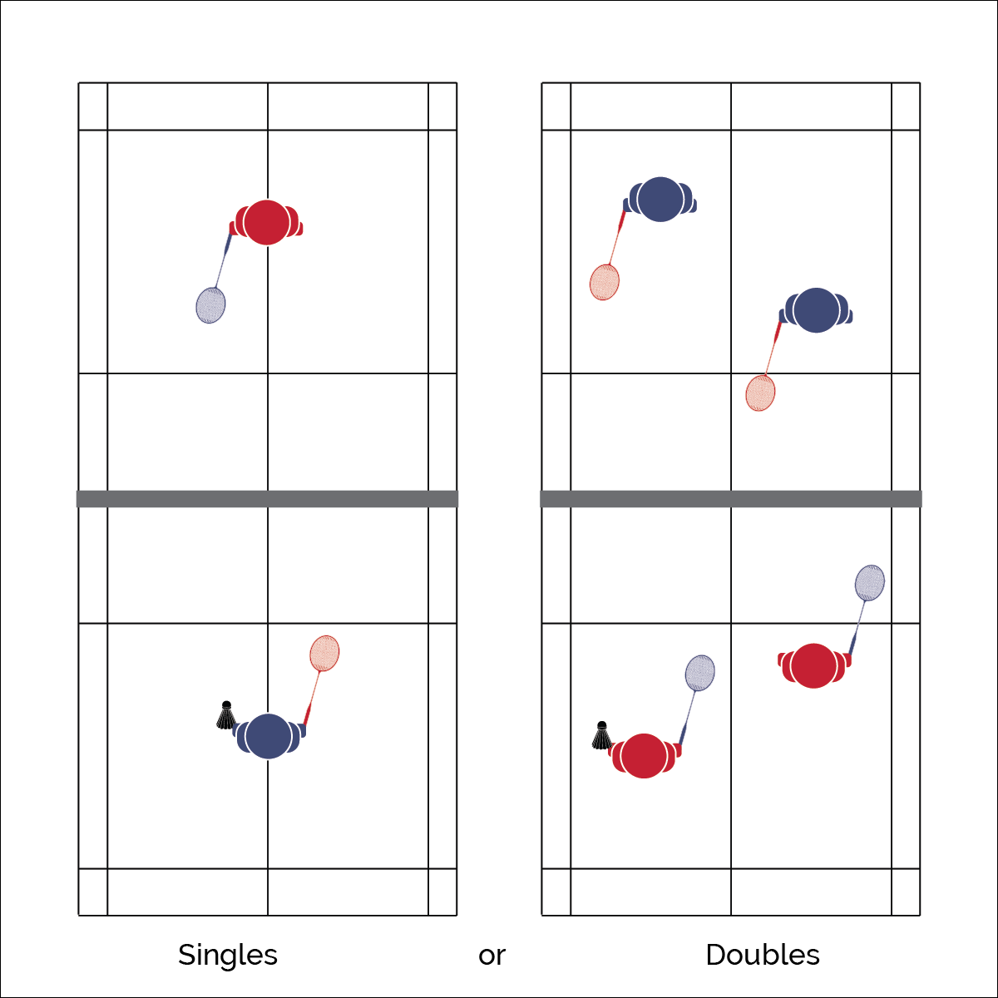

* **Skill:** I will volley the shuttle over the net to my partner, demonstrating control and accuracy.
* **Cognitive:** I will discuss concepts that helped me be successful in hitting the shuttle to my partner.
* **Fitness:** I will stay actively engaged in the activity for the entire class.
* **Personal & Social Responsibility:** I will show respect by safely using all badminton equipment.

**VOLLEY CHALLENGE**

* Athletic Stance
* Spot Shuttle (Eye Contact)
* Wrists

**Equipment:**

* 1 net per 4 students
* 1 racquet per student
* 1 shuttle per 2 students

**Set-Up:**

1. Set up badminton nets to create 1 court per 4 students.
2. Pair students, 2 pairs at each net.
3. If nets are limited, students can split the courts and share with classmates.

**Activity Procedures:**

1. Today’s activity is called Volley Challenge.
2. The object of the activity is to see how many times you and your partner can volley the shuttle over the net without letting it hitting the floor.
3. If you and your partner get 25 or more consecutive volleys, try these challenges:
   1. Use non-dominant hand
   2. Switch hands (racquet in dominant hand for 1 hit, then non-dominant hand for the next)

**Grade Level Progression:**

**L1:** Play the activity as described with a focus on accurate Forehand and Backhand strokes.

**L2:** Utilize the Move to Improve Self-Analysis Worksheet with specific strategies for improving performance in the Badminton Volley Challenge.

**VOLLEY CHALLENGE**



* **Standard 1 [H1.L1-2]:** Demonstrates competency and/or refines activity-specific movement skills in 2 or more lifetime activities (net/wall games) (L1); Refines activity-specific movement skills in 1 or more lifetime activities (net/wall games) (L2).
* **Standard 2 [H2. L1-2]:** Uses movement concepts and principles to analyze and improve performance of self and/or others in a selected skill (L1); Describes the speed/accuracy trade-off in throwing and striking skills (L2).
* **Standard 4 [H2 .L1]:** Exhibits proper etiquette, respect for others, and teamwork while engaging in physical activity and/or social dance.
* **Standard 4 [H3.L1]:** Uses communication skills and strategies that promote team or group dynamics.
* **Standard 4 [H5.L1]:** Applies best practices for participating safely in physical activity, exercise, and dance. Applies best practices for participating safely in physical activity.



* **Adaptation:** Use a line on the floor to represent the net.
* **Extension:** Students create their own volleying challenges.



Volley, Dominant, Non-Dominant, Shuttle, Communication, Actively Engaged, Space, Relationship, Effort



* **DOK 1:** What would you include in a list of movement concepts related to Volley Challenge?
* **DOK 2:** How did you apply these concepts in your skill practice?
* **DOK 3:** How could you adapt this activity to make the practice more challenging? To make it less challenging?



**Identify Critical Content:** Volley Challenge is a very fundamental activity. However, it creates a perfect learning environment for identifying important movement concepts that will guide skill development and performance throughout the entire Badminton module. Take the time to help students explore the concepts of space, relationships, and effort with respect to their movement performances. Challenge them to think beyond surface thoughts and ideas about how these concepts related to their practice performance and prompt them to demonstrate their ideas during the activity.

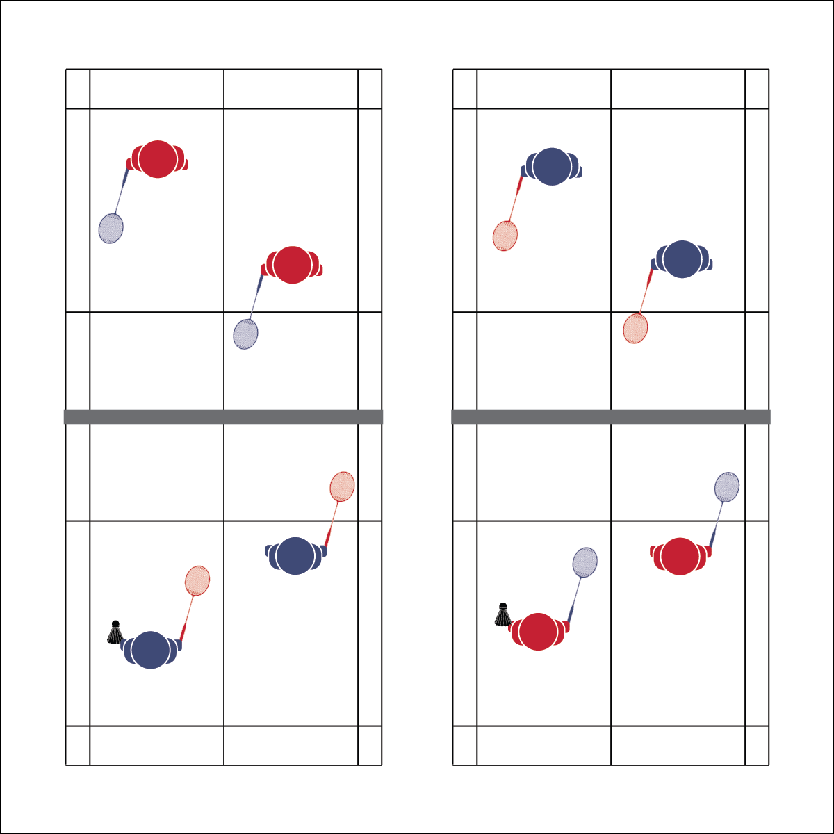

**Equipment:**

* 1 net per 4 students
* 1 racquet per student
* 1 shuttle per 2 students
* Badminton 101 Skill Cue Charts

**Set-Up:**

1. Set up badminton nets to create 1 court per 4 students.
2. Pair students, 2 pairs at each net.
3. If nets are limited, students can split the courts and share with classmates.

* **Skill:** I will perform each shot, demonstrating all cues.
* **Cognitive:** I will identify each of the different shots when they are demonstrated by the teacher.
* **Fitness:** I will stay actively engaged in physical education class.
* **Personal & Social Responsibility:** I will safely participate by using the equipment correctly.

**BADMINTON 101**

* Use cues on teach cards that correlate with different shots

**Activity Procedures:**

1. Today’s activity is called Badminton 101
2. The object of the activity is to learn and practice different shots used in badminton.
3. Teachers: Demonstrate and explain the different shots. Highlight the critical elements and skill cues provided on the Skill Cue Charts.
4. After I demonstrate each shot, you and your partner will practice that shot for [a set period of time].
5. When you hear the stop signal, come back to the teacher court for a demonstration of the next shot. (Continue until the class has completed all of the different shots.)

**Grade Level Progression:**

**L1:** Execute the activity as described. Prompt students to recite cues.

**L2:** Prompt students to complete the Badminton Wikipedia Scavenger Hunt (as homework or during an inactive PE day). Use this assignment to prompt class discussion with respect to the historical and cultural significance of badminton.

**BADMINTON 101**



* **Standard 1 [H1.L1]:** Demonstrates competency and/or refines activity-specific movement skills in 2 or more lifetime activities.
* **Standard 2 [H1.L1]:** Applies the terminology associated with exercise and participation in net/wall games appropriately (L1); Identifies and discusses the historical and cultural roles of games, sports, and dance in a society (L2).
* **Standard 4 [H2.L1]:** Exhibits proper etiquette, respect for others, and teamwork while engaging in physical activity.
* **Standard 4 [H5.L1]:** Applies best practices for participating safely in physical activity.



* **Adaptation:** Have the students go through the skill in slow motion, without using a shuttle. Using a lowered net (cones and jump ropes set up) will also allow for more practice and success.
* **Extension:** Have students put the skills together and allow gameplay with a partner. Gameplay should utilize the rules and skills learned that day.



Etiquette, Clear, Smash, Drop, Forehand, Backhand, Serve, Backhand Serve, Forehand Serve, Service Line, Center Line, Safety, Skill



* **DOK 1:** What skill is being demonstrated? (Demonstrate a skill)
* **DOK 2:** How would you use this skill during gameplay?
* **DOK 3:** Can you describe a shot sequence that could be used to gain an offensive advantage?



**Preview new content:** Search and prepare YouTube videos demonstrating elite performances of each badminton shot. Show each video to students at the start of class or just before your skill demonstration. Students will connect what they see to their own learning in a way that will help analyze technique, performance, and engagement.

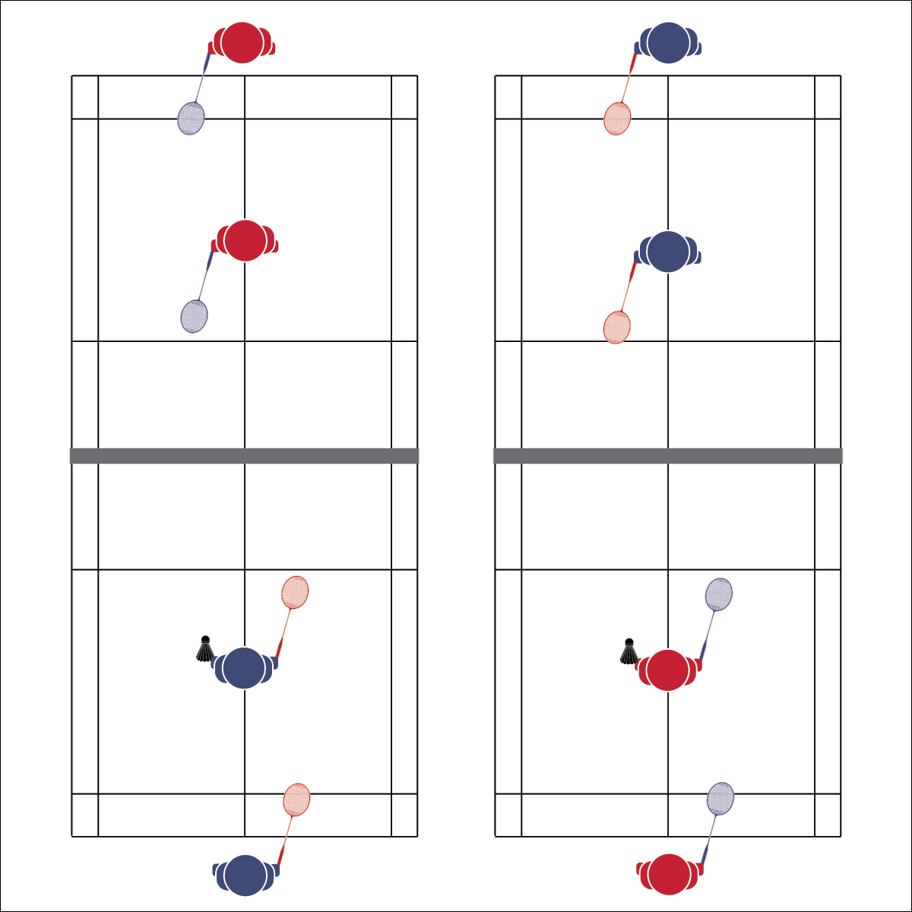

**Activity Procedures:**

1. Today’s activity is called Move and Clear.
2. The object of the activity is to work on clearing the shuttle while repetitively switching with your partner.
3. When I say “GO,” 1 side will serve to the opposing team. 1 player from that team will return the shot over the net with a clear. Once that person has made the clear, they will run behind the end line, and their partner will move to the court to return the next shot. The serving team also begins the same rotation as both teams hit the shuttle back and forth.
4. Keep track of how many times you can consecutively hit the shuttle without a miss.
5. Focus on proper form and cues for the clear shot.
6. Freeze when you hear the stop signal, and we will switch opponents.

**Grade Level Progression:**

**L1:** Play the activity as described with a focus on accurate forehand and backhand strokes.

**L2:** Utilize the Move to Improve Self-Analysis Worksheet with specific strategies for improving performance in the Move and Clear practice task.

**MOVE AND CLEAR**

* **Skill:** I will perform a clear shot, demonstrating all cues.
* **Cognitive:** I will discuss movement patterns that were used during this activity.
* **Fitness:** I will stay actively engaged during physical education class so that my heart rate increases.
* **Personal & Social Responsibility:** I will demonstrate respect towards my teammate and opponents.
* Athletic Stance
* Racquet Face Open
* High and Deep
* Quick Feet

**Equipment:**

* 1 net per 4 students
* 1 racquet per student
* 1 shuttle per 4 students

**Set-Up:**

1. Set up badminton nets to create 1 court per 4 students.
2. Pair students, 2 pairs at each net.
3. If nets are limited, students can split the courts and share with classmates.



* **DOK 1:** Describe the flight of shuttle during a clear shot.
* **DOK 2:** How does your racquet swing affect the flight of the shuttle?
* **DOK 3:** How can you adapt this task in order to practice a different type of badminton shot?



* **Standard 1 [H1.L1]:** Demonstrates competency and/or refines activity-specific movement skills in 2 or more lifetime activities (net/wall games) (L1); Refines activity-specific movement skills in 1 or more lifetime activities (net/wall games) (L2).
* **Standard 2 [H1. L1]:** Uses movement concepts and principles to analyze and improve performance of self and/or others in a selected skill.
* **Standard 4 [H2. L1]:** Exhibits proper etiquette, respect for others, and teamwork while engaging in physical activity.
* **Standard 4 [H5.L1]:** Applies best practices for participating safely in physical activity.



* **Adaptation:** Simplify the activity by removing the player rotation. Students work with a partner to see how many consecutive clears they can hit during a rally.
* **Extension:** Challenge students by increasing the distance they must go before and after a clear. For example, rather than moving to the end line, students must move outside the back corner of the court.

**MOVE AND CLEAR**



Clear, Athletic Stance, Speed, Power, Agility, Health-Related Fitness, Skill-Related Fitness, Cardiorespiratory Endurance, Timing, Actively Engaged



**Help students engage in complex tasks:** Move and Clear creates a dynamic activity environment that forces students to think about their skill performance while safely navigating court movement. There’s potential for this activity to become more about movement than learning. Look for teachable moments, positive examples, and student leadership. Stop the task, prompt discussion, refocus student effort, and then resume the activity.

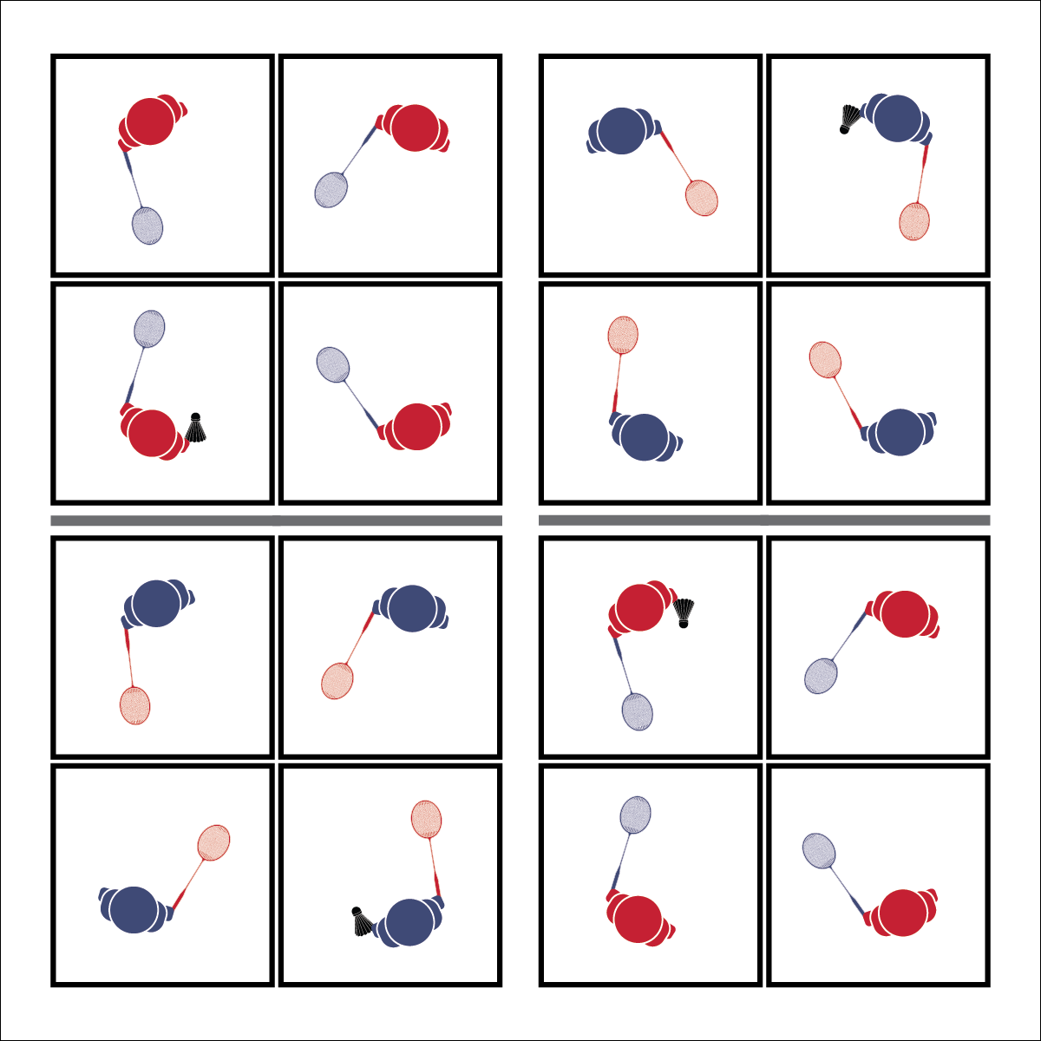

**Activity Procedures:**

1. Today’s activity is called Racquet Square.
2. The object of the activity is to complete different challenges within the 4 squares.
3. When I say “GO,” each member of your group will get into 1 of the 4 squares on your court. To start, it doesn’t matter what square you are in.
4. The first challenge is to pass the shuttle using any shot from square to square (in any order) without a fault. When you’ve mastered that challenge, try others:
   1. Pass in order from square 1 to 2 to 3 to 4, back to 1.
   2. Pass from square to square (any order) using a drop shot only.
   3. Pass in order from square to square, adding a second shuttle.
   4. The final challenge is to play a badminton version of four square. 4 square serves to 2 square to start the round. When a player is ‘out’ they move to square 1 and other players rotate.

**Grade Level Progression:**

**L1:** Play the activity as described with a focus on control and accuracy of the drop shot.

**L2:** Utilize the Move to Improve Self-Analysis Worksheet with specific strategies for improving performance in the Move and Clear practice task.

* **Skill:** I will perform the drop shot, demonstrating all cues.
* **Cognitive:** I will discuss specific movement concepts and how they relate to personal skill improvement.
* **Fitness:** I will be actively engaged in an effort to increase my heart rate.
* **Personal & Social Responsibility:** I will demonstrate respect for my group by using words to encourage their effort.

**Equipment:**

* 1 net per 8 students
* 1 racquet per student
* 1 shuttle per 4 students

**Set-Up:**

1. Set up badminton nets to create 1 court per 4 students.
2. Each court divided into 4 quadrants using the center line and net as dividers.
3. Pair students, 2 pairs at each net.

**RACQUET SQUARE**

* Athletic Stance
* Soft Touches
* Placement

**RACQUET SQUARE**



* **Adaptation:** Use different equipment that might be easier for students who are struggling, such as a larger racquet, balloon, or soft ball.
* **Extension:** Allow students to create custom rules after staying in four square for 3 consecutive serves.



Sportsmanship, Drop Shot, Soft Hits, Balance, Positioning



* **Standard 1 [H1.L1]:** Demonstrates competency and/or refines activity-specific movement skills in 2 or more lifetime activities (L1);Refines activity-specific movement skills in 1 or more lifetime activities (net/wall games) (L2).
* **Standard 2 [H2.L1]:** Uses movement concepts and principles to analyze and improve performance of self and/or others in a selected skill.
* **Standard 4 [H2.L1]:** Exhibits proper etiquette, respect for others, and teamwork while engaging in physical activity.
* **Standard 4 [H3.L1]:** Uses communication skills and strategies that promote team or group dynamics.
* **Standard 4 [H5.L1]:** Applies best practices for participating safely in physical activity.



* **DOK 1:** How can you recognize a good drop shot? Use specific descriptors.
* **DOK 2:** As a player on defense who is working to return a drop shot, what did you notice about drop shots that were hit to you?
* **DOK 3:** How is a drop shot related to offensive play? How is it related to defensive play?



**Help students elaborate on content:** As students describe what a good drop shot looks like, prompt them to provide descriptive details. This requires students to make inferences about what they’ve seen and experienced during the practice activity. Continue to extend the discussion by asking students to provide support for the inferences that they make. For example, you might ask, “Why does a good drop shot make your opponent move?”

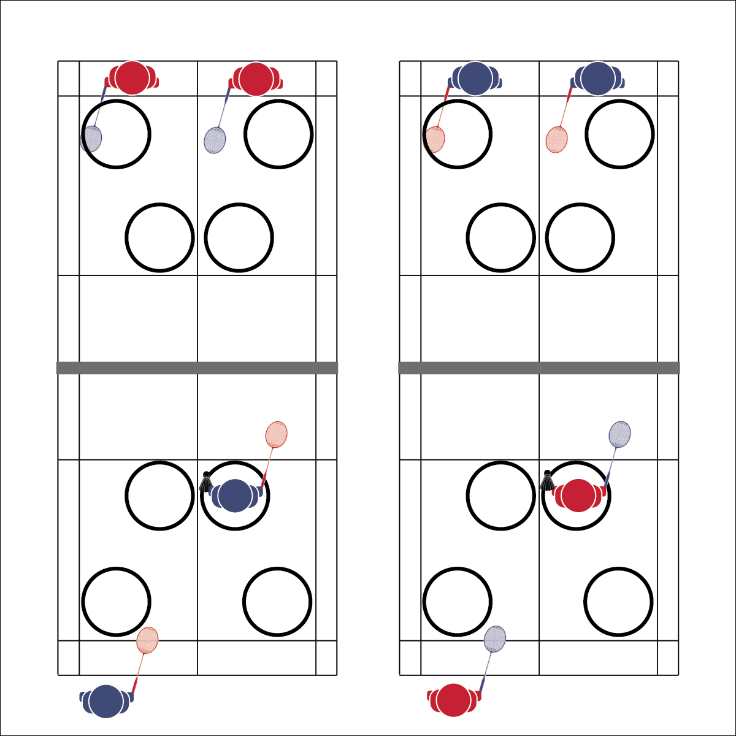

* **Skill:** I will demonstrate a serve with correct form, making at least three shuttles in the hoop.
* **Cognitive:** I will identify movement concepts applied to successful serves.
* **Fitness:** I will be actively engaged in an effort to improve my badminton skills.
* **Personal & Social Responsibility:** I will demonstrate safe play by making sure the area around me is clear before I serve.

**TARGET PRACTICE**

* Athletic Stance
* Drop Birdie
* Wrist Flick
* Contact

**Equipment:**

* 1 net per 4 students
* 1 racquet per student
* 6 shuttles per 4 students
* 6 hula hoops per court
* Badminton 101 Skill Cue Chart for Serving

**Set-Up:**

1. Set up badminton nets to create 1 court per 4 students.
2. Place 6 hula hoops at each court with 3 hoops on each side. Position hoops where a good serve would land.
3. Pair students, 2 pairs at each court, and each court with 6 shuttles.

**Activity Procedures:**

1. Today’s activity is called Target Practice. The object of the activity is to practice serving form and placement by serving shuttles into the hoops. We’ll begin with a basic forehand serve. (Teacher demonstrates)
2. When I say “GO,” serve the shuttle over the net and into a hoop. The hula hoops are placed where a “good” serve would land.
3. Take turns with your partner and see how many shuttles you can get in the hoops as a team (1 shuttle = 1 point). The pair across the net will work with you to check placement, total points, collect shuttles, and then serve them back.
4. Teachers, allow students adequate practice time and then demonstrate and practice the backhand serve.

**Grade Level Progression:**

**L1:** Play the activity as described with a focus on control and accuracy of the serve.

**L2:** Provide progressively smaller targets such as small hoops or buckets, making the activity more challenging with an increased focus on refining consistency in form and accuracy.



* **Adaptation:** Create larger a target area or eliminate areas altogether. Points are earned each time the shuttle is served over the net.
* **Extension:** Assign a specific point number to the different hoops. For example: Blue=3; Green=2; Red=1. Students are responsible for totaling and tracking their score.



Target, Placement, Balance, Force, Position, Skill-Related Fitness



* **Standard 1 [H1.L1-2]:** Demonstrates competency and/or refines activity-specific movement skills in 2 or more lifetime activities (L1): Refines activity-specific movement skills in 1 or more lifetime activities (outdoor pursuits, individual-performance activities, aquatics, net/wall games, or target games) (L2).
* **Standard 2 [H2. L1]:** Uses movement concepts and principles to analyze and improve performance of self and/or others in a selected skill (L1).
* **Standard 4 [H5.L1]:** Applies best practices for participating safely in physical activity (L1).



* **DOK 1:** What are the 2 types of serves?
* **DOK 2:** What are the similarities and differences between the 2 types of serves?
* **DOK 3:** What strategic advantage does the forehand serve offer? Why? (Provide detailed examples of game situations.)
* **DOK 3:** What strategic advantage does the backhand serve offer? Why? (Provide detailed examples of game situations.)



**Help students examine similarities and differences:** Understanding the advantages and limitations of different shots is fundamental strategic knowledge for badminton participation. The similarities and differences between the 2 types of serves help to illustrate the importance of knowing when and why different shots can and should be used.

**TARGET PRACTICE**

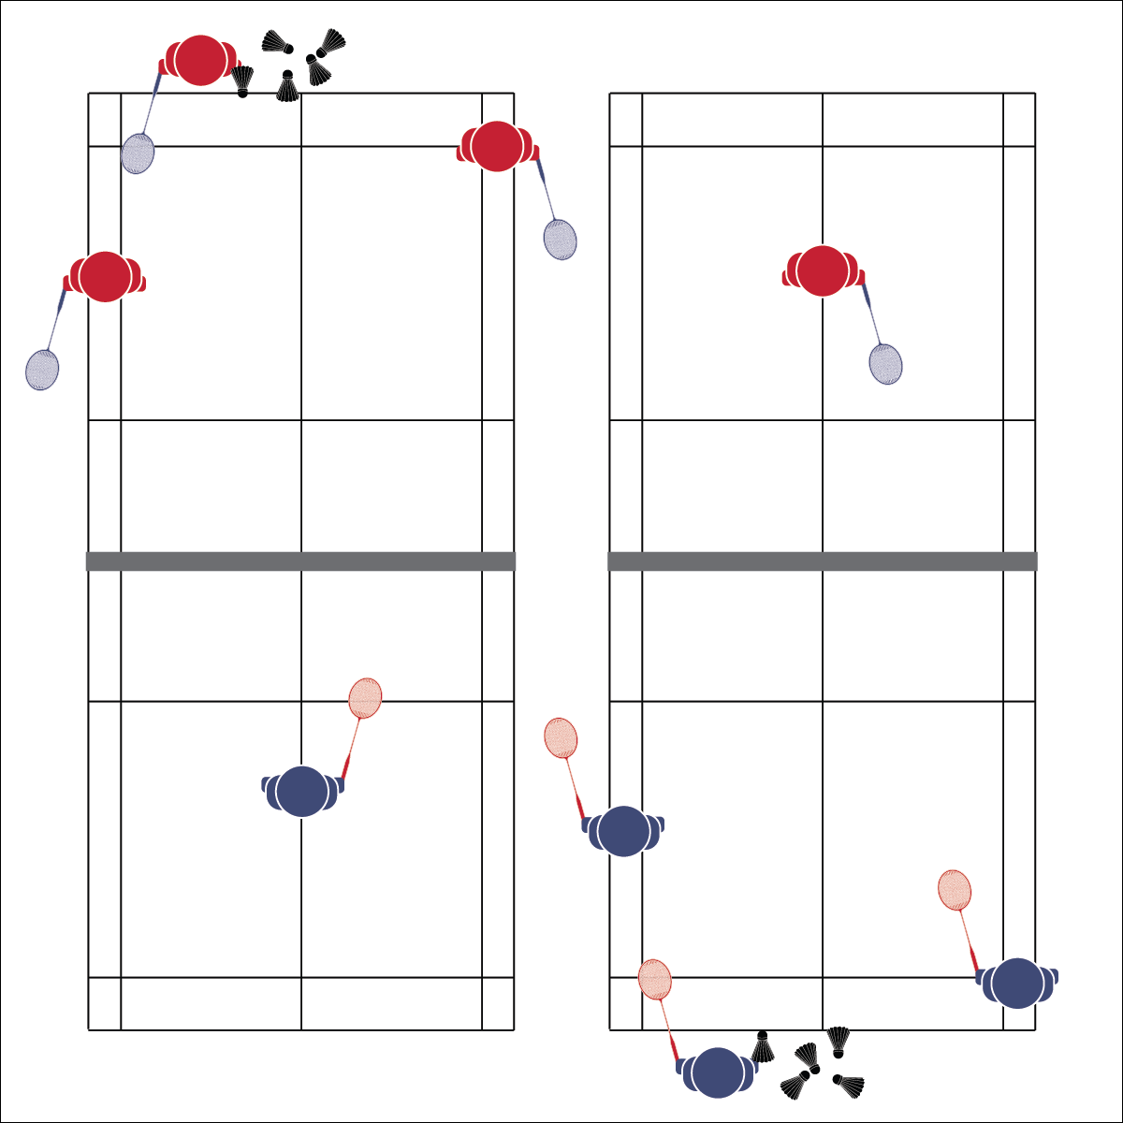

**Activity Procedures:**

1. Today’s activity is called Cover the Court. This is a fun drill designed to work on footwork and positioning.
2. The object of the activity is to return 6 consecutive serves successfully. You’ll start at center court, move to return a serve, and then move back to center court before returning the next serve.
3. The server has 6 shuttles ready to serve 1 at a time. The returner is ready at center court. 2 corner judges are positioned on the server side at each corner, watching for successful returns. Each successful return is a point.
4. Play begins with the server serving 1 shuttle into a corner. The returner moves to hit the serve. As soon as the shuttle is hit, the server can serve another shuttle into a different corner to be returned. This continues until all 6 shuttles have been served.
5. Rotate positions: Server to Returner; Returner to Right Corner; Right Corner to Left Corner; Left Corner to Server.

**Grade Level Progression:**

**L1:** Play the activity as described with a focus on footwork and positioning.

**L1:** Prior to restarting the drill after each position rotation, students will quiz the returner, asking her/him to identify court markings/lines (utilize Badminton 101 Diagrams).

**Equipment:**

* 1 net per 4 students
* 1 racquet per student
* 6 shuttles per 4 students
* Badminton 101 Diagrams (Quiz is optional)

**Set-Up:**

1. Set up badminton nets to create 1 court per 4 students.
2. Students in groups of 4, each group at a net with 6 shuttles.
3. Rotate student through 4 positions: Server, Returner, Right Corner Judge, Left Corner Judge.

* **Skill:** I will demonstrate quick footwork and court positioning by quickly moving from starting position to return each shuttle, then back to starting position.
* **Cognitive:** I will identify badminton court markings.
* **Fitness:** I will stay actively engaged during physical education class so that my heart rate increases.
* **Personal & Social Responsibility:** I will participate safely by making sure the activity area is clear for activity.

**COVER THE COURT**

* Athletic Stance
* Watch Shuttle
* Quick Feet

**COVER THE COURT**



* **DOK 1:** Can you remember what each line on the badminton court is called and explain why it’s there?
* **DOK 2:** How does [name a line] affect how you play?
* **DOK 3:** How would you adapt the court to make the game easier and more recreational?
* **DOK 1:** Which component(s) of skill-related fitness are important to successful participation in badminton?
* **DOK 2:** How does that component affect your ability to return serves in this activity?
* **DOK 3:** Based on your performance in this activity, how would you interpret your skill-related fitness level (for 1 or more components)? Support your answer with specific examples.



* **Adaptation:** Allow more time for the returner to get back to the center position before the next shot is served. Use a low net or center floor line to create modified courts.
* **Extension:** Play rapid fire with 2 servers alternating serves as soon as the shuttle crosses the net.



Agility, Speed, Athletic Stance, Health-Related Fitness, Skill-Related Fitness, Positioning, Quick



* **Standard 1 [H1.L1-2]:** Demonstrates competency and/or refines activity-specific movement skills in 2 or more lifetime activities (L1): Refines activity-specific movement skills in 1 or more lifetime activities (outdoor pursuits, individual-performance activities, aquatics, net/wall games, or target games) (L2).
* **Standard 2 [H1. L1]:** Applies the terminology associated with exercise and participation in selected individual-performance activities, dance, net/wall games, target games, aquatics, and/or outdoor pursuits appropriately (L1).
* **Standard 4 [H5.L1]:** Applies best practices for participating safely in physical activity (L1).



**Help students practice skills, strategies, and processes:** It’s important to design meaningful learning tasks designed to guide students through the process of skill development through purposeful practice. Allow students to experiment with different concepts and strategies within a dynamic activity environment, exploring what works for them and what doesn’t.

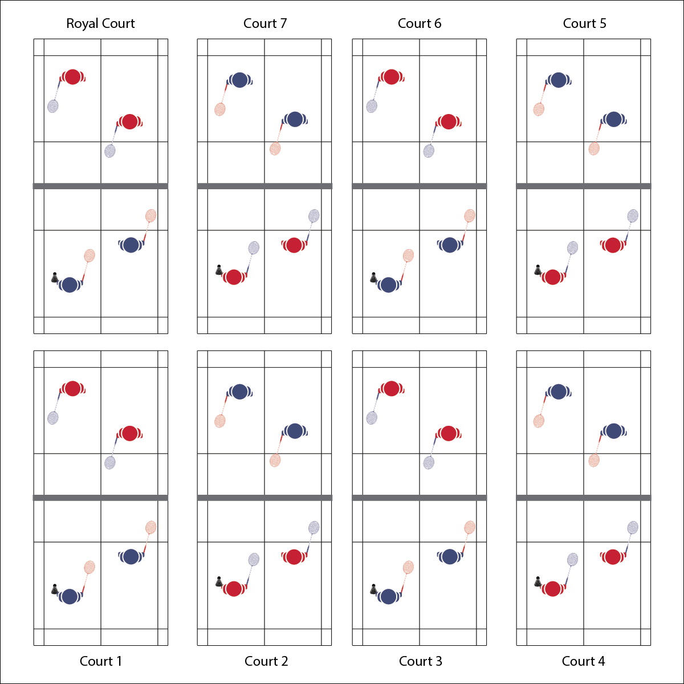

**Equipment:**

* 1 net per 4 students
* 1 racquet per student
* 1 shuttle per court
* Badminton Self and Social Inventory

**Set-Up:**

1. Set up badminton nets to create 1 court per 4 students. Number each court 1, 2, 3, 4, etc. Identify the highest number court as the Royal Court.
2. Pair students, 2 pairs at each court.
3. Each student with a racquet and 1 shuttle per court.

* **Skill:** I will demonstrate a minimum of 3 different shots within each game played during the lesson.
* **Cognitive:** I will demonstrate an understanding of court markings during each game played.
* **Fitness:** I will stay actively engaged throughout each game in order to increase my heart rate.
* **Personal & Social Responsibility:** I will show respect toward my opponent by playing fairly and communicating using positive language.

**Activity Procedures:**

1. Today’s activity is called King/Queen of the Court.
2. The object of the activity is for you and your partner to win short matches in order to move up toward the royal court. If you don’t win, you’ll move 1 court away from the royal court.
3. Teachers: Depending on class size and playing area, this activity can be played in singles or doubles.
4. When I say “GO” you will play an opposing team (player) for 3 minutes. The winner will move up 1 court toward the Royal Court. The winner on the Royal Court will stay and defend her/his position. The team that loses the match will move 1 court away from the Royal Court. The team that loses on the number 1 court will stay and try again. If the score is tied on any court when the 3 minute time expires, play Rock, Paper, Scissor to determine the winner.

**Grade Level Progression:**

**L1:** Play the activity as described with a focus on rules, etiquette, and safety.

**L2:** Utilize the Badminton Self-Efficacy and Social Support Inventory to help students evaluate their associations with badminton as a part of a healthy and active lifestyle. Review the inventory individually with students or use general responses to discuss this topic as a group.

**KING/QUEEN OF THE COURT**

* Play Fairly
* Demonstrate Sportsmanship
* Have Fun

**KING/QUEEN OF THE COURT**



* **Adaptation:** Create 2 sets of courts for students of different skill levels. Identify 1 set of courts as the “Olympic Finals” and the other set as the “Community Recreation League.” Allow students to self-select their level of participation with some guidance.
* **Extension:** Ask interested students to help you organize a badminton event outside of physical education class. This could be a teachers vs. student event, an intramural league, or just an opportunity for a pick-up game.



Sportsmanship, Etiquette, Safety, Opponent, Strategy, Skill, Cooperation



* **Standard 1 [H1.L1]:** Demonstrates competency and/or refines activity-specific movement skills in 2 or more lifetime activities.
* **Standard 2 [H1. L1]:** Applies the terminology associated with exercise and participation in selected individual-performance activities, net/wall games.
* **Standard 4 [H2. L1]:** Exhibits proper etiquette, respect for others, and teamwork while engaging in physical activity.
* **Standard 4 [H 5. L1]:** Applies best practices for participating safely in physical activity.
* **Standard 5 [H4.L1-2]:** Identifies the opportunity for social support in a self-selected physical activity or dance (L1); Evaluates the opportunity for social interaction and social support in a self-selected physical activity or dance (L2).



* **DOK 1:** What is sportsmanship?
* **DOK 2:** How does sportsmanship affect how enjoyable a badminton experiences can be?
* **DOK 3:** How is sportsmanship related to skill performance? Provide illustrations to support your answer.



**Organize students to interactive with content:** Creating a positive learning environment with appropriate challenges and experiences is a crucial component of any lesson. Understanding the social dynamics of a group in a physical activity setting will help set students up for successful and enjoyable participation. If possible, allow students to self-select their level of participation with respect to challenge and competition. Students who thrive on competition may enjoy more intense participation, while others may thrive with more social and less intense participation.

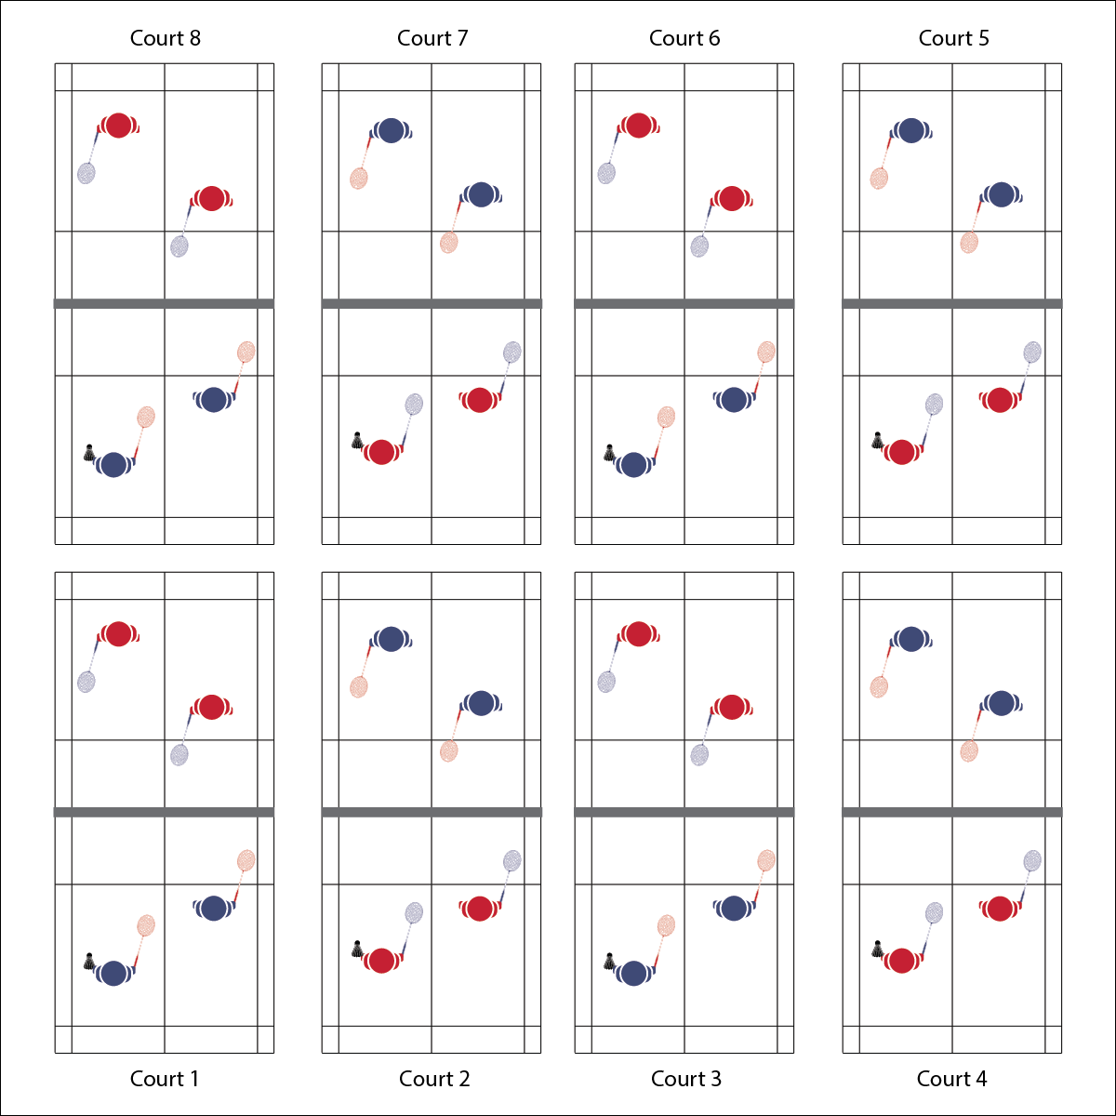

* **Skill:** I will demonstrate competency in badminton gameplay by using a variety of skills and strategies.
* **Cognitive:** I will demonstrate badminton etiquette by playing correctly and fairly.
* **Fitness:** I will stay actively engaged throughout the entire badminton tournament in order to improve fitness and skills.
* **Personal & Social Responsibility:** I will use positive communication and safety practices during the tournament

**ROUND ROBIN TOURNAMENT**

* Play Fairly
* Demonstrate Sportsmanship
* Have Fun

**Equipment:**

* 1 net per 4 students
* 1 racquet per student
* 1 shuttle per court
* Round Robin Tournament Card

**Set-Up:**

1. Set up badminton nets to create 1 court per 4 students.
2. Create teams and a bracquet for a doubles tournament.

**Activity Procedures:**

1. Today we’ll begin our Badminton Round Robin Tournament. During the tournament, you and your partner will play multiple games and track your win/loss record.
2. When I say “GO,” you and your partner will check the tournament schedule to see who you will be playing against. Then, go directly to your assigned court. Begin play when you hear the start signal.
3. Each match will last 5 minutes. When you hear the stop signal, a representative from each team will report your score to me (the teacher). Then, find your next opponent, move to your assigned court, and begin on the start signal. Continue until the tournament is completed.
4. Teachers: Post the teams and brackets on a board so the students can see who they are playing. You can play this tournament in a doubles or singles format depending on number of courts and class size.

**Grade Level Progression:**

**L1:** Play the activity as described with a focus on rules, etiquette, and safety.

**L2:** Utilize the Badminton Fitness Portfolio Page to help students evaluate the role of badminton with respect to their long-term fitness plan. Review the portfolio page individually with students or use general responses to discuss this topic as a group.



**Manage response rates with tiered questioning techniques:** The debrief questions above are purposefully written with ascending cognitive complexity in order to support students in extending their thinking about the content. It’s not enough for students to provide 1- or 2-word responses. They must back up their thinking with justifications and illustrations.



* **DOK 1:** What is health-related fitness? What is skill-related fitness?
* **DOK 2:** How would you summarize how each type of fitness is impacted by badminton participation? Be sure to reference specific components of fitness.
* **DOK 3:** How would you adapt a badminton game or activity to better address specific components of fitness? Elaborate.
* **DOK 4:** Thinking about both positive and negative health habits and behaviors you’ve demonstrated in the past, what do you see as the consequences (good/bad) of your previous choices with respect to badminton participation?



Tournament, Sportsmanship, Fair Play, Strategy, Skill-Related Fitness, Health-Related Fitness



* **Standard 1 [H1.L1]:** Demonstrates competency and/or refines activity-specific movement skills in 2 or more lifetime activities (net/wall games) (L1).
* **Standard 2 [H1.L1]:** Applies the terminology associated with exercise and participation in selected individual-performance activities, net/wall games.
* **Standard 3 [H11.L2]:** Develops and maintains a fitness portfolio (L2).
* **Standard 4 [H2 L1]:** Exhibits proper etiquette, respect for others, and teamwork while engaging in physical activity (L1).
* **Standard 4 [H3.L1]:** Uses communication skills and strategies that promote team or group dynamics (L1).
* **Standard 4 [H5.L1]:** Applies best practices for participating safely in physical activity (L1).



* **DOK 1:** What is health-related fitness? What is skill-related fitness?
* **DOK 2:** How would you summarize how each type of fitness is impacted by badminton participation? Be sure to reference specific components of fitness.
* **DOK 3:** How would you adapt a badminton game or activity to better address specific components of fitness? Elaborate.
* **DOK 4:** Thinking about both positive and negative health habits and behaviors you’ve demonstrated in the past, what do you see as the consequences (good/bad) of your previous choices with respect to badminton participation?



**Manage response rates with tiered questioning techniques:** The debrief questions above are purposefully written with ascending cognitive complexity in order to support students in extending their thinking about the content. It’s not enough for students to provide 1- or 2-word responses. They must back up their thinking with justifications and illustrations.



* **Adaptation:** Create 2 sets of tournament brackets for students of different skill levels. Identify 1 set of courts as the “Olympic Finals” and the other set as the “Community Recreation League.” Allow students to self-select their level of participation with some guidance.
* **Extension:** Play a singles tournament, extending the “season” to allow everyone to play one another.

**ROUND ROBIN TOURNAMENT**