­­

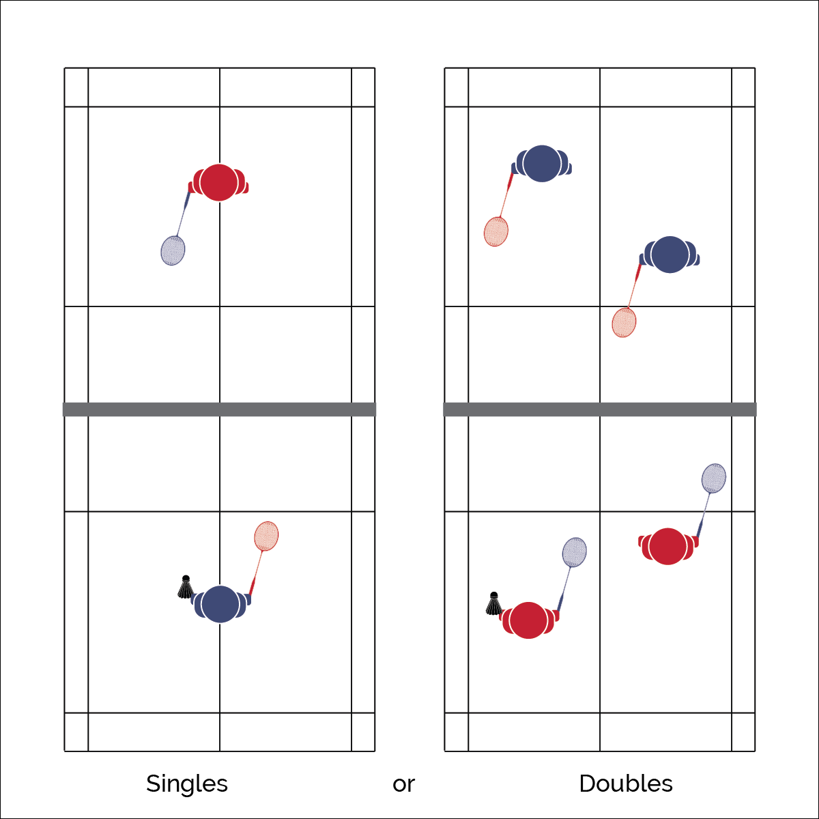

* **Skill:** I will volley the shuttle over the net to my partner, demonstrating control and accuracy.
* **Cognitive:** I will discuss concepts that helped me be successful in hitting the shuttle to my partner.
* **Fitness:** I will stay actively engaged in the activity for the entire class.
* **Personal & Social Responsibility:** I will show respect by safely using all badminton equipment.

**VOLLEY CHALLENGE**

* Athletic Stance
* Spot Shuttle (Eye Contact)
* Wrists

**Equipment:**

* 1 net per 4 students
* 1 racquet per student
* 1 shuttle per 2 students

**Set-Up:**

1. Set up badminton nets to create 1 court per 4 students.
2. Pair students, 2 pairs at each net.
3. If nets are limited, students can split the courts and share with classmates.

**Activity Procedures:**

1. Today’s activity is called Volley Challenge.
2. The object of the activity is to see how many times you and your partner can volley the shuttle over the net without letting it hitting the floor.
3. If you and your partner get 25 or more consecutive volleys, try these challenges:
   1. Use non-dominant hand
   2. Switch hands (racquet in dominant hand for 1 hit, then non-dominant hand for the next)

**Grade Level Progression:**

**L1:** Play the activity as described with a focus on accurate Forehand and Backhand strokes.

**L2:** Utilize the Move to Improve Self-Analysis Worksheet with specific strategies for improving performance in the Badminton Volley Challenge.

**VOLLEY CHALLENGE**



* **Standard 1 [H1.L1-2]:** Demonstrates competency and/or refines activity-specific movement skills in 2 or more lifetime activities (net/wall games) (L1); Refines activity-specific movement skills in 1 or more lifetime activities (net/wall games) (L2).
* **Standard 2 [H2. L1-2]:** Uses movement concepts and principles to analyze and improve performance of self and/or others in a selected skill (L1); Describes the speed/accuracy trade-off in throwing and striking skills (L2).
* **Standard 4 [H2 .L1]:** Exhibits proper etiquette, respect for others, and teamwork while engaging in physical activity and/or social dance.
* **Standard 4 [H3.L1]:** Uses communication skills and strategies that promote team or group dynamics.
* **Standard 4 [H5.L1]:** Applies best practices for participating safely in physical activity, exercise, and dance. Applies best practices for participating safely in physical activity.



* **Adaptation:** Use a line on the floor to represent the net.
* **Extension:** Students create their own volleying challenges.



Volley, Dominant, Non-Dominant, Shuttle, Communication, Actively Engaged, Space, Relationship, Effort



* **DOK 1:** What would you include in a list of movement concepts related to Volley Challenge?
* **DOK 2:** How did you apply these concepts in your skill practice?
* **DOK 3:** How could you adapt this activity to make the practice more challenging? To make it less challenging?



**Identify Critical Content:** Volley Challenge is a very fundamental activity. However, it creates a perfect learning environment for identifying important movement concepts that will guide skill development and performance throughout the entire Badminton module. Take the time to help students explore the concepts of space, relationships, and effort with respect to their movement performances. Challenge them to think beyond surface thoughts and ideas about how these concepts related to their practice performance and prompt them to demonstrate their ideas during the activity.



* **DOK 1:** What is health-related fitness? What is skill-related fitness?
* **DOK 2:** How would you summarize how each type of fitness is impacted by badminton participation? Be sure to reference specific components of fitness.
* **DOK 3:** How would you adapt a badminton game or activity to better address specific components of fitness? Elaborate.
* **DOK 4:** Thinking about both positive and negative health habits and behaviors you’ve demonstrated in the past, what do you see as the consequences (good/bad) of your previous choices with respect to badminton participation?



**Manage response rates with tiered questioning techniques:** The debrief questions above are purposefully written with ascending cognitive complexity in order to support students in extending their thinking about the content. It’s not enough for students to provide 1- or 2-word responses. They must back up their thinking with justifications and illustrations.