­­

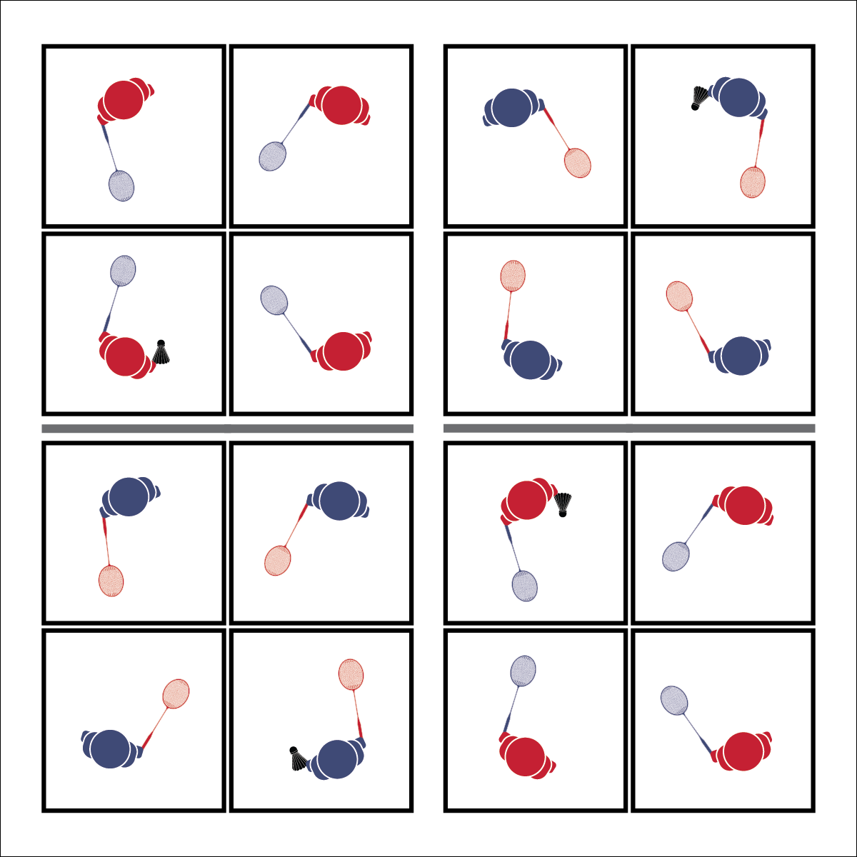

**Activity Procedures:**

1. Today’s activity is called Racquet Square.
2. The object of the activity is to complete different challenges within the 4 squares.
3. When I say “GO,” each member of your group will get into 1 of the 4 squares on your court. To start, it doesn’t matter what square you are in.
4. The first challenge is to pass the shuttle using any shot from square to square (in any order) without a fault. When you’ve mastered that challenge, try others:
   1. Pass in order from square 1 to 2 to 3 to 4, back to 1.
   2. Pass from square to square (any order) using a drop shot only.
   3. Pass in order from square to square, adding a second shuttle.
   4. The final challenge is to play a badminton version of four square. 4 square serves to 2 square to start the round. When a player is ‘out’ they move to square 1 and other players rotate.

**Grade Level Progression:**

**L1:** Play the activity as described with a focus on control and accuracy of the drop shot.

**L2:** Utilize the Move to Improve Self-Analysis Worksheet with specific strategies for improving performance in the Move and Clear practice task.

* **Skill:** I will perform the drop shot, demonstrating all cues.
* **Cognitive:** I will discuss specific movement concepts and how they relate to personal skill improvement.
* **Fitness:** I will be actively engaged in an effort to increase my heart rate.
* **Personal & Social Responsibility:** I will demonstrate respect for my group by using words to encourage their effort.
* Athletic Stance
* Soft Touches
* Placement

**RACQUET SQUARE**

**Equipment:**

* 1 net per 8 students
* 1 racquet per student
* 1 shuttle per 4 students

**Set-Up:**

1. Set up badminton nets to create 1 court per 4 students.
2. Each court divided into 4 quadrants using the center line and net as dividers.
3. Pair students, 2 pairs at each net.

**RACQUET SQUARE**



**Help students elaborate on content:** As students describe what a good drop shot looks like, prompt them to provide descriptive details. This requires students to make inferences about what they’ve seen and experienced during the practice activity. Continue to extend the discussion by asking students to provide support for the inferences that they make. For example, you might ask, “Why does a good drop shot make your opponent move?”



* **DOK 1:** How can you recognize a good drop shot? Use specific descriptors.
* **DOK 2:** As a player on defense who is working to return a drop shot, what did you notice about drop shots that were hit to you?
* **DOK 3:** How is a drop shot related to offensive play? How is it related to defensive play?



Sportsmanship, Drop Shot, Soft Hits, Balance, Positioning



* **Standard 1 [H1.L1]:** Demonstrates competency and/or refines activity-specific movement skills in 2 or more lifetime activities (L1);Refines activity-specific movement skills in 1 or more lifetime activities (net/wall games) (L2).
* **Standard 2 [H2.L1]:** Uses movement concepts and principles to analyze and improve performance of self and/or others in a selected skill.
* **Standard 4 [H2.L1]:** Exhibits proper etiquette, respect for others, and teamwork while engaging in physical activity.
* **Standard 4 [H3.L1]:** Uses communication skills and strategies that promote team or group dynamics.
* **Standard 4 [H5.L1]:** Applies best practices for participating safely in physical activity.



* **Adaptation:** Use different equipment that might be easier for students who are struggling, such as a larger racquet, balloon, or soft ball.
* **Extension:** Allow students to create custom rules after staying in four square for 3 consecutive serves.



* **DOK 1:** What is health-related fitness? What is skill-related fitness?
* **DOK 2:** How would you summarize how each type of fitness is impacted by badminton participation? Be sure to reference specific components of fitness.
* **DOK 3:** How would you adapt a badminton game or activity to better address specific components of fitness? Elaborate.
* **DOK 4:** Thinking about both positive and negative health habits and behaviors you’ve demonstrated in the past, what do you see as the consequences (good/bad) of your previous choices with respect to badminton participation?



**Manage response rates with tiered questioning techniques:** The debrief questions above are purposefully written with ascending cognitive complexity in order to support students in extending their thinking about the content. It’s not enough for students to provide 1- or 2-word responses. They must back up their thinking with justifications and illustrations.