­­

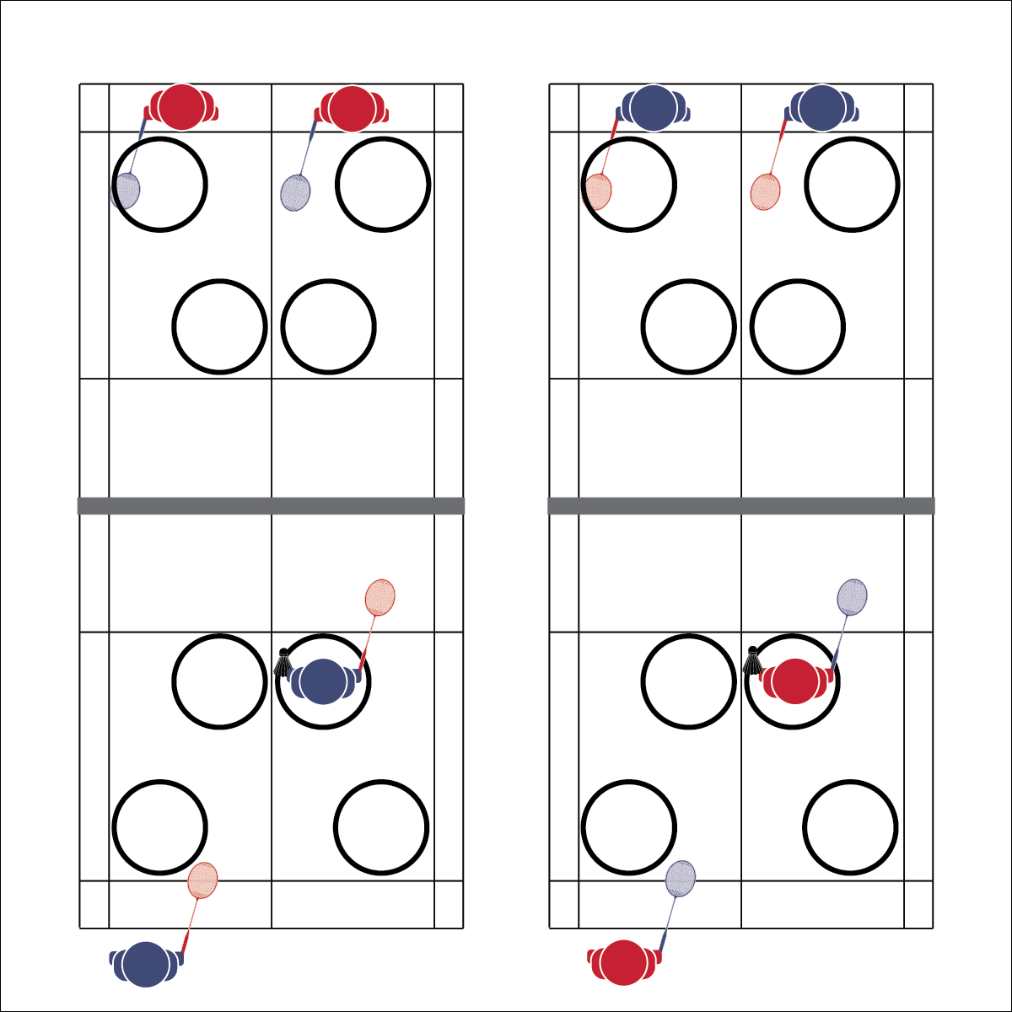

**Activity Procedures:**

1. Today’s activity is called Target Practice. The object of the activity is to practice serving form and placement by serving shuttles into the hoops. We’ll begin with a basic forehand serve. (Teacher demonstrates)
2. When I say “GO,” serve the shuttle over the net and into a hoop. The hula hoops are placed where a “good” serve would land.
3. Take turns with your partner and see how many shuttles you can get in the hoops as a team (1 shuttle = 1 point). The pair across the net will work with you to check placement, total points, collect shuttles, and then serve them back.
4. Teachers, allow students adequate practice time and then demonstrate and practice the backhand serve.

**Grade Level Progression:**

**L1:** Play the activity as described with a focus on control and accuracy of the serve.

**L2:** Provide progressively smaller targets such as small hoops or buckets, making the activity more challenging with an increased focus on refining consistency in form and accuracy.

* **Skill:** I will demonstrate a serve with correct form, making at least three shuttles in the hoop.
* **Cognitive:** I will identify movement concepts applied to successful serves.
* **Fitness:** I will be actively engaged in an effort to improve my badminton skills.
* **Personal & Social Responsibility:** I will demonstrate safe play by making sure the area around me is clear before I serve.
* Athletic Stance
* Drop Birdie
* Wrist Flick
* Contact

**TARGET PRACTICE**

**Equipment:**

* 1 net per 4 students
* 1 racquet per student
* 6 shuttles per 4 students
* 6 hula hoops per court
* Badminton 101 Skill Cue Chart for Serving

**Set-Up:**

1. Set up badminton nets to create 1 court per 4 students.
2. Place 6 hula hoops at each court with 3 hoops on each side. Position hoops where a good serve would land.
3. Pair students, 2 pairs at each court, and each court with 6 shuttles.

**TARGET PRACTICE**



Target, Placement, Balance, Force, Position, Skill-Related Fitness



* **Standard 1 [H1.L1-2]:** Demonstrates competency and/or refines activity-specific movement skills in 2 or more lifetime activities (L1): Refines activity-specific movement skills in 1 or more lifetime activities (outdoor pursuits, individual-performance activities, aquatics, net/wall games, or target games) (L2).
* **Standard 2 [H2. L1]:** Uses movement concepts and principles to analyze and improve performance of self and/or others in a selected skill (L1).
* **Standard 4 [H5.L1]:** Applies best practices for participating safely in physical activity (L1).



* **DOK 1:** What are the 2 types of serves?
* **DOK 2:** What are the similarities and differences between the 2 types of serves?
* **DOK 3:** What strategic advantage does the forehand serve offer? Why? (Provide detailed examples of game situations.)
* **DOK 3:** What strategic advantage does the backhand serve offer? Why? (Provide detailed examples of game situations.)



**Help students examine similarities and differences:** Understanding the advantages and limitations of different shots is fundamental strategic knowledge for badminton participation. The similarities and differences between the 2 types of serves help to illustrate the importance of knowing when and why different shots can and should be used.



* **Adaptation:** Create larger a target area or eliminate areas altogether. Points are earned each time the shuttle is served over the net.
* **Extension:** Assign a specific point number to the different hoops. For example: Blue=3; Green=2; Red=1. Students are responsible for totaling and tracking their score.



* **DOK 1:** What is health-related fitness? What is skill-related fitness?
* **DOK 2:** How would you summarize how each type of fitness is impacted by badminton participation? Be sure to reference specific components of fitness.
* **DOK 3:** How would you adapt a badminton game or activity to better address specific components of fitness? Elaborate.
* **DOK 4:** Thinking about both positive and negative health habits and behaviors you’ve demonstrated in the past, what do you see as the consequences (good/bad) of your previous choices with respect to badminton participation?



**Manage response rates with tiered questioning techniques:** The debrief questions above are purposefully written with ascending cognitive complexity in order to support students in extending their thinking about the content. It’s not enough for students to provide 1- or 2-word responses. They must back up their thinking with justifications and illustrations.