­­

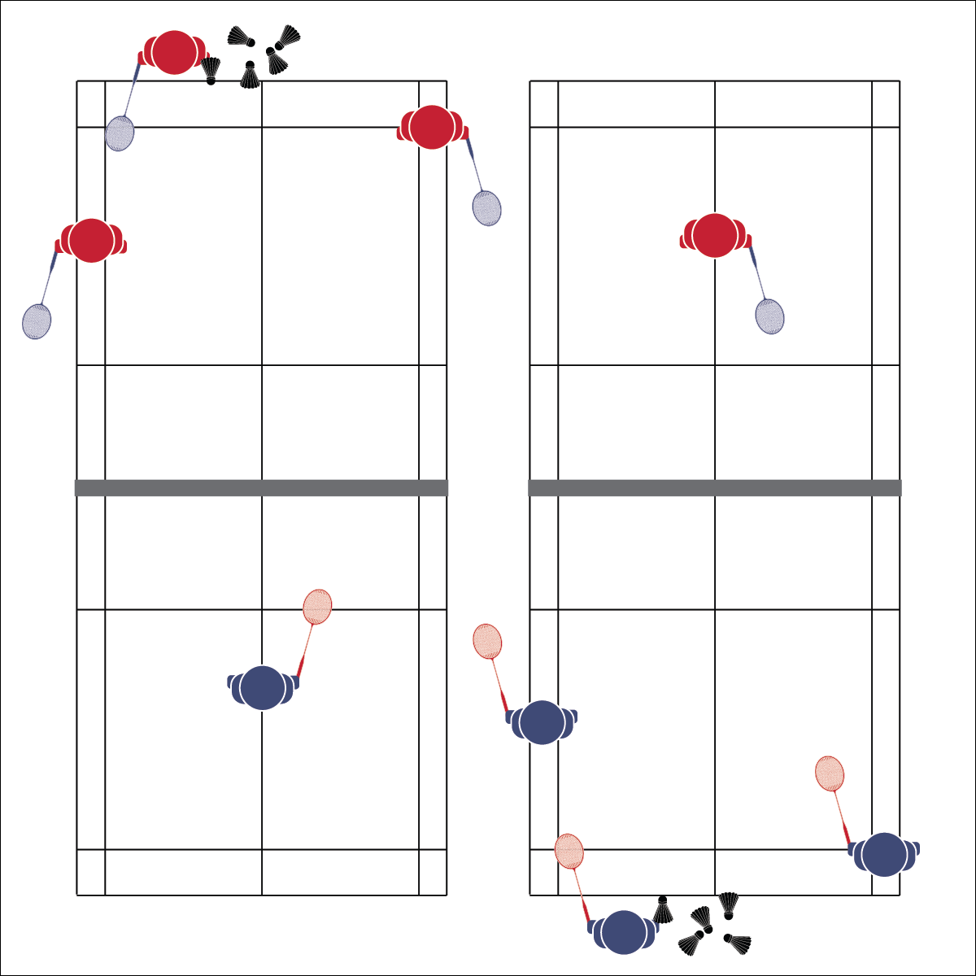

**COVER THE COURT**

* **Skill:** I will demonstrate quick footwork and court positioning by quickly moving from starting position to return each shuttle, then back to starting position.
* **Cognitive:** I will identify badminton court markings.
* **Fitness:** I will stay actively engaged during physical education class so that my heart rate increases.
* **Personal & Social Responsibility:** I will participate safely by making sure the activity area is clear for activity.
* Athletic Stance
* Watch Shuttle
* Quick Feet

**Equipment:**

* 1 net per 4 students
* 1 racquet per student
* 6 shuttles per 4 students
* Badminton 101 Diagrams (Quiz is optional)

**Set-Up:**

1. Set up badminton nets to create 1 court per 4 students.
2. Students in groups of 4, each group at a net with 6 shuttles.
3. Rotate student through 4 positions: Server, Returner, Right Corner Judge, Left Corner Judge.

**Activity Procedures:**

1. Today’s activity is called Cover the Court. This is a fun drill designed to work on footwork and positioning.
2. The object of the activity is to return 6 consecutive serves successfully. You’ll start at center court, move to return a serve, and then move back to center court before returning the next serve.
3. The server has 6 shuttles ready to serve 1 at a time. The returner is ready at center court. 2 corner judges are positioned on the server side at each corner, watching for successful returns. Each successful return is a point.
4. Play begins with the server serving 1 shuttle into a corner. The returner moves to hit the serve. As soon as the shuttle is hit, the server can serve another shuttle into a different corner to be returned. This continues until all 6 shuttles have been served.
5. Rotate positions: Server to Returner; Returner to Right Corner; Right Corner to Left Corner; Left Corner to Server.

**Grade Level Progression:**

**L1:** Play the activity as described with a focus on footwork and positioning.

**L1:** Prior to restarting the drill after each position rotation, students will quiz the returner, asking her/him to identify court markings/lines (utilize Badminton 101 Diagrams).

**COVER THE COURT**



Agility, Speed, Athletic Stance, Health-Related Fitness, Skill-Related Fitness, Positioning, Quick



* **Standard 1 [H1.L1-2]:** Demonstrates competency and/or refines activity-specific movement skills in 2 or more lifetime activities (L1): Refines activity-specific movement skills in 1 or more lifetime activities (outdoor pursuits, individual-performance activities, aquatics, net/wall games, or target games) (L2).
* **Standard 2 [H1. L1]:** Applies the terminology associated with exercise and participation in selected individual-performance activities, dance, net/wall games, target games, aquatics, and/or outdoor pursuits appropriately (L1).
* **Standard 4 [H5.L1]:** Applies best practices for participating safely in physical activity (L1).



* **DOK 1:** Can you remember what each line on the badminton court is called and explain why it’s there?
* **DOK 2:** How does [name a line] affect how you play?
* **DOK 3:** How would you adapt the court to make the game easier and more recreational?
* **DOK 1:** Which component(s) of skill-related fitness are important to successful participation in badminton?
* **DOK 2:** How does that component affect your ability to return serves in this activity?
* **DOK 3:** Based on your performance in this activity, how would you interpret your skill-related fitness level (for 1 or more components)? Support your answer with specific examples.



**Help students practice skills, strategies, and processes:** It’s important to design meaningful learning tasks designed to guide students through the process of skill development through purposeful practice. Allow students to experiment with different concepts and strategies within a dynamic activity environment, exploring what works for them and what doesn’t.



* **Adaptation:** Allow more time for the returner to get back to the center position before the next shot is served. Use a low net or center floor line to create modified courts.
* **Extension:** Play rapid fire with 2 servers alternating serves as soon as the shuttle crosses the net.



* **DOK 1:** What is health-related fitness? What is skill-related fitness?
* **DOK 2:** How would you summarize how each type of fitness is impacted by badminton participation? Be sure to reference specific components of fitness.
* **DOK 3:** How would you adapt a badminton game or activity to better address specific components of fitness? Elaborate.
* **DOK 4:** Thinking about both positive and negative health habits and behaviors you’ve demonstrated in the past, what do you see as the consequences (good/bad) of your previous choices with respect to badminton participation?



**Manage response rates with tiered questioning techniques:** The debrief questions above are purposefully written with ascending cognitive complexity in order to support students in extending their thinking about the content. It’s not enough for students to provide 1- or 2-word responses. They must back up their thinking with justifications and illustrations.