­­

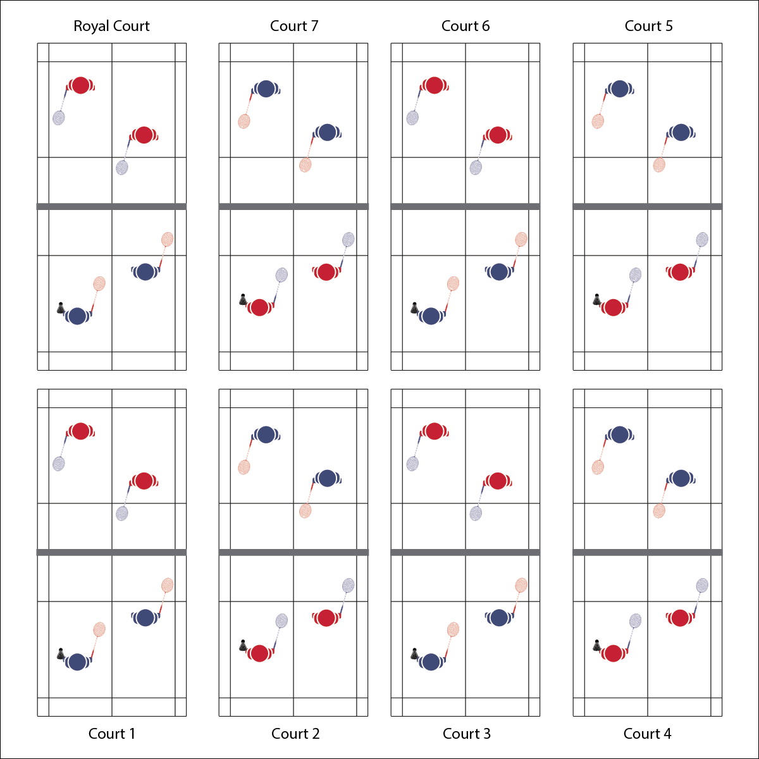

**Activity Procedures:**

1. Today’s activity is called King/Queen of the Court.
2. The object of the activity is for you and your partner to win short matches in order to move up toward the royal court. If you don’t win, you’ll move 1 court away from the royal court.
3. Teachers: Depending on class size and playing area, this activity can be played in singles or doubles.
4. When I say “GO” you will play an opposing team (player) for 3 minutes. The winner will move up 1 court toward the Royal Court. The winner on the Royal Court will stay and defend her/his position. The team that loses the match will move 1 court away from the Royal Court. The team that loses on the number 1 court will stay and try again. If the score is tied on any court when the 3 minute time expires, play Rock, Paper, Scissor to determine the winner.

**Grade Level Progression:**

**L1:** Play the activity as described with a focus on rules, etiquette, and safety.

**L2:** Utilize the Badminton Self-Efficacy and Social Support Inventory to help students evaluate their associations with badminton as a part of a healthy and active lifestyle. Review the inventory individually with students or use general responses to discuss this topic as a group.

**KING/QUEEN OF THE COURT**

**Equipment:**

* 1 net per 4 students
* 1 racquet per student
* 1 shuttle per court
* Badminton Self and Social Inventory

**Set-Up:**

1. Set up badminton nets to create 1 court per 4 students. Number each court 1, 2, 3, 4, etc. Identify the highest number court as the Royal Court.
2. Pair students, 2 pairs at each court.
3. Each student with a racquet and 1 shuttle per court.

* **Skill:** I will demonstrate a minimum of 3 different shots within each game played during the lesson.
* **Cognitive:** I will demonstrate an understanding of court markings during each game played.
* **Fitness:** I will stay actively engaged throughout each game in order to increase my heart rate.
* **Personal & Social Responsibility:** I will show respect toward my opponent by playing fairly and communicating using positive language.
* Play Fairly
* Demonstrate Sportsmanship
* Have Fun

**KING/QUEEN OF THE COURT**



Sportsmanship, Etiquette, Safety, Opponent, Strategy, Skill, Cooperation



* **Standard 1 [H1.L1]:** Demonstrates competency and/or refines activity-specific movement skills in 2 or more lifetime activities.
* **Standard 2 [H1. L1]:** Applies the terminology associated with exercise and participation in selected individual-performance activities, net/wall games.
* **Standard 4 [H2. L1]:** Exhibits proper etiquette, respect for others, and teamwork while engaging in physical activity.
* **Standard 4 [H 5. L1]:** Applies best practices for participating safely in physical activity.
* **Standard 5 [H4.L1-2]:** Identifies the opportunity for social support in a self-selected physical activity or dance (L1); Evaluates the opportunity for social interaction and social support in a self-selected physical activity or dance (L2).



* **DOK 1:** What is sportsmanship?
* **DOK 2:** How does sportsmanship affect how enjoyable a badminton experiences can be?
* **DOK 3:** How is sportsmanship related to skill performance? Provide illustrations to support your answer.



**Organize students to interactive with content:** Creating a positive learning environment with appropriate challenges and experiences is a crucial component of any lesson. Understanding the social dynamics of a group in a physical activity setting will help set students up for successful and enjoyable participation. If possible, allow students to self-select their level of participation with respect to challenge and competition. Students who thrive on competition may enjoy more intense participation, while others may thrive with more social and less intense participation.



* **Adaptation:** Create 2 sets of courts for students of different skill levels. Identify 1 set of courts as the “Olympic Finals” and the other set as the “Community Recreation League.” Allow students to self-select their level of participation with some guidance.
* **Extension:** Ask interested students to help you organize a badminton event outside of physical education class. This could be a teachers vs. student event, an intramural league, or just an opportunity for a pick-up game.



* **DOK 1:** What is health-related fitness? What is skill-related fitness?
* **DOK 2:** How would you summarize how each type of fitness is impacted by badminton participation? Be sure to reference specific components of fitness.
* **DOK 3:** How would you adapt a badminton game or activity to better address specific components of fitness? Elaborate.
* **DOK 4:** Thinking about both positive and negative health habits and behaviors you’ve demonstrated in the past, what do you see as the consequences (good/bad) of your previous choices with respect to badminton participation?



**Manage response rates with tiered questioning techniques:** The debrief questions above are purposefully written with ascending cognitive complexity in order to support students in extending their thinking about the content. It’s not enough for students to provide 1- or 2-word responses. They must back up their thinking with justifications and illustrations.