­­

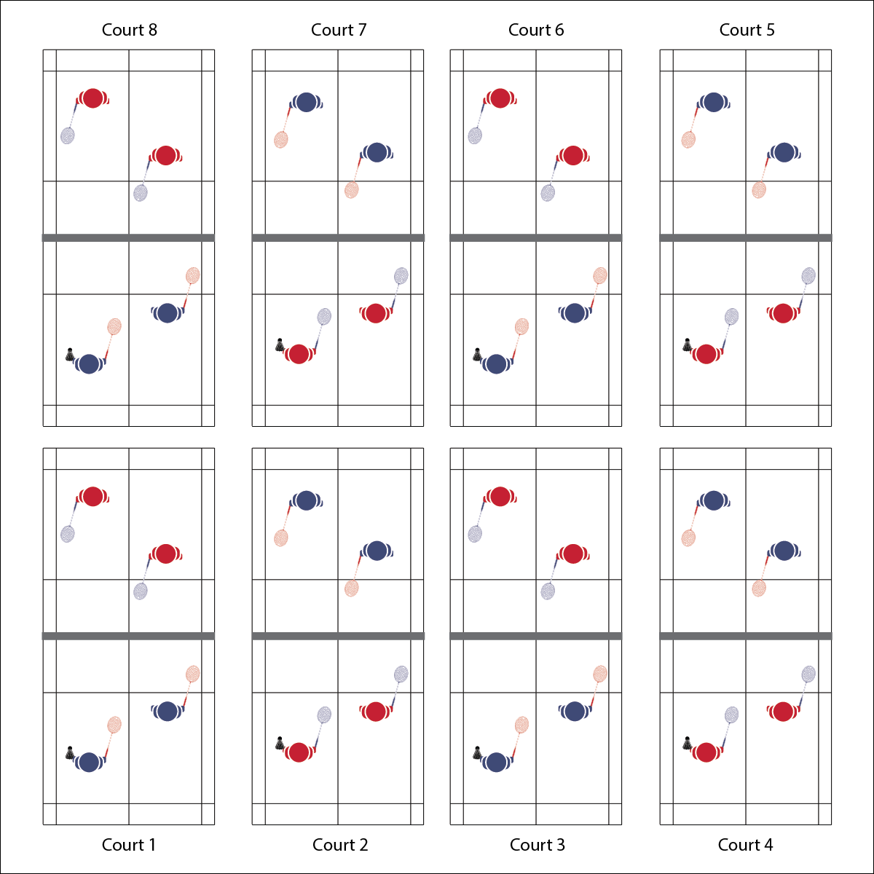

**Activity Procedures:**

1. Today we’ll begin our Badminton Round Robin Tournament. During the tournament, you and your partner will play multiple games and track your win/loss record.
2. When I say “GO,” you and your partner will check the tournament schedule to see who you will be playing against. Then, go directly to your assigned court. Begin play when you hear the start signal.
3. Each match will last 5 minutes. When you hear the stop signal, a representative from each team will report your score to me (the teacher). Then, find your next opponent, move to your assigned court, and begin on the start signal. Continue until the tournament is completed.
4. Teachers: Post the teams and brackets on a board so the students can see who they are playing. You can play this tournament in a doubles or singles format depending on number of courts and class size.

**Grade Level Progression:**

**L1:** Play the activity as described with a focus on rules, etiquette, and safety.

**L2:** Utilize the Badminton Fitness Portfolio Page to help students evaluate the role of badminton with respect to their long-term fitness plan. Review the portfolio page individually with students or use general responses to discuss this topic as a group.

**Equipment:**

* 1 net per 4 students
* 1 racquet per student
* 1 shuttle per court
* Round Robin Tournament Card

**Set-Up:**

1. Set up badminton nets to create 1 court per 4 students.
2. Create teams and a bracket for a doubles tournament.

* Play Fairly
* Demonstrate Sportsmanship
* Have Fun
* **Skill:** I will demonstrate competency in badminton gameplay by using a variety of skills and strategies.
* **Cognitive:** I will demonstrate badminton etiquette by playing correctly and fairly.
* **Fitness:** I will stay actively engaged throughout the entire badminton tournament in order to improve fitness and skills.
* **Personal & Social Responsibility:** I will use positive communication and safety practices during the tournament

**ROUND ROBIN TOURNAMENT**

**ROUND ROBIN TOURNAMENT**



Tournament, Sportsmanship, Fair Play, Strategy, Skill-Related Fitness, Health-Related Fitness

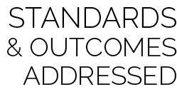

* **Standard 1 [H1.L1]:** Demonstrates competency and/or refines activity-specific movement skills in 2 or more lifetime activities (net/wall games) (L1).
* **Standard 2 [H1.L1]:** Applies the terminology associated with exercise and participation in selected individual-performance activities, net/wall games.
* **Standard 3 [H11.L2]:** Develops and maintains a fitness portfolio (L2).
* **Standard 4 [H2 L1]:** Exhibits proper etiquette, respect for others, and teamwork while engaging in physical activity (L1).
* **Standard 4 [H3.L1]:** Uses communication skills and strategies that promote team or group dynamics (L1).
* **Standard 4 [H5.L1]:** Applies best practices for participating safely in physical activity (L1).



* **Adaptation:** Create 2 sets of tournament brackets for students of different skill levels. Identify 1 set of courts as the “Olympic Finals” and the other set as the “Community Recreation League.” Allow students to self-select their level of participation with some guidance.
* **Extension:** Play a singles tournament, extending the “season” to allow everyone to play one another.



* **DOK 1:** What is health-related fitness? What is skill-related fitness?
* **DOK 2:** How would you summarize how each type of fitness is impacted by badminton participation? Be sure to reference specific components of fitness.
* **DOK 3:** How would you adapt a badminton game or activity to better address specific components of fitness? Elaborate.
* **DOK 4:** Thinking about both positive and negative health habits and behaviors you’ve demonstrated in the past, what do you see as the consequences (good/bad) of your previous choices with respect to badminton participation?



**Manage response rates with tiered questioning techniques:** The debrief questions above are purposefully written with ascending cognitive complexity in order to support students in extending their thinking about the content. It’s not enough for students to provide 1- or 2-word responses. They must back up their thinking with justifications and illustrations.



* **DOK 1:** What is health-related fitness? What is skill-related fitness?
* **DOK 2:** How would you summarize how each type of fitness is impacted by badminton participation? Be sure to reference specific components of fitness.
* **DOK 3:** How would you adapt a badminton game or activity to better address specific components of fitness? Elaborate.
* **DOK 4:** Thinking about both positive and negative health habits and behaviors you’ve demonstrated in the past, what do you see as the consequences (good/bad) of your previous choices with respect to badminton participation?



**Manage response rates with tiered questioning techniques:** The debrief questions above are purposefully written with ascending cognitive complexity in order to support students in extending their thinking about the content. It’s not enough for students to provide 1- or 2-word responses. They must back up their thinking with justifications and illustrations.