­­­

* Clear
* Smash
* Drop
* Forehand
* Backhand
* Serve

­

* **Skill:** I will perform each shot, demonstrating all cues.
* **Cognitive:** I will identify each of the different shots when they are demonstrated by the teacher.
* **Fitness:** I will stay actively engaged in physical education class.
* **Personal & Social Responsibility:** I will safely participate by using the equipment correctly.
* **Standard 1 [H1.L1-2]:** Demonstrates competency and/or refines activity-specific movement skills in 2 or more lifetime activities (net/wall games) (L1).
* **Standard 4 [H2 .L1]:** Exhibits proper etiquette, respect for others, and teamwork while engaging in physical activity and/or social dance (L1).
* **Standard 4 [H5.L1]:** Applies best practices for participating safely in physical activity, exercise, and dance (L1).
* Move to Improve Self-Analysis Worksheet

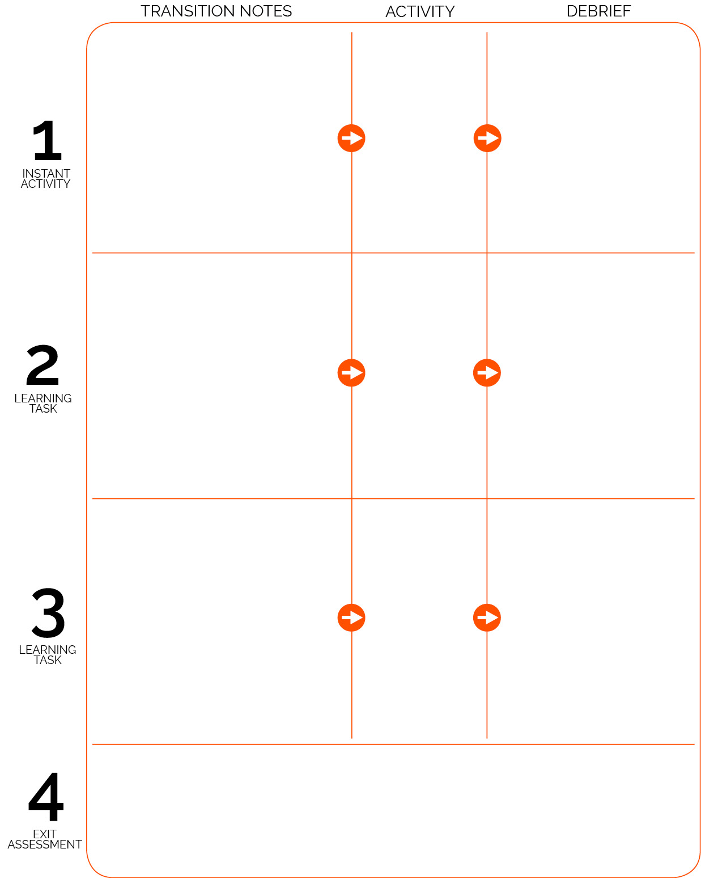

**DOK 1:** What skills did you discover in this activity?

**DOK 2:** Which skill was the easiest to learn/teach? Why?

**DOK 2:** Which skill was the most difficult to learn/teach? Why?

**DOK 1:** Which shot did we just practice?

**DOK 2:** How would you use this shot during gameplay?

**DOK 3:** Can you describe a shot sequence that includes this shot that could be used to gain an offensive advantage?

Provide 5 minutes at the end of the lesson for student to fill out the Move to Improve Self-Analysis Worksheet. Review student answers and use this information to set the hook at the start of the next lesson.

Post Movement Concept Posters, activity instructions, and challenges on the wall. Students enter the activity area, find a partner and a racquet and shuttle, then move to an open court and begin Volley Challenge. As court fills, late arrivals join groups to create doubles play.

**DOK 1:** Name a movement concept related to Badminton?

**DOK 2:** How can we apply concepts in skill practice?

**DOK 3:** How could you adapt this activity to make it more challenging? Less challenging?

Volley Challenge

Badminton 101  
(Guided Discovery)

Badminton 101  
(Demos & Practice)

Demonstrate 1 skill chart for the entire class, then allow 3 to 5 minutes of practice time for that skill. Repeat for all skills. Reference the guided discovery done earlier. Emphasize skill/performance refinement with your demonstrations.

Show elite level badminton play via YouTube to set the instructional hook. Provide a set of Badminton 101 Skill Cue Charts at each court. 4 students per court. Each student is responsible for 1 Skill Chart. S/he explores the cues, then works to teach other group members.