­­

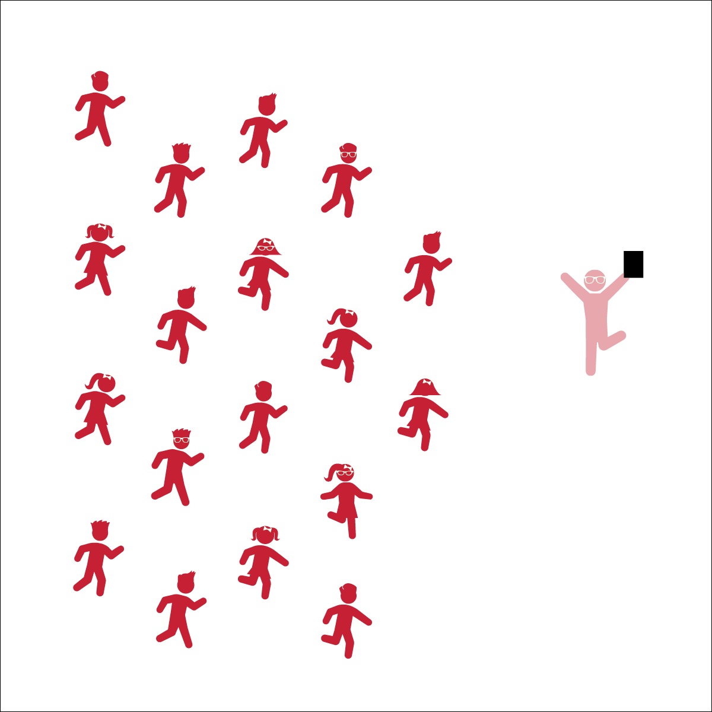

* **Skill:** I will move in my personal space to the rhythm of the music.
* **Cognitive:** I will discuss different Pop See Ko dance moves during class discussion.
* **Fitness:** I will actively participate by moving my body to the rhythm of the music.
* **Personal & Social Responsibility:** I will safely share personal space with my classmates.

**POP SEE KO**

* Listen and Respond
* Follow the Conversation
* Move to the Music

**Equipment:**

* Music Player
* (Optional) The song “Pop See Ko” (Available on [iTunes](https://itunes.apple.com/us/album/pop-see-ko-single/id993755810), [YouTube](https://app.gonoodle.com/channels/koo-koo-kanga-roo/pop-see-ko-2-0))
* (Level 2) 1 hula hoop or poly spot per group of 4 students

**Set-Up:**

1. Level 1: Students stand in a scattered formation facing the teacher (on individual spots).
2. Level 2: Students stand in groups of 4 around a hula hoop.
3. Level 3: Students stand in larger groups of 8-12.

**Activity Procedures:**

1. Today’s activity is called Pop See Ko. It is a conversation song and dance created by the group Koo Koo Kangaroo.
2. The object of the dance is to have fun and be creative while we move around.
3. Teachers, lead the students as detailed on the Pop See Ko Conversation Sheet.
4. When appropriate, call on individual students to choose dance moves for the group to perform.
5. Continue the dance, repeating the call and response format so that each student gets a chance to perform a unique dance move while the class follows along.

**Grade Level Progression:**

**K:** Students follow teacher-led movements.

**1st:** Organize students into small groups of 4. 1 student starts the conversation with another, and the whole group will dance along with the responder. Then, the responder will become the caller and start the conversation with another student. Continue this process to give every member of the group a turn.

**2nd:** Students perform the activity as described for 1st grade with additional teacher encouragements to create movements that include the whole body (both arm and leg movements).

**POP SEE KO**



* Move in an area free of visual distractions.
* Use short cue words with a demonstration rather than long explanations.
* Perform this dance in a circle. Rotate the designation of leader from student to student around the circle until all students have had the opportunity to be a movement leader/responder.



Dance, Leader, Follower, Upper Body, Lower Body, Movement, Locomotor Skills, Non-Locomotor Skills, Responsibility, Respect



* **Standard 2 (E1.K-2)** Differentiates between movement in personal (self-space) and general space (Ka); Moves in personal space to a rhythm (Kb); Moves in self-space and general space in response to designated beats/rhythms (1); Combines locomotor skills in general space to a rhythm (2).
* **Standard 4 (E4.K-2)** Shares equipment and space with others (K); Works independently with others in a variety of class environments (e.g., small and large groups) (1); Works independently with others in partner environments (2).



* **DOK 1:** How did this dance make you feel?
* **DOK 2:** Pick a specific movement within the dance that made you feel some emotion. Describe why you think it made you feel the way it did.
* **DOK 2:** How did it make you feel to lead a dance move? Why do you think it made you feel that way?
* **DOK 2:** What was 1 movement you liked that someone else led us in? What made you like it?

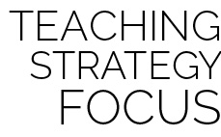

**Create a safe environment for self-expression:** Pop See Ko is a fun dance activity that provides students with an opportunity to be creative and express themselves through rhythmic movement. Be sure to find a good compromise between challenging your students with an opportunity to be a leader and allowing them to remain in their comfort zones. Encourage students to be as creative as they can be while both remaining safe and controlled with their movements and having a fun time leading and following many different rhythmic movements.

**MOVING 8s**

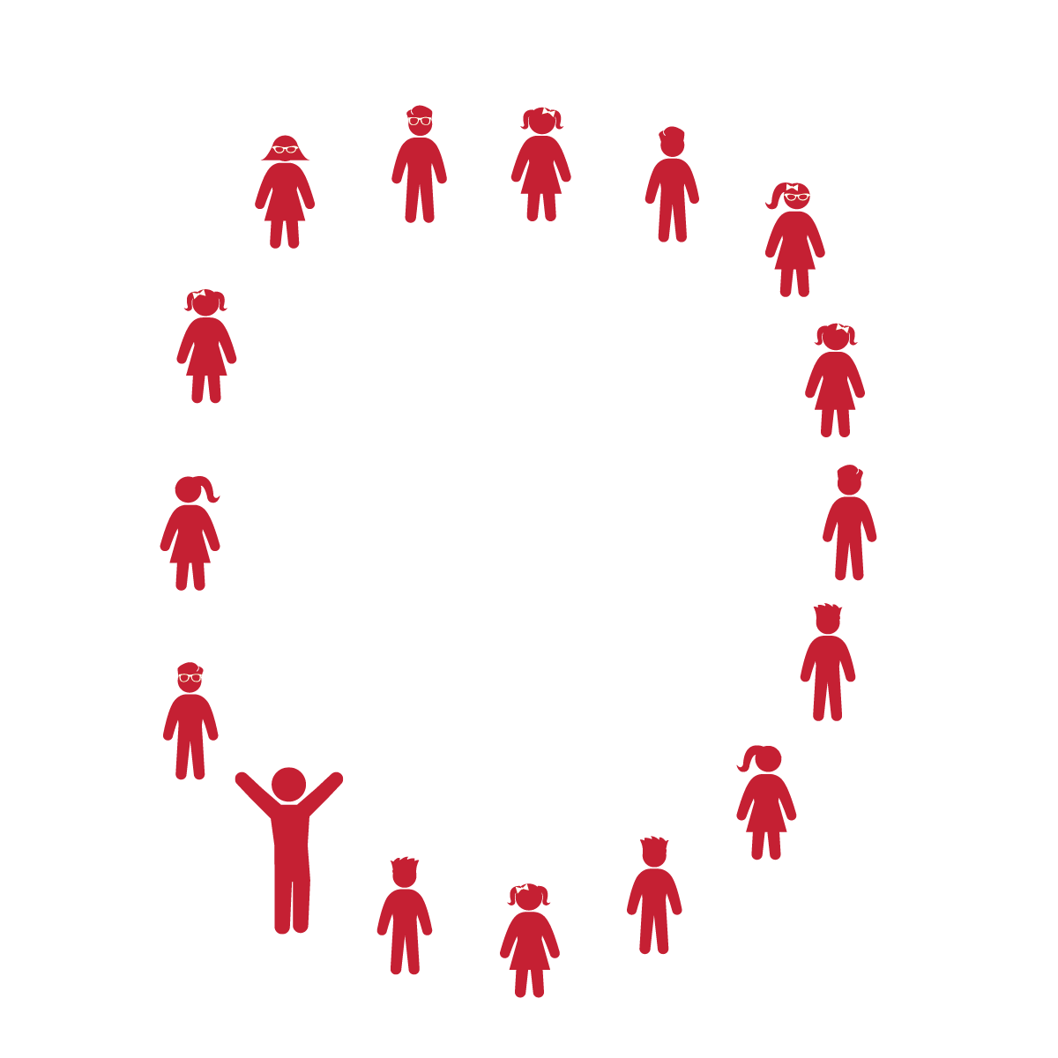

**Equipment:**

* Music Player
* The song “The Way You Make Me Feel” (Available on [iTunes](https://itunes.apple.com/us/album/way-you-make-me-feel-single/id159292399?i=159294429))

Note: You can use similar songs with moderate tempo and a clear beat

**Set-Up:**

1. Students sit or stand in a large circle

**Activity Procedures:**

1. Today’s activity is called Moving 8s.
2. The object of the activity is to learn about beat, rhythm, and tempo. The beat is like the heartbeat of the song. You might tap your foot to the beat as you listen to a song. The beat is what we are counting in this activity.
3. The rhythm is the pattern of the music, or the movement in the song. The tempo is the speed of the song and can increase or decrease throughout a song or dance.
4. This activity is like Simon Says. I am going to count out aloud, “1-2-3-4,” and you are going to repeat back to me, “5-6-7-8.” The numbers represent the beat of the song. The movements we perform will go along with the rhythm of the music. I may increase or decrease the tempo as we play this activity.
5. Teachers, use the Moving 8s Activity Card to lead the students in this activity.

**Grade Level Progression:**

**K:** Play this activity first without music. Start sitting down and then progress to standing up. Next, try the movements with music.

**1st:** Play this activity first without music, but start standing up. Next, add music and pathway movement around the circle. Change direction and then move both in and out of the circle.

**2nd:** After performing this activity in a circle with music, prompt students to scatter and move in general space, listening to your call and moving only on their “5-6-7-8” response.

* **Skill:** I will perform locomotor skills to the beat of the music.
* **Cognitive:** I will count and clap the beat of the song.
* **Fitness:** I will be actively engaged in this dance by moving to the beat of the song.
* **Personal & Social Responsibility:** I will follow directions and stay safely on task.
* Listen and Respond
* Listen and Watch My Count and Movements
* Respond and Perform the Same Movements

**MOVING 8s**



* Students make a traditional conga line and perform movements along with the teacher or selected line leader.
* Students partner up and take turns being the leader. 1 partner starts by performing a movement while saying, “1-2-3-4.” Then, the other partner responds by performing the same movement saying, “5-6-7-8.”



Beat, Rhythm, Tempo, Dance, Leader, Follower, Upper Body, Lower Body, Movement, Locomotor Skills, Non-Locomotor Skills



* **Standard 1 (E5.K-2)** Performs locomotor skills in response to teacher-led creative dance (K); Combines locomotor and non-locomotor skills in a teacher-designed dance (1); Performs a teacher- and/or student-designed rhythmic activity with correct response to simple rhythms (2).
* **Standard 4 (E1.K-2)** Follows directions in group settings (e.g., safe behaviors, following rules, taking turns) (K); Accepts personal responsibility by using equipment and space appropriately (1); Practices skills with minimal teacher prompting (2).



* **DOK 1:** How did this dance make you feel?
* **DOK 2:** What was the beat/rhythm we followed during our dance? Can you count it and clap it for me?
* **DOK 2:** What different movements did we perform to the beat of the music? What are some other movements can we perform?
* **DOK 2:** Can you clap and count a fast beat? What does a slow beat sound like when you clap and count?



**Pace the Progression:** Start the activity with a lot of repetition of counting, clapping, and other movements while students follow along with you. Don’t rush into playing the music. Wait until the students understand how to count out the beat at a slow and a fast tempo before introducing the music to the activity. Save some time at the end of the activity for trying 1 of the challenge progressions and/or allowing them to make up their own movements. Focus on staying on the beat with the song. Clapping is a great way to highlight the rhythm and guide students through the activity.

**A VERY SIMPLE DANCE**



* **Skill:** I will perform all of the movements to this dance.
* **Cognitive:** I will identify the locomotor and non-locomotor movements used in this dance.
* **Fitness:** I will stay actively engaged in this dance.
* **Personal & Social Responsibility:** I will talk about the how I was able to express feelings through dance movements.
* Listen and Move to Music Cues
* Follow the Teacher’s Calls and Movements

**Equipment:**

* Music Player
* The song “A Very Simple Dance” (Sesame Street Productions, Available on [iTunes](https://itunes.apple.com/us/album/a-very-simple-dance/id391019308?i=391019569) and via [YouTube](https://youtu.be/OxRFqhKlo6w))

**Set-Up:**

1. Students stand in a scattered formation, facing the teacher.

**Activity Procedures:**

1. Today’s activity is called A Very Simple Dance.
2. The focus of the activity is to use what we have learned about putting movements to rhythm and to express happiness by performing this dance. Then we’ll get a chance to create our own dance.
3. Teachers, use the Simple List Dance Activity Card to lead this activity.
4. Listen to the cues of the music and perform responses with the students.

**Grade Level Progression:**

**K:** Perform the activity as described above.

**1st:** Have students perform the dance in groups of 3-4.

**2nd:** Have students perform the dance in groups of 3-4. After performing the dance, each group will create and perform their own “Simple Dance” consisting of 3 or 4 movements with each movement lasting 4 beats. The dance must start with “clap your hands” and finish with “all fall down.”

**A VERY SIMPLE DANCE**



* Create a dance modification that can be done in a seated position.
* Add brightly colored scarves or ribbon wands.
* Allow students to create a movement of their own that the whole class will try to perform.



* **DOK 1:** How did this dance make you feel?
* **DOK 2:** What locomotor and non-locomotor skills did you use/perform in this dance?
* **DOK 2:** Would increasing the tempo of the song make the dance harder or easier? Why?
* **DOK 3:** How can you use this dance to help make a friend feel better or express how you feel?



* **Standard 1 (E5.K-2)** Performs locomotor skills in response to teacher-led creative dance (K); Combines locomotor and non-locomotor skills in a teacher-designed dance (1); Performs a teacher- and/or student-designed rhythmic activity with correct response to simple rhythms (2).
* **Standard 2 (E1.K-2)** Differentiates between movement in personal (self-space) and general space (Ka); Moves in personal space to a rhythm (Kb); Moves in self-space and general space in response to designated beats/rhythms (1); Combines locomotor skills in general space to a rhythm (2).
* **Standard 5 (E3.K-2)** Identifies physical activities that are enjoyable (Ka); Discusses the enjoyment of playing with friends (Kb); Describes positive feelings that result from participating in physical activities (1a); Discusses personal reasons (i.e., the “why”) for enjoying physical activities (1b); Identifies physical activities that provide self-expression (e.g., dance, gymnastics routines, practice tasks/games environment) (2).



Beat, Rhythm, Tempo, Dance, Leader, Follower, Upper Body, Lower Body, Movement, Locomotor Skills, Non-Locomotor Skills, Call, Response



**Review content:** This dance helps bring together the concepts of beats (counting music), rhythm (pattern), and tempo (speed) of a song and dance. This song also helps students explore a variety of basic locomotor and non-locomotor dance movements while reviewing the concept of call and response and see why that learning strategy is important to many dances.

**THE DANCING DUKE OF YORK**



* **Skill:** I will perform movements to the rhythm and tempo of the song.
* **Cognitive:** I will discuss how the tempo of the song changed our dance performance.
* **Fitness:** I will stay actively engaged in this dance.
* **Personal & Social Responsibility:** I will take turns listening and responding during class discussion.
* Respect Self-Space
* Follow Song Cues and Teacher Movements

**Equipment:**

* Music Player
* The song “Noble Duke of York” (Available on [iTunes](https://itunes.apple.com/us/album/the-noble-duke-of-york/id433893845?i=433894017))

**Set-Up:**

1. Students stand in a scattered formation, facing the teacher.
2. The teacher models the movements while singing/saying *The Grand Old Duke of York* nursery rhyme or while playing the “Noble Duke of York” song.

**Activity Procedures:**

1. Today’s activity is called The Dancing Duke of York. Today we are going to pretend we are the Noble Duke of York and move our bodies to the lyrics (words) of the song.
2. The object of the activity is to follow the musical cues of the song and move our bodies through different levels.
3. Teachers, follow The Dancing Duke of York Activity Card.

**Grade Level Progression:**

**K:** Sing/say the song slowly or pause the music in between music cues so that students can learn each response. Once they’ve learned each one, practice performing the dance without stopping.

**1st:** Change the original action word “March” to other locomotor skills. Example: “He *galloped* up the hill and *jumped* down again.”

**2nd:** Have the students perform the dance faster and faster as you say/sing the song faster and faster each time.

**THE DANCING DUKE OF YORK**

* Allow the students to perform the song while sitting by using only their hands and arms. To march, the students can pat their thighs or wave their hands and arms back and forth.
* Progressively increase or decrease the tempo of the song to accommodate the class.



* **DOK 1:** How did this dance make you feel?
* **DOK 1:** What is a locomotor skill? What are the different locomotor skills that you’ve learned?
* **DOK 2:** Can you demonstrate the 3 different levels we moved through today? Low? Middle? High?
* **DOK 3:** What happened to the difficulty of the dance when we tried to do it slower? Faster?
* **DOK 3:** Did it get easier or harder the more times we sang and danced the song? Why do you think that is?



**Scaffold Instruction:** This activity is an adaptation of a children’s nursery rhyme (*The Grand Old Duke of York*), wherein a variety of basic non-locomotor and locomotor movements are incorporated into the song, “Noble Duke of York.” Once your students have mastered the movements in this song, it can be used as a challenging warm-up (i.e., get faster and faster) or cool-down activity (go slower and slower). In a classroom setting, students can begin by sitting in their chairs: on the words “up” and “down,” the students stand up/sit down as directed. Have the students move in their personal space until they understand the song cues and associated movements. Sing the song/rhyme slowly to start, getting to a normal pace as the students learn the movements.



* **Standard 1 (E5.K-2)** Performs locomotor skills in response to teacher-led creative dance (K); Combines locomotor and non-locomotor skills in a teacher-designed dance (1); Performs a teacher- and/or student-designed rhythmic activity with correct response to simple rhythms (2).
* **Standard 1 (E8.1-2)** Transfers weight from one body part to another in self-space in dance environments (1); Transfers weight from feet to different body parts/bases of support for balance and/or travel (2).
* **Standard 2 (E2.1a)** Travels demonstrating low, middle, and high levels (1a).



Beat, Rhythm, Tempo, Dance, Actively Engage, Song Cues, Locomotor Skills, Self-Space

**THE HOKEY POKEY**



* **Skill:** I will work to keep my balance during the Hokey Pokey.
* **Cognitive:** I will make the correct movements with the correct body parts during this dance.
* **Fitness:** I will stay actively engaged and work to increase my heart rate.
* **Personal & Social Responsibility:** I will safely move in personal space.
* Follow Song Cues and Teacher Movements

**Equipment:**

* Music Player
* The song “The Hokey Pokey” (Available on [iTunes](https://itunes.apple.com/us/album/hokey-pokey-deluxe/id472163229?i=472163231))

**Set-Up:**

1. Students and teacher stand in a large circle formation.

**Activity Procedures:**

1. Today’s activity is called The Hokey Pokey. The object of the activity is to practice moving only 1 part of our body at a time.
2. As the song asks the students to put different body parts into the circle, the students stick those body parts toward the center of the circle. When the song calls for it, they turn and put that body part outside of the circle. The song will then instruct students to shake that body part. Finally, students turn around (do the Hokey Pokey) and prepare for the next body part.
3. This dance can be performed with the song being played or sung by the teacher and class.
4. Teachers, use The Hokey Pokey Activity card as a reference for this dance.

**Grade Level Progression:**

**K-1st:** Students perform the song as described above.

**2nd:** Students perform in a circle, on spot markers, or across from a partner in a hula hoop. Perform the song as explained above. However, prompt students to move to a different spot every time they hear the lyric, “That’s what it’s all about.”

**THE HOKEY POKEY**



* Perform the dance in seated position.
* Perform the dance with a parachute. The students lift and take a step underneath the parachute for “in” and step back outside of the parachute for “out.” For “turning around,” the students place the parachute on the ground and turn around.
* Allow students to suggest other body parts to put in and out of the circle as you sing the song as a class.



Dance, Actively Engage, Song Cues, Locomotor Skills, Non-Locomotor Skills, Self-Space



* **Standard 1 [S1.E8.1-2]:** Transfers weight from one body part to another in self-space in dance and gymnastics environments (1); Transfers weight from feet to different body parts/bases of support for balance and/or travel (2).
* **Standard 2 [S2.E1.K-2]:** Differentiates between movement in personal (self-space) and general space (Ka); Moves in personal space to a rhythm (Kb); Moves in self-space and general space in response to designated beats/rhythms (1); Combines locomotor skills in general space to a rhythm (2).



* **DOK 1:** How did this dance make you feel?
* **DOK 1:** Can you identify the different body parts that we moved today during our dance?
* **DOK 2:** How would you apply what you learned during this dance to develop your own version of the “Hokey Pokey” dance?



**Help students learn right and left:** The Hokey Pokey can be a fun and challenging song for K-2 students, especially for those who do not yet know the difference between their right and left. This dance is a fun way to learn and practice basic directions.

**THE BIRDIE DANCE**



* **Skill:** I will perform the moves of the Birdie Dance in the correct order (sequence).
* **Cognitive:** I will discuss movement pathways.
* **Fitness:** I will stay actively engaged in order to increase my heart rate.
* **Personal & Social Responsibility:** I will safely move in personal space.
* Follow Song Cues and Teacher Movements

**Equipment:**

* Music Player
* The song “Birdie Dance” or “The Chicken Dance” (Available on [iTunes](https://itunes.apple.com/us/album/birdie-dance/id660338812?i=660339165))

**Set-Up:**

1. Students and teacher stand in a large circle formation.
2. Alternate set-up: Students perform this dance facing a partner or in small groups.

**Activity Procedures:**

1. Today’s activity is called The Birdie Dance.
2. The object of the activity is to move our bodies like a bird from a medium level to a low level and back.
3. The music will play and we will perform the movements as we hear the song cues.
4. Teachers, use The Birdie Dance Activity Card as a reference for this dance.

**Grade Level Progression:**

**K:** Perform dance as described above.

**1st:** Students perform this song with a partner.

**2nd:** Students perform this song in small groups of 3-6 students.

**THE BIRDIE DANCE**



* Students start in a seated circle formation. The teacher leads the class in the 4 movements (cheep, flap, wiggle, clap). During the bridge, the students join hands and lean to the right/left instead of skipping to the right/left.
* Move in an area free of visual distractions.
* Use short cue words with a demonstration, not long explanations.



Dance, Actively Engage, Song Cues, Locomotor Skills, Non-Locomotor Skills, Self-Space



* **Standard 1 (E5.K-2)** Performs locomotor skills in response to teacher-led creative dance (K); Combines locomotor and non-locomotor skills in a teacher-designed dance (1); Performs a teacher- and/or student-designed rhythmic activity with correct response to simple rhythms (2).
* **Standard 2 (E1.K-2)** Differentiates between movement in personal (self-space) and general space (Ka); Moves in personal space to a rhythm (Kb); Moves in self-space and general space in response to designated beats/rhythms (1); Combines locomotor skills in general space to a rhythm (2).



* **DOK 1:** How did this dance make you feel?
* **DOK 1:** What different pathways and shapes did we move in today? During which parts of the song and dance did we use them?
* **DOK 2:** What did you notice about the number of beats used for each movement?
* **DOK 2:** How did the different movements in the dance represent birds?



**Access prior knowledge:** This song and dance is performed at many social events that a K-2 student might attend. When you introduce it in class, they may already know this song and be ready for a challenge. Allow students to create fitness modifications that make the dance more vigorous. This provides a good opportunity to help them see that physical fitness can be integrated into all areas of their lives and that dancing can be a fun way to interact with others.

**SITTING SQUARE DANCE**

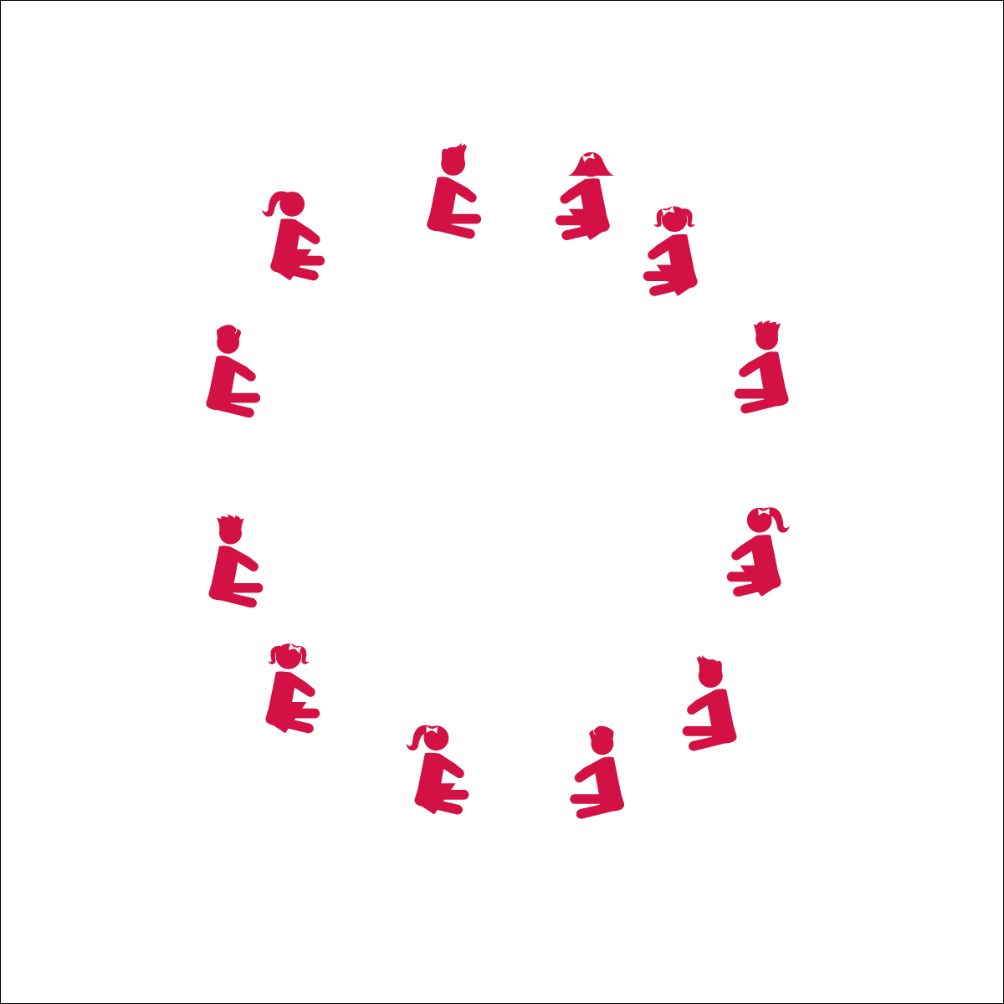

* **Skill:** I will perform this dance to the rhythm and tempo of the music.
* **Cognitive:** I will discuss dance movements and how those movements made me feel.
* **Fitness:** I will stay actively engaged in this dance.
* **Personal & Social Responsibility:** I will follow directions without teacher reminders.
* Listen Carefully
* Follow Teacher Calls

**Equipment:**

* Music Player
* The song “Cotton Eyed Joe” (Available on [iTunes](https://itunes.apple.com/us/album/cotton-eyed-joe/id257896457?i=257896526))

**Set-Up:**

1. Students sit in a circle or a tight scattered formation facing the teacher

**Activity Procedures:**

1. Today we’re going to do a dance called a Sitting Square Dance!
2. When the music starts, I will guide the class through a series of movements to the beat of the music. This is a call and response dance, and it will help us learn the basic structure of square dancing.
3. Teachers, use the Sitting Square Dance Activity Card to guide this activity

**Grade Level Progression:**

**K:** Have students perform the movements without music. Slowly introduce each set of movements as they master the previous sets.

**1st:** Perform the dance with short breaks between playing the music and stopping the music. Then, challenge the students to perform several sets of movements in a row without stopping.

**2nd:** Perform the dance with students standing up. Circle left and right to a count of 4 or 8.

**SITTING SQUARE DANCE**



* The teacher performs a movement to count of 1-2-3-4 and the students repeat that movement to the count of 5-6-7-8.
* Use short cue words with a demonstration, not long explanations.



Beat, Count, Rhythm, Locomotor Skill, Non-Locomotor Skill, March, Personal Space, General Space, Song Cues, Direction



* **Standard 1 (E5.K-2)** Performs locomotor skills in response to teacher-led creative dance (K); Combines locomotor and non-locomotor skills in a teacher-designed dance (1); Performs a teacher- and/or student-designed rhythmic activity with correct response to simple rhythms (2).
* **Standard 4 (E1.K-2)** Follows directions in group settings (e.g., safe behaviors, following rules, taking turns) (K); Accepts personal responsibility by using equipment and space appropriately (1); Practices skills with minimal teacher prompting (2).



* **DOK 1:** How did this dance make you feel?
* **DOK 1:** Can you recall the different sets of movements that I asked you to do?
* **DOK 2:** What did you notice about the amount of time provided for each movement and the rhythm of the song?
* **DOK 3:** What would happen if I stopped calling out the movements? How would everyone know what movements to do next?



**Organize activity in a variety of settings:** This another great call and response dance. Allowing the students to sit during the dance can be a great transition dance in a variety of settings. This dance lays a great foundation for partner dances and for more complex square dances taught in later grades. Remember: square dances are fun and social. Enjoy it with them and feel free to make up your own movements or ask them for suggestions.

**KINDERPOLKA**

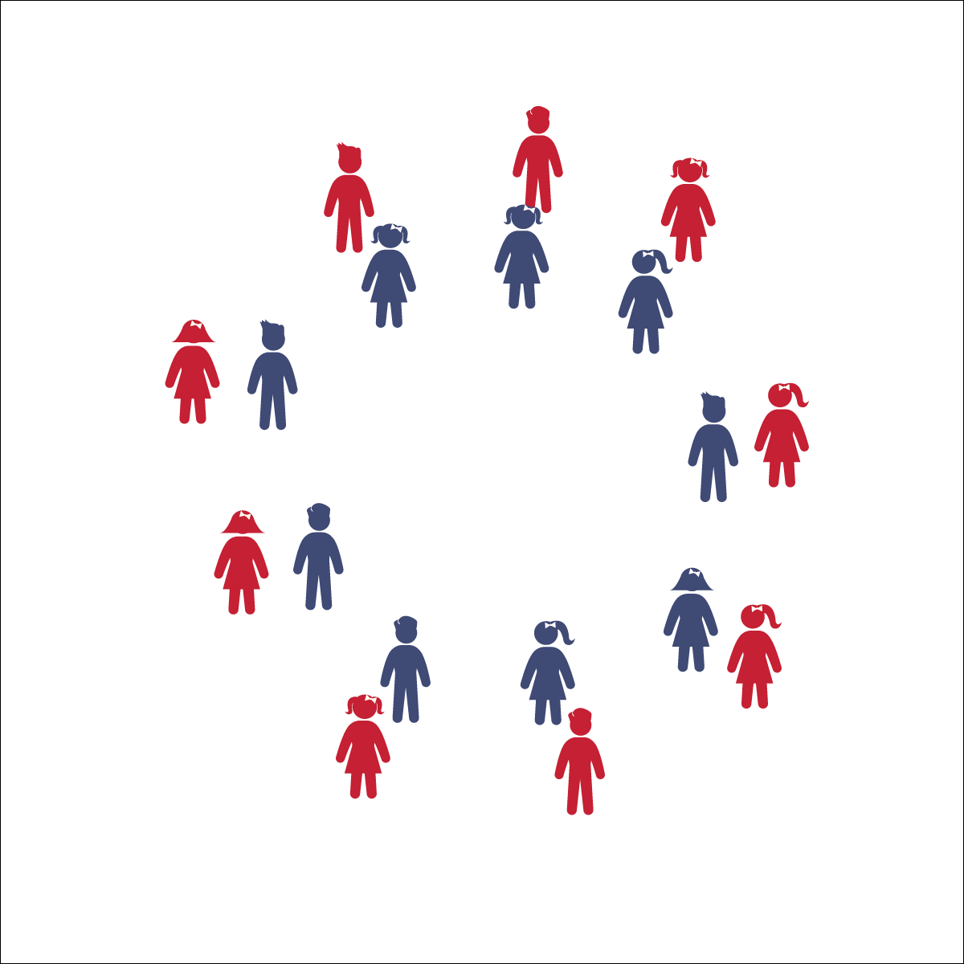

**Activity Procedures:**

1. Today we are going to learn a dance that was created in Germany called Kinderpolka. This is a fun partner dance that mimics adults waving their fingers and saying, “No No No,” to a child when the child keeps asking for something, even after the parent has already said no.
2. During the song, follow my cues and listen to the music.
3. This song has a slow tempo and clear beat. Listen to the beat of the song as we perform the movements to the rhythm of my count.
4. Teachers, use the Kinderpolka Activity Card to guide the dance. Start by teaching the students each part of the dance without the music. When they have learned the movements, have them try the dance with the music.
5. Repeat dance and enjoy. After learning the Kinderpolka, try the Supercharged version!

**Grade Level Progression:**

**K:** First learn the dance without partners, in a large circle. After they learn the dance, have students dance with a partner.

**1st:** Perform the dance as written. Try the Supercharge movements if the class has learned the dance and is ready for a challenge.

**2nd:** Perform the dance 1 time through as written, and then perform the dance again with the Supercharge movements.

**Equipment:**

* Music Player
* The song “Kinderpolka” (Available on [iTunes](https://itunes.apple.com/us/album/kinderpolka/id970580154?i=970580727))

**Set-Up:**

1. Students in pairs.
2. Pairs face each other in 2 large circles (inner and outer).

* **Skill:** I will perform dance movements to the rhythm and tempo of the music.
* **Cognitive:** I will discuss how I could dance without music.
* **Fitness:** I will actively engage in supercharged dance moves when prompted by the teachers.
* **Personal & Social Responsibility:** I will safely share space with my partner.
* Follow Teacher and Song Cues
* Find the Beat
* Say the Movements to the Rhythm

**KINDERPOLKA**



* Perform the dance while holding a scarf instead of holding hands.
* Perform the dance 1 movement at a time with a partner and slowly transition from 1 part of the dance to the other as the students master each movement.



* **DOK 1:** How did this dance make you feel?
* **DOK 1:** Do you remember where this dance was created?
* **DOK 2:** What movements did we use in this dance that we used in other dances?
* **DOK 2:** What is the difference between the regular moves and the supercharged movements?
* **DOK 3:** What would happen if the music stopped playing? How would you know what to do next?



* **Standard 1 (E5.K-2)** Performs locomotor skills in response to teacher-led creative dance (K); Combines locomotor and non-locomotor skills in a teacher-designed dance (1); Performs a teacher- and/or student-designed rhythmic activity with correct response to simple rhythms (2).
* **Standard 2 (E1.K-2)** Differentiates between movement in personal (self-space) and general space (Ka); Moves in personal space to a rhythm (Kb); Moves in self-space and general space in response to designated beats/rhythms (1); Combines locomotor skills in general space to a rhythm (2).
* **Standard 4 (E4.K-2)** Shares equipment and space with others (K); Works independently with others in a variety of class environments (e.g., small and large groups); (1); Works independently with others in partner environments (2).



Beat, Count, Rhythm, Locomotor Skill, Non-Locomotor Skill, March, Personal Space, General Space, Song Cues, Direction, Culture



**Discuss culture and diversity:** “Kinder” is a German word for “young” or “child,” and “polka” is a type of dance. This is a cultural dance that provides a great opportunity to show your students where Germany is on a map. Discuss how and why this dance was created and when it might be performed in Germany.

**MEXICAN HAT DANCE**

## 

* **Skill:** I will use locomotor and non-locomotor movements to the rhythm and tempo of the music.
* **Cognitive:** I will talk about how vigorous movement affects my heart rate.
* **Fitness:** I will stay actively engaged in order to increase my heart rate.
* **Personal & Social Responsibility:** I will safely share space with my partner.
* Follow Song Cues and Teacher Movements

**Equipment:**

* Music Player
* The song “The Mexican Hat Dance” (Available on [iTunes](https://itunes.apple.com/us/album/jarabe-tapatio-mexican-hat/id164142726?i=164143029))
* Optional: 1 hula hoop or spot marker for every 2 students

**Set-Up:**

1. Students in pairs.
2. Partners stand opposite each other by a hula hoop or spot marker.

**Activity Procedures:**

1. Today’s activity is called The Mexican Hat Dance
2. The object of the activity is to work with a partner to perform a fun 2-part dance!
3. Teachers, first introduce each movement without music and then with music as students master the dance.
4. Use The Mexican Hat Dance Activity Card to guide this dance.

**Grade Level Progression:**

**K:** Perform this dance in a large circle.

**1st:** Students perform this dance around a hula hoop. They touch their heels inside the hula hoop for part 1 and skip around the hula hoop for part 2. Try the Supercharged movements if the class has learned the dance and is ready for a challenge.

**2nd:** Students perform the dance with hula hoop between them and then dance again with the Supercharged movements.

**MEXICAN HAT DANCE**



* Perform the dance with less vigorous movements and without music.
* Perform to this song with rhythm sticks while sitting down. For part 1, tap the ground with both sticks and then tap the sticks together twice instead of claps. For part 2, alternate tapping to the beat with the stick in your right hand and then your left.
* To add a challenge, perform this dance with a basketball. For part 1, bounce the ball instead of performing each heel tap and use the 2 claps as a rest. For part 2, dribble around the room or pivot all the way around (360 degrees) left and then all the way around 360 degrees to the right. Remember to stay on beat with the rhythm of the song.



Beat, Rhythm, Locomotor Skill, Non-Locomotor Skill, Stationary, Personal Space, General Space, Song Cues, Culture, Vigorous



* **Standard** **1 [S1.E8.1-2]:** Transfers weight from one body part to another in self-space in dance and gymnastics environments (1); Transfers weight from feet to different body parts/bases of support for balance and/or travel (2).
* **Standard 2 [S2.E1.K-2]:** Differentiates between movement in personal (self-space) and general space (Ka); Moves in personal space to a rhythm (Kb); Moves in self-space and general space in response to designated beats/rhythms (1); Combines locomotor skills in general space to a rhythm (2).



* **DOK 1:** How did this dance make you feel?
* **DOK 1:** What were the 2 movement patterns we performed today during the Mexican Hat Dance?
* **DOK 1:** What locomotor skills did we use during this dance?
* **DOK 2:** If you could modify this dance to using 2 different sets of movement patterns, what would they be? Why?
* **DOK 2:** How did the supercharge movements make our dance more vigorous?
* **DOK 3:** What did dancing more vigorously do to our heart rates and why?



**Discuss culture and diversity:** This is another cultural dance, which provides the opportunity to talk about another country and cultural traditions. Discuss the role of dance in culture and how powerful it is to learn about how other people live and dance.



* **DOK:** Question



**Strategy Focus:** How to teach the strategy focus

**GOLDFISH DANCE**

## 

**Activity Procedures:**

1. Today’s activity is called The Goldfish Dance. The object of the activity is to learn about some healthy habits that humans and goldfish like to do everyday. During this song we’ll pretend we are goldfish!
2. When the music starts, follow my movements and the musical cues from the song. We’ll perform movements that goldfish and people do.
3. Whenever the song asks us to come back to our rock, return to your spot in the circle (or personal spots) and lay down.
4. Be sure you are moving safely when you are in personal space (when pretending to sleep), when you are moving in the circle, and when you move around in general space.
5. Teachers, use The Goldfish Song Activity Card to guide the activity.

**Grade Level Progression:**

**K:** Students stay on the circle when performing the dance. When they “go swimming,” students lie on their bellies and move their arms and legs as if they are swimming.

**1st:** Follow the movements and musical cues as written.

**2nd:** Encourage the students to think of other healthy habits that people do. Perform healthy habits as fish and create a lyrical stanza and movements for each habit. Sing and perform this together as class.

* **Skill:** I will perform movements to the rhythm and tempo of the music.
* **Cognitive:** I will identify healthy behaviors.
* **Fitness:** I will stay actively engaged in this dance.
* **Personal & Social Responsibility:** I will follow directions without teacher reminders.
* Follow Song Cues and Teacher Movements

**Equipment:**

* Music Player
* The song “The Goldfish Song” by Laurie Berkner (Available on [iTunes](https://itunes.apple.com/us/album/the-goldfish/id377990680?i=377990782))

**Set-Up:**

1. Start activity in a circle with students laying down on their stomachs.
2. The dance can also be performed on personal spot markers.



* Perform the dance in seated positon and with upper body movements.
* Emphasize divergent ideas to eliminate fear of doing a movement incorrectly.

**GOLDFISH DANCE**



Beat, Rhythm, Locomotor Skill, Non-Locomotor Skill, Stationary, Personal Space, General Space, Song Cues, Stroke (Swimming)



* **Standard** **1 (E5.K-2)** Performs locomotor skills in response to teacher-led creative dance (K); Combines locomotor and non-locomotor skills in a teacher-designed dance (1); Performs a teacher- and/or student-designed rhythmic activity with correct response to simple rhythms (2).
* **Standard 3 (E1.K-2)** Identifies active-play opportunities outside physical education class (K); Discusses the benefits of being active and exercising and/or playing (1); Describes large-motor and/or manipulative physical activities for participation outside physical education class (e.g., before and after school, at home, at the park, with friends, with the family) (2).
* **Standard 4 (E1.K-2)** Follows directions in group settings (e.g., safe behaviors, following rules, taking turns) (K); Accepts personal responsibility by using equipment and space appropriately (1); Practices skills with minimal teacher prompting (2).



* **DOK** **1:** How did this dance make you feel?
* **DOK 1:** What healthy activities did we pretend to do in this dance?
* **DOK 2:** Why are these activities good to do every day?
* **DOK 1:** What cues did we follow in this song?
* **DOK 2:** How did we know what to do and when?



**Have fun with academic integration:** Once the students learn this dance, it is likely to be one of their favorites and can be used often as a warm-up/cool-down or transition. As an integrated lesson, this can easily be worked into conversations about ecosystems (e.g., where fish live, what else lives in a goldfish’s ecosystem, etc.). As a dance, this activity provides the class an opportunity to move freely at different levels in general space. It also requires students to perform very basic choreography without realizing they are preforming a dance. Have fun and use this dance to explore space while learning about healthy habits.