­­

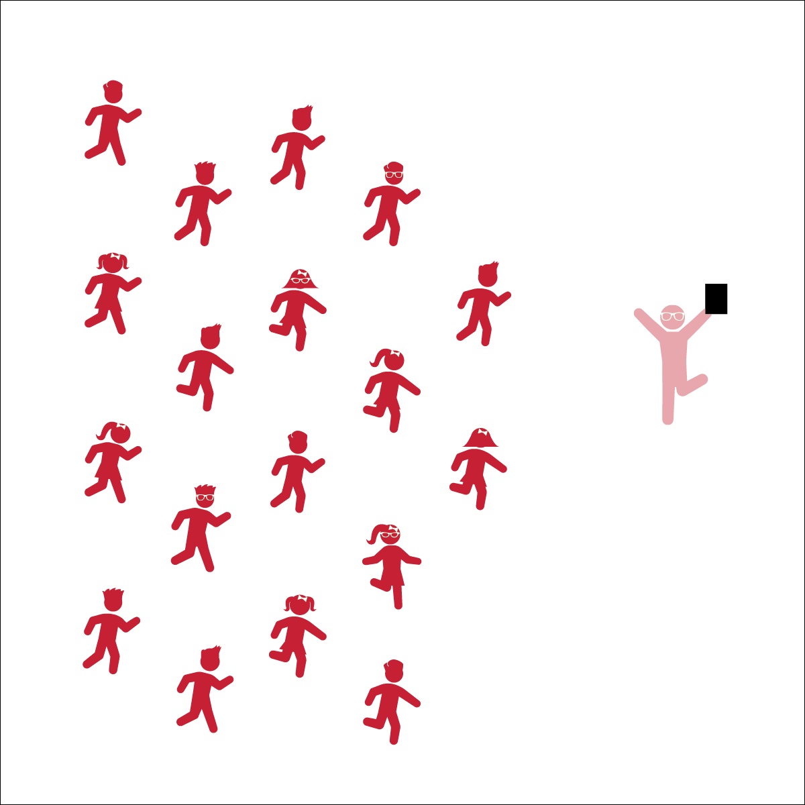

* **Skill:** I will move in my personal space to the rhythm of the music.
* **Cognitive:** I will discuss different Pop See Ko dance moves during class discussion.
* **Fitness:** I will actively participate by moving my body to the rhythm of the music.
* **Personal & Social Responsibility:** I will safely share personal space with my classmates.

**POP SEE KO**

* Listen and Respond
* Follow the Conversation
* Move to the Music

**Equipment:**

* Music Player
* (Optional) The song “Pop See Ko” (Available on [iTunes](https://itunes.apple.com/us/album/pop-see-ko-single/id993755810), [YouTube](https://app.gonoodle.com/channels/koo-koo-kanga-roo/pop-see-ko-2-0))
* (Level 2) 1 hula hoop or poly spot per group of 4 students

**Set-Up:**

1. Level 1: Students stand in a scattered formation facing the teacher (on individual spots).
2. Level 2: Students stand in groups of 4 around a hula hoop.
3. Level 3: Students stand in larger groups of 8-12.

**Activity Procedures:**

1. Today’s activity is called Pop See Ko. It is a conversation song and dance created by the group Koo Koo Kangaroo.
2. The object of the dance is to have fun and be creative while we move around.
3. Teachers, lead the students as detailed on the Pop See Ko Conversation Sheet.
4. When appropriate, call on individual students to choose dance moves for the group to perform.
5. Continue the dance, repeating the call and response format so that each student gets a chance to perform a unique dance move while the class follows along.

**Grade Level Progression:**

**K:** Students follow teacher-led movements.

**1st:** Organize students into small groups of 4. 1 student starts the conversation with another, and the whole group will dance along with the responder. Then, the responder will become the caller and start the conversation with another student. Continue this process to give every member of the group a turn.

**2nd:** Students perform the activity as described for 1st grade with additional teacher encouragements to create movements that include the whole body (both arm and leg movements).

**POP SEE KO**



* Move in an area free of visual distractions.
* Use short cue words with a demonstration rather than long explanations.
* Perform this dance in a circle. Rotate the designation of leader from student to student around the circle until all students have had the opportunity to be a movement leader/responder.



Dance, Leader, Follower, Upper Body, Lower Body, Movement, Locomotor Skills, Non-Locomotor Skills, Responsibility, Respect



* **Standard 2 (E1.K-2)** Differentiates between movement in personal (self-space) and general space (Ka); Moves in personal space to a rhythm (Kb); Moves in self-space and general space in response to designated beats/rhythms (1); Combines locomotor skills in general space to a rhythm (2).
* **Standard 4 (E4.K-2)** Shares equipment and space with others (K); Works independently with others in a variety of class environments (e.g., small and large groups) (1); Works independently with others in partner environments (2).



* **DOK 1:** How did this dance make you feel?
* **DOK 2:** Pick a specific movement within the dance that made you feel some emotion. Describe why you think it made you feel the way it did.
* **DOK 2:** How did it make you feel to lead a dance move? Why do you think it made you feel that way?
* **DOK 2:** What was 1 movement you liked that someone else led us in? What made you like it?

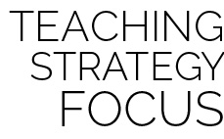

**Create a safe environment for self-expression:** Pop See Ko is a fun dance activity that provides students with an opportunity to be creative and express themselves through rhythmic movement. Be sure to find a good compromise between challenging your students with an opportunity to be a leader and allowing them to remain in their comfort zones. Encourage students to be as creative as they can be while both remaining safe and controlled with their movements and having a fun time leading and following many different rhythmic movements.



* **DOK:** Question



**Strategy Focus:** How to teach the strategy focus