­­

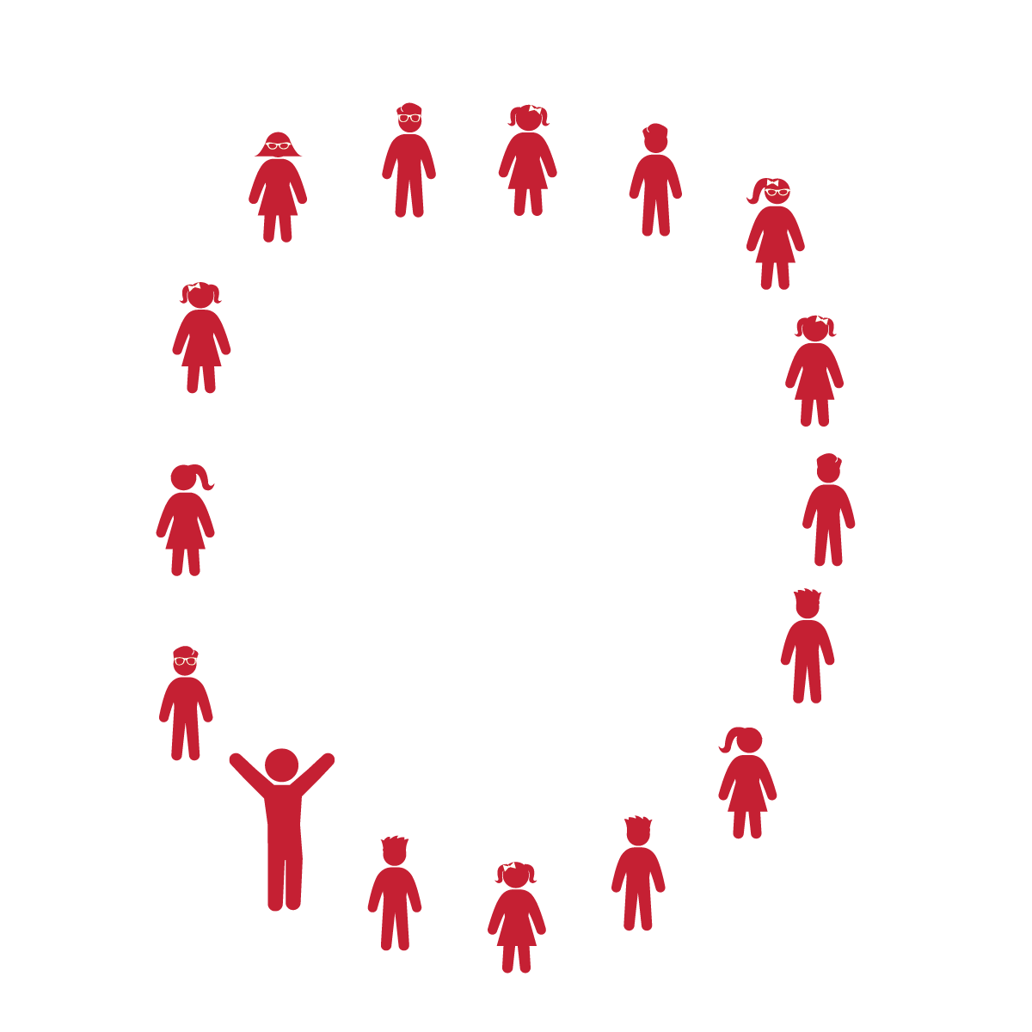

**Equipment:**

* Music Player
* The song “The Way You Make Me Feel” (Available on [iTunes](https://itunes.apple.com/us/album/way-you-make-me-feel-single/id159292399?i=159294429))

Note: You can use similar songs with moderate tempo and a clear beat

**Set-Up:**

* Students sit or stand in a large circle

**Activity Procedures:**

1. Today’s activity is called Moving 8s.
2. The object of the activity is to learn about beat, rhythm, and tempo. The beat is like the heartbeat of the song. You might tap your foot to the beat as you listen to a song. The beat is what we are counting in this activity.
3. The rhythm is the pattern of the music, or the movement in the song. The tempo is the speed of the song and can increase or decrease throughout a song or dance.
4. This activity is like Simon Says. I am going to count out aloud, “1-2-3-4,” and you are going to repeat back to me, “5-6-7-8.” The numbers represent the beat of the song. The movements we perform will go along with the rhythm of the music. I may increase or decrease the tempo as we play this activity.
5. Teachers, use the Moving 8s Activity Card to lead the students in this activity.

**Grade Level Progression:**

**K:** Play this activity first without music. Start sitting down and then progress to standing up. Next, try the movements with music.

**1st:** Play this activity first without music, but start standing up. Next, add music and pathway movement around the circle. Change direction and then move both in and out of the circle.

**2nd:** After performing this activity in a circle with music, prompt students to scatter and move in general space, listening to your call and moving only on their “5-6-7-8” response.

* Listen and Respond
* Listen and Watch My Count and Movements
* Respond and Perform the Same Movements
* **Skill:** I will perform locomotor skills to the beat of the music.
* **Cognitive:** I will count and clap the beat of the song.
* **Fitness:** I will be actively engaged in this dance by moving to the beat of the song.
* **Personal & Social Responsibility:** I will follow directions and stay safely on task.

**MOVING 8s**

**MOVING 8s**



Beat, Rhythm, Tempo, Dance, Leader, Follower, Upper Body, Lower Body, Movement, Locomotor Skills, Non-Locomotor Skills



* **Standard 1 (E5.K-2)** Performs locomotor skills in response to teacher-led creative dance (K); Combines locomotor and non-locomotor skills in a teacher-designed dance (1); Performs a teacher- and/or student-designed rhythmic activity with correct response to simple rhythms (2).
* **Standard 4 (E1.K-2)** Follows directions in group settings (e.g., safe behaviors, following rules, taking turns) (K); Accepts personal responsibility by using equipment and space appropriately (1); Practices skills with minimal teacher prompting (2).



* **DOK 1:** How did this dance make you feel?
* **DOK 2:** What was the beat/rhythm we followed during our dance? Can you count it and clap it for me?
* **DOK 2:** What different movements did we perform to the beat of the music? What are some other movements can we perform?
* **DOK 2:** Can you clap and count a fast beat? What does a slow beat sound like when you clap and count?



**Pace the Progression:** Start the activity with a lot of repetition of counting, clapping, and other movements while students follow along with you. Don’t rush into playing the music. Wait until the students understand how to count out the beat at a slow and a fast tempo before introducing the music to the activity. Save some time at the end of the activity for trying 1 of the challenge progressions and/or allowing them to make up their own movements. Focus on staying on the beat with the song. Clapping is a great way to highlight the rhythm and guide students through the activity.



* Students make a traditional conga line and perform movements along with the teacher or selected line leader.
* Students partner up and take turns being the leader. 1 partner starts by performing a movement while saying, “1-2-3-4.” Then, the other partner responds by performing the same movement saying, “5-6-7-8.”



* **DOK:** Question



**Strategy Focus:** How to teach the strategy focus