­­

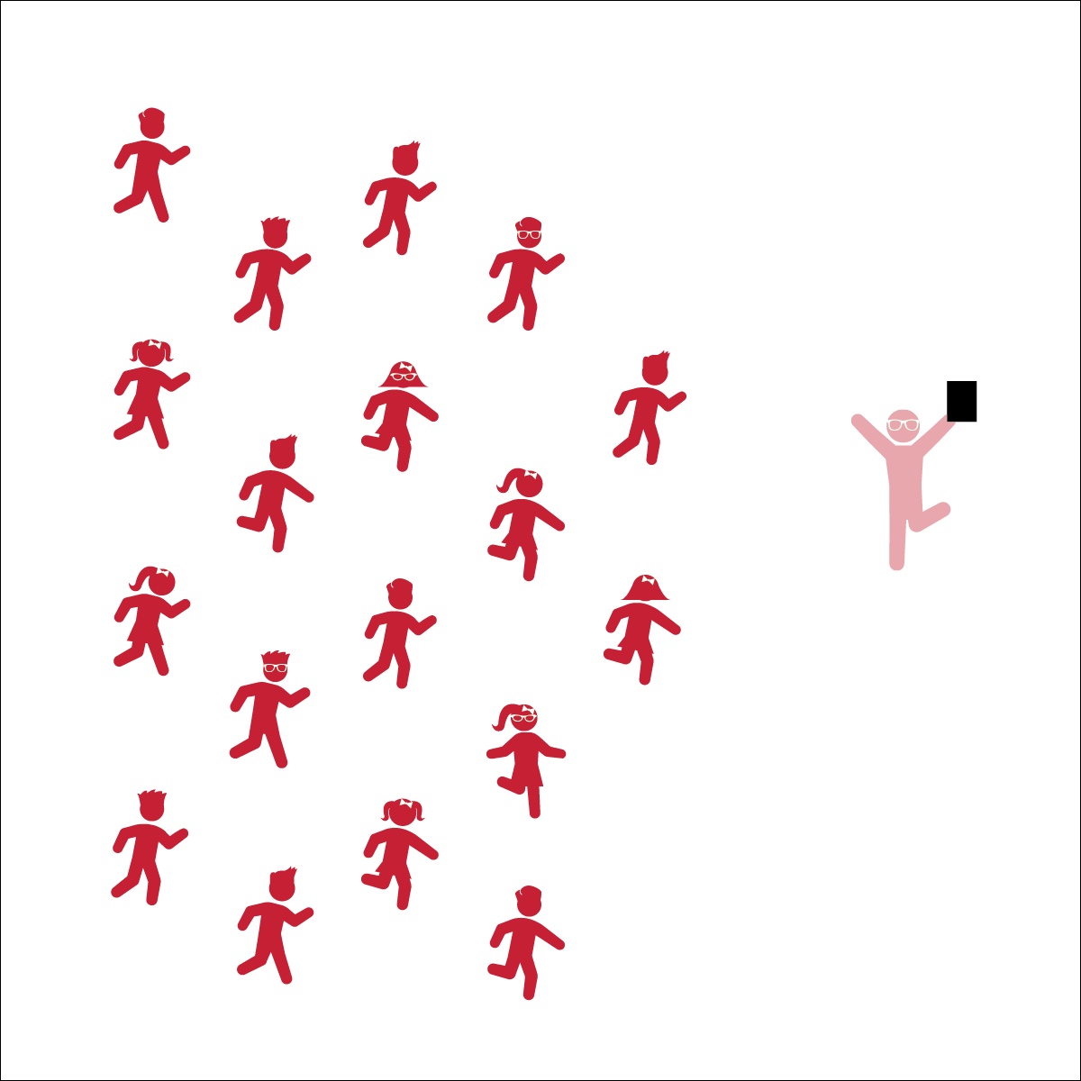

**A VERY SIMPLE DANCE**

* **Skill:** I will perform all of the movements to this dance.
* **Cognitive:** I will identify the locomotor and non-locomotor movements used in this dance.
* **Fitness:** I will stay actively engaged in this dance.
* **Personal & Social Responsibility:** I will talk about the how I was able to express feelings through dance movements.
* Listen and Move to Music Cues
* Follow the Teacher’s Calls and Movements

**Equipment:**

* Music Player
* The song “A Very Simple Dance” (Sesame Street Productions, Available on [iTunes](https://itunes.apple.com/us/album/a-very-simple-dance/id391019308?i=391019569) and via [YouTube](https://youtu.be/OxRFqhKlo6w))

**Set-Up:**

1. Students stand in a scattered formation, facing the teacher.

**Activity Procedures:**

1. Today’s activity is called A Very Simple Dance.
2. The focus of the activity is to use what we have learned about putting movements to rhythm and to express happiness by performing this dance. Then we’ll get a chance to create our own dance.
3. Teachers, use the Simple List Dance Activity Card to lead this activity.
4. Listen to the cues of the music and perform responses with the students.

**Grade Level Progression:**

**K:** Perform the activity as described above.

**1st:** Have students perform the dance in groups of 3-4.

**2nd:** Have students perform the dance in groups of 3-4. After performing the dance, each group will create and perform their own “Simple Dance” consisting of 3 or 4 movements with each movement lasting 4 beats. The dance must start with “clap your hands” and finish with “all fall down.”



* **DOK 1:** How did this dance make you feel?
* **DOK 2:** What locomotor and non-locomotor skills did you use/perform in this dance?
* **DOK 2:** Would increasing the tempo of the song make the dance harder or easier? Why?
* **DOK 3:** How can you use this dance to help make a friend feel better or express how you feel?

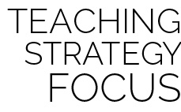

**Review content:** This dance helps bring together the concepts of beats (counting music), rhythm (pattern), and tempo (speed) of a song and dance. This song also helps students explore a variety of basic locomotor and non-locomotor dance movements while reviewing the concept of call and response and see why that learning strategy is important to many dances.

**A VERY SIMPLE DANCE**



**Review content:** This dance helps bring together the concepts of beats (counting music), rhythm (pattern), and tempo (speed) of a song and dance. This song also helps students explore a variety of basic locomotor and non-locomotor dance movements while reviewing the concept of call and response and see why that learning strategy is important to many dances.



* **DOK 1:** How did this dance make you feel?
* **DOK 2:** What locomotor and non-locomotor skills did you use/perform in this dance?
* **DOK 2:** Would increasing the tempo of the song make the dance harder or easier? Why?
* **DOK 3:** How can you use this dance to help make a friend feel better or express how you feel?



* **Standard 1 (E5.K-2)** Performs locomotor skills in response to teacher-led creative dance (K); Combines locomotor and non-locomotor skills in a teacher-designed dance (1); Performs a teacher- and/or student-designed rhythmic activity with correct response to simple rhythms (2).
* **Standard 2 (E1.K-2)** Differentiates between movement in personal (self-space) and general space (Ka); Moves in personal space to a rhythm (Kb); Moves in self-space and general space in response to designated beats/rhythms (1); Combines locomotor skills in general space to a rhythm (2).
* **Standard 5 (E3.K-2)** Identifies physical activities that are enjoyable (Ka); Discusses the enjoyment of playing with friends (Kb); Describes positive feelings that result from participating in physical activities (1a); Discusses personal reasons (i.e., the “why”) for enjoying physical activities (1b); Identifies physical activities that provide self-expression (e.g., dance, gymnastics routines, practice tasks/games environment) (2).



Beat, Rhythm, Tempo, Dance, Leader, Follower, Upper Body, Lower Body, Movement, Locomotor Skills, Non-Locomotor Skills, Call, Response



* Create a dance modification that can be done in a seated position.
* Add brightly colored scarves or ribbon wands.
* Allow students to create a movement of their own that the whole class will try to perform.



* **DOK:** Question



**Strategy Focus:** How to teach the strategy focus