­­

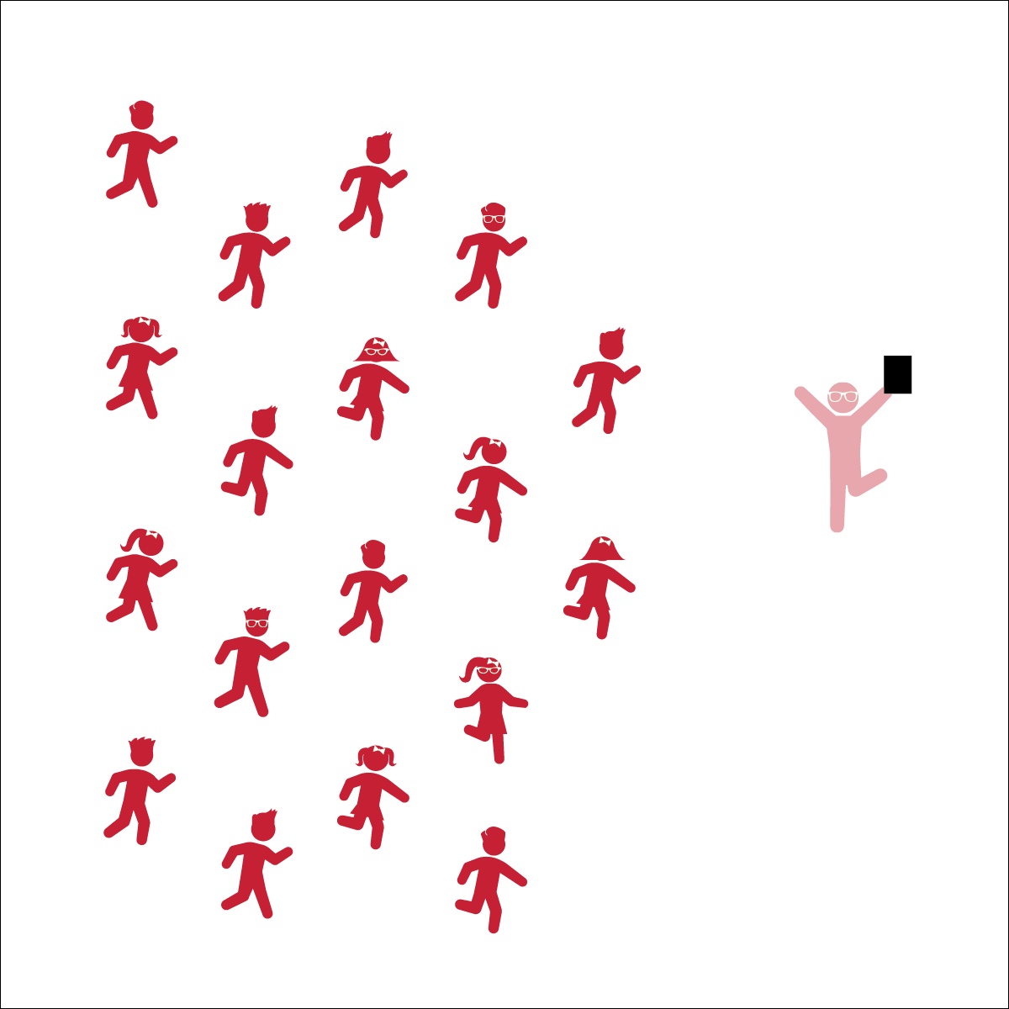

**Activity Procedures:**

1. Today’s activity is called The Dancing Duke of York. Today we are going to pretend we are the Noble Duke of York and move our bodies to the lyrics (words) of the song.
2. The object of the activity is to follow the musical cues of the song and move our bodies through different levels.
3. Teachers, follow The Dancing Duke of York Activity Card.

**Grade Level Progression:**

**K:** Sing/say the song slowly or pause the music in between music cues so that students can learn each response. Once they’ve learned each one, practice performing the dance without stopping.

**1st:** Change the original action word “March” to other locomotor skills. Example: “He *galloped* up the hill and *jumped* down again.”

**2nd:** Have the students perform the dance faster and faster as you say/sing the song faster and faster each time.

**THE DANCING DUKE OF YORK**

* **Skill:** I will perform movements to the rhythm and tempo of the song.
* **Cognitive:** I will discuss how the tempo of the song changed our dance performance.
* **Fitness:** I will stay actively engaged in this dance.
* **Personal & Social Responsibility:** I will take turns listening and responding during class discussion.
* Respect Self-Space
* Follow Song Cues and Teacher Movements

**Equipment:**

* Music Player
* The song “Noble Duke of York” (Available on [iTunes](https://itunes.apple.com/us/album/the-noble-duke-of-york/id433893845?i=433894017))

**Set-Up:**

1. Students stand in a scattered formation, facing the teacher.
2. The teacher models the movements while singing/saying *The Grand Old Duke of York* nursery rhyme or while playing the “Noble Duke of York” song.

**THE DANCING DUKE OF YORK**

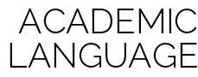

Beat, Rhythm, Tempo, Dance, Actively Engage, Song Cues, Locomotor Skills, Self-Space



* **Standard 1 (E5.K-2)** Performs locomotor skills in response to teacher-led creative dance (K); Combines locomotor and non-locomotor skills in a teacher-designed dance (1); Performs a teacher- and/or student-designed rhythmic activity with correct response to simple rhythms (2).
* **Standard 1 (E8.1-2)** Transfers weight from one body part to another in self-space in dance environments (1); Transfers weight from feet to different body parts/bases of support for balance and/or travel (2).
* **Standard 2 (E2.1a)** Travels demonstrating low, middle, and high levels (1a).



* **DOK 1:** How did this dance make you feel?
* **DOK 1:** What is a locomotor skill? What are the different locomotor skills that you’ve learned?
* **DOK 2:** Can you demonstrate the 3 different levels we moved through today? Low? Middle? High?
* **DOK 3:** What happened to the difficulty of the dance when we tried to do it slower? Faster?
* **DOK 3:** Did it get easier or harder the more times we sang and danced the song? Why do you think that is?

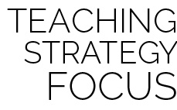

**Scaffold Instruction:** This activity is an adaptation of a children’s nursery rhyme (*The Grand Old Duke of York*), wherein a variety of basic non-locomotor and locomotor movements are incorporated into the song, “Noble Duke of York.” Once your students have mastered the movements in this song, it can be used as a challenging warm-up (i.e., get faster and faster) or cool-down activity (go slower and slower). In a classroom setting, students can begin by sitting in their chairs: on the words “up” and “down,” the students stand up/sit down as directed. Have the students move in their personal space until they understand the song cues and associated movements. Sing the song/rhyme slowly to start, getting to a normal pace as the students learn the movements.

* Allow the students to perform the song while sitting by using only their hands and arms. To march, the students can pat their thighs or wave their hands and arms back and forth.
* Progressively increase or decrease the tempo of the song to accommodate the class.

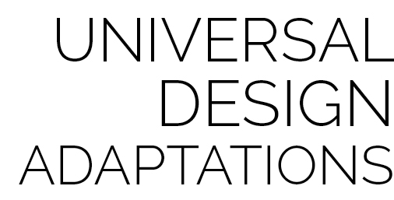

* **DOK:** Question



**Strategy Focus:** How to teach the strategy focus