­­

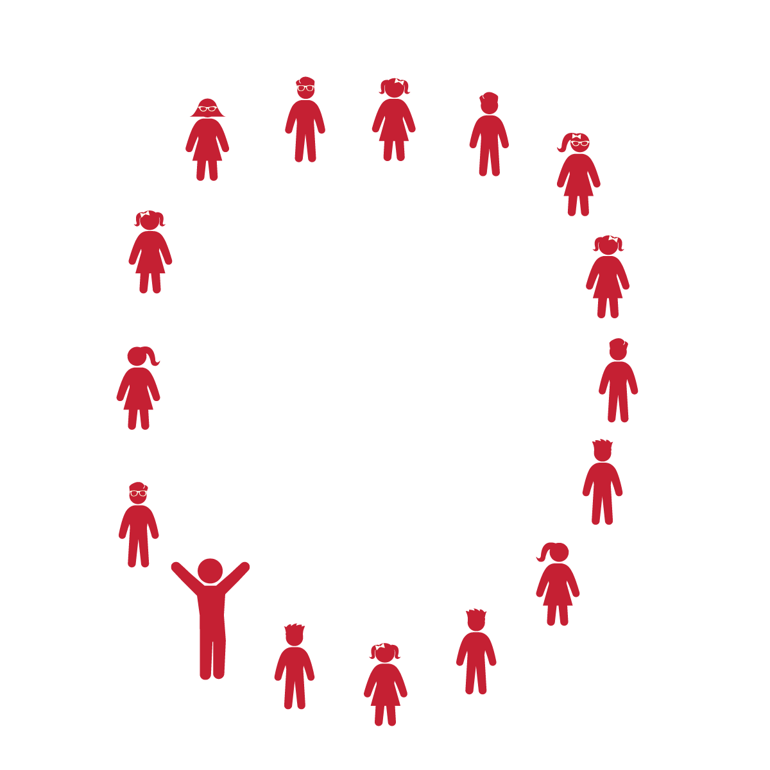

**Activity Procedures:**

1. Today’s activity is called The Hokey Pokey. The object of the activity is to practice moving only 1 part of our body at a time.
2. As the song asks the students to put different body parts into the circle, the students stick those body parts toward the center of the circle. When the song calls for it, they turn and put that body part outside of the circle. The song will then instruct students to shake that body part. Finally, students turn around (do the Hokey Pokey) and prepare for the next body part.
3. This dance can be performed with the song being played or sung by the teacher and class.
4. Teachers, use The Hokey Pokey Activity card as a reference for this dance.

**Grade Level Progression:**

**K-1st:** Students perform the song as described above.

**2nd:** Students perform in a circle, on spot markers, or across from a partner in a hula hoop. Perform the song as explained above. However, prompt students to move to a different spot every time they hear the lyric, “That’s what it’s all about.”

**Equipment:**

* Music Player
* The song “The Hokey Pokey” (Available on [iTunes](https://itunes.apple.com/us/album/hokey-pokey-deluxe/id472163229?i=472163231))

**Set-Up:**

1. Students and teacher stand in a large circle formation.

* Follow Song Cues and Teacher Movements
* **Skill:** I will work to keep my balance during the Hokey Pokey.
* **Cognitive:** I will make the correct movements with the correct body parts during this dance.
* **Fitness:** I will stay actively engaged and work to increase my heart rate.
* **Personal & Social Responsibility:** I will safely move in personal space.

**THE HOKEY POKEY**

**THE HOKEY POKEY**



Dance, Actively Engage, Song Cues, Locomotor Skills, Non-Locomotor Skills, Self-Space



* **Standard 1 [S1.E8.1-2]:** Transfers weight from one body part to another in self-space in dance and gymnastics environments (1); Transfers weight from feet to different body parts/bases of support for balance and/or travel (2).
* **Standard 2 [S2.E1.K-2]:** Differentiates between movement in personal (self-space) and general space (Ka); Moves in personal space to a rhythm (Kb); Moves in self-space and general space in response to designated beats/rhythms (1); Combines locomotor skills in general space to a rhythm (2).



* **DOK 1:** How did this dance make you feel?
* **DOK 1:** Can you identify the different body parts that we moved today during our dance?
* **DOK 2:** How would you apply what you learned during this dance to develop your own version of the “Hokey Pokey” dance?

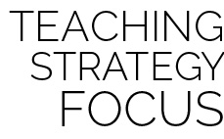

**Help students learn right and left:** The Hokey Pokey can be a fun and challenging song for K-2 students, especially for those who do not yet know the difference between their right and left. This dance is a fun way to learn and practice basic directions.

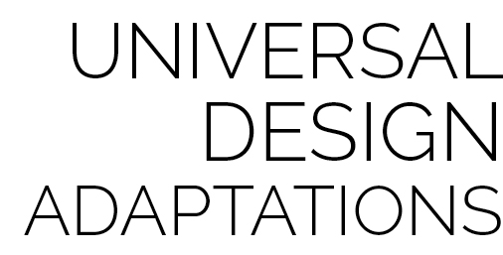

* Perform the dance in seated position.
* Perform the dance with a parachute. The students lift and take a step underneath the parachute for “in” and step back outside of the parachute for “out.” For “turning around,” the students place the parachute on the ground and turn around.
* Allow students to suggest other body parts to put in and out of the circle as you sing the song as a class.



* **DOK:** Question



**Strategy Focus:** How to teach the strategy focus