­­

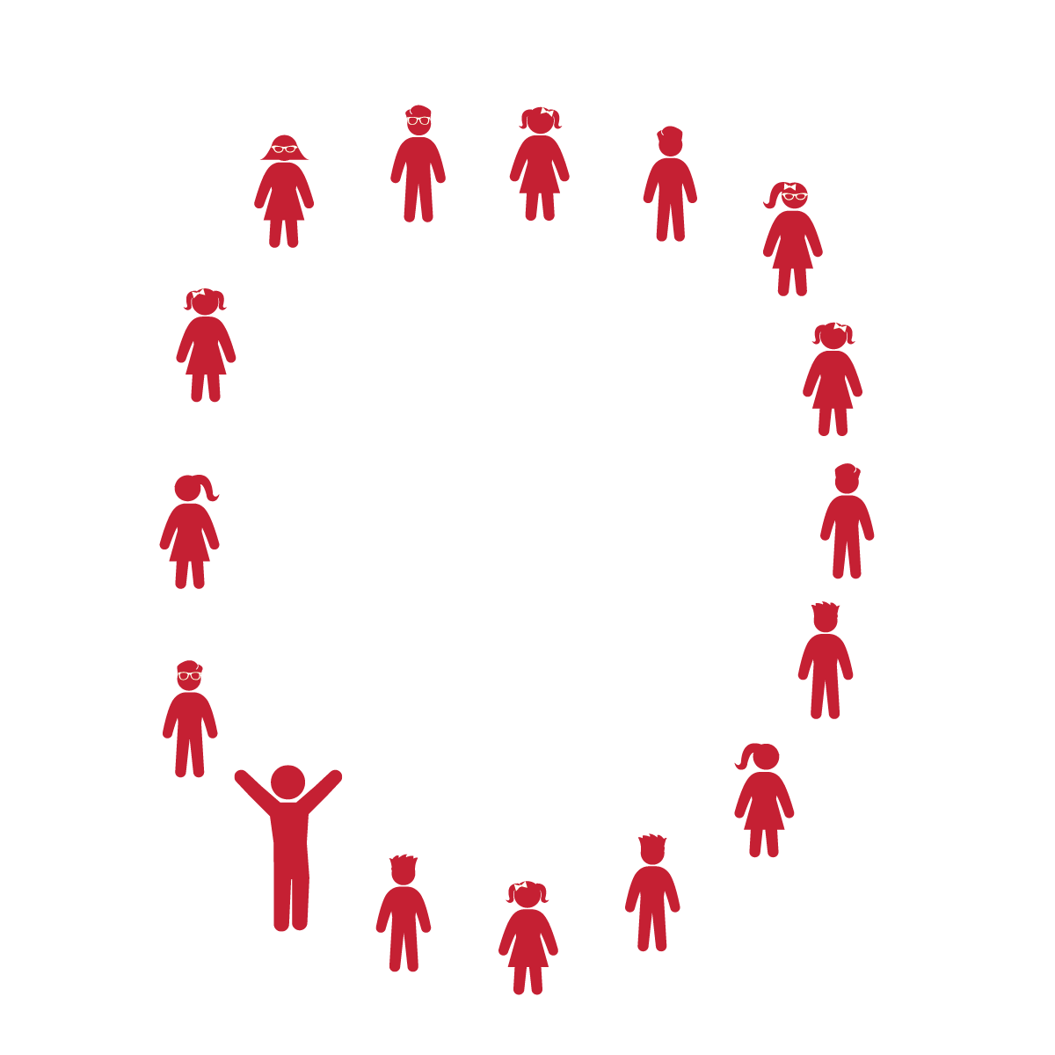

**THE BIRDIE DANCE**

**Activity Procedures:**

1. Today’s activity is called The Birdie Dance.
2. The object of the activity is to move our bodies like a bird from a medium level to a low level and back.
3. The music will play and we will perform the movements as we hear the song cues.
4. Teachers, use The Birdie Dance Activity Card as a reference for this dance.

**Grade Level Progression:**

**K:** Perform dance as described above.

**1st:** Students perform this song with a partner.

**2nd:** Students perform this song in small groups of 3-6 students.

**Equipment:**

* Music Player
* The song “Birdie Dance” or “The Chicken Dance” (Available on [iTunes](https://itunes.apple.com/us/album/birdie-dance/id660338812?i=660339165))

**Set-Up:**

1. Students and teacher stand in a large circle formation.
2. Alternate set-up: Students perform this dance facing a partner or in small groups.

* Follow Song Cues and Teacher Movements
* **Skill:** I will perform the moves of the Birdie Dance in the correct order (sequence).
* **Cognitive:** I will discuss movement pathways.
* **Fitness:** I will stay actively engaged in order to increase my heart rate.
* **Personal & Social Responsibility:** I will safely move in personal space.

**THE BIRDIE DANCE**



Dance, Actively Engage, Song Cues, Locomotor Skills, Non-Locomotor Skills, Self-Space



* **Standard 1 (E5.K-2)** Performs locomotor skills in response to teacher-led creative dance (K); Combines locomotor and non-locomotor skills in a teacher-designed dance (1); Performs a teacher- and/or student-designed rhythmic activity with correct response to simple rhythms (2).
* **Standard 2 (E1.K-2)** Differentiates between movement in personal (self-space) and general space (Ka); Moves in personal space to a rhythm (Kb); Moves in self-space and general space in response to designated beats/rhythms (1); Combines locomotor skills in general space to a rhythm (2).



* **DOK 1:** How did this dance make you feel?
* **DOK 1:** What different pathways and shapes did we move in today? During which parts of the song and dance did we use them?
* **DOK 2:** What did you notice about the number of beats used for each movement?
* **DOK 2:** How did the different movements in the dance represent birds?

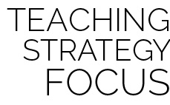

**Access prior knowledge:** This song and dance is performed at many social events that a K-2 student might attend. When you introduce it in class, they may already know this song and be ready for a challenge. Allow students to create fitness modifications that make the dance more vigorous. This provides a good opportunity to help them see that physical fitness can be integrated into all areas of their lives and that dancing can be a fun way to interact with others.



* Students start in a seated circle formation. The teacher leads the class in the 4 movements (cheep, flap, wiggle, clap). During the bridge, the students join hands and lean to the right/left instead of skipping to the right/left.
* Move in an area free of visual distractions.
* Use short cue words with a demonstration, not long explanations.



* **DOK:** Question



**Strategy Focus:** How to teach the strategy focus