­­

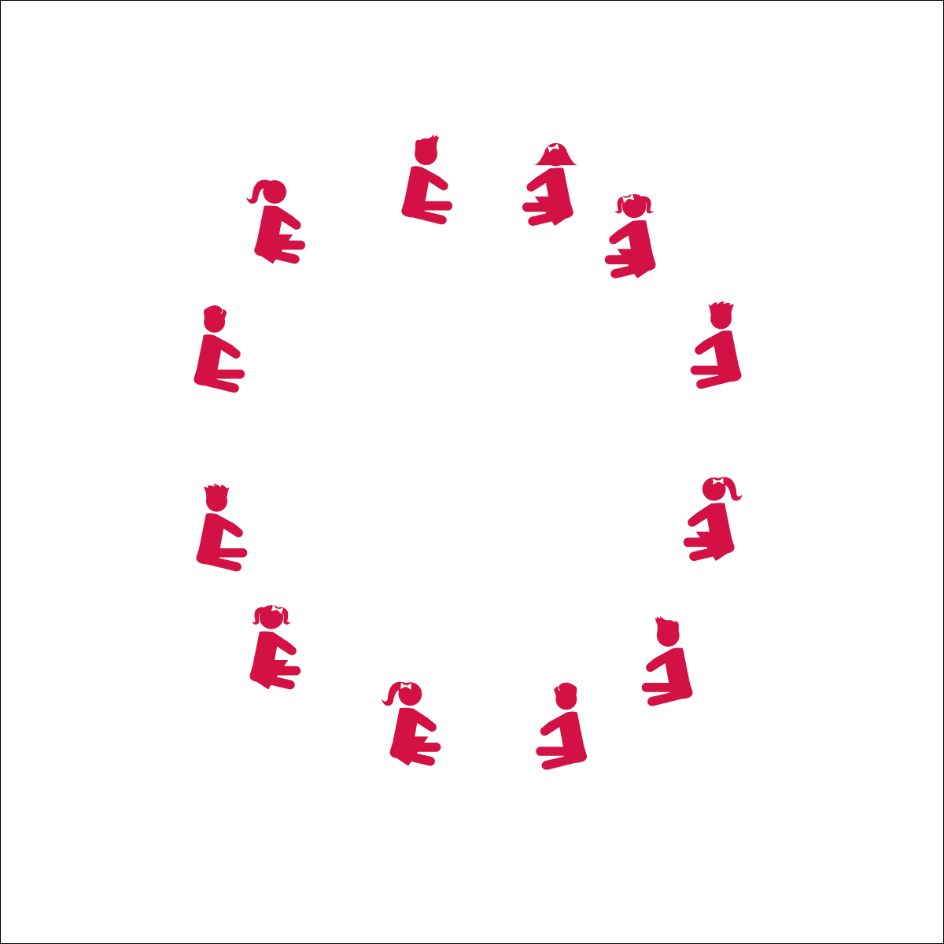

**SITTING SQUARE DANCE**

* **Skill:** I will perform this dance to the rhythm and tempo of the music.
* **Cognitive:** I will discuss dance movements and how those movements made me feel.
* **Fitness:** I will stay actively engaged in this dance.
* **Personal & Social Responsibility:** I will follow directions without teacher reminders.
* Listen Carefully
* Follow Teacher Calls

**Equipment:**

* Music Player
* The song “Cotton Eyed Joe” (Available on [iTunes](https://itunes.apple.com/us/album/cotton-eyed-joe/id257896457?i=257896526))

**Set-Up:**

1. Students sit in a circle or a tight scattered formation facing the teacher

**Activity Procedures:**

1. Today we’re going to do a dance called a Sitting Square Dance!
2. When the music starts, I will guide the class through a series of movements to the beat of the music. This is a call and response dance, and it will help us learn the basic structure of square dancing.
3. Teachers, use the Sitting Square Dance Activity Card to guide this activity

**Grade Level Progression:**

**K:** Have students perform the movements without music. Slowly introduce each set of movements as they master the previous sets.

**1st:** Perform the dance with short breaks between playing the music and stopping the music. Then, challenge the students to perform several sets of movements in a row without stopping.

**2nd:** Perform the dance with students standing up. Circle left and right to a count of 4 or 8.

**SITTING SQUARE DANCE**



Beat, Count, Rhythm, Locomotor Skill, Non-Locomotor Skill, March, Personal Space, General Space, Song Cues, Direction



* **Standard 1 (E5.K-2)** Performs locomotor skills in response to teacher-led creative dance (K); Combines locomotor and non-locomotor skills in a teacher-designed dance (1); Performs a teacher- and/or student-designed rhythmic activity with correct response to simple rhythms (2).
* **Standard 4 (E1.K-2)** Follows directions in group settings (e.g., safe behaviors, following rules, taking turns) (K); Accepts personal responsibility by using equipment and space appropriately (1); Practices skills with minimal teacher prompting (2).



* **DOK 1:** How did this dance make you feel?
* **DOK 1:** Can you recall the different sets of movements that I asked you to do?
* **DOK 2:** What did you notice about the amount of time provided for each movement and the rhythm of the song?
* **DOK 3:** What would happen if I stopped calling out the movements? How would everyone know what movements to do next?

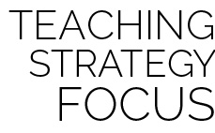

**Organize activity in a variety of settings:** This another great call and response dance. Allowing the students to sit during the dance can be a great transition dance in a variety of settings. This dance lays a great foundation for partner dances and for more complex square dances taught in later grades. Remember: square dances are fun and social. Enjoy it with them and feel free to make up your own movements or ask them for suggestions.



* The teacher performs a movement to count of 1-2-3-4 and the students repeat that movement to the count of 5-6-7-8.
* Use short cue words with a demonstration, not long explanations.



* **DOK:** Question



**Strategy Focus:** How to teach the strategy focus