­­

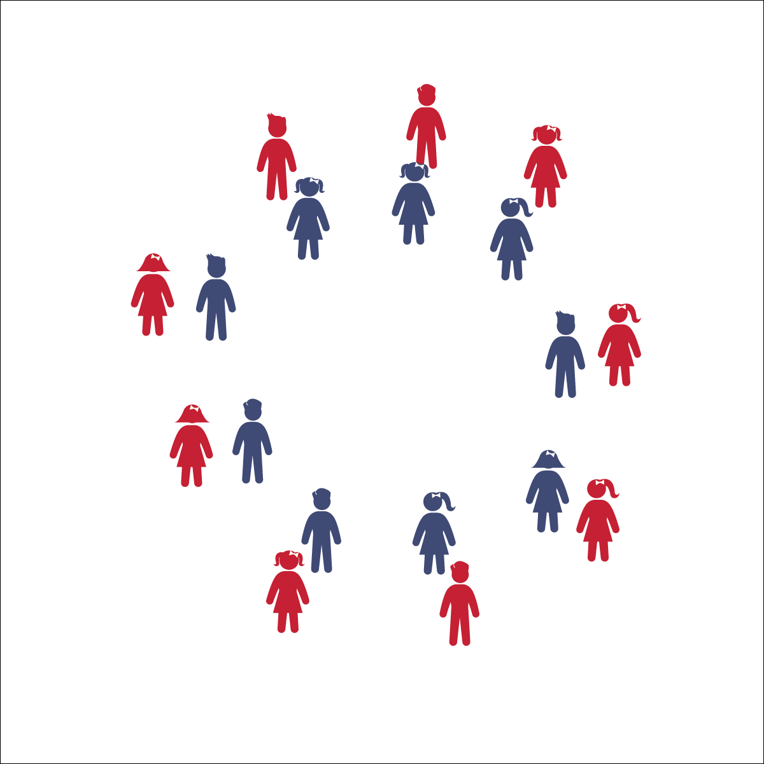

**KINDERPOLKA**

* **Skill:** I will perform dance movements to the rhythm and tempo of the music.
* **Cognitive:** I will discuss how I could dance without music.
* **Fitness:** I will actively engage in supercharged dance moves when prompted by the teachers.
* **Personal & Social Responsibility:** I will safely share space with my partner.
* Follow Teacher and Song Cues
* Find the Beat
* Say the Movements to the Rhythm

**Equipment:**

* Music Player
* The song “Kinderpolka” (Available on [iTunes](https://itunes.apple.com/us/album/kinderpolka/id970580154?i=970580727))

**Set-Up:**

1. Students in pairs.
2. Pairs face each other in 2 large circles (inner and outer).

**Activity Procedures:**

1. Today we are going to learn a dance that was created in Germany called Kinderpolka. This is a fun partner dance that mimics adults waving their fingers and saying, “No No No,” to a child when the child keeps asking for something, even after the parent has already said no.
2. During the song, follow my cues and listen to the music.
3. This song has a slow tempo and clear beat. Listen to the beat of the song as we perform the movements to the rhythm of my count.
4. Teachers, use the Kinderpolka Activity Card to guide the dance. Start by teaching the students each part of the dance without the music. When they have learned the movements, have them try the dance with the music.
5. Repeat dance and enjoy. After learning the Kinderpolka, try the Supercharged version!

**Grade Level Progression:**

**K:** First learn the dance without partners, in a large circle. After they learn the dance, have students dance with a partner.

**1st:** Perform the dance as written. Try the Supercharge movements if the class has learned the dance and is ready for a challenge.

**2nd:** Perform the dance 1 time through as written, and then perform the dance again with the Supercharge movements.

**KINDERPOLKA**



Beat, Count, Rhythm, Locomotor Skill, Non-Locomotor Skill, March, Personal Space, General Space, Song Cues, Direction, Culture



* **Standard 1 (E5.K-2)** Performs locomotor skills in response to teacher-led creative dance (K); Combines locomotor and non-locomotor skills in a teacher-designed dance (1); Performs a teacher- and/or student-designed rhythmic activity with correct response to simple rhythms (2).
* **Standard 2 (E1.K-2)** Differentiates between movement in personal (self-space) and general space (Ka); Moves in personal space to a rhythm (Kb); Moves in self-space and general space in response to designated beats/rhythms (1); Combines locomotor skills in general space to a rhythm (2).
* **Standard 4 (E4.K-2)** Shares equipment and space with others (K); Works independently with others in a variety of class environments (e.g., small and large groups); (1); Works independently with others in partner environments (2).



* **DOK 1:** How did this dance make you feel?
* **DOK 1:** Do you remember where this dance was created?
* **DOK 2:** What movements did we use in this dance that we used in other dances?
* **DOK 2:** What is the difference between the regular moves and the supercharged movements?
* **DOK 3:** What would happen if the music stopped playing? How would you know what to do next?

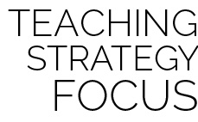

**Discuss culture and diversity:** “Kinder” is a German word for “young” or “child,” and “polka” is a type of dance. This is a cultural dance that provides a great opportunity to show your students where Germany is on a map. Discuss how and why this dance was created and when it might be performed in Germany.



* Perform the dance while holding a scarf instead of holding hands.
* Perform the dance 1 movement at a time with a partner and slowly transition from 1 part of the dance to the other as the students master each movement.



* **DOK:** Question



**Strategy Focus:** How to teach the strategy focus