­­

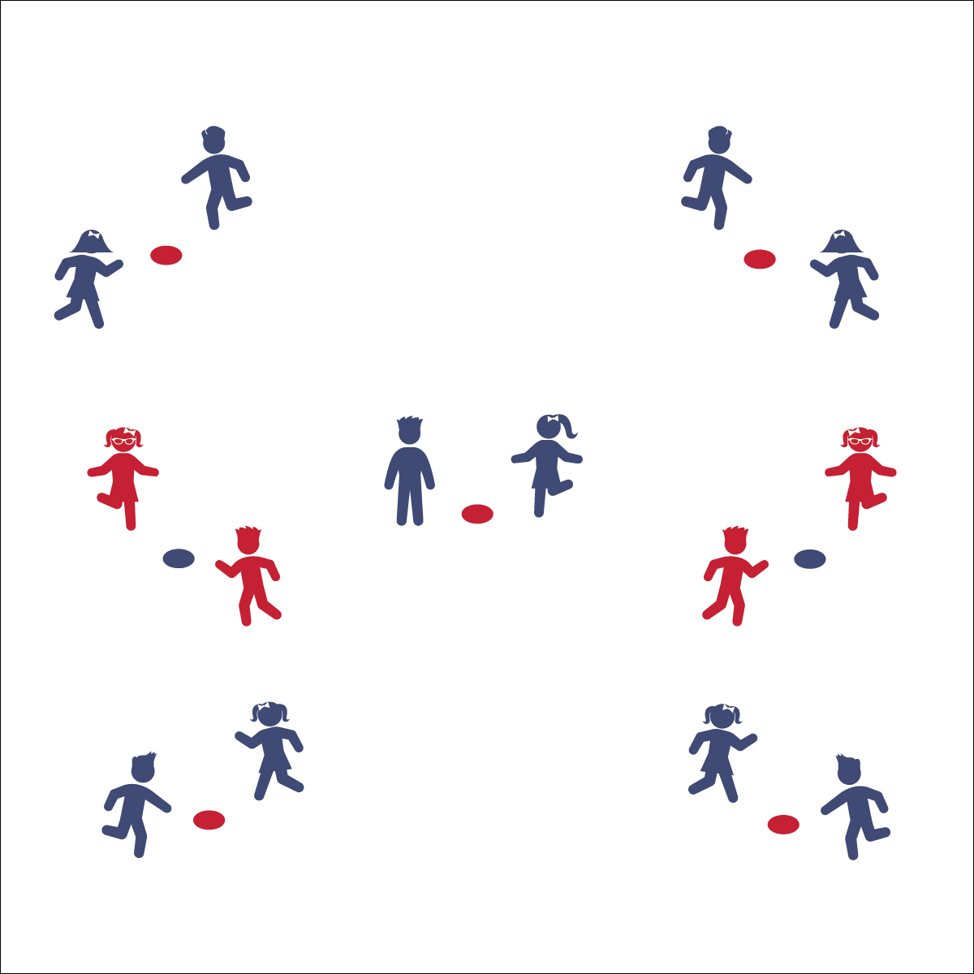

**Activity Procedures:**

1. Today’s activity is called The Mexican Hat Dance
2. The object of the activity is to work with a partner to perform a fun 2-part dance!
3. Teachers, first introduce each movement without music and then with music as students master the dance.
4. Use The Mexican Hat Dance Activity Card to guide this dance.

**Grade Level Progression:**

**K:** Perform this dance in a large circle.

**1st:** Students perform this dance around a hula hoop. They touch their heels inside the hula hoop for part 1 and skip around the hula hoop for part 2. Try the Supercharged movements if the class has learned the dance and is ready for a challenge.

**2nd:** Students perform the dance with hula hoop between them and then dance again with the Supercharged movements.

**MEXICAN HAT DANCE**

* **Skill:** I will use locomotor and non-locomotor movements to the rhythm and tempo of the music.
* **Cognitive:** I will talk about how vigorous movement affects my heart rate.
* **Fitness:** I will stay actively engaged in order to increase my heart rate.
* **Personal & Social Responsibility:** I will safely share space with my partner.
* Follow Song Cues and Teacher Movements

**Equipment:**

* Music Player
* The song “The Mexican Hat Dance” (Available on [iTunes](https://itunes.apple.com/us/album/jarabe-tapatio-mexican-hat/id164142726?i=164143029))
* Optional: 1 hula hoop or spot marker for every 2 students

**Set-Up:**

1. Students in pairs.
2. Partners stand opposite each other by a hula hoop or spot marker.

**MEXICAN HAT DANCE**



Beat, Rhythm, Locomotor Skill, Non-Locomotor Skill, Stationary, Personal Space, General Space, Song Cues, Culture, Vigorous



* **Standard** **1 [S1.E8.1-2]:** Transfers weight from one body part to another in self-space in dance and gymnastics environments (1); Transfers weight from feet to different body parts/bases of support for balance and/or travel (2).
* **Standard 2 [S2.E1.K-2]:** Differentiates between movement in personal (self-space) and general space (Ka); Moves in personal space to a rhythm (Kb); Moves in self-space and general space in response to designated beats/rhythms (1); Combines locomotor skills in general space to a rhythm (2).

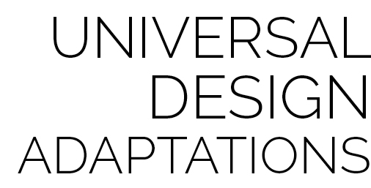

* Perform the dance with less vigorous movements and without music.
* Perform to this song with rhythm sticks while sitting down. For part 1, tap the ground with both sticks and then tap the sticks together twice instead of claps. For part 2, alternate tapping to the beat with the stick in your right hand and then your left.
* To add a challenge, perform this dance with a basketball. For part 1, bounce the ball instead of performing each heel tap and use the 2 claps as a rest. For part 2, dribble around the room or pivot all the way around (360 degrees) left and then all the way around 360 degrees to the right. Remember to stay on beat with the rhythm of the song.



* **DOK 1:** How did this dance make you feel?
* **DOK 1:** What were the 2 movement patterns we performed today during the Mexican Hat Dance?
* **DOK 1:** What locomotor skills did we use during this dance?
* **DOK 2:** If you could modify this dance to using 2 different sets of movement patterns, what would they be? Why?
* **DOK 2:** How did the supercharge movements make our dance more vigorous?
* **DOK 3:** What did dancing more vigorously do to our heart rates and why?

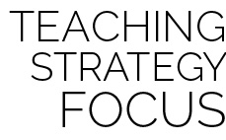

**Discuss culture and diversity:** This is another cultural dance, which provides the opportunity to talk about another country and cultural traditions. Discuss the role of dance in culture and how powerful it is to learn about how other people live and dance.



* **DOK:** Question



**Strategy Focus:** How to teach the strategy focus