­­

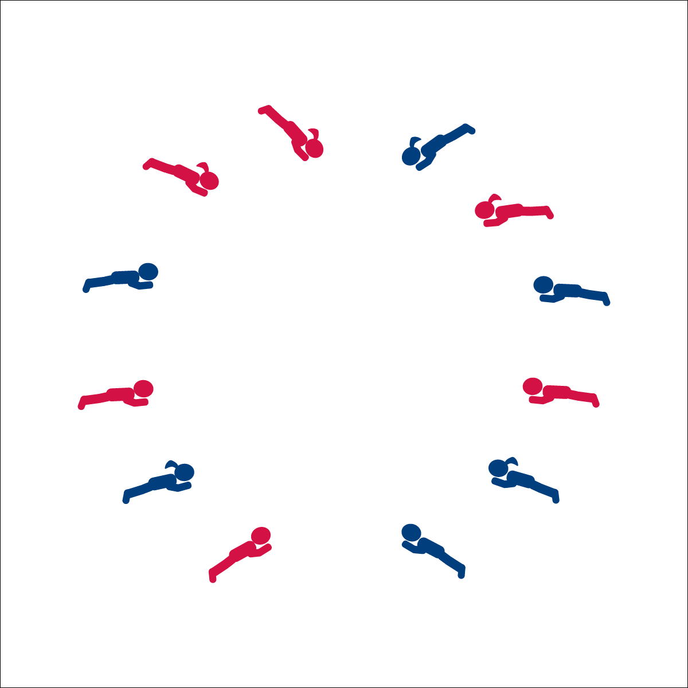

**GOLDFISH DANCE**

**Activity Procedures:**

1. Today’s activity is called The Goldfish Dance. The object of the activity is to learn about some healthy habits that humans and goldfish like to do everyday. During this song we’ll pretend we are goldfish!
2. When the music starts, follow my movements and the musical cues from the song. We’ll perform movements that goldfish and people do.
3. Whenever the song asks us to come back to our rock, return to your spot in the circle (or personal spots) and lay down.
4. Be sure you are moving safely when you are in personal space (when pretending to sleep), when you are moving in the circle, and when you move around in general space.
5. Teachers, use The Goldfish Song Activity Card to guide the activity.

**Grade Level Progression:**

**K:** Students stay on the circle when performing the dance. When they “go swimming,” students lie on their bellies and move their arms and legs as if they are swimming.

**1st:** Follow the movements and musical cues as written.

**2nd:** Encourage the students to think of other healthy habits that people do. Perform healthy habits as fish and create a lyrical stanza and movements for each habit. Sing and perform this together as class.

**Equipment:**

* Music Player
* The song “The Goldfish Song” by Laurie Berkner (Available on [iTunes](https://itunes.apple.com/us/album/the-goldfish/id377990680?i=377990782))

**Set-Up:**

1. Start activity in a circle with students laying down on their stomachs.
2. The dance can also be performed on personal spot markers.

* Follow Song Cues and Teacher Movements
* **Skill:** I will perform movements to the rhythm and tempo of the music.
* **Cognitive:** I will identify healthy behaviors.
* **Fitness:** I will stay actively engaged in this dance.
* **Personal & Social Responsibility:** I will follow directions without teacher reminders.

**GOLDFISH DANCE**



Beat, Rhythm, Locomotor Skill, Non-Locomotor Skill, Stationary, Personal Space, General Space, Song Cues, Stroke (Swimming)



* **Standard** **1 (E5.K-2)** Performs locomotor skills in response to teacher-led creative dance (K); Combines locomotor and non-locomotor skills in a teacher-designed dance (1); Performs a teacher- and/or student-designed rhythmic activity with correct response to simple rhythms (2).
* **Standard 3 (E1.K-2)** Identifies active-play opportunities outside physical education class (K); Discusses the benefits of being active and exercising and/or playing (1); Describes large-motor and/or manipulative physical activities for participation outside physical education class (e.g., before and after school, at home, at the park, with friends, with the family) (2).
* **Standard 4 (E1.K-2)** Follows directions in group settings (e.g., safe behaviors, following rules, taking turns) (K); Accepts personal responsibility by using equipment and space appropriately (1); Practices skills with minimal teacher prompting (2).



* Perform the dance in seated positon and with upper body movements.
* Emphasize divergent ideas to eliminate fear of doing a movement incorrectly.



* **DOK** **1:** How did this dance make you feel?
* **DOK 1:** What healthy activities did we pretend to do in this dance?
* **DOK 2:** Why are these activities good to do every day?
* **DOK 1:** What cues did we follow in this song?
* **DOK 2:** How did we know what to do and when?

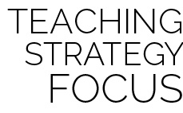

**Have fun with academic integration:** Once the students learn this dance, it is likely to be one of their favorites and can be used often as a warm-up/cool-down or transition. As an integrated lesson, this can easily be worked into conversations about ecosystems (e.g., where fish live, what else lives in a goldfish’s ecosystem, etc.). As a dance, this activity provides the class an opportunity to move freely at different levels in general space. It also requires students to perform very basic choreography without realizing they are preforming a dance. Have fun and use this dance to explore space while learning about healthy habits.



* **DOK:** Question



**Strategy Focus:** How to teach the strategy focus