­­­

* Beat
* Rhythm
* Tempo
* Dance

­

* **Skill:** I will perform locomotor skills to the beat of the music.
* **Cognitive:** I will count and clap the beat of the song.
* **Fitness:** I will be actively engaged in this dance by moving to the beat of the song.
* **Personal & Social Responsibility:** I will follow directions and stay safely on task.
* **Standard 1 (E5.K-2)** Performs locomotor skills in response to teacher-led creative dance (K); Combines locomotor and non-locomotor skills in a teacher-designed dance (1); Performs a teacher- and/or student-designed rhythmic activity with correct response to simple rhythms (2).
* **Standard 4 (E1.K-2)** Follows directions in group settings (e.g., safe behaviors, following rules, taking turns) (K); Accepts personal responsibility by using equipment and space appropriately (1); Practices skills with minimal teacher prompting (2).
* Holistic Rubric and Self-Assessment

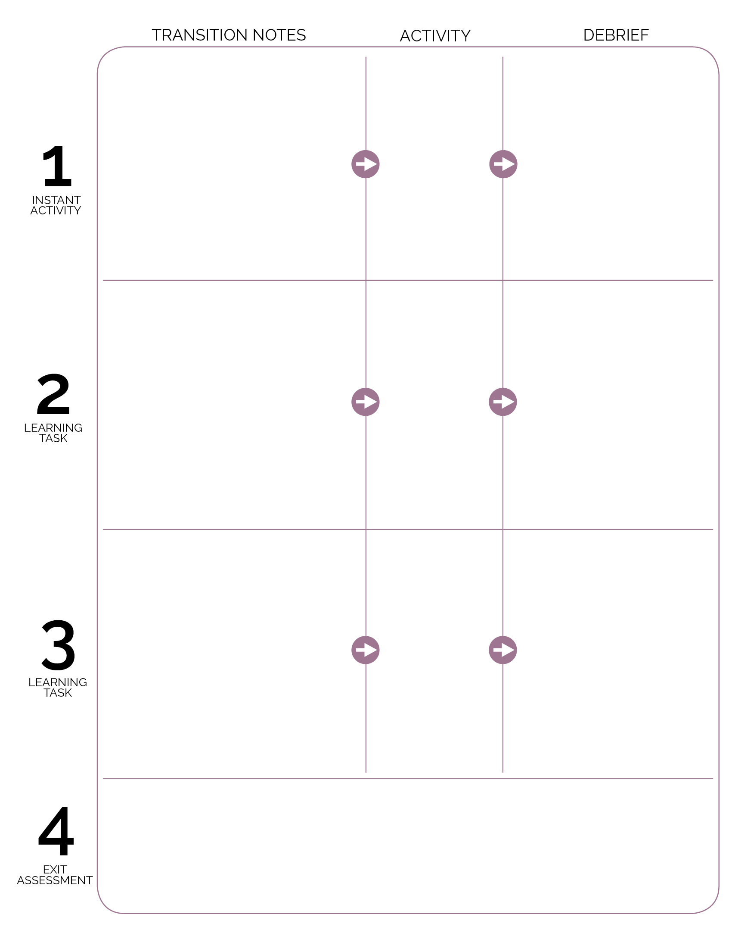

The Self-Assessment is posted on the whiteboard. Complete this assessment as a class, with the pre-assessment done for the class performance and a goal set for class improvement. Save this work for the next self-assessment and for reviewing progress throughout the module.

**DOK** **1:** How did this dance make you feel?

**DOK 1:** What healthy activities did we pretend to do in this dance?

**DOK 2:** Why are these activities good to do every day?

**DOK 1:** What was the beat/rhythm we followed during our dance? Can you count it and clap it for me?

**DOK 2:** What different movements did we perform to the beat of the music? What are some other movements can we perform?

“How quickly can we return to our circle?” Count down from 10 as students move back to circle formation. Review the words beat, rhythm, and tempo before starting the Moving 8s activity.

As students enter, bring them to the center circle and begin the Goldfish Dance. Introduce academic language and the criteria from the rubric.

**DOK 1:** How did this dance make you feel?

**DOK 2:** Pick a specific movement within the dance. Describe why you think it made you feel the way it did.

**DOK 2:** How did it make you feel to lead a dance move? Why do you think it made you feel that way?

Moving 8s

Pop See Ko

Goldfish Dance

Students move to personal floor spots and face the video screen. Show and follow along to the Pop See Ko video.