FUTURE FORWARD HABIT SCRAMBLE

STUDENT TARGETS
- Physical: I will throw, toss, or roll a foam ball or flying disc with control and accuracy.
- Cognitive: I will review and discuss healthy habits that I could add to my daily routine.
- Social/Emotional: I will support my teammates as they work to define and select healthy habits that can help them reach their GREAT goals.

EQUIPMENT & SET-UP | 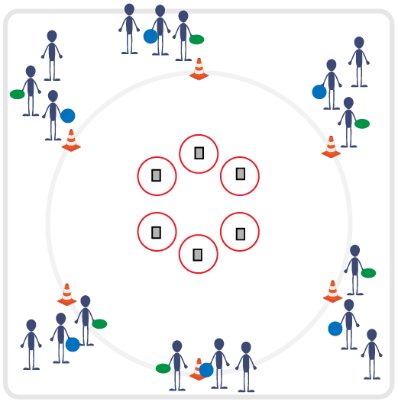
Equipment:
- 1 foam ball or foam flying disc per student
- 6 hula hoops
- 1 cone per team of 3 students
- Multiple sets of Healthy Habit Cards (print & cut)
- 1 Streak Builder Worksheet per student

Set-Up:
- Create a small circle of hoops inside the center of the activity area.
- Place piles of Healthy Habit Cards in each hoop.
- Create a large circle of cones on the outside of the larger circle with enough room in between them for throwing foam balls / flying discs.
- Create teams of 3. Send each team to a cone.

ACTIVITY PROCEDURES
- This game is called Future Forward Habit Scramble. The object is for your team to collect as many Healthy Habit Cards as possible.
- On the start signal, the first player in line will toss, throw, or roll a foam ball or disc into one of the center hoops. If the tossed object lands in (or passes through) one of the hoops, the tosser can jog to collect the object and a Healthy Habit Card. If the object does not land in (or pass through) a hoop, the tosser will only collect the object and not a card. Objects do not have to stay in a hoop to count.
- When the tosser returns, the next teammate in line will toss, throw, or roll a foam object and repeat the process. Continue until you hear the stop signal. How many cards can you collect?
- After you hear the stop signal, read and discuss each Healthy Habits Cards with your team. Each member of the team will choose one habit for their 21-Day Streak Builder. Fill out the Streak Builder Worksheet, then take it home and hang it in your room to complete at the end of each day.

PRIORITY OUTCOMES
- Social Awareness (Empowerment) Identifies and utilizes family, school, and community resources and supports in the pursuit of defined personal and collective community goals.
- Relationship Skills (Empowerment) Applies constructive language to encourage self and others in the active pursuit of personal and collective goals.

DEBRIEF QUESTIONS
- DOK 1: What is a healthy habit?
- DOK 2: How do healthy habits affect your overall well-being?
- DOK 3: How is streak-building related to building a healthy habit?

