­­

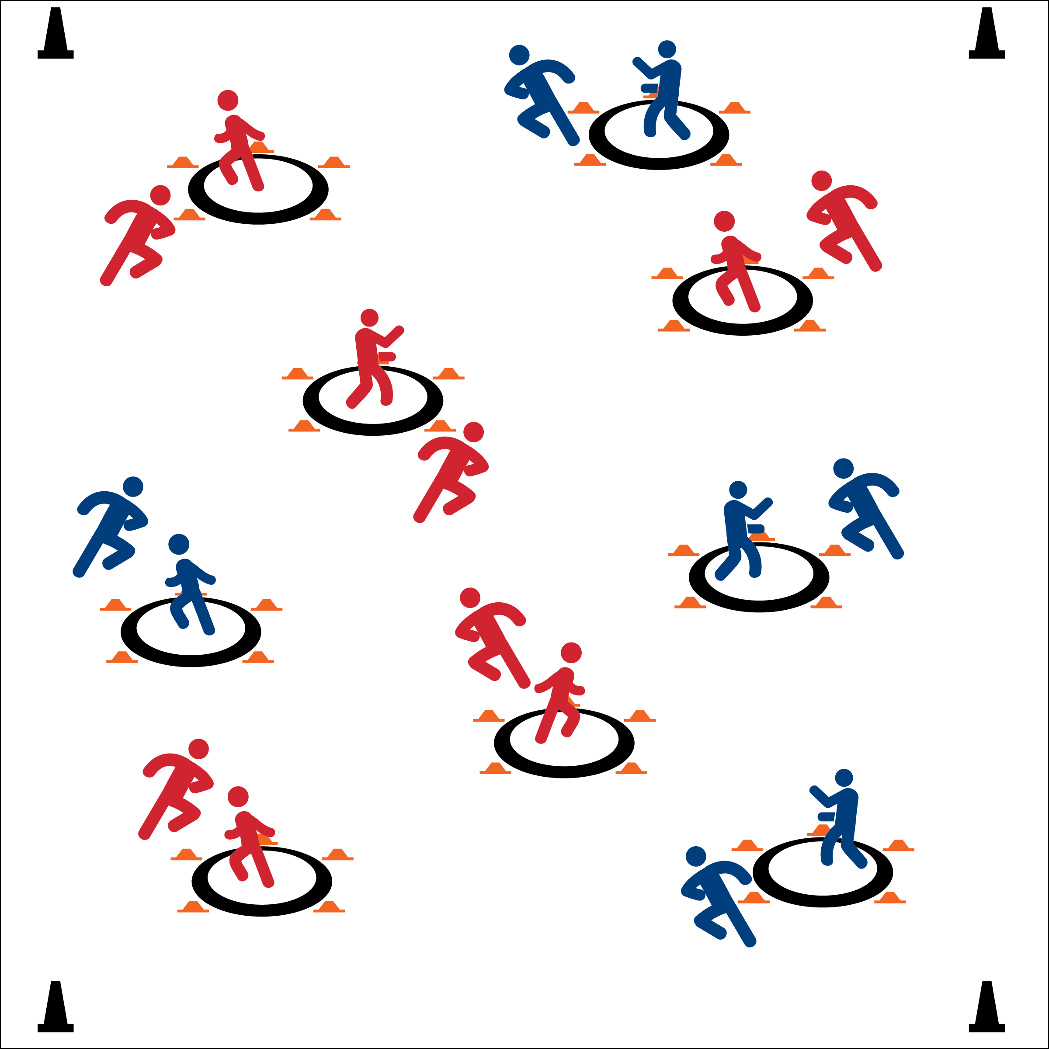

Created by: Piper Cronin

Adapted from “Coneheads” by Kevin Tiller

From the *Great Games Handbook* ([HERE](http://www.usgames.com/the-great-games-handbook))

* **Fitness:** I will safely participate in order to increase my heart rate and warm-up my body.
* **Fitness:** I will discuss the importance of maintaining a healthy body.
* Eyes Up
* Be Aware of Your Surroundings
* Tag Safely

**Equipment:**

* 4 cones for boundaries
* 1 hula hoop per 2 students
* 5 low profile cones per 2 students

**Set-Up:**

1. Pair students. Scatter pairs in open space.
2. One partner is the guardian and stands in a hoop with 5 low profile cones surrounding and touching the outside of the hoop.
3. The other partner is the scavenger and stands next to her/his partner outside the hoop.

**Activity Procedures:**

1. Today we’re going to warm-up our bodies playing Guardian. The object of the game is for your scavenger to collect low profile cones, while your guardian keeps your cones safe.
2. On the start signal, scavengers will go to another hoop to collect a cone (they can only carry one at a time). The Guardian in the hoop will try to tag the scavenger’s arm.
3. If tagged, the scavenger must leave move to another hoop without a cone and try again. If the scavenger grabs a cone without being tagged, they must quickly bring it to their guardian and place it next to their hoop.
4. After 1 minute we’ll change roles. Freeze on the stop signal.

**Grade Level Progression:**

**Middle School:** Play several practice rounds at a speed-walking pace. As students demonstrate safe behaviors increase the pace of the activity. Enlarge the activity area for greater aerobic impact.

**High School:** When students are tagged, introduce activity-based re-entry stations with muscular fitness exercises required for re-entry.



* **Standard 3** **[M1.6]** Describes how being physically active leads to a healthy body.
* **Standard 3 [H1.L1]** Discusses the benefits of a physically active lifestyle as it relates to college/career productivity.



* **DOK 1:** How does it feel to have a healthy body?
* **DOK 2:** What do you know about how physical activity and maintaining a healthy body?
* **DOK 3:** How is being healthy related to how productive you are in school or at a job? Provide examples and evidence to support your answer.