­­

Created by: Elyse Loughlin

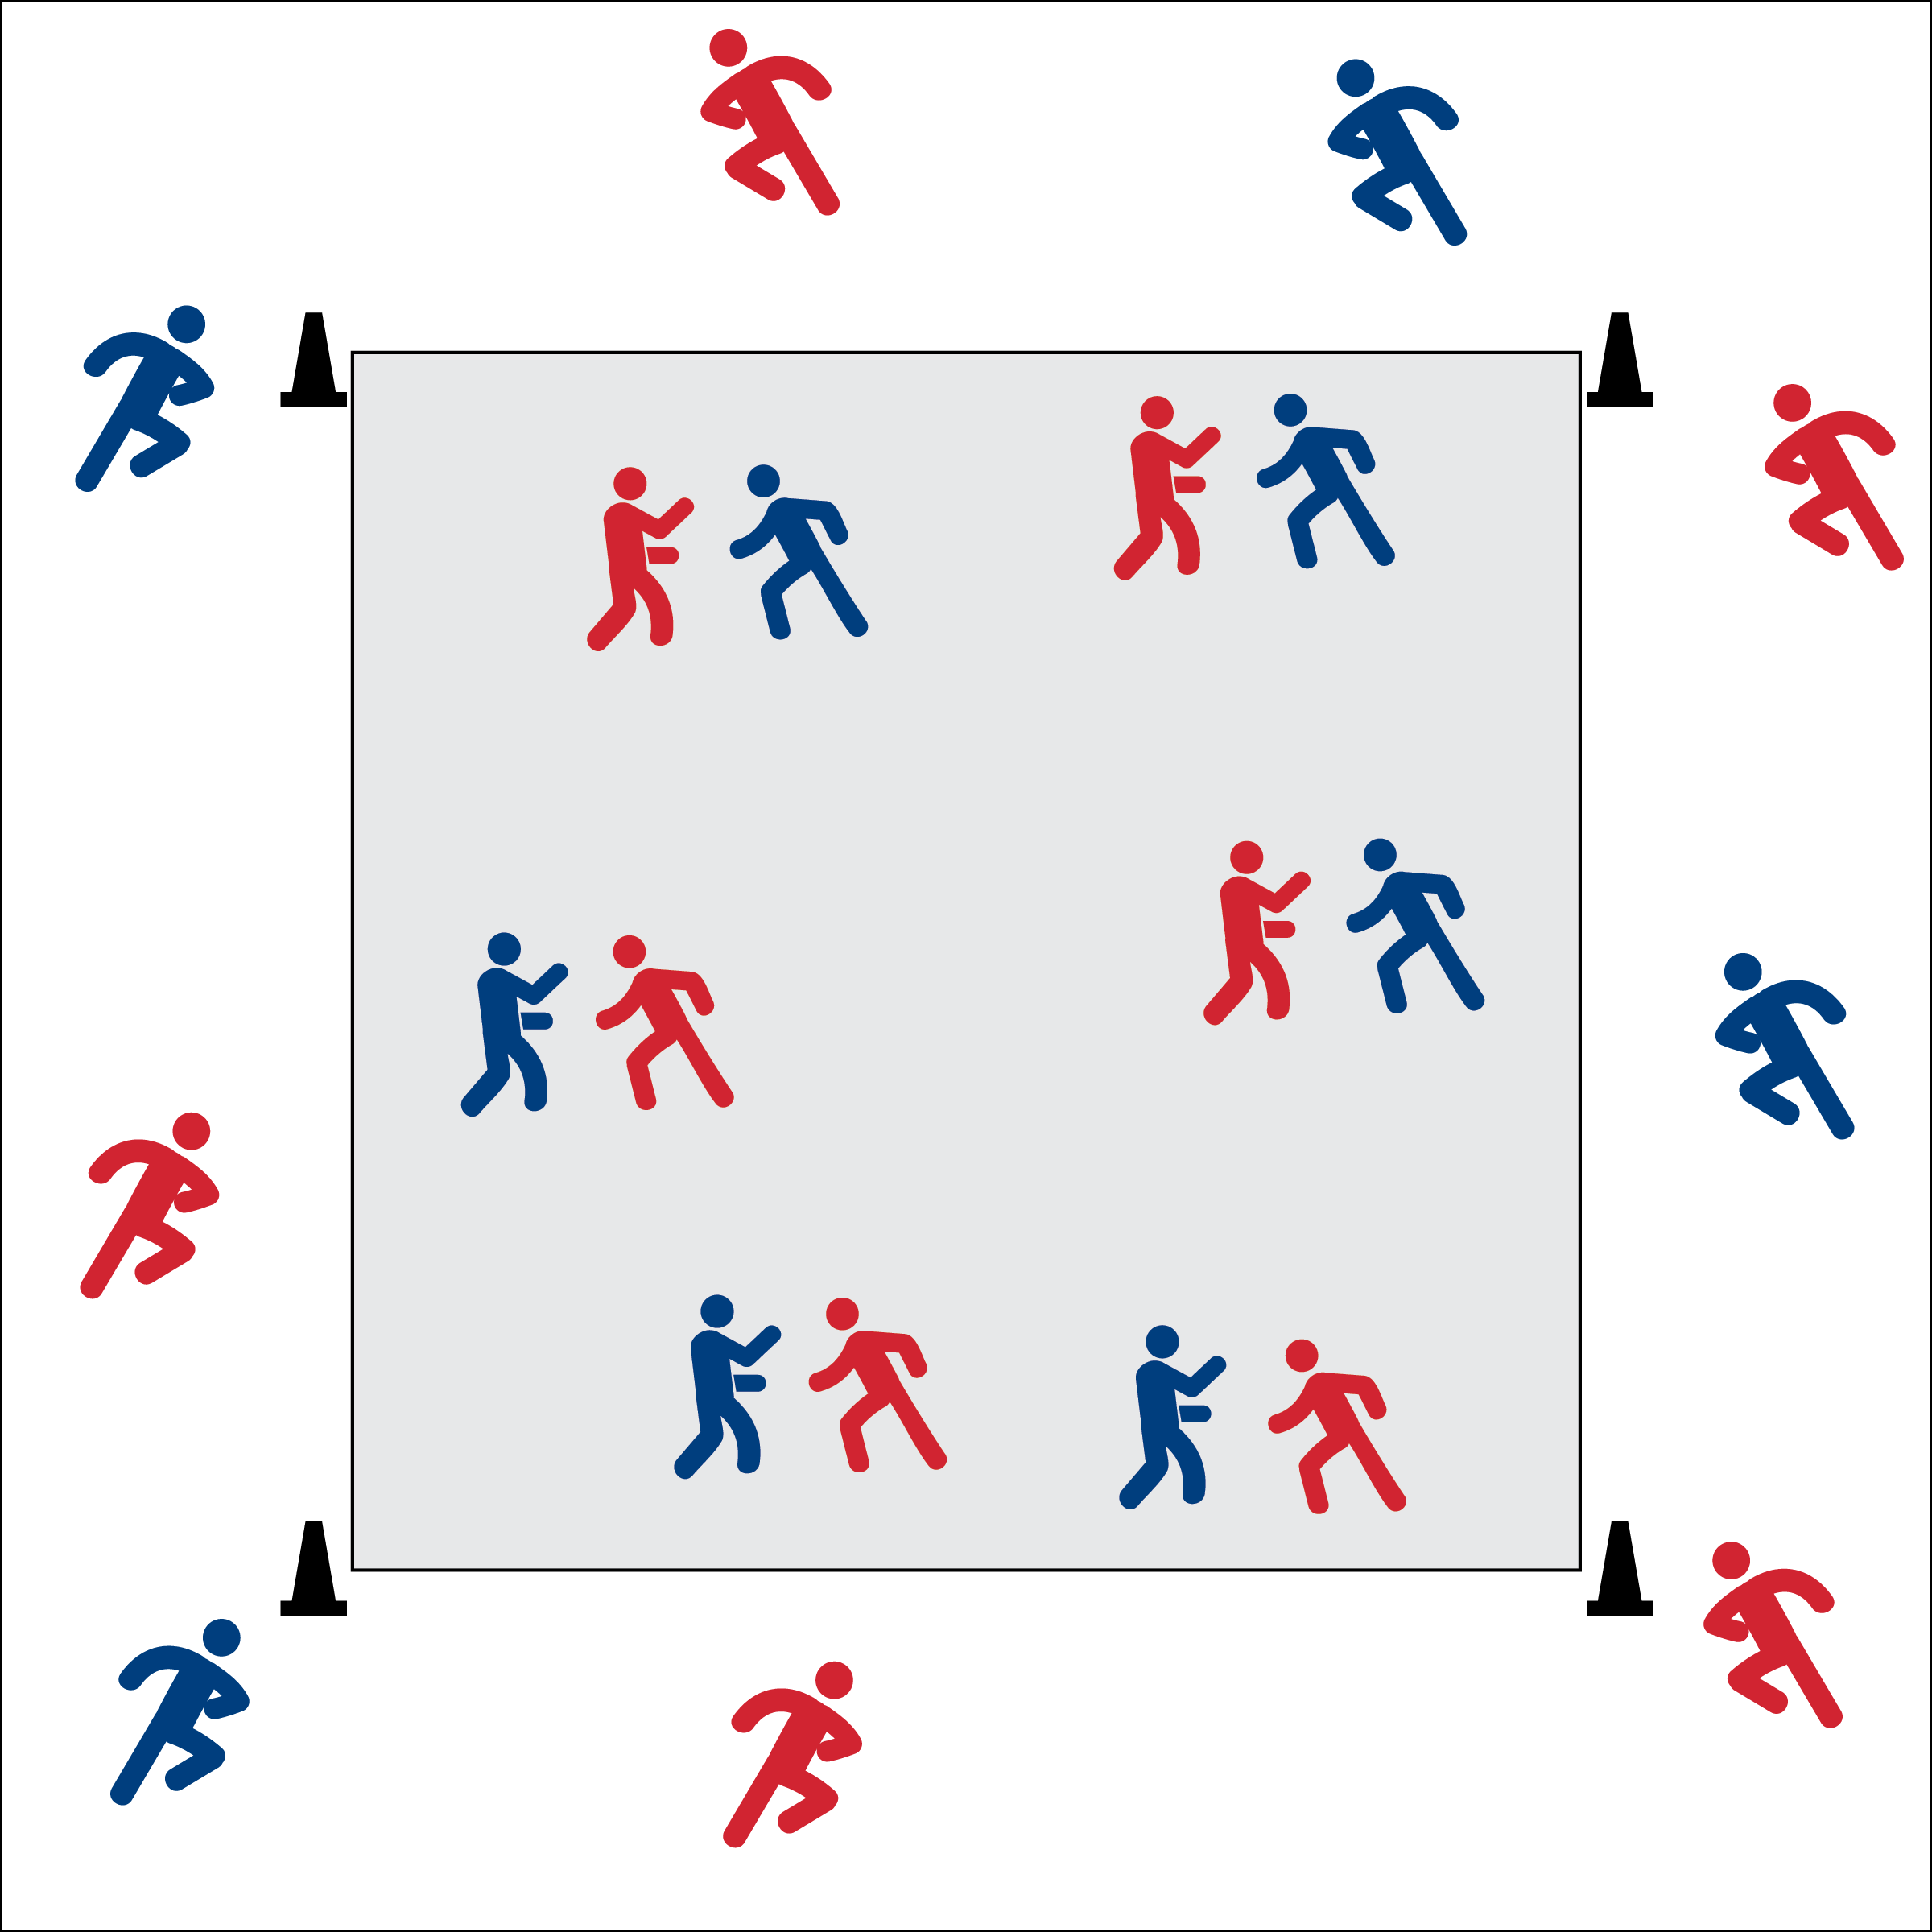

* Once, Twice, Throw!
* Pace Your Lap
* Win or Lose, Quickly Start Again



* **DOK 1:** How can you recognize an activity that helps to improve your fitness?
* **DOK 2:** How does your favorite physical activity affect your personal fitness?
* **DOK 3:** In what ways could you modify this activity in order to improve each of the 5 components of fitness? Provide details.
* **Fitness:** I will participate and stay active in order to increase my heart rate.
* **Fitness:** I will discuss ways to improve my overall fitness.



* **Standard 3** **[M1.6]** Describes how being physically active leads to a healthy body.
* **Standard 1 [H3.L1]** Demonstrates competency in one or more specialized skills in health-related fitness activities.

**Activity Procedures:**

1. Today we’re going to warm-up our bodies playing Rock, Paper, Scissor Victory Lap.
2. The object is to win as many games of RPS as possible. After each win, you’ll run a victory lap around the cones to celebrate your success. Find a new partner as soon as you complete your lap and play again.
3. If you don’t win, quickly find a new partner and play again.

**Grade Level Progression:**

**Middle School:** Play this game and incorporate dribbling/ball control skills from any middle school invasion game. Students dribble a basketball, soccer ball, or floor hockey ball during their victory laps.

**High School:** Create muscular fitness and/or flexibility stations at each cone. After each win, students jog to a cone, complete the station activity, and then return to find a new opponent.

**Equipment:**

* 4 cones for boundaries

**Set-Up:**

1. Create a lap area with 4 cones.
2. Students gather in the center of the lap area.