­­

Created by: Jim DeLine

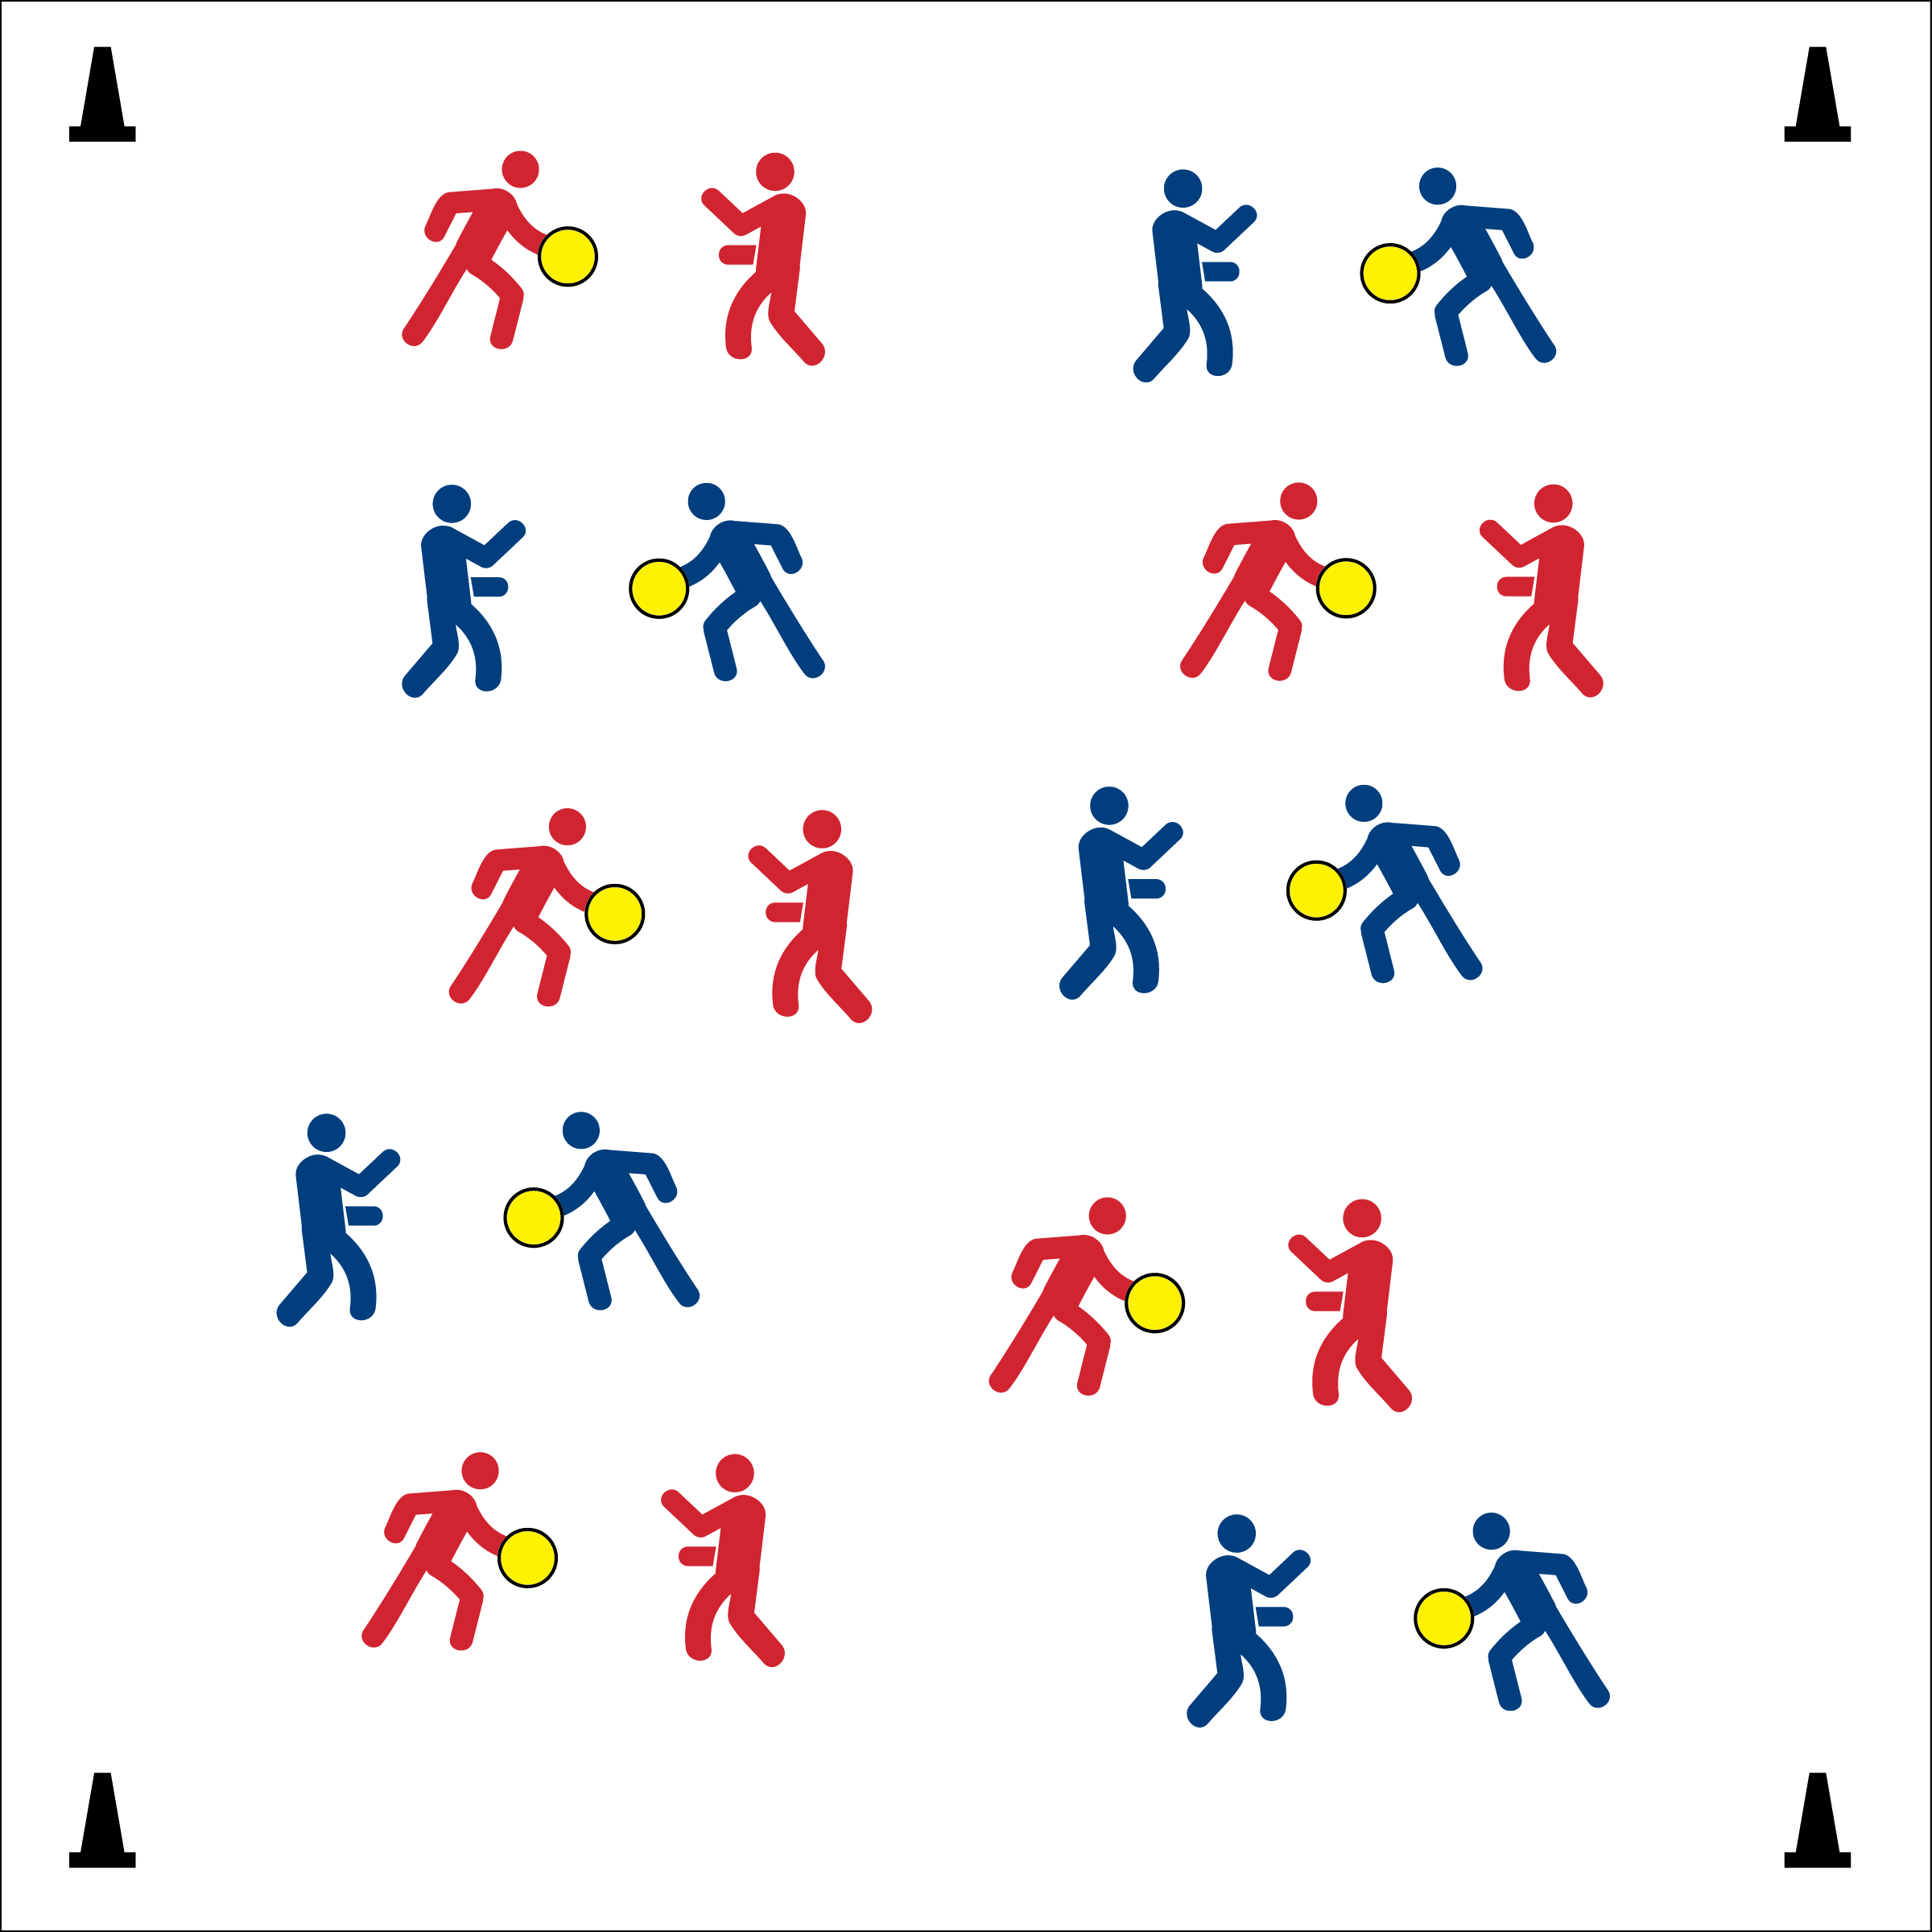

* Look for Hands Up, Eyes Ready
* Accurate and Controlled Tosses
* Two Handed Catches / Soft Hands



* **DOK 1:** How can you recognize proper etiquette in physical education class?
* **DOK 2:** How does etiquette affect a physical activity experience for participants?
* **DOK 3:** How does etiquette change in other settings? Why does it change? Provide support for your answer.
* **DOK 4:** Using information provide in this discussion on etiquette, analyze both the positive and negative consequences of past behaviors in physical activity settings.



* **Standard 1** **[M3.6]** Catches with a mature pattern from a variety of trajectories using different objects in varying practice tasks.
* **Standard 4 [H2.L1]** Exhibits proper etiquette, respect for others and teamwork while engaging in physical activity and/or social dance.

**Activity Procedures:**

1. Today we’re going to focus on accuracy and control while we practice tossing and receiving (or volleying).
2. The object of Toss 3 is to work with as many Toss 3 partners as you can while the music is playing.
3. When the music starts, the partner with the ball will begin with a toss (or strike). Each pair will make 3 tosses (volleys). The partner who now has the ball will travel and find a new partner who does not have a ball.
4. Freeze when the music stops.

**Grade Level Progression:**

**Middle & High School:** Increase the number of Tosses/Volleys any odd number. Odd numbers maintain the change of possession as students change partners.

* **Skill:** I will accurately toss/catch or volley with a variety of partners.
* **Fitness:** I will stay actively engaged and prepare my body for physical activity.

**Equipment:**

* 1 ball per pair
* 4 cones
* *(For racquet activities, each partner with a racquet and 1 shuttle or ball per pair.)*

**Set-Up:**

1. Create a large activity space using 4 cones to mark boundaries.
2. Scatter pairs of students throughout the activity area. Each pair with a ball.