­­

Created by: Lori S. Dunn

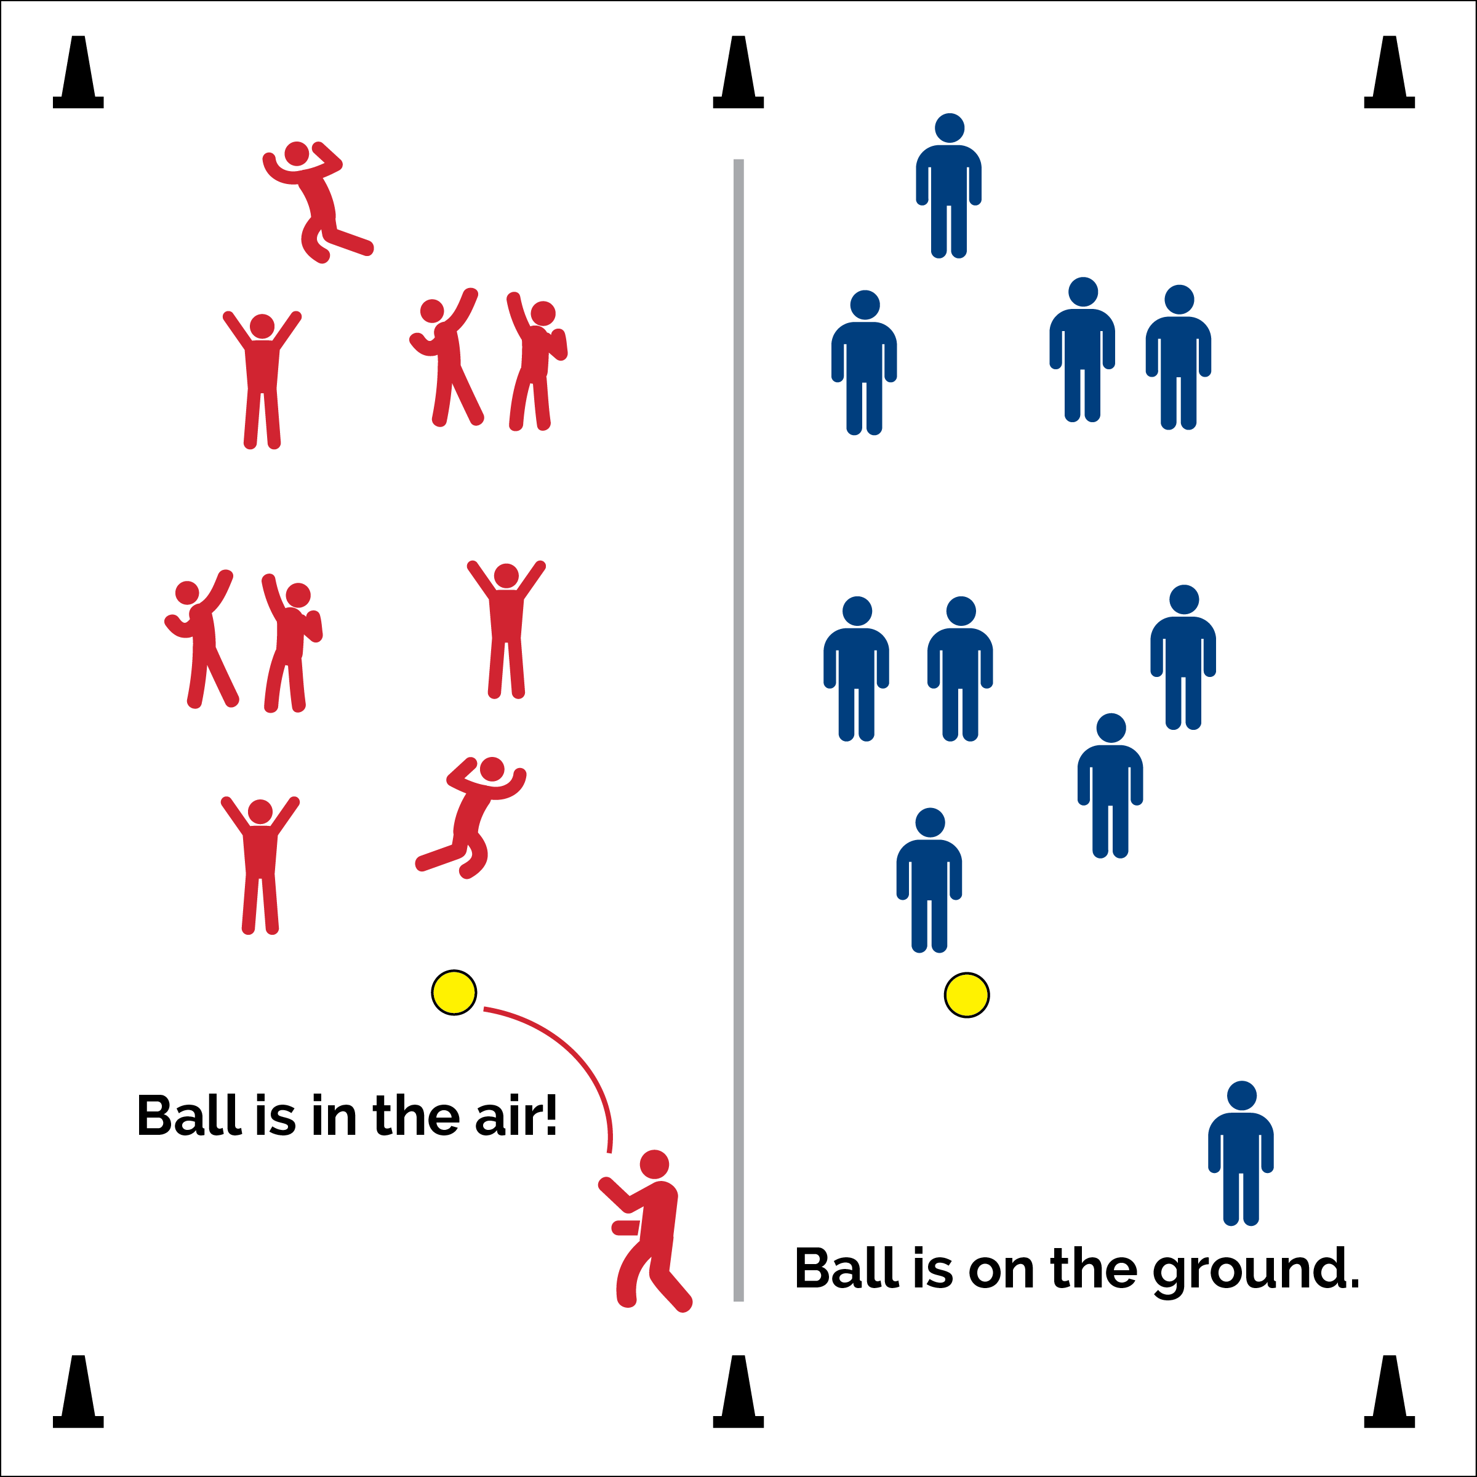



* **DOK 1:** What is self-control?
* **DOK 2:** How does self-control affect your ability to learn and develop new skills?
* **DOK 3:** Can you formulate a theory of the importance of self-control in education? How would you test your theory?
* **DOK 4:** What information can you gather to support your theory of self-control? How can you gather that information?



* **Standard 4** **[M1.6]** Exhibits personal responsibility by using appropriate etiquette, demonstrating respect for facilities and exhibiting safe behaviors.
* **Standard 4 [H1.L1]** Employs effective self-management skills to analyze barriers and modify physical activity patterns appropriately, as needed.

**Activity Procedures:**

1. There are times when it’s good to party and get excited, and there are times when it’s important to show self-control and focus. We’re going to practice both in a game of Party Control Patrol.
2. I’m going to throw the foam ball high into the air. When the ball is in the air it’s time for everyone to party (laugh, dance, cheer). As soon as the ball touches the ground, everyone must become still and silent.
3. Watch the ball as it lands. If it’s headed in your direction, move out of the way and allow it to land/roll untouched.
4. The person closest to the ball when it comes to a stop becomes the next tosser.

**Grade Level Progression:**

**Middle & High School:** Pair students. Each pair will create a handshake/cheer and perform it while the ball is in the air. When the ball lands, everyone will become still and silent.

* Focus On The Ball
* Celebrate When It’s Time
* Focus When Focus Is Required
* **Personal & Social Responsibility:** I will demonstrate self-control and respect for the etiquette of physical education class.

**Equipment:**

* 1 foam ball (or juggling scarf)

**Set-Up:**

1. Students scattered in open space.
2. Teacher begins with foam ball.