­­

Created by: Charla Krahnke  
& Don Puckett

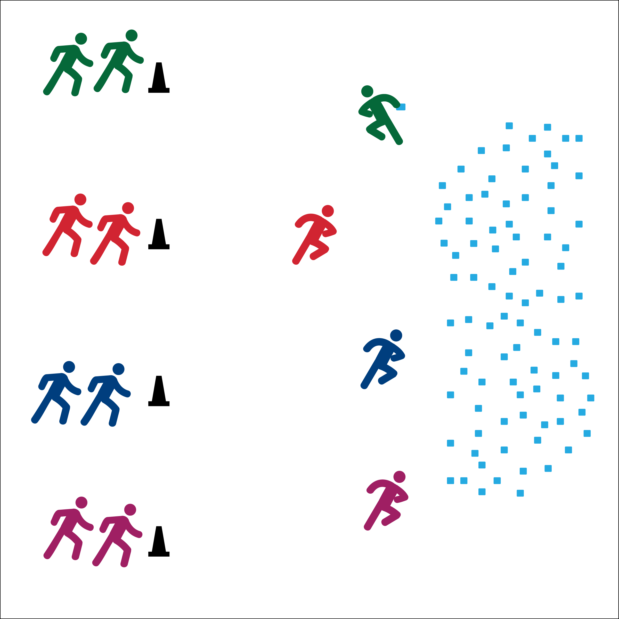

**Equipment:**

* 1 complete deck of cards
* 6 to 10 cones

**Set-Up:**

1. Create a line of cones at one end of the activity area.
2. At the opposite end, place cards scattered and face down.
3. Create equal teams of 3 or 4 players, each team at a cone. Assign each team a different number.

**Activity Procedures:**

1. It’s time to warm up with Aerobic Numbers.
2. The object of the game is for your team to quickly find all 4 cards with your number on it. For example, if your team is assigned the number 6, then you must find the 6 of hearts, 6 of diamonds, 6 of spades, and 6 of clubs.
3. On the start signal the first player on your team will run and turn 1 card over. If the card matches your number, bring it back to your team. If not, flip it back over and run back to your team without a card.
4. When one player returns to the team cone, another runs to the cards. When you find all 4 card yell out, “*All numbers are in!*” and begin doing jumping jacks.

**Grade Level Progression:** Add skill/locomotor combinations based on the unit that you’re teaching. For example, students can hand or foot dribble to the cards.



* **Standard 3 [M12.6]** Describes the role of warm-ups and cool-downs before and after physical activity (6).
* **Outcome 4 [M5.6]** Cooperates with a small group of classmates during adventure activities, game play or team-building activities (6).
* **Outcome 4 [H3.L1]** Uses communication skills and strategies that promote team/group dynamics (L1).
* Follow Instructions
* Use Positive Language
* Stay Active



* **DOK 1:** What are team dynamics?
* **DOK 2:** How can you use communication skills to promote positive team dynamics?
* **DOK 3:** Can you predict what may happen to team dynamics if teammates do not use positive communication?
* **DOK 1:** What is a warm-up?
* **DOK 2:** What do you know about safe warm-up exercises?
* **DOK 3:** Can you describe an example of a workout or sport performance starting with a warm-up and ending with a cool-down?
* **Personal & Social Responsibility:** I will demonstrate positive communication skills and strategies to help my team have a safe and enjoyable warm-up.