­­

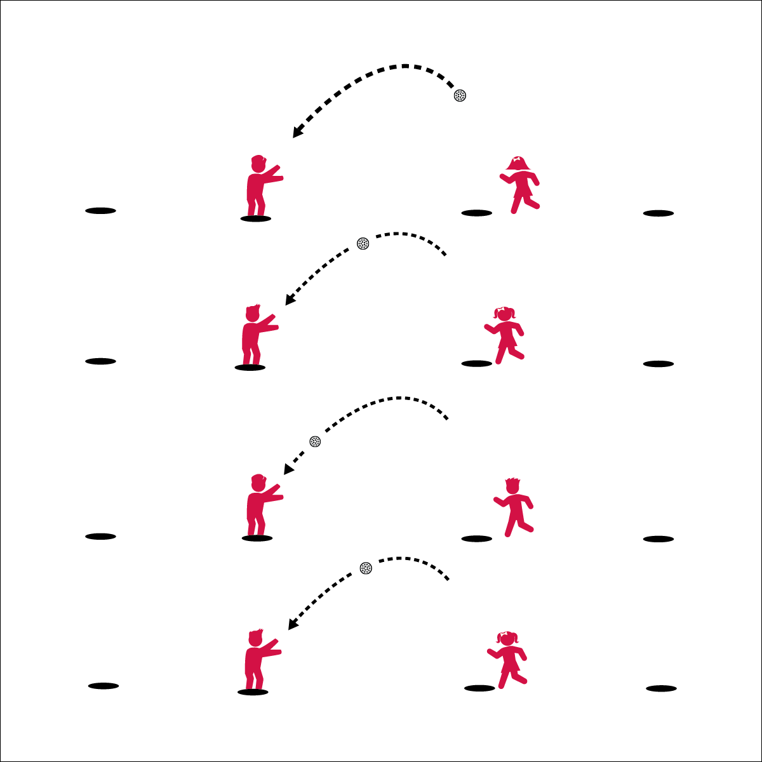

* **Skill:** I will demonstrate the skill cues for catching and successfully catch high fly balls thrown by my partner.
* Follow Ball with Your Eyes
* Arms Up, Ready, & Relaxed
* Thumbs Together Up High,  
  Pinkies Together Down Low
* Absorb the Ball

**Equipment:**

* 4 spot markers per pair
* 1 softball (plastic or foam)

**Set-Up:**

1. Create relay-race lanes with 4 spot makers in each lane – 15 to 20 feet apart.
2. 1 softball on the 1st spot in each lane.
3. Pair students, 1 pair per lane.

**Activity Procedures:**

1. It’s time to warm up with a game called Center Field Relay.
2. The object of the game is for you and your partner to go from spot to spot, down to the end of your relay lane and then back again.
3. On the start signal Partner A will run to the first spot and then turn to face Partner B. Partner B has the ball and will toss a high fly ball to the spot for Partner A to catch. As soon as a catch is made, Partner B will run to the next open spot and get ready for a high fly ball from Partner A.
4. When you reach the final spot, give each other a big high-5, and then start this pattern again, moving back to your original spot.
5. When you reach the final spot, stand together and gently toss the ball back and forth while you wait for other teams to finish.

**Grade Level Progression:** Add throws of different trajectories (e.g., line drives). Give each player a softball glove to catch with.



* **DOK 1:** What are the cues for catching a ball above your head?
* **DOK 2:** How does this compare to catching a ball at your waist?
* **DOK 3:** How could we adapt this game to help us practice for different sports?



* **Standard 1 [M21.6-8]:** Catches, with a mature pattern, from different trajectories using a variety of objects in a varying practice tasks (6); Catches, with a mature pattern, from different trajectories using a variety of objects in small-sided game play (7); Catches, using an implement, from different trajectories and speeds in a dynamic environment or modified game play (8).