­­

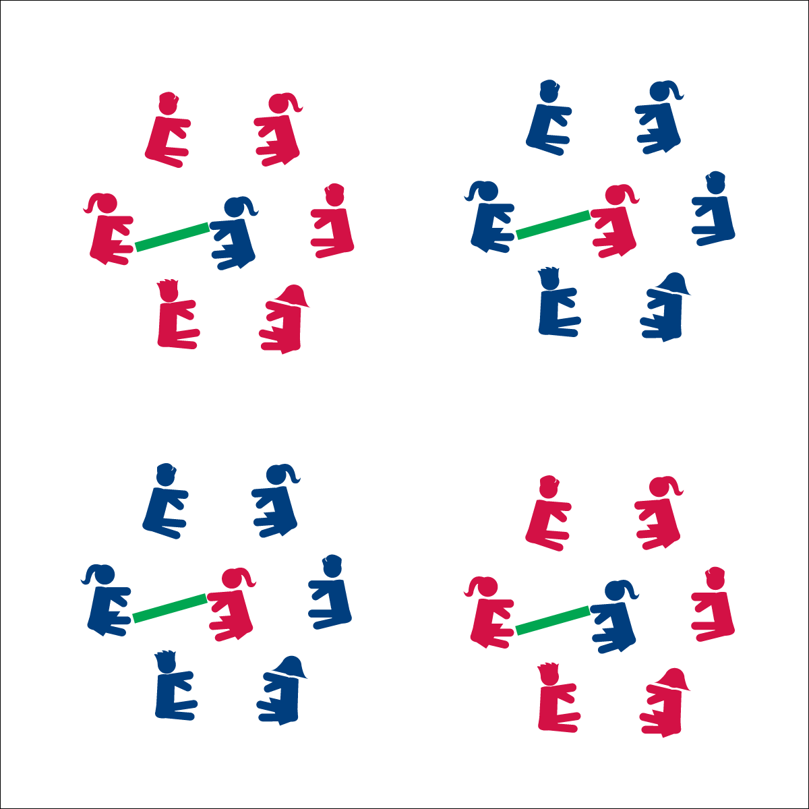



* **Standard 4** **[M5.6-8]** Cooperates with a small group of classmates during adventure activities, game play or team-building activities (6); Problem-solves with a small group of classmates during adventure activities, small-group initiatives or game play (7); Cooperates with multiple classmates on problem-solving initiatives including adventure activities, large-group initiatives and game play (8).

**Activity Procedures:**

1. It’s time to learn names and test our reaction time. This activity is called Name Noodle. The object of the game is for the player in the center to use the noodle to tag the foot of the player whose name is called.
2. If the player whose name is called calls a new name before being tagged, the player in the middle must quickly react and work to tag the new player’s foot. If a player’s foot is tagged before a new name is called, that player moves to the center and becomes the new tagger.
3. If all names in the circle are called without anyone being tagged, the tagger chooses a new person to take her/his place.

**Progression:**

No name can be repeated until all players’ names are called.

**Equipment:**

* 1 foam noodle per 7 students
* 1 spot marker per 7 students

**Set-Up:**

1. Create groups of 7 students.
2. In each group, 6 students form a circle with 1 student in the center holding the foam noodle and sitting on the spot marker.
3. Students on the outside of each circle sit with their legs extended and feet in the center of the circle.
4. Circles should be just large enough so that the student in the center can reach the outside feet with the noodle.

* Listen
* Respond
* Stay Safe
* **Cognitive:** I will discuss the importance of cooperation and how cooperative behavior relates to learning.



* **DOK 1:** What does cooperate mean?
* **DOK 2:** What did cooperation look like in your game of Name Noodle?
* **DOK 3:** How is cooperation related to learning in class? How did it relate to your ability to learn and practice your classmates’ names?