­­

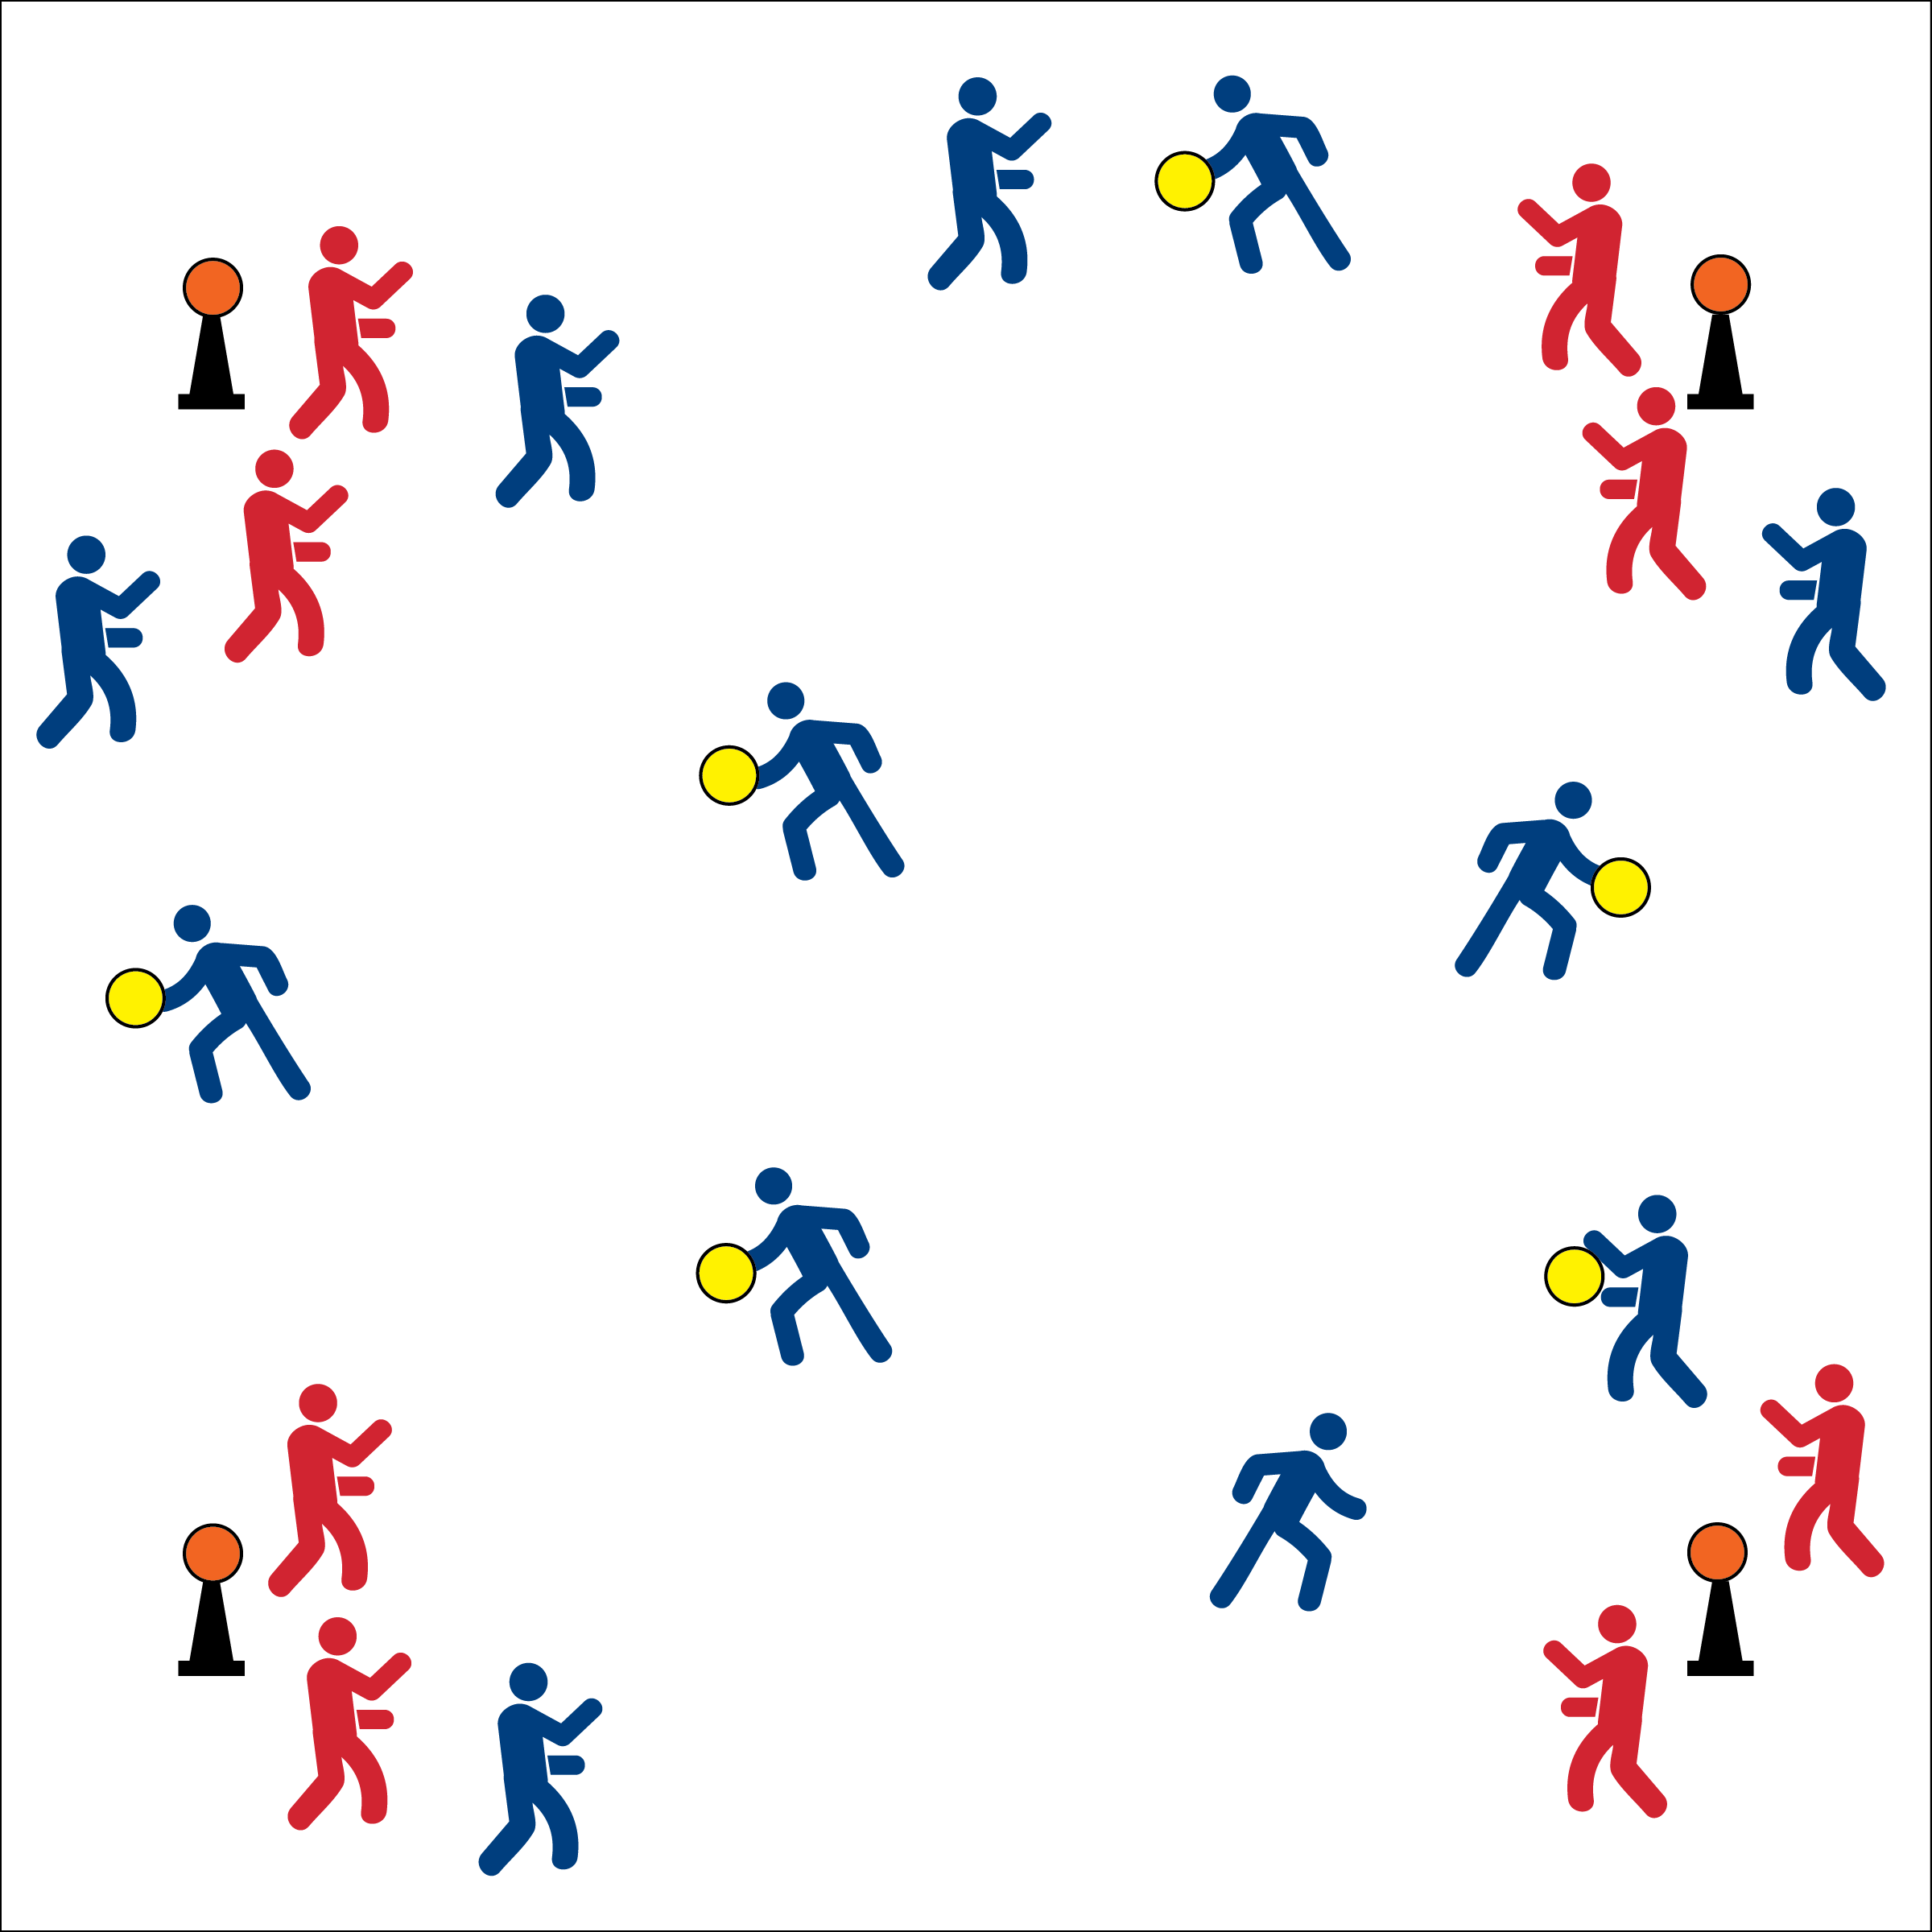



* **DOK 1:** What is a passing lane?
* **DOK 2:** How can you apply what you know about off-the-ball movement in order to create passing lanes?
* **DOK 3:** How is this game related to your favorite sport (e.g., basketball, soccer, etc.)?



* **Standard** **2 [M3.8]** Creates open space by staying spread on offense, cutting and passing quickly, and using fakes off the ball.
* **Standard 4 [H2.L1]** Exhibits proper etiquette, respect for others and teamwork while engaging in physical activity and/or social dance.

**Activity Procedures:**

1. It’s time to warm up with a game called Capture the Corner.
2. The object of the game is for offensive teams to “capture” the corners by throwing their foam balls and knocking a playground ball off of a cone. Defensive teams are assigned to a cone and will work to knock offensive shots away.
3. If a corner is “captured,” the offensive scoring the point will change roles with the defense at that cone.
4. Offense, players with the ball cannot take any steps, they can only pivot. Players “off the ball” can move throughout the activity area using quick cuts and fakes in order to move into space with an open passing lane
5. Defense, you must stay within 4 feet of your assigned cone and cannot touch the cone or the playground ball with any part of your body.
6. Begin on the start signal. Freeze on the stop signal.

**Grade Level Progressions:**

**MS:** Use a variety of sizes of game balls (e.g., larger foam balls for throwing, smaller PG balls as targets.

**HS:** Limit the number of passes made before a shot attempt must be taken. Add court defender who can intercept passes.

**Equipment:**

* 4 cones (12” or larger)
* 4 playground balls
* 1 foam ball per pair

**Set-Up:**

1. Create a large activity area with 1 cone in each corner and a playground ball balanced on top of each cone. (Use 6 cones/balls for larger class sizes and activity spaces.)
2. Students work in pairs. Send a pair to each cone to play defense. Other pairs begin scattered in general space.

* **Skill:** I will create open space by staying spread on offense, cutting and passing quickly, and using off-the-ball fakes.
* Short, Quick Passes
* Move to Open Space
* Use Passing Lanes