­­



Adapted by Brandon Herwick and Rich Wiles from activity instructions by Justin Cahill

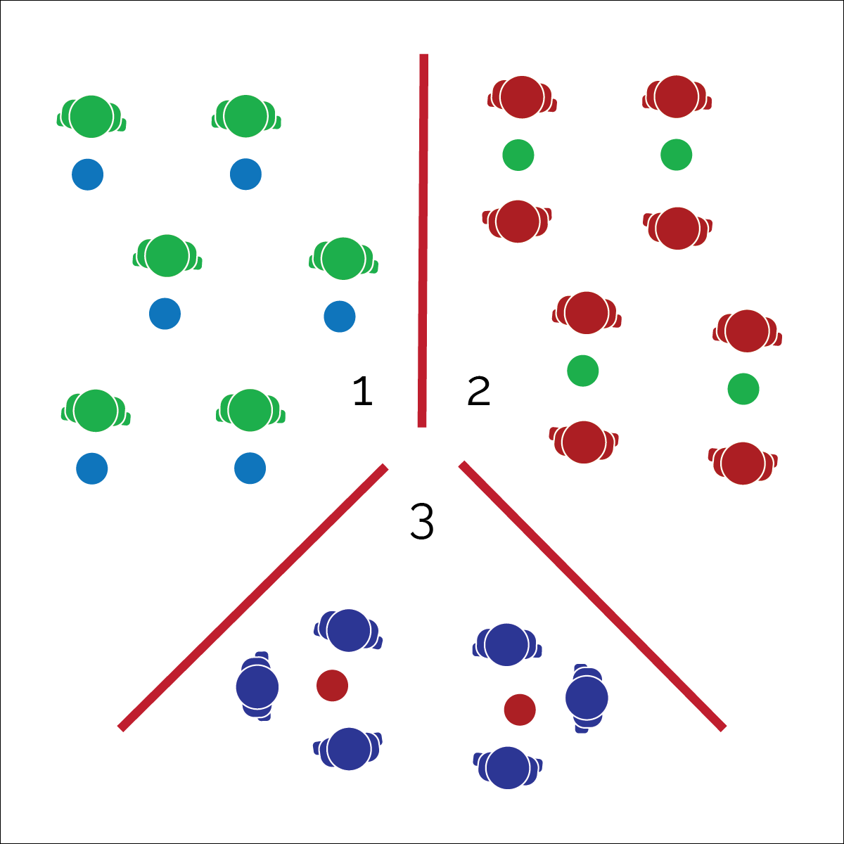

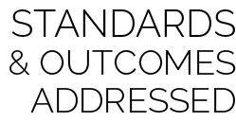

* **Standard 1 [M1.6-8]** Demonstrates correct rhythm and pattern for social dance form (6); Demonstrates correct rhythm and pattern for a different dance form from among folk, social, creative, line, and world dance (7); Exhibits command of rhythm and timing by creating a movement sequence to music as an individual or in a group (8).
* **Standard 4 [M5.6-8]** Cooperates with a small group of classmates during adventure activities, game play, or team-building activities (6); Problem-solves with a small group of classmates during adventure activities, small-group initiatives, or game play (7); Cooperates with multiple classmates on problem-solving initiatives including adventure activities, large-group initiatives, and game play (8).

**Activity Procedures:**

1. This is an incredibly fun dance activity that uses forward and back jumping sequences to improve teamwork, increase cardiorespiratory endurance, and boost brain power!
2. We will practice each progression using the Triangle Dance Activity Card.
3. Remember to keep your head up and eyes forward, encourage each other, start slow and try the extra challenges as you get more confident with this dance.
4. Teachers, teach the movements using the Triangle Dance Activity Card. Then add music!

**Progression/Extension:**

* Add the additional “2.0 Challenges” listed in the Grade 6-12 Activity Card.

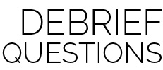

* **DOK 1:** What does cooperation look like in a Triangle Dance performance?
* **DOK 2:** How does cooperation affect a dance performance? How does it affect enjoyment?

**Equipment:**

* Music Player
* Video Tutorial by Jedd Austin ([YouTube](https://youtu.be/dNbhxzbeRYI))
* Song with moderate tempo (80-100 bpm)
* 1 poly spot for each student or Floormarx
* Optional: tempo-modifying app such as Tempo Slow (available on the App Store)

**Set-Up:**

1. Students spread out behind a spot marker or Floormarx spot in general space.
2. Teach the 3 sequences using tutorial video and Triangle Dance Activity Card.
3. Students practice and then progress to working with a partner, then groups of 3.

* **Skill:** I will perform dance movements with the beat and tempo of the music.
* **Personal & Social Responsibility:** I will cooperate with my classmates to learn and perform the dance.
* Move Safely
* Work Cooperatively
* Find Your Energy