­­

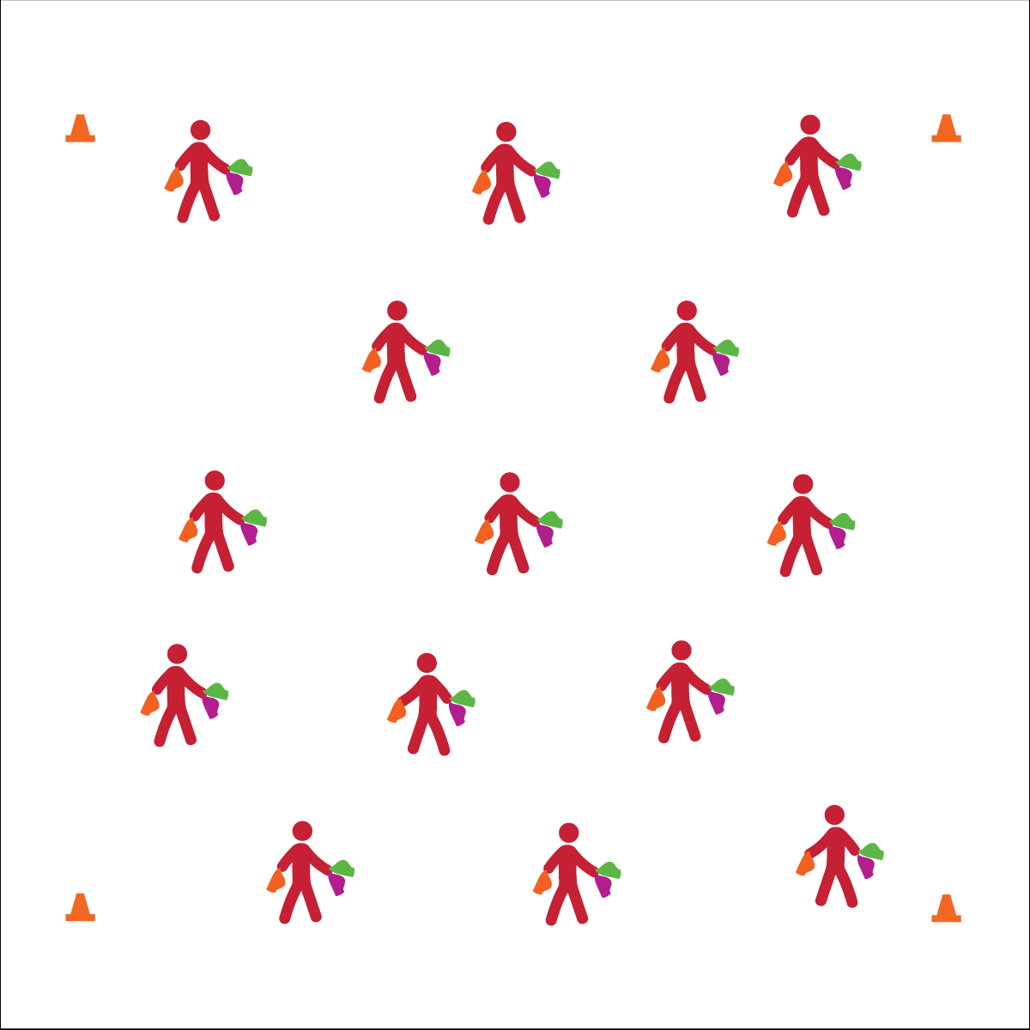

**BASIC JUGGLING**

* Focus on Form
* Put in Work
* Be Patient with Yourself
* Stay Safe

**Activity Procedures:**

1. Today we’ll begin our Circus Arts module with basic scarf juggling.
2. We’ll follow the juggling progression on the OPEN Activity Card and then spend time practicing each challenge on our own.
3. Teachers, use part 1 of the Scarf Juggling Activity Card to follow this activity sequence: 1) diagonal toss/catch 1 scarf; 2) crisscross toss/toss catch/catch 2 scarves; 3) Cascade (X pattern) with 3 scarves.
4. Use this activity’s debrief questions to discuss the suggested forces of science topic.
5. When students are ready, progress to Column Juggling in part 2 of the Activity Card.

**Grade Level Progression:**

**6th:** Students perform 1 or more basic skills from Level 1 of the activity card.

**7th:** Students perform all of the skills from Level 1 of the activity card.

**8th:** Students perform all Level 1 skills and 1 or more Level 2 Skills.

**Equipment:**

* 3 juggling scarves per student
* Circus Arts Activity Cards
* Music

**Set-Up:**

1. Students scattered in activity area, each with 3 juggling scarves.
2. Display Basic Juggling Cue Chart.

* **Skill:** I will perform cascade juggling with scarves.
* **Cognitive:** I will discuss and explain Newton’s first law of motion.
* **Fitness:** I will participate and actively engage in circus arts activities.
* **Personal & Social Responsibility:** I will identify and demonstrate responsible behaviors related to safe, positive circus arts participation.

**BASIC JUGGLING**



* Use larger scarves and focus on basic toss and catch.
* Toss scarves into a target such as a hoop.



Juggle, Cascade, Gravity, Wind Resistance, Newton’s Laws of Motion, Actively Engage, Responsibility, Safe



* **Standard 1 [M25.6-8]** Demonstrates correct technique for basic skills in one self-selected individual-performance activity (6); Demonstrates correct technique for a variety of skills in one self-selected individual-performance activity (7); Demonstrates correct technique for basic skills in at least two self-selected individual-performance activities (8).
* **Standard 2 [M12.6-8]** Varies application of force during dance or gymnastic activities (6); Identifies and applies Newton’s laws of motion to various dance or movement activities (7); Describes & applies mechanical advantage(s) for a variety of movement patterns (8).
* **Standard 4 [M1.6-7]** Exhibits personal responsibility by using appropriate etiquette, demonstrating respect for facilities, and exhibiting safe behaviors (6); Exhibits responsible social behaviors by cooperating with classmates, demonstrating inclusive behaviors, and supporting classmates (7).
* **Standard 5 [M3.6-8]** Recognizes individual challenges and copes in a positive way, such as extending effort, asking for help/feedback, and/or modifying the tasks (6);Generates positive strategies such as offering suggestions/assistance, leading/following others, and/or providing possible solutions when faced with a group challenge (7);Develops a plan of action and makes appropriate decisions based on that plan when faced with an individual challenge (8).



* **DOK 1:** What is gravity?
* **DOK 2:** Can you explain how juggling is affected by gravity?
* **DOK 3:** How is wind resistance related to juggling? Provide examples.
* **DOK 1:** What is Newton’s first law of motion?
* **DOK 2:** Can you explain how gravity affects the inertia of objects being juggled?
* **DOK 3:** Can you elaborate on each aspect of juggling that is related to Newton’s first law of motion?

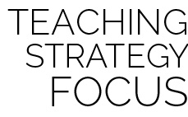

**Preview New Content:** As you begin the Circus Arts module, take a few minutes at the start of the lesson to demonstrate the various skills that will be taught over the course of the unit using the unique equipment. YouTube is a great resources for hundreds of juggling/circus demonstrations and tutorials.

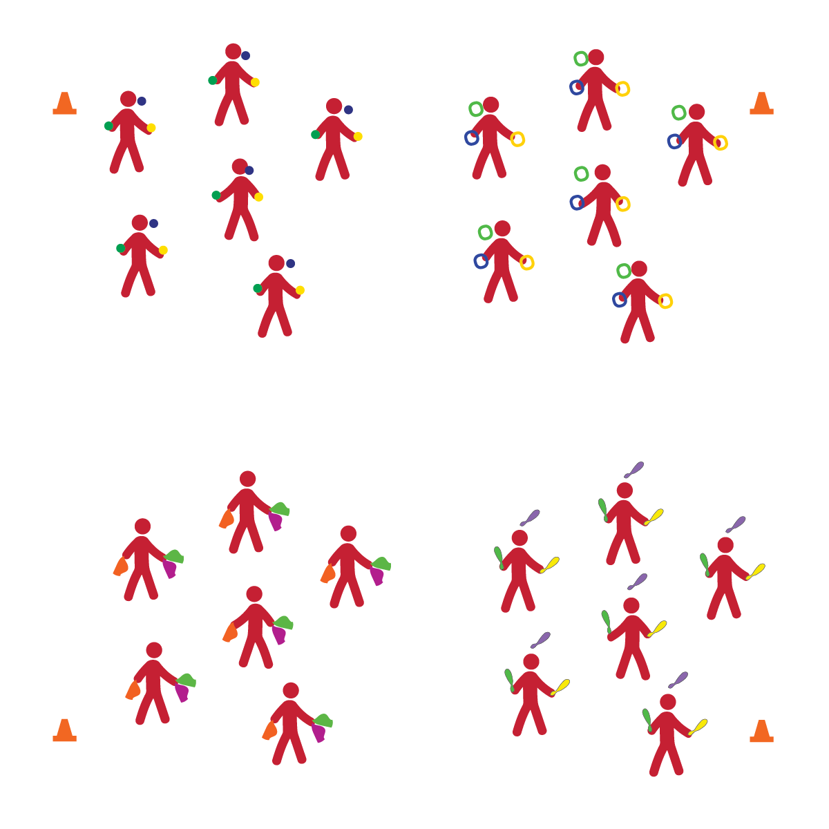

**ADVANCED JUGGLING**

* **Skill:** I will perform cascade juggling with the object of my choice.
* **Cognitive:** I will discuss and explain center of gravity.
* **Fitness:** I will participate and actively engage in circus arts activities.
* **Personal & Social Responsibility:** I will remain focused, demonstrate grit, and work to overcome challenges related to circus arts skills and tricks.
* Focus on Form
* Put in Work
* Be Patient with Yourself
* Stay Safe

**Equipment:**

* 6 sets of each type of juggling equipment
* 4 Cones
* 4 Task Tents
* Juggling Station Cards
* Circus Arts Activity Cards

**Set-Up:**

1. Create 4 activity areas (1 each for scarves, balls, rings, and clubs) using cones, task tents, and station cards.

**Activity Procedures:**

1. This is an advanced juggling day, and you’ll get an opportunity to practice juggling with a variety of different juggling objects.
2. There are 4 stations set up throughout our space. You can choose which area you’d like to work in. When you hear the change signal, move to a new area and try a different juggling object.
3. Juggling scarves are available at one area for those who’d like to review what we’ve learned and also to try advanced scarf juggling tricks.
4. Any time you hear the stop signal, hold your objects and listen for instruction.

**Grade Level Progression:**

**6th:** Students perform 1 or more basic skills from Level 1 of the activity card.

**7th:** Students perform all of the skills from Level 1 of the activity card.

**8th:** Students perform all Level 1 skills and 1 or more Level 2 Skills.

**ADVANCED JUGGLING**

* Practice basic tossing and catching of a variety of objects.
* Allow students to choose the object they’re working with.
* Use video demonstrations.



* **Standard 1 [M25.6-8]** Demonstrates correct technique for basic skills in one self-selected individual-performance activity (6); Demonstrates correct technique for a variety of skills in one self-selected individual-performance activity (7); Demonstrates correct technique for basic skills in at least two self-selected individual-performance activities (8).
* **Standard 2 [M12.6-8]** Varies application of force during dance or gymnastic activities (6); Identifies and applies Newton’s laws of motion to various dance or movement activities (7); Describes & applies mechanical advantage(s) for a variety of movement patterns (8).
* **Standard 4 [M1.6-7]** Exhibits personal responsibility by using appropriate etiquette, demonstrating respect for facilities, and exhibiting safe behaviors (6); Exhibits responsible social behaviors by cooperating with classmates, demonstrating inclusive behaviors, and supporting classmates (7).
* **Standard 5 [M3.6-8]** Recognizes individual challenges and copes in a positive way, such as extending effort, asking for help/feedback, and/or modifying the tasks (6); Generates positive strategies such as offering suggestions/assistance, leading/following others, and/or providing possible solutions when faced with a group challenge (7);Develops a plan of action and makes appropriate decisions based on that plan when faced with an individual challenge (8).



* **DOK 1:** What is center of gravity?
* **DOK 2:** What can you tell me about a juggling club’s center of gravity?
* **DOK 3:** How could you test where the club’s center of gravity is?
* **DOK 1:** What is grit?
* **DOK 2:** How can grit help you learn how to juggle different objects?
* **DOK 3:** How is grit related to goal setting and action planning?
* **DOK 4:** If you were going to interview classmates about how grit helps them succeed in physical education class, what questions would you ask?



**Organize students to interact with content:** Setting up activity stations for each still/piece of equipment provides students with an opportunity to choose the juggling level that will challenge them while still providing successful participation. It’s import to allow students to take responsibility for their own learning and skill development with guidance and encouragement from both peers and the teacher.



Center of Gravity, Focus, Grit, Overcome

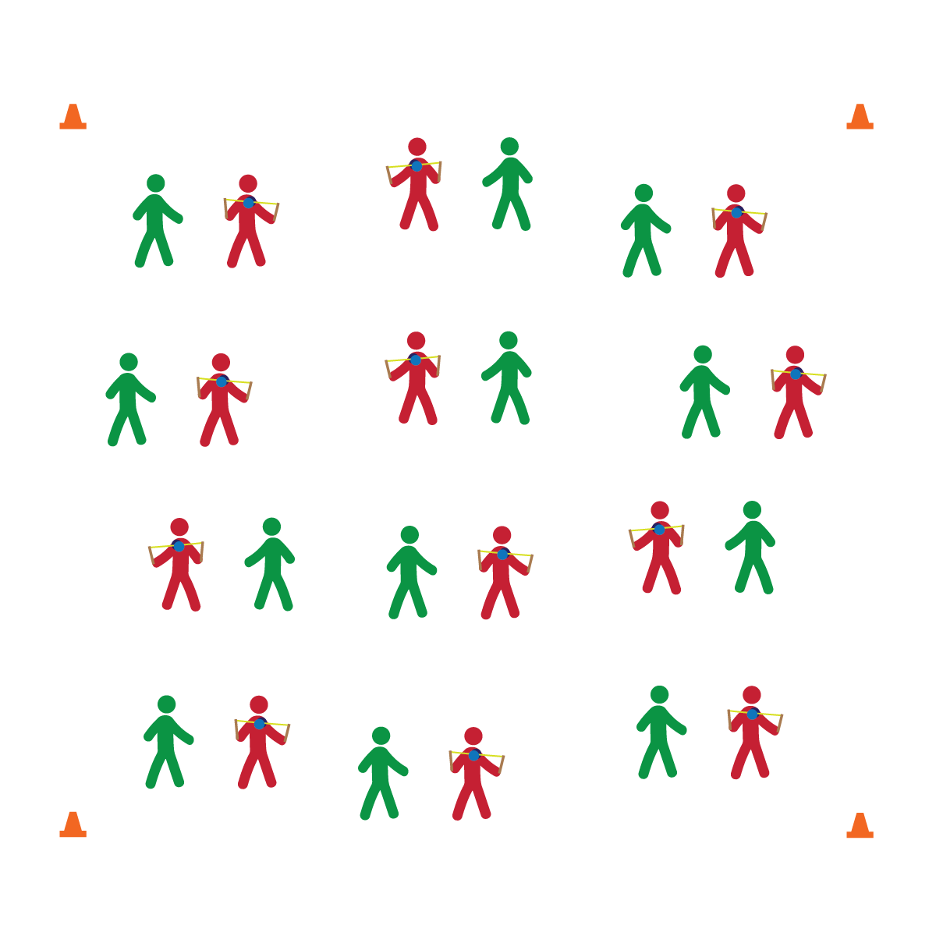

**DIABOLO**

* **Skill:** I will perform a rolling start with the diabolo.
* **Cognitive:** I will discuss and explain Newton’s second law of motion.
* **Fitness:** I will participate and actively engage in circus arts activities.
* **Personal & Social Responsibility:** I will remain focused, demonstrate grit, and work to overcome challenges related to circus arts skills and tricks.
* Focus on Form
* Put in Work
* Be Patient with Yourself
* Stay Safe

**Equipment:**

* 1 diabolo per 2 (or 3) students
* Circus Arts Activity Cards
* Music

**Set-Up:**

1. Pair (or group) students depending on how much equipment you have available.
2. Each pair or group with a diabolo.

**Activity Procedures:**

1. Today we’ll begin learning the basics of how to use a diabolo.
2. I will demonstrate (or show via YouTube) each trick, and then you and your partner will take turns trying each trick. After each trick, we’ll discuss the forces of science that apply to diabolo performance.
3. Any time that you hear the stop signal, hold your objects and listen for instruction.

**Grade Level Progression:**

**6th:** Students perform 1 or more basic skills from Level 1 of the activity card.

**7th:** Students perform all of the skills from Level 1 of the activity card.

**8th:** Students perform all Level 1 skills and 1 or more Level 2 Skills.

**DIABOLO**

* Provide physical assistance when/where appropriate.



* **Standard 1 [M25.6-8]** Demonstrates correct technique for basic skills in one self-selected individual-performance activity (6); Demonstrates correct technique for a variety of skills in one self-selected individual-performance activity (7); Demonstrates correct technique for basic skills in at least two self-selected individual-performance activities (8).
* **Standard 2 [M12.6-8]** Varies application of force during dance or gymnastic activities (6); Identifies and applies Newton’s laws of motion to various dance or movement activities (7); Describes & applies mechanical advantage(s) for a variety of movement patterns (8).
* **Standard 4 [M1.6-7]** Exhibits personal responsibility by using appropriate etiquette, demonstrating respect for facilities, and exhibiting safe behaviors (6); Exhibits responsible social behaviors by cooperating with classmates, demonstrating inclusive behaviors, and supporting classmates (7).
* **Standard 5 [M3.6-8]** Recognizes individual challenges and copes in a positive way, such as extending effort, asking for help/feedback, and/or modifying the tasks (6); Generates positive strategies such as offering suggestions/assistance, leading/following others, and/or providing possible solutions when faced with a group challenge (7);Develops a plan of action and makes appropriate decisions based on that plan when faced with an individual challenge (8).



Newton’s Laws of Motion, Acceleration, Individual Challenges, Cope



* **DOK 1:** What are Newton’s 3 laws of motion?
* **DOK 2:** Can you explain how each law is related to performing with the diabolo?
* **DOK 3:** Can you think of another activity that you enjoy and describe how one or more of Newton’s laws of motion are related to its performance?
* **DOK 1:** What does it mean to cope?
* **DOK 2:** What are ways that people cope with different challenges/emotions?
* **DOK 3:** Can you elaborate on the reason it’s important to cope with emotions when learning how to perform with the diabolo?



**Help students elaborate on content:** During group discussion, prompt students to provide support and evidence for their answers. Wait for them to expand their thinking by providing as much detail as possible. Then, encourage other students to expand on their classmates’ answers with ideas and evidence of their own.

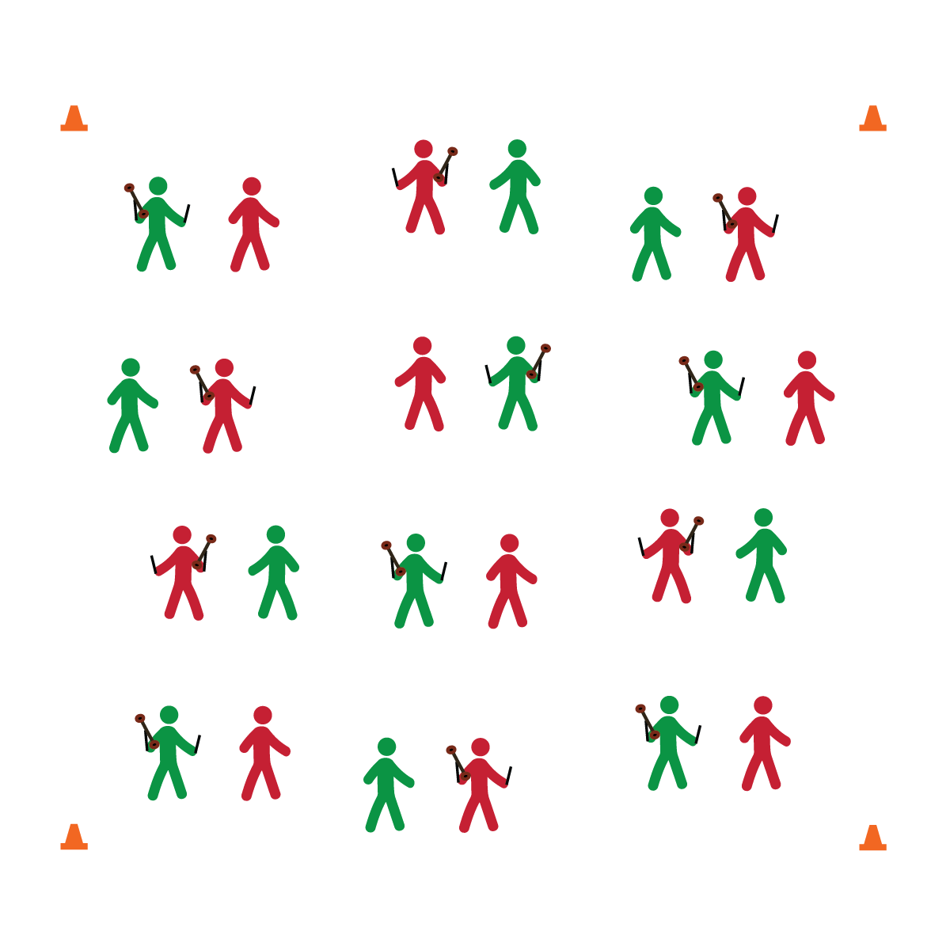

**FLOWER STICKS**

* **Skill:** I will perform a ground start with the flower sticks.
* **Cognitive:** I will discuss and explain Newton’s third law of motion.
* **Fitness:** I will participate and actively engage in circus arts activities.
* **Personal & Social Responsibility:** I will remain focused, demonstrate grit, and work to overcome challenges related to circus arts skills and tricks.
* Focus on Form
* Put in Work
* Be Patient with Yourself
* Stay Safe

**Equipment:**

* 1 set of flower sticks per 2 (or 3) students
* Circus Arts Activity Cards
* Music

**Set-Up:**

1. Pair (or group) students depending on how much equipment you have available.
2. Each pair or group with a set of flower sticks.

**Activity Procedures:**

1. Today we’ll begin learning the basics of how to use flower sticks.
2. I will demonstrate (or show via YouTube), and then you and your partner will take turns trying each trick. After each trick, we’ll discuss the forces of science that apply to flower stick performance.
3. Any time you hear the stop signal, hold your objects and listen for instruction.

**Grade Level Progression:**

**6th:** Students perform 1 or more basic skills from Level 1 of the activity card.

**7th:** Students perform all of the skills from Level 1 of the activity card.

**8th:** Students perform all Level 1 skills and 1 or more Level 2 Skills.

**FLOWER STICKS**



* Provide physical assistance when/where appropriate.
* Allow students to perform rhythmic activities with the control sticks.



* **Standard 1 [M25.6-8]** Demonstrates correct technique for basic skills in one self-selected individual-performance activity (6); Demonstrates correct technique for a variety of skills in one self-selected individual-performance activity (7); Demonstrates correct technique for basic skills in at least two self-selected individual-performance activities (8).
* **Standard 2 [M12.6-8]** Varies application of force during dance or gymnastic activities (6); Identifies and applies Newton’s laws of motion to various dance or movement activities (7); Describes & applies mechanical advantage(s) for a variety of movement patterns (8).
* **Standard 5 [M3.6-8]** Recognizes individual challenges and copes in a positive way, such as extending effort, asking for help/feedback, and/or modifying the tasks (6); Generates positive strategies such as offering suggestions/assistance, leading/following others, and/or providing possible solutions when faced with a group challenge (7);Develops a plan of action and makes appropriate decisions based on that plan when faced with an individual challenge (8).



Growth Mindset, Grit, Perseverance



**Help students process content:** After the class discusses movement and/or scientific concepts, allow them to return to their practice with a focus on the ideas that have been discussed. Circulate through the class and take time to have individual discussions to invoke deeper thinking and processing.



* **DOK 1:** How would you describe a ground start with the flower sticks?
* **DOK 2:** How is Newton’s first law of motion related to performing a ground start?
* **DOK 3:** Thinking about Newton’s Second Law of Motion, why is force an important component of Flower Stick performing? Elaborate with details about how force should/could be applied.
* **DOK 1:** What does perseverance mean?
* **DOK 2:** What sort of language would you use when encouraging someone to persevere? Provide examples.
* **DOK 3:** How is grit related to perseverance?

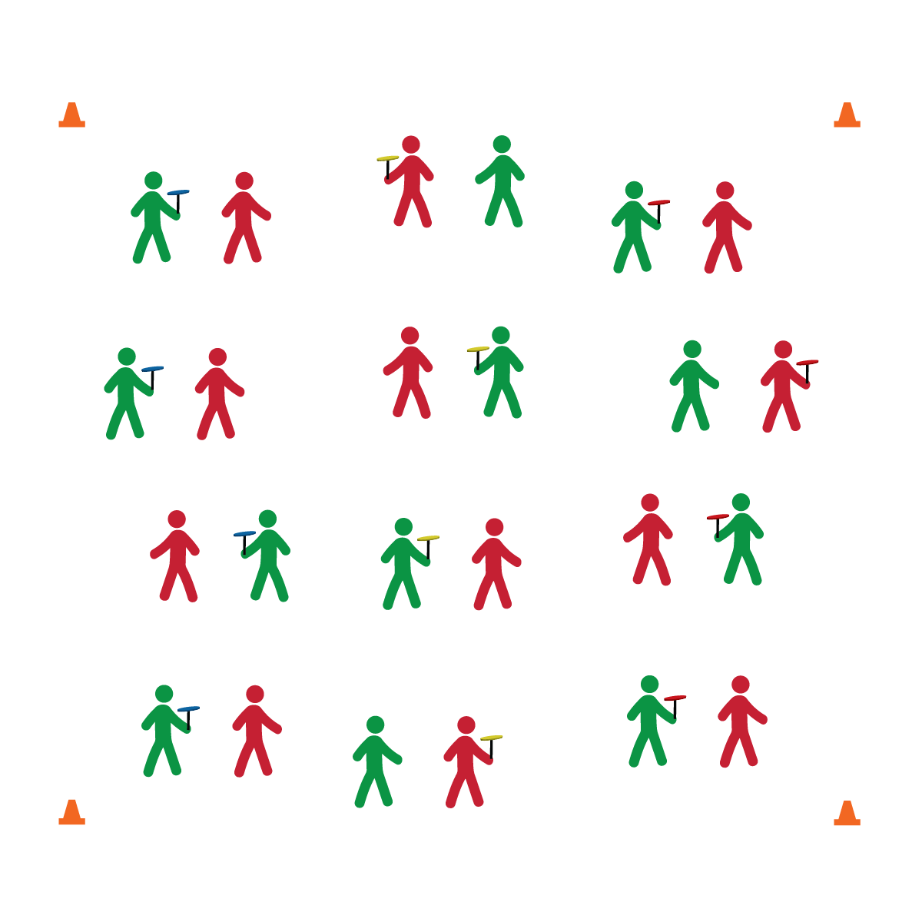

**SPINNING PLATES**

* **Skill:** I will perform a beginner spin up with spinning plates.
* **Cognitive:** I will discuss and explain how center of gravity affects balance.
* **Fitness:** I will participate and actively engage in circus arts activities.
* **Personal & Social Responsibility:** I will remain focused, demonstrate grit, and work to overcome challenges related to circus arts skills and tricks.
* Focus on Form
* Put in Work
* Be Patient with Yourself
* Stay Safe

**Equipment:**

* 1 spinning plate and stick per student
* Circus Arts Activity Cards
* Music

**Set-Up:**

1. Pair (or group) students depending on how much equipment you have available.
2. Each student with a plate and stick.

**Activity Procedures:**

1. Today we’ll begin learning the basics of plate spinning.
2. I will demonstrate (or show via YouTube), and then you and your partner will take turns trying each trick. After each trick, we’ll discuss the forces of science that apply to spinning plates.
3. Any time you hear the stop signal, hold your objects and listen for instruction.

**Grade Level Progression:**

**6th:** Students perform 1 or more basic skills from Level 1 of the activity card.

**7th:** Students perform all of the skills from Level 1 of the activity card.

**8th:** Students perform all Level 1 skills and 1 or more Level 2 Skills.

**SPINNING PLATES**



* Provide physical assistance when/where appropriate.



**Helps students engage in complex tasks:** The steps and techniques for all circus arts skills are specific and complex for beginners. Provide bursts of complex challenge for students mixed with tasks that are more easily attainable. Then return to complex tasks with a fresh attitude and improved resolve. For example, practice the beginner spin up with all students, then pair students who can complete the task with students who cannot. Have students who can spin up the plate do so, and then hand the spinning plate to their partner allowing her/him to experience success with a Toss and Catch. This will build interest and motivation to master the complex task of spinning up the plate.



* **DOK 1:** What is balance?
* **DOK 2:** How does the plate’s center of gravity influence its balance?
* **DOK 3:** How is acceleration related to plate spinning?
* **DOK 1:** How can you recognize appropriate decisions in physical education class?
* **DOK 2:** What do you notice about the decisions and behavior of students who successfully spun a plate?
* **DOK 3:** Can you describe the sequence of events that led up to a person learning how to spin a plate? Elaborate on the appropriate decisions required.



* **Standard 1 [M25.6-8]** Demonstrates correct technique for basic skills in one self-selected individual-performance activity (6); Demonstrates correct technique for a variety of skills in one self-selected individual-performance activity (7); Demonstrates correct technique for basic skills in at least two self-selected individual-performance activities (8).
* **Standard 2 [M12.6-8]** Varies application of force during dance or gymnastic activities (6); Identifies and applies Newton’s laws of motion to various dance or movement activities (7); Describes & applies mechanical advantage(s) for a variety of movement patterns (8).
* **Standard 4 [M1.6-7]** Exhibits personal responsibility by using appropriate etiquette, demonstrating respect for facilities, and exhibiting safe behaviors (6); Exhibits responsible social behaviors by cooperating with classmates, demonstrating inclusive behaviors, and supporting classmates (7).
* **Standard 5 [M3.6-8]** Recognizes individual challenges and copes in a positive way, such as extending effort, asking for help/feedback, and/or modifying the tasks (6); Generates positive strategies such as offering suggestions/assistance, leading/following others, and/or providing possible solutions when faced with a group challenge (7);Develops a plan of action and makes appropriate decisions based on that plan when faced with an individual challenge (8).



Personal Responsibility, Appropriate, Plan of Action

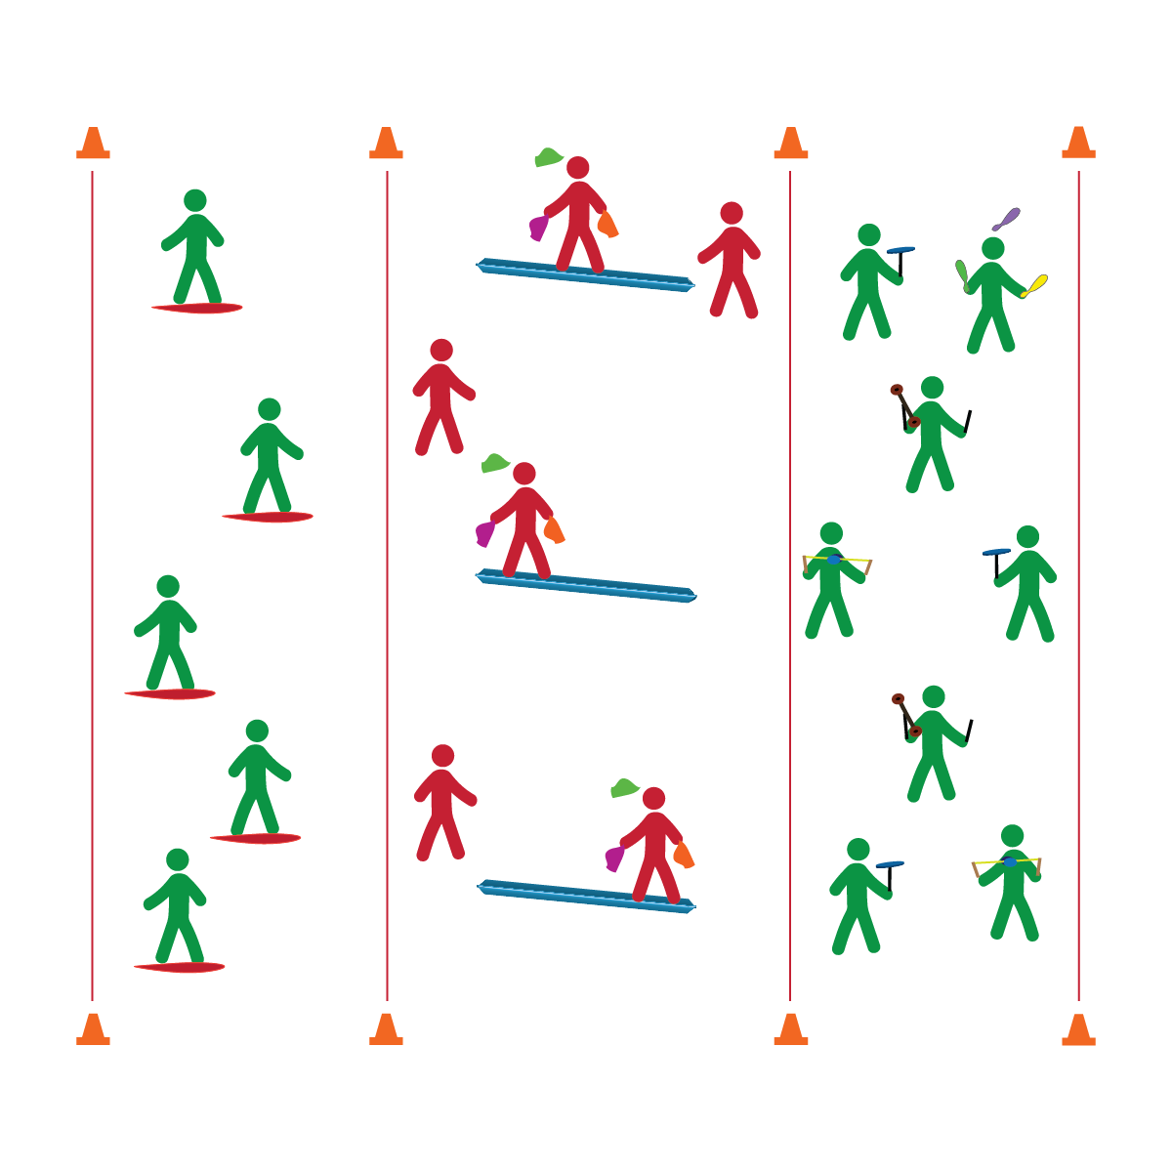

**BALANCE CHALLENGES**

**Equipment:**

* 1 Spooner Board per 3 students
* 2 – 4 low balance beams
* 24 – 48 juggling scarves
* A variety of circus arts equipment for circus practice
* 3 cones
* 3 task tents
* Circus Arts Activity and Station Cards

**Set-Up:**

1. Create 3 activity areas (1 each for Spooner Boards, Low Balance Beam, circus practice) using cones, task tents, and station cards.
2. Break students into 3 groups, send each group to an activity area.

**Activity Procedures:**

1. Today we’ll begin to practice several balance challenges. The object is to learn how to perform a circus arts trick while balancing on a board or beam.
2. At area 1, students will follow teacher instruction/demonstrations using Spooner Boards. At area 2, students will practice beam challenges, which includes scarf juggling on the beam. At area 3, students will review and practice other circus arts tricks with the object of their choice (spinning plates, diabolo, flower sticks, or juggling objects).
3. Rotate stations every 5 to 10 minutes.
4. Any time you hear the stop signal, hold your objects and listen for instruction.

**Grade Level Progression:**

**6th:** Students perform scarf juggling on the balance beam or stationary Spooner Board.

**7th:** Students perform basic skills from 2 circus arts objects on the beam or stationary Spooner Board.

**8th:** Students perform a variety of circus arts skills while moving on the balance beam or Spooner Board.

* **Skill:** I will perform 1 basic Spooner Board challenge.
* **Cognitive:** I will discuss and explain the mechanics of a pivot point.
* **Fitness:** I will participate and actively engage in circus arts activities.
* **Personal & Social Responsibility:** I will remain focused, demonstrate grit, and work to overcome challenges related to circus arts skills and tricks.
* Focus on Form
* Put in Work
* Be Patient with Yourself
* Stay Safe

**BALANCE CHALLENGES**



* Use floor lines/markings instead of balance beams and boards.
* Provide physical assistance when/where appropriate.



* **DOK 1:** What is balance?
* **DOK 1:** How can you recognize whether or not something is balanced?
* **DOK 2:** How would you compare (and contrast) balancing on the low beam with balancing on the Spooner Board?
* **DOK 1:** What is a pivot point?
* **DOK 2:** How can you change the pivot point of the Spooner Board?
* **DOK 3:** How is the board’s pivot point related to different balance challenges and Spooner Board tricks?



* **Standard 1 [M25.6-8]** Demonstrates correct technique for basic skills in one self-selected individual-performance activity (6); Demonstrates correct technique for a variety of skills in one self-selected individual-performance activity (7); Demonstrates correct technique for basic skills in at least two self-selected individual-performance activities (8).
* **Standard 2 [M12.6-8]** Varies application of force during dance or gymnastic activities (6); Identifies and applies Newton’s laws of motion to various dance or movement activities (7); Describes & applies mechanical advantage(s) for a variety of movement patterns (8).
* **Standard 4 [M1.6-7]** Exhibits personal responsibility by using appropriate etiquette, demonstrating respect for facilities, and exhibiting safe behaviors (6); Exhibits responsible social behaviors by cooperating with classmates, demonstrating inclusive behaviors, and supporting classmates (7).
* **Standard 5 [M3.6-8]** Recognizes individual challenges and copes in a positive way, such as extending effort, asking for help/feedback, and/or modifying the tasks (6); Generates positive strategies such as offering suggestions/assistance, leading/following others, and/or providing possible solutions when faced with a group challenge (7);Develops a plan of action and makes appropriate decisions based on that plan when faced with an individual challenge (8).



Balance, Actively Engage, Pivot Point



**Help students examine similarities and differences:** Students who find basic Spooner Board skills challenging will benefit from balance practice on a low foam beam. As students master the beam, help them explore and process the similarities between performing on the beam and performing on the Spooner Board. Next, prompt students to transfer what they’ve learned on the beam to the board.

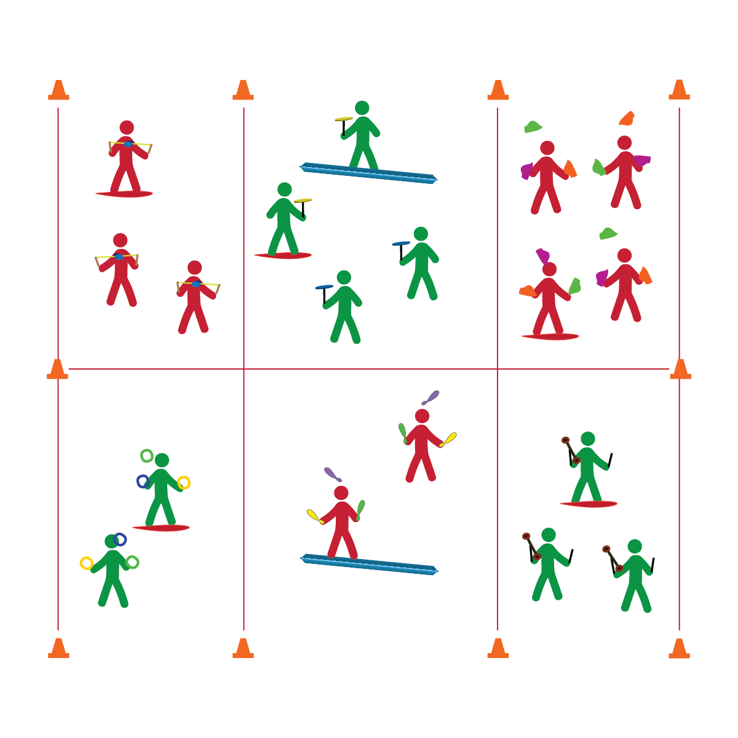

**CIRCUS PRACTICE**

**Equipment:**

* A variety of circus arts equipment
* Circus Arts Activity Cards
* Music

**Set-Up:**

1. Create several activity areas – 1 area for each type of circus arts equipment.
2. Provide Spooner Boards and balance beams for advanced practice.

* **Skill:** I will perform a minimum of 2 tricks/skills with the circus arts equipment of my choice.
* **Cognitive:** I will be discuss and explain how different scientific principles apply to circus arts.
* **Fitness:** I will use circus arts activities as an enjoyable way to manage stress and be social in a positive environment.
* **Personal & Social Responsibility:** I will remain focused, demonstrate grit, and work to overcome challenges related to circus arts skills and tricks.
* Focus on Form
* Put in Work
* Be Patient with Yourself
* Stay Safe

**Activity Procedures:**

1. It’s time for purposeful circus practice.
2. Choose a circus arts object and work to perfect your skills (Spooner Board, juggling objects, spinning plates, diabolo, or flower stick). You can work in pairs, groups, or as a solo performer.
3. On the start signal, collect the equipment you’ve chosen to use. Then, use the Circus Arts Activity Cards to help guide your practice.
4. Any time you hear the stop signal, hold your objects and listen for instruction.

**Grade Level Progression:**

*See previous progressions and apply expectations to circus practice sessions.*

**CIRCUS PRACTICE**



* Substitute rhythmic movements for complex tricks.
* Provide physical assistance when/where appropriate.



* **DOK 1:** How can you recognize a positive environment?
* **DOK 2:** Can you explain how personal behavior affects a positive environment?
* **DOK 3:** How is a positive environment related to practicing circus arts routines?



* **Standard 1 [M25.6-8]** Demonstrates correct technique for basic skills in one self-selected individual-performance activity (6); Demonstrates correct technique for a variety of skills in one self-selected individual-performance activity (7); Demonstrates correct technique for basic skills in at least two self-selected individual-performance activities (8).
* **Standard 3 [M18.6-8]** Identifies positive and negative results of stress and appropriate ways of dealing with each (6); Practices strategies for dealing with stress, such as deep breathing, guided visualization, and aerobic exercise (7); Demonstrates basic movements used in other stress-reducing activities such as yoga and Tai Chi (8).
* **Standard 5 [M3.6-8]** Recognizes individual challenges and copes in a positive way, such as extending effort, asking for help/feedback, and/or modifying the tasks (6); Generates positive strategies such as offering suggestions/assistance, leading/following others, and/or providing possible solutions when faced with a group challenge (7);Develops a plan of action and makes appropriate decisions based on that plan when faced with an individual challenge (8).



Stress Management, Positive Environment, Focus, Grit



**Help students practice skills:** As students practice, encourage them to explore and define alternate ways of executing skills or using a particular piece of equipment. Create an environment that rewards exploration and risk taking, and highlight students who succeed in mastering a stunt that wasn’t specifically taught in class.

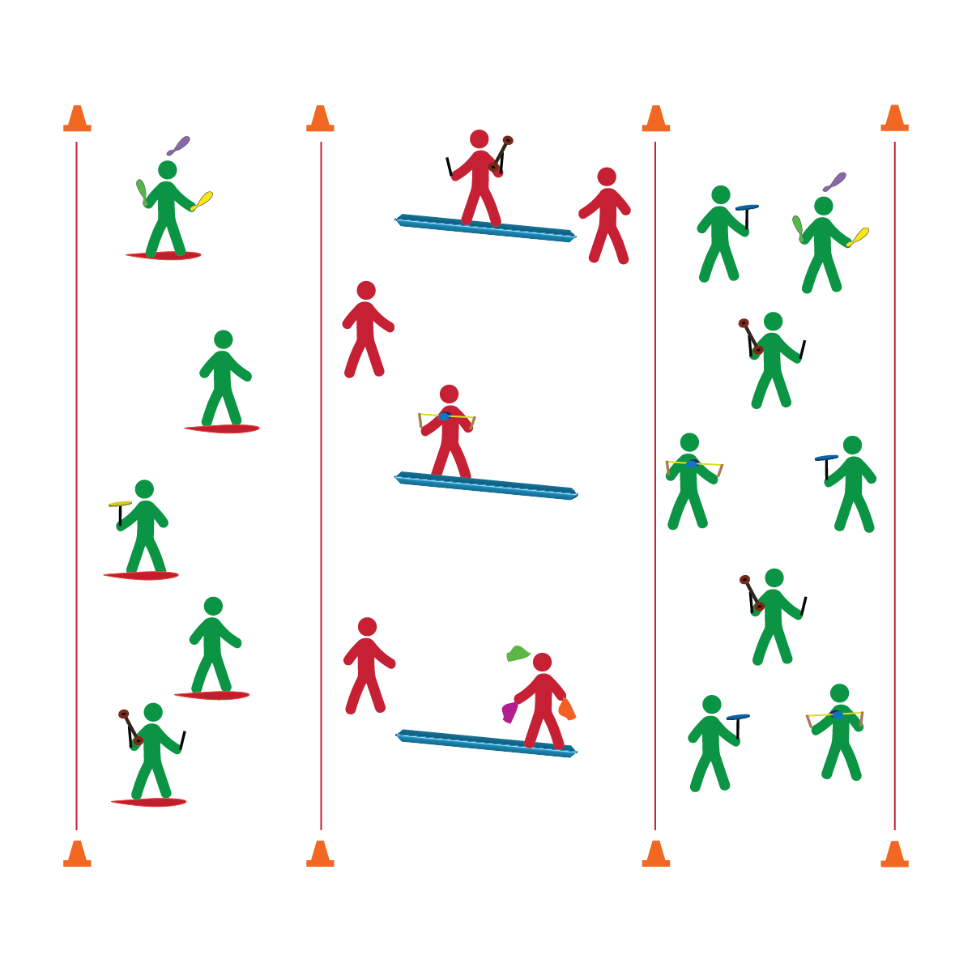

**CIRCUS COMBINATIONS**

* **Skill:** I will cascade juggle scarves while balancing on a Spooner Board or balance beam.
* **Cognitive:** I will neatly and accurately complete a Routine Planning Card.
* **Fitness:** I will focus on breathing and visualize successful participation just before practicing my complete routine.
* **Personal & Social Responsibility:** I will remain focused, demonstrate grit, and work to overcome challenges related to circus arts skills and tricks.
* Focus on Form
* Put in Work
* Be Patient with Yourself
* Stay Safe

**Equipment:**

* A variety of circus arts equipment
* Routine Planning Cards
* Music

**Set-Up:**

1. Create 3 areas (1 each for stationary practice, Spooner Board practice, and beam practice).
2. Create equipment areas for each type of circus arts equipment.

**Activity Procedures:**

1. It’s time to build circus combinations by working to bring together the skills that you’ve learned into a choreographed performance.
2. You’re required to use a balance apparatus (Spooner Board or balance beam) as well as one performance object (juggling objects, spinning plates, diabolo, or flower stick). You can work in pairs, groups, or as a solo performer.
3. On the start signal, collect the equipment you’ve chosen to use. Then, use the Circus Routine Planning Card to help guide your practice.
4. Any time you hear the stop signal, hold your objects and listen for instruction.

**Grade Level Progression:**

*See previous progressions and apply expectations to circus combination routines.*

**CIRCUS COMBINATIONS**



* Substitute rhythmic movements for complex tricks.
* Provide physical assistance when/where appropriate.



* **Standard 1 [M25.6-8]** Demonstrates correct technique for basic skills in one self-selected individual-performance activity (6); Demonstrates correct technique for a variety of skills in one self-selected individual-performance activity (7); Demonstrates correct technique for basic skills in at least two self-selected individual-performance activities (8).
* **Standard 3 [M18.6-8]** Identifies positive and negative results of stress and appropriate ways of dealing with each (6); Practices strategies for dealing with stress, such as deep breathing, guided visualization, and aerobic exercise (7); Demonstrates basic movements used in other stress-reducing activities such as yoga and Tai Chi (8).
* **Standard 4 [M1.6-7]** Exhibits personal responsibility by using appropriate etiquette, demonstrating respect for facilities, and exhibiting safe behaviors (6); Exhibits responsible social behaviors by cooperating with classmates, demonstrating inclusive behaviors, and supporting classmates (7).
* **Standard 5 [M3.6-8]** Recognizes individual challenges and copes in a positive way, such as extending effort, asking for help/feedback, and/or modifying the tasks (6); Generates positive strategies such as offering suggestions/assistance, leading/following others, and/or providing possible solutions when faced with a group challenge (7);Develops a plan of action and makes appropriate decisions based on that plan when faced with an individual challenge (8).



* **DOK 1:** How can you recognize a growth mindset?
* **DOK 2:** Can you explain how a growth mindset affects your self-talk?
* **DOK 3:** How could you adapt negative self-talk statements to create more positive, growth-mindset statements?
* **DOK 4:** Design and practice a circus arts routine using manipulative skills (e.g., juggling, plate spinning, etc.).



Focus, Visualize, Practice, Grit, Growth Mindset



**Help students examine their reasoning:** Developing a growth mindset requires students to become aware of their self-talk and how it impacts their performance and motivation to persevere. Oftentimes this requires a reflection and critique of attitudes and assumptions, which can be uncomfortable. Nurture students along this path with positive language, modeling the self-talk that is associated with a growth mindset.

## 

**Equipment:**

* A variety of circus arts equipment
* Show Line-Up Cards
* Music
* Cones to mark areas
* Seating for audience

**Set-Up:**

1. Using cones (or other organization solutions), create a stage area, a green room waiting area, and an audience seating area.
2. Post the show lineup card so students know the order of performances.

* **Skill:** I will perform a circus arts routine with a group, with a partner, or as a solo act.
* **Cognitive:** I will execute my planned routine following the choreographed moves.
* **Fitness:** I will focus on breathing and visualize successful participation just before performing my routine.
* **Personal & Social Responsibility:** I will demonstrate responsible and respectful behaviors during all circus arts performances.

**CIRCUS PERFORMANCE**

* Have Fun
* Follow the Format
* Stay in Control
* Keep Going

**Activity Procedures:**

1. It’s time to put all of our hard work in the circus spotlight!
2. You and your partner (or group, or solo act) will follow the show lineup. Enter the stage area from the green room waiting area when it’s your turn. You’ll perform your routine and then return to the audience.
3. Remember, I’m looking for skill performance, creativity, and fun! Do your very best, and if there are any hiccups or mistakes, just remember: the show must go on!

**Grade Level Progression:**

*See previous progressions and apply expectations to circus performance sessions.*

**CIRCUS PERFORMANCE**



* Substitute rhythmic movements for complex tricks.
* Provide physical assistance when/where appropriate.



* **Standard 1 [M25.6-8]** Demonstrates correct technique for basic skills in one self-selected individual-performance activity (6); Demonstrates correct technique for a variety of skills in one self-selected individual-performance activity (7); Demonstrates correct technique for basic skills in at least two self-selected individual-performance activities (8).
* **Standard 3 [M18.6-8]** Identifies positive and negative results of stress and appropriate ways of dealing with each (6); Practices strategies for dealing with stress, such as deep breathing, guided visualization, and aerobic exercise (7); Demonstrates basic movements used in other stress-reducing activities such as yoga and Tai Chi (8).
* **Standard 4 [M1.6-7]** Exhibits personal responsibility by using appropriate etiquette, demonstrating respect for facilities, and exhibiting safe behaviors (6); Exhibits responsible social behaviors by cooperating with classmates, demonstrating inclusive behaviors, and supporting classmates (7).



Focus, Visualize, Perform, Grit, Growth Mindset



* **DOK 1:** How would you describe visualization as it relates to your circus arts performance?
* **DOK 2:** How can you apply what you know about visualization to develop a pre-performance routine?
* **DOK 3:** As you visualize your routine, can you describe the sequence of your performance? Provide as many details as possible.
* **DOK 4:** Practice and perform a circus arts routine using manipulative skills (e.g., juggling, plate spinning, etc.).



**Help students represent knowledge:** The creation and performance of a circus arts routine represents the highest level of student growth. It allows students to create their own interpretation of the content being presented. Truly rigorous teaching and learning will produce students who display active engagement, self-challenge, creative thinking, and a desire for excellence.