­­

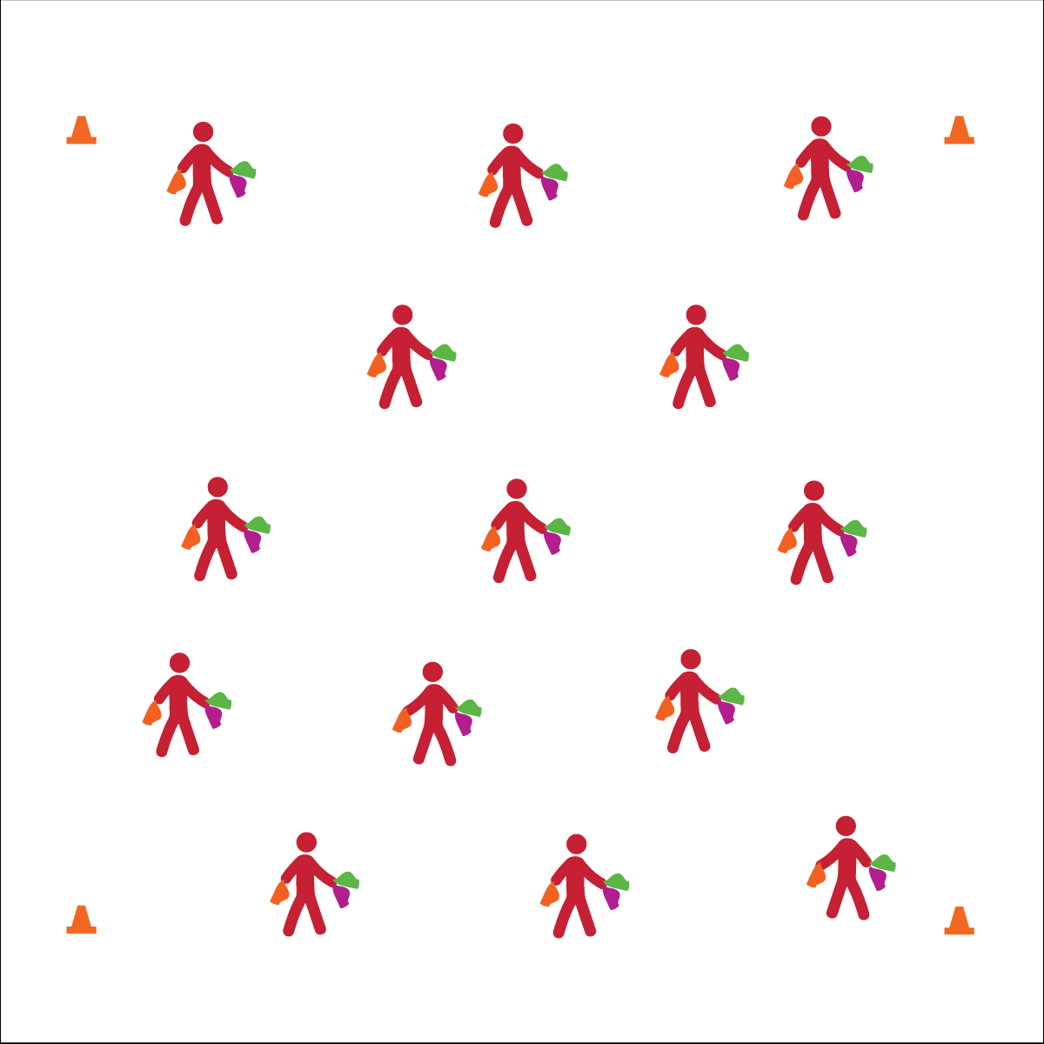

**BASIC JUGGLING**

* Focus on Form
* Put in Work
* Be Patient with Yourself
* Stay Safe

**Activity Procedures:**

1. Today we’ll begin our Circus Arts module with basic scarf juggling.
2. We’ll follow the juggling progression on the OPEN Activity Card and then spend time practicing each challenge on our own.
3. Teachers, use part 1 of the Scarf Juggling Activity Card to follow this activity sequence: 1) diagonal toss/catch 1 scarf; 2) crisscross toss/toss catch/catch 2 scarves; 3) Cascade (X pattern) with 3 scarves.
4. Use this activity’s debrief questions to discuss the suggested forces of science topic.
5. When students are ready, progress to Column Juggling in part 2 of the Activity Card.

**Grade Level Progression:**

**6th:** Students perform 1 or more basic skills from Level 1 of the activity card.

**7th:** Students perform all of the skills from Level 1 of the activity card.

**8th:** Students perform all Level 1 skills and 1 or more Level 2 Skills.

**Equipment:**

* 3 juggling scarves per student
* Circus Arts Activity Cards
* Music

**Set-Up:**

1. Students scattered in activity area, each with 3 juggling scarves.
2. Display Basic Juggling Cue Chart.

* **Skill:** I will perform cascade juggling with scarves.
* **Cognitive:** I will discuss and explain Newton’s first law of motion.
* **Fitness:** I will participate and actively engage in circus arts activities.
* **Personal & Social Responsibility:** I will identify and demonstrate responsible behaviors related to safe, positive circus arts participation.

**BASIC JUGGLING**



* Use larger scarves and focus on basic toss and catch.
* Toss scarves into a target such as a hoop.



Juggle, Cascade, Gravity, Wind Resistance, Newton’s Laws of Motion, Actively Engage, Responsibility, Safe



* **Standard 1 [M25.6-8]** Demonstrates correct technique for basic skills in one self-selected individual-performance activity (6); Demonstrates correct technique for a variety of skills in one self-selected individual-performance activity (7); Demonstrates correct technique for basic skills in at least two self-selected individual-performance activities (8).
* **Standard 2 [M12.6-8]** Varies application of force during dance or gymnastic activities (6); Identifies and applies Newton’s laws of motion to various dance or movement activities (7); Describes & applies mechanical advantage(s) for a variety of movement patterns (8).
* **Standard 4 [M1.6-7]** Exhibits personal responsibility by using appropriate etiquette, demonstrating respect for facilities, and exhibiting safe behaviors (6); Exhibits responsible social behaviors by cooperating with classmates, demonstrating inclusive behaviors, and supporting classmates (7).
* **Standard 5 [M3.6-8]** Recognizes individual challenges and copes in a positive way, such as extending effort, asking for help/feedback, and/or modifying the tasks (6);Generates positive strategies such as offering suggestions/assistance, leading/following others, and/or providing possible solutions when faced with a group challenge (7);Develops a plan of action and makes appropriate decisions based on that plan when faced with an individual challenge (8).



* **DOK 1:** What is gravity?
* **DOK 2:** Can you explain how juggling is affected by gravity?
* **DOK 3:** How is wind resistance related to juggling? Provide examples.
* **DOK 1:** What is Newton’s first law of motion?
* **DOK 2:** Can you explain how gravity affects the inertia of objects being juggled?
* **DOK 3:** Can you elaborate on each aspect of juggling that is related to Newton’s first law of motion?

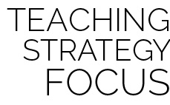

**Preview New Content:** As you begin the Circus Arts module, take a few minutes at the start of the lesson to demonstrate the various skills that will be taught over the course of the unit using the unique equipment. YouTube is a great resources for hundreds of juggling/circus demonstrations and tutorials.