­­

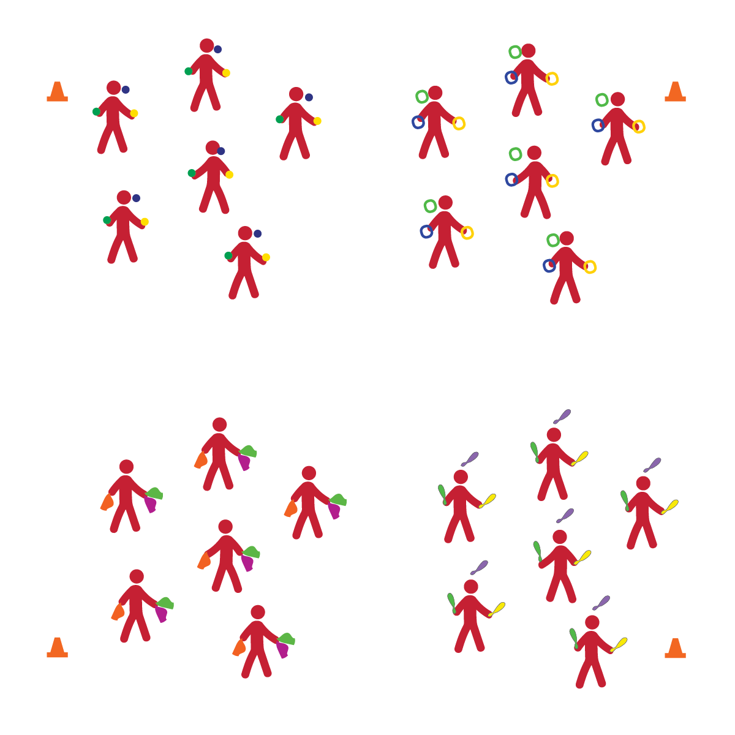

**ADVANCED JUGGLING**

* **Skill:** I will perform cascade juggling with the object of my choice.
* **Cognitive:** I will discuss and explain center of gravity.
* **Fitness:** I will participate and actively engage in circus arts activities.
* **Personal & Social Responsibility:** I will remain focused, demonstrate grit, and work to overcome challenges related to circus arts skills and tricks.
* Focus on Form
* Put in Work
* Be Patient with Yourself
* Stay Safe

**Equipment:**

* 6 sets of each type of juggling equipment
* 4 Cones
* 4 Task Tents
* Juggling Station Cards
* Circus Arts Activity Cards

**Set-Up:**

1. Create 4 activity areas (1 each for scarves, balls, rings, and clubs) using cones, task tents, and station cards.

**Activity Procedures:**

1. This is an advanced juggling day, and you’ll get an opportunity to practice juggling with a variety of different juggling objects.
2. There are 4 stations set up throughout our space. You can choose which area you’d like to work in. When you hear the change signal, move to a new area and try a different juggling object.
3. Juggling scarves are available at one area for those who’d like to review what we’ve learned and also to try advanced scarf juggling tricks.
4. Any time you hear the stop signal, hold your objects and listen for instruction.

**Grade Level Progression:**

**6th:** Students perform 1 or more basic skills from Level 1 of the activity card.

**7th:** Students perform all of the skills from Level 1 of the activity card.

**8th:** Students perform all Level 1 skills and 1 or more Level 2 Skills.

**ADVANCED JUGGLING**



Center of Gravity, Focus, Grit, Overcome



* **Standard 1 [M25.6-8]** Demonstrates correct technique for basic skills in one self-selected individual-performance activity (6); Demonstrates correct technique for a variety of skills in one self-selected individual-performance activity (7); Demonstrates correct technique for basic skills in at least two self-selected individual-performance activities (8).
* **Standard 2 [M12.6-8]** Varies application of force during dance or gymnastic activities (6); Identifies and applies Newton’s laws of motion to various dance or movement activities (7); Describes & applies mechanical advantage(s) for a variety of movement patterns (8).
* **Standard 4 [M1.6-7]** Exhibits personal responsibility by using appropriate etiquette, demonstrating respect for facilities, and exhibiting safe behaviors (6); Exhibits responsible social behaviors by cooperating with classmates, demonstrating inclusive behaviors, and supporting classmates (7).
* **Standard 5 [M3.6-8]** Recognizes individual challenges and copes in a positive way, such as extending effort, asking for help/feedback, and/or modifying the tasks (6); Generates positive strategies such as offering suggestions/assistance, leading/following others, and/or providing possible solutions when faced with a group challenge (7);Develops a plan of action and makes appropriate decisions based on that plan when faced with an individual challenge (8).



* **DOK 1:** What is center of gravity?
* **DOK 2:** What can you tell me about a juggling club’s center of gravity?
* **DOK 3:** How could you test where the club’s center of gravity is?
* **DOK 1:** What is grit?
* **DOK 2:** How can grit help you learn how to juggle different objects?
* **DOK 3:** How is grit related to goal setting and action planning?
* **DOK 4:** If you were going to interview classmates about how grit helps them succeed in physical education class, what questions would you ask?



**Organize students to interact with content:** Setting up activity stations for each still/piece of equipment provides students with an opportunity to choose the juggling level that will challenge them while still providing successful participation. It’s import to allow students to take responsibility for their own learning and skill development with guidance and encouragement from both peers and the teacher.

* Practice basic tossing and catching of a variety of objects.
* Allow students to choose the object they’re working with.
* Use video demonstrations.

