­­

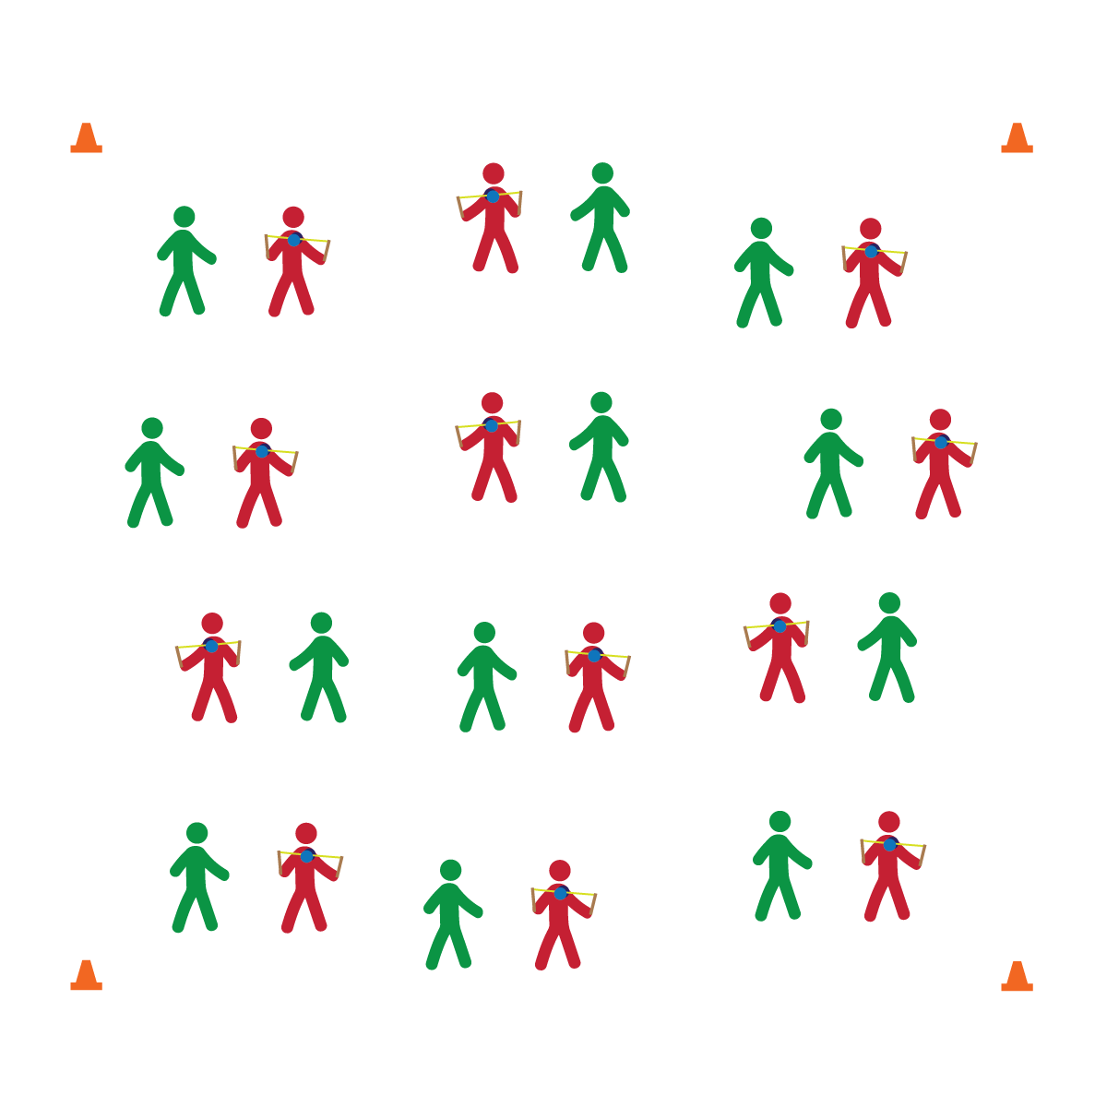

**DIABOLO**

* **Skill:** I will perform a rolling start with the diabolo.
* **Cognitive:** I will discuss and explain Newton’s second law of motion.
* **Fitness:** I will participate and actively engage in circus arts activities.
* **Personal & Social Responsibility:** I will remain focused, demonstrate grit, and work to overcome challenges related to circus arts skills and tricks.
* Focus on Form
* Put in Work
* Be Patient with Yourself
* Stay Safe

**Equipment:**

* 1 diabolo per 2 (or 3) students
* Circus Arts Activity Cards
* Music

**Set-Up:**

1. Pair (or group) students depending on how much equipment you have available.
2. Each pair or group with a diabolo.

**Activity Procedures:**

1. Today we’ll begin learning the basics of how to use a diabolo.
2. I will demonstrate (or show via YouTube) each trick, and then you and your partner will take turns trying each trick. After each trick, we’ll discuss the forces of science that apply to diabolo performance.
3. Any time that you hear the stop signal, hold your objects and listen for instruction.

**Grade Level Progression:**

**6th:** Students perform 1 or more basic skills from Level 1 of the activity card.

**7th:** Students perform all of the skills from Level 1 of the activity card.

**8th:** Students perform all Level 1 skills and 1 or more Level 2 Skills.

**DIABOLO**

* Provide physical assistance when/where appropriate.

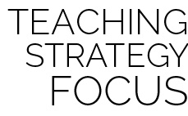

**Help students elaborate on content:** During group discussion, prompt students to provide support and evidence for their answers. Wait for them to expand their thinking by providing as much detail as possible. Then, encourage other students to expand on their classmates’ answers with ideas and evidence of their own.



* **DOK 1:** What are Newton’s 3 laws of motion?
* **DOK 2:** Can you explain how each law is related to performing with the diabolo?
* **DOK 3:** Can you think of another activity that you enjoy and describe how one or more of Newton’s laws of motion are related to its performance?
* **DOK 1:** What does it mean to cope?
* **DOK 2:** What are ways that people cope with different challenges/emotions?
* **DOK 3:** Can you elaborate on the reason it’s important to cope with emotions when learning how to perform with the diabolo?



* **Standard 1 [M25.6-8]** Demonstrates correct technique for basic skills in one self-selected individual-performance activity (6); Demonstrates correct technique for a variety of skills in one self-selected individual-performance activity (7); Demonstrates correct technique for basic skills in at least two self-selected individual-performance activities (8).
* **Standard 2 [M12.6-8]** Varies application of force during dance or gymnastic activities (6); Identifies and applies Newton’s laws of motion to various dance or movement activities (7); Describes & applies mechanical advantage(s) for a variety of movement patterns (8).
* **Standard 4 [M1.6-7]** Exhibits personal responsibility by using appropriate etiquette, demonstrating respect for facilities, and exhibiting safe behaviors (6); Exhibits responsible social behaviors by cooperating with classmates, demonstrating inclusive behaviors, and supporting classmates (7).
* **Standard 5 [M3.6-8]** Recognizes individual challenges and copes in a positive way, such as extending effort, asking for help/feedback, and/or modifying the tasks (6); Generates positive strategies such as offering suggestions/assistance, leading/following others, and/or providing possible solutions when faced with a group challenge (7);Develops a plan of action and makes appropriate decisions based on that plan when faced with an individual challenge (8).



Newton’s Laws of Motion, Acceleration, Individual Challenges, Cope