­­

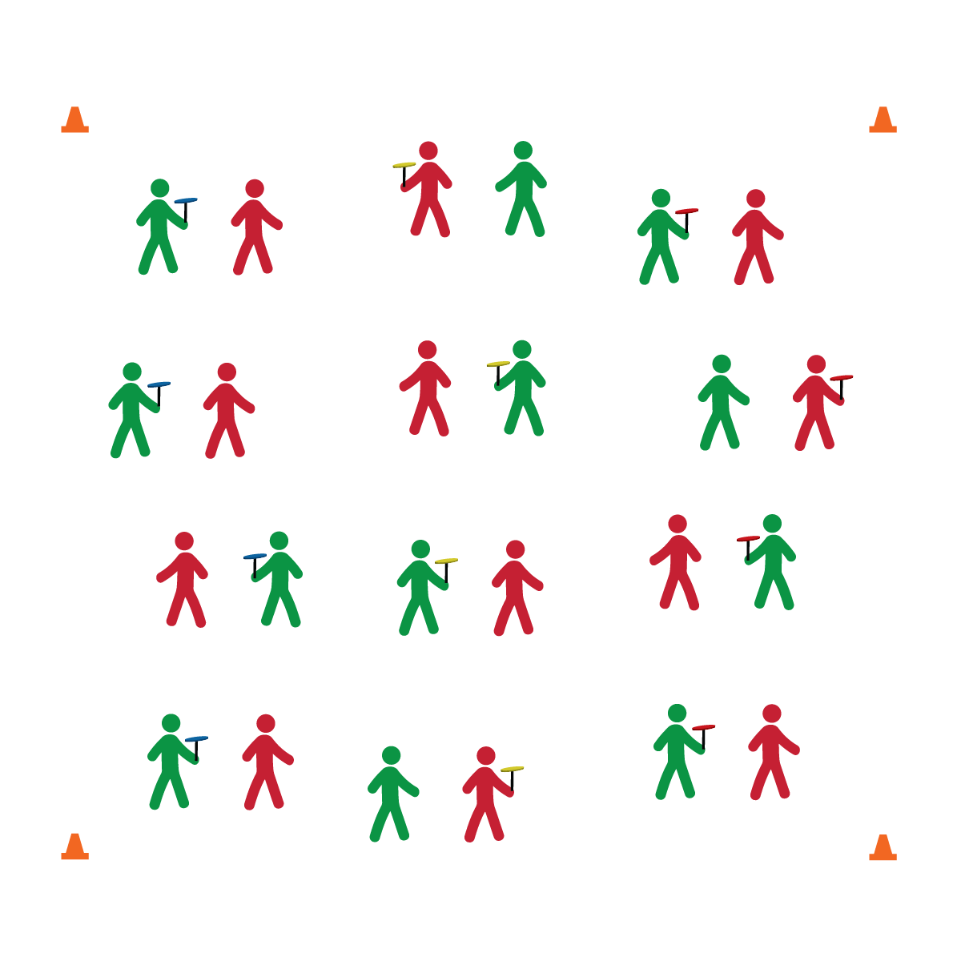

**SPINNING PLATES**

* **Skill:** I will perform a beginner spin up with spinning plates.
* **Cognitive:** I will discuss and explain how center of gravity affects balance.
* **Fitness:** I will participate and actively engage in circus arts activities.
* **Personal & Social Responsibility:** I will remain focused, demonstrate grit, and work to overcome challenges related to circus arts skills and tricks.
* Focus on Form
* Put in Work
* Be Patient with Yourself
* Stay Safe

**Equipment:**

* 1 spinning plate and stick per student
* Circus Arts Activity Cards
* Music

**Set-Up:**

1. Pair (or group) students depending on how much equipment you have available.
2. Each student with a plate and stick.

**Activity Procedures:**

1. Today we’ll begin learning the basics of plate spinning.
2. I will demonstrate (or show via YouTube), and then you and your partner will take turns trying each trick. After each trick, we’ll discuss the forces of science that apply to spinning plates.
3. Any time you hear the stop signal, hold your objects and listen for instruction.

**Grade Level Progression:**

**6th:** Students perform 1 or more basic skills from Level 1 of the activity card.

**7th:** Students perform all of the skills from Level 1 of the activity card.

**8th:** Students perform all Level 1 skills and 1 or more Level 2 Skills.

**SPINNING PLATES**



* Provide physical assistance when/where appropriate.

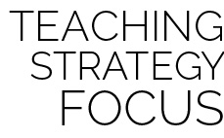

**Helps students engage in complex tasks:** The steps and techniques for all circus arts skills are specific and complex for beginners. Provide bursts of complex challenge for students mixed with tasks that are more easily attainable. Then return to complex tasks with a fresh attitude and improved resolve. For example, practice the beginner spin up with all students, then pair students who can complete the task with students who cannot. Have students who can spin up the plate do so, and then hand the spinning plate to their partner allowing her/him to experience success with a Toss and Catch. This will build interest and motivation to master the complex task of spinning up the plate.



* **DOK 1:** What is balance?
* **DOK 2:** How does the plate’s center of gravity influence its balance?
* **DOK 3:** How is acceleration related to plate spinning?
* **DOK 1:** How can you recognize appropriate decisions in physical education class?
* **DOK 2:** What do you notice about the decisions and behavior of students who successfully spun a plate?
* **DOK 3:** Can you describe the sequence of events that led up to a person learning how to spin a plate? Elaborate on the appropriate decisions required.



* **Standard 1 [M25.6-8]** Demonstrates correct technique for basic skills in one self-selected individual-performance activity (6); Demonstrates correct technique for a variety of skills in one self-selected individual-performance activity (7); Demonstrates correct technique for basic skills in at least two self-selected individual-performance activities (8).
* **Standard 2 [M12.6-8]** Varies application of force during dance or gymnastic activities (6); Identifies and applies Newton’s laws of motion to various dance or movement activities (7); Describes & applies mechanical advantage(s) for a variety of movement patterns (8).
* **Standard 4 [M1.6-7]** Exhibits personal responsibility by using appropriate etiquette, demonstrating respect for facilities, and exhibiting safe behaviors (6); Exhibits responsible social behaviors by cooperating with classmates, demonstrating inclusive behaviors, and supporting classmates (7).
* **Standard 5 [M3.6-8]** Recognizes individual challenges and copes in a positive way, such as extending effort, asking for help/feedback, and/or modifying the tasks (6); Generates positive strategies such as offering suggestions/assistance, leading/following others, and/or providing possible solutions when faced with a group challenge (7);Develops a plan of action and makes appropriate decisions based on that plan when faced with an individual challenge (8).



Personal Responsibility, Appropriate, Plan of Action