­­

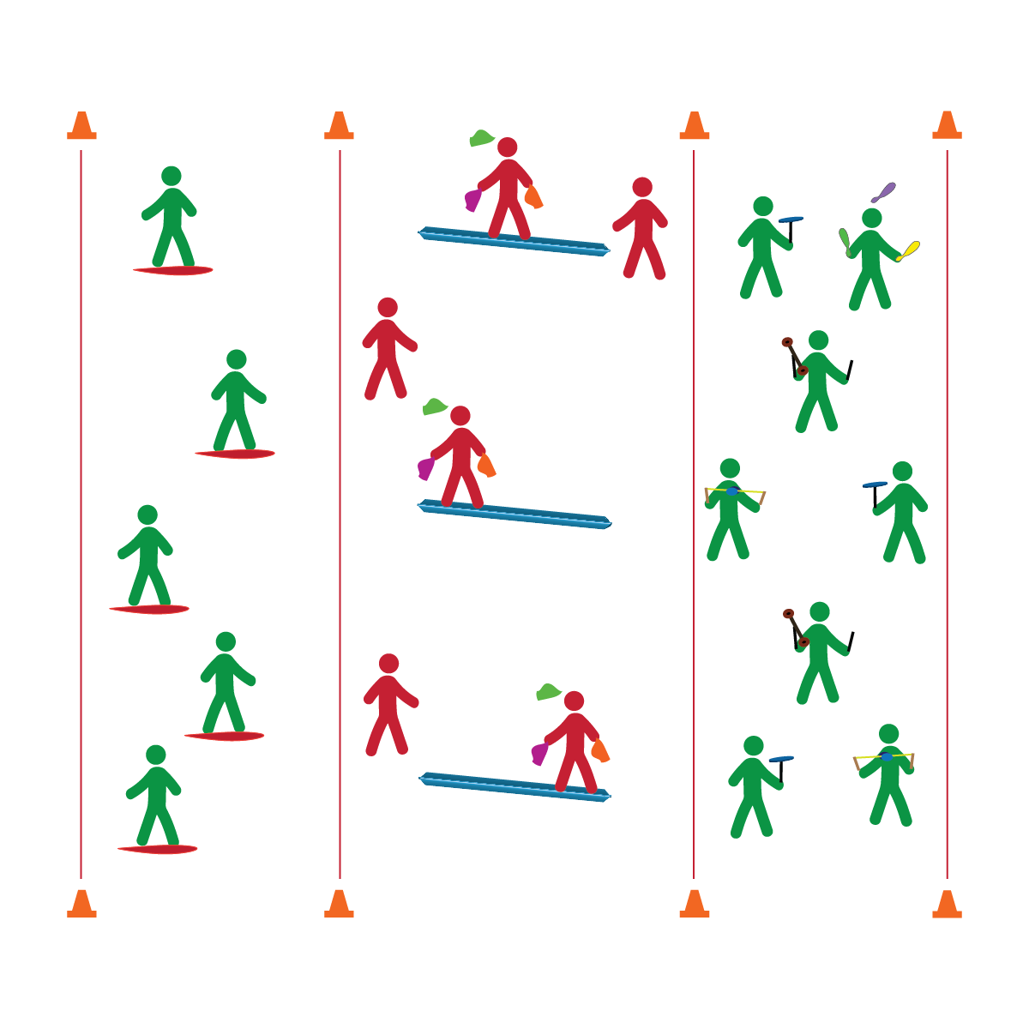

**BALANCE CHALLENGES**

* **Skill:** I will perform 1 basic Spooner Board challenge.
* **Cognitive:** I will discuss and explain the mechanics of a pivot point.
* **Fitness:** I will participate and actively engage in circus arts activities.
* **Personal & Social Responsibility:** I will remain focused, demonstrate grit, and work to overcome challenges related to circus arts skills and tricks.
* Focus on Form
* Put in Work
* Be Patient with Yourself
* Stay Safe

**Equipment:**

* 1 Spooner Board per 3 students
* 2 – 4 low balance beams
* 24 – 48 juggling scarves
* A variety of circus arts equipment for circus practice
* 3 cones
* 3 task tents
* Circus Arts Activity and Station Cards

**Set-Up:**

1. Create 3 activity areas (1 each for Spooner Boards, Low Balance Beam, circus practice) using cones, task tents, and station cards.
2. Break students into 3 groups, send each group to an activity area.

**Activity Procedures:**

1. Today we’ll begin to practice several balance challenges. The object is to learn how to perform a circus arts trick while balancing on a board or beam.
2. At area 1, students will follow teacher instruction/demonstrations using Spooner Boards. At area 2, students will practice beam challenges, which includes scarf juggling on the beam. At area 3, students will review and practice other circus arts tricks with the object of their choice (spinning plates, diabolo, flower sticks, or juggling objects).
3. Rotate stations every 5 to 10 minutes.
4. Any time you hear the stop signal, hold your objects and listen for instruction.

**Grade Level Progression:**

**6th:** Students perform scarf juggling on the balance beam or stationary Spooner Board.

**7th:** Students perform basic skills from 2 circus arts objects on the beam or stationary Spooner Board.

**8th:** Students perform a variety of circus arts skills while moving on the balance beam or Spooner Board.

**BALANCE CHALLENGES**



Balance, Actively Engage, Pivot Point



* **Standard 1 [M25.6-8]** Demonstrates correct technique for basic skills in one self-selected individual-performance activity (6); Demonstrates correct technique for a variety of skills in one self-selected individual-performance activity (7); Demonstrates correct technique for basic skills in at least two self-selected individual-performance activities (8).
* **Standard 2 [M12.6-8]** Varies application of force during dance or gymnastic activities (6); Identifies and applies Newton’s laws of motion to various dance or movement activities (7); Describes & applies mechanical advantage(s) for a variety of movement patterns (8).
* **Standard 4 [M1.6-7]** Exhibits personal responsibility by using appropriate etiquette, demonstrating respect for facilities, and exhibiting safe behaviors (6); Exhibits responsible social behaviors by cooperating with classmates, demonstrating inclusive behaviors, and supporting classmates (7).
* **Standard 5 [M3.6-8]** Recognizes individual challenges and copes in a positive way, such as extending effort, asking for help/feedback, and/or modifying the tasks (6); Generates positive strategies such as offering suggestions/assistance, leading/following others, and/or providing possible solutions when faced with a group challenge (7);Develops a plan of action and makes appropriate decisions based on that plan when faced with an individual challenge (8).



* **DOK 1:** What is balance?
* **DOK 1:** How can you recognize whether or not something is balanced?
* **DOK 2:** How would you compare (and contrast) balancing on the low beam with balancing on the Spooner Board?
* **DOK 1:** What is a pivot point?
* **DOK 2:** How can you change the pivot point of the Spooner Board?
* **DOK 3:** How is the board’s pivot point related to different balance challenges and Spooner Board tricks?

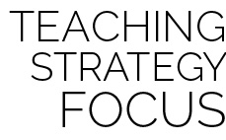

**Help students examine similarities and differences:** Students who find basic Spooner Board skills challenging will benefit from balance practice on a low foam beam. As students master the beam, help them explore and process the similarities between performing on the beam and performing on the Spooner Board. Next, prompt students to transfer what they’ve learned on the beam to the board.



* Use floor lines/markings instead of balance beams and boards.
* Provide physical assistance when/where appropriate.