­­

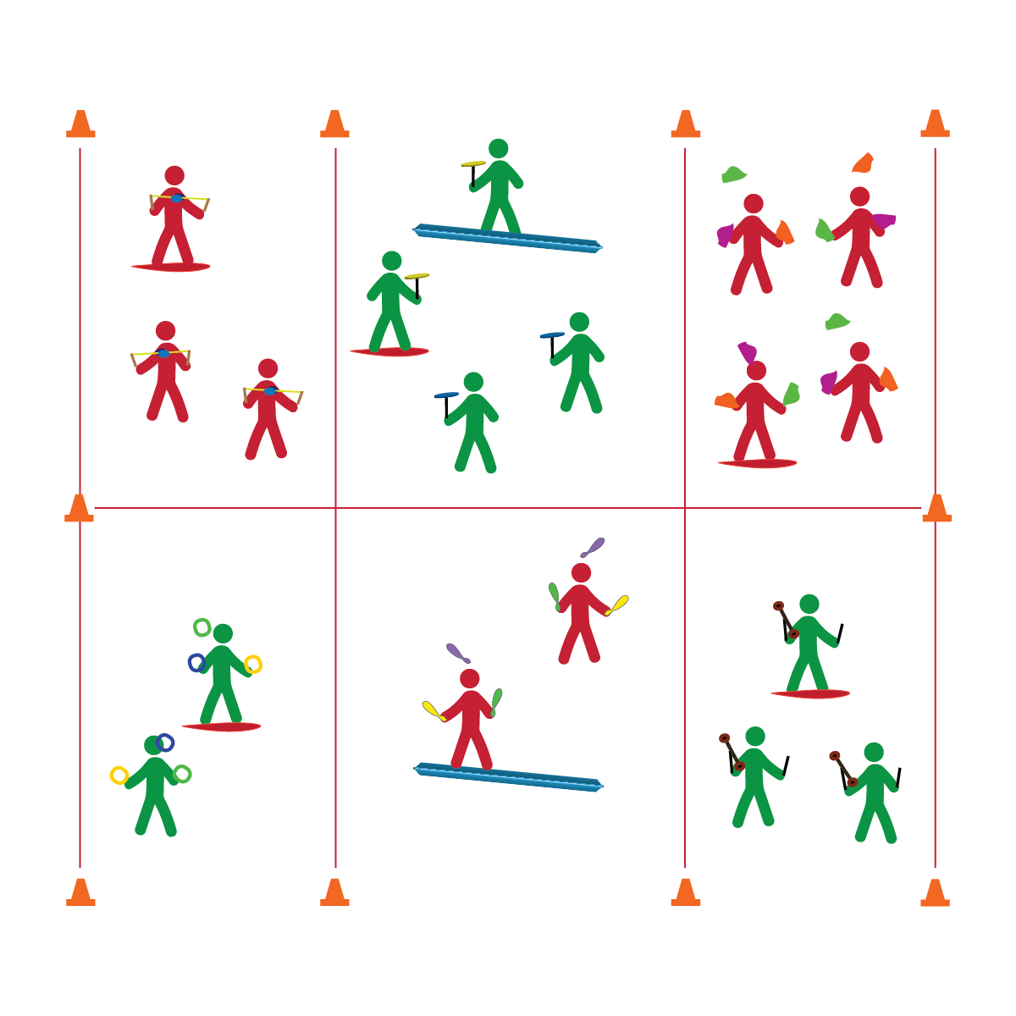

* **Skill:** I will perform a minimum of 2 tricks/skills with the circus arts equipment of my choice.
* **Cognitive:** I will be discuss and explain how different scientific principles apply to circus arts.
* **Fitness:** I will use circus arts activities as an enjoyable way to manage stress and be social in a positive environment.
* **Personal & Social Responsibility:** I will remain focused, demonstrate grit, and work to overcome challenges related to circus arts skills and tricks.

**CIRCUS PRACTICE**

* Focus on Form
* Put in Work
* Be Patient with Yourself
* Stay Safe

**Equipment:**

* A variety of circus arts equipment
* Circus Arts Activity Cards
* Music

**Set-Up:**

1. Create several activity areas – 1 area for each type of circus arts equipment.
2. Provide Spooner Boards and balance beams for advanced practice.

**Activity Procedures:**

1. It’s time for purposeful circus practice.
2. Choose a circus arts object and work to perfect your skills (Spooner Board, juggling objects, spinning plates, diabolo, or flower stick). You can work in pairs, groups, or as a solo performer.
3. On the start signal, collect the equipment you’ve chosen to use. Then, use the Circus Arts Activity Cards to help guide your practice.
4. Any time you hear the stop signal, hold your objects and listen for instruction.

**Grade Level Progression:**

*See previous progressions and apply expectations to circus practice sessions.*

**CIRCUS PRACTICE**

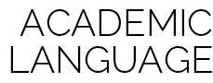

Stress Management, Positive Environment, Focus, Grit



* **Standard 1 [M25.6-8]** Demonstrates correct technique for basic skills in one self-selected individual-performance activity (6); Demonstrates correct technique for a variety of skills in one self-selected individual-performance activity (7); Demonstrates correct technique for basic skills in at least two self-selected individual-performance activities (8).
* **Standard 3 [M18.6-8]** Identifies positive and negative results of stress and appropriate ways of dealing with each (6); Practices strategies for dealing with stress, such as deep breathing, guided visualization, and aerobic exercise (7); Demonstrates basic movements used in other stress-reducing activities such as yoga and Tai Chi (8).
* **Standard 5 [M3.6-8]** Recognizes individual challenges and copes in a positive way, such as extending effort, asking for help/feedback, and/or modifying the tasks (6); Generates positive strategies such as offering suggestions/assistance, leading/following others, and/or providing possible solutions when faced with a group challenge (7);Develops a plan of action and makes appropriate decisions based on that plan when faced with an individual challenge (8).



* **DOK 1:** How can you recognize a positive environment?
* **DOK 2:** Can you explain how personal behavior affects a positive environment?
* **DOK 3:** How is a positive environment related to practicing circus arts routines?

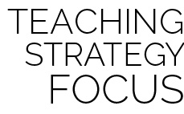

**Help students practice skills:** As students practice, encourage them to explore and define alternate ways of executing skills or using a particular piece of equipment. Create an environment that rewards exploration and risk taking, and highlight students who succeed in mastering a stunt that wasn’t specifically taught in class.



* Substitute rhythmic movements for complex tricks.
* Provide physical assistance when/where appropriate.