­­

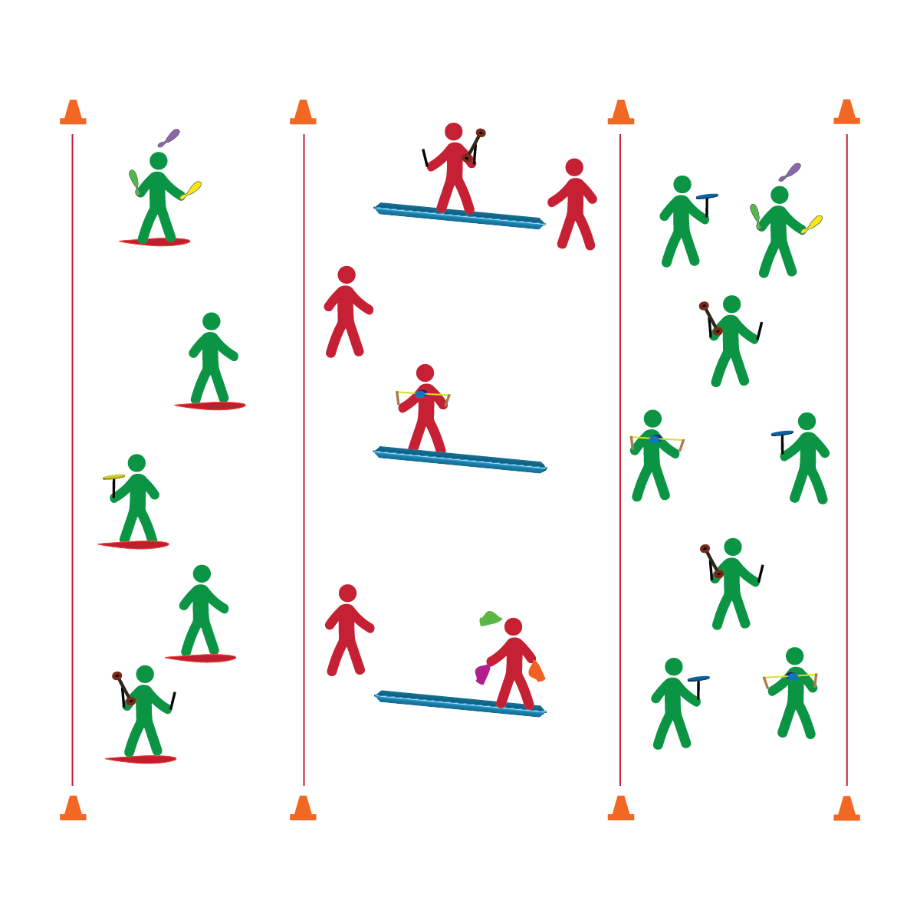

**CIRCUS COMBINATIONS**

* **Skill:** I will cascade juggle scarves while balancing on a Spooner Board or balance beam.
* **Cognitive:** I will neatly and accurately complete a Routine Planning Card.
* **Fitness:** I will focus on breathing and visualize successful participation just before practicing my complete routine.
* **Personal & Social Responsibility:** I will remain focused, demonstrate grit, and work to overcome challenges related to circus arts skills and tricks.
* Focus on Form
* Put in Work
* Be Patient with Yourself
* Stay Safe

**Equipment:**

* A variety of circus arts equipment
* Routine Planning Cards
* Music

**Set-Up:**

1. Create 3 areas (1 each for stationary practice, Spooner Board practice, and beam practice).
2. Create equipment areas for each type of circus arts equipment.

**Activity Procedures:**

1. It’s time to build circus combinations by working to bring together the skills that you’ve learned into a choreographed performance.
2. You’re required to use a balance apparatus (Spooner Board or balance beam) as well as one performance object (juggling objects, spinning plates, diabolo, or flower stick). You can work in pairs, groups, or as a solo performer.
3. On the start signal, collect the equipment you’ve chosen to use. Then, use the Circus Routine Planning Card to help guide your practice.
4. Any time you hear the stop signal, hold your objects and listen for instruction.

**Grade Level Progression:**

*See previous progressions and apply expectations to circus combination routines.*

**CIRCUS COMBINATIONS**



Focus, Visualize, Practice, Grit, Growth Mindset



* **Standard 1 [M25.6-8]** Demonstrates correct technique for basic skills in one self-selected individual-performance activity (6); Demonstrates correct technique for a variety of skills in one self-selected individual-performance activity (7); Demonstrates correct technique for basic skills in at least two self-selected individual-performance activities (8).
* **Standard 3 [M18.6-8]** Identifies positive and negative results of stress and appropriate ways of dealing with each (6); Practices strategies for dealing with stress, such as deep breathing, guided visualization, and aerobic exercise (7); Demonstrates basic movements used in other stress-reducing activities such as yoga and Tai Chi (8).
* **Standard 4 [M1.6-7]** Exhibits personal responsibility by using appropriate etiquette, demonstrating respect for facilities, and exhibiting safe behaviors (6); Exhibits responsible social behaviors by cooperating with classmates, demonstrating inclusive behaviors, and supporting classmates (7).
* **Standard 5 [M3.6-8]** Recognizes individual challenges and copes in a positive way, such as extending effort, asking for help/feedback, and/or modifying the tasks (6); Generates positive strategies such as offering suggestions/assistance, leading/following others, and/or providing possible solutions when faced with a group challenge (7);Develops a plan of action and makes appropriate decisions based on that plan when faced with an individual challenge (8).



* **DOK 1:** How can you recognize a growth mindset?
* **DOK 2:** Can you explain how a growth mindset affects your self-talk?
* **DOK 3:** How could you adapt negative self-talk statements to create more positive, growth-mindset statements?
* **DOK 4:** Design and practice a circus arts routine using manipulative skills (e.g., juggling, plate spinning, etc.).

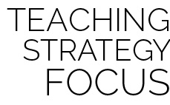

**Help students examine their reasoning:** Developing a growth mindset requires students to become aware of their self-talk and how it impacts their performance and motivation to persevere. Oftentimes this requires a reflection and critique of attitudes and assumptions, which can be uncomfortable. Nurture students along this path with positive language, modeling the self-talk that is associated with a growth mindset.



* Substitute rhythmic movements for complex tricks.
* Provide physical assistance when/where appropriate.