­­

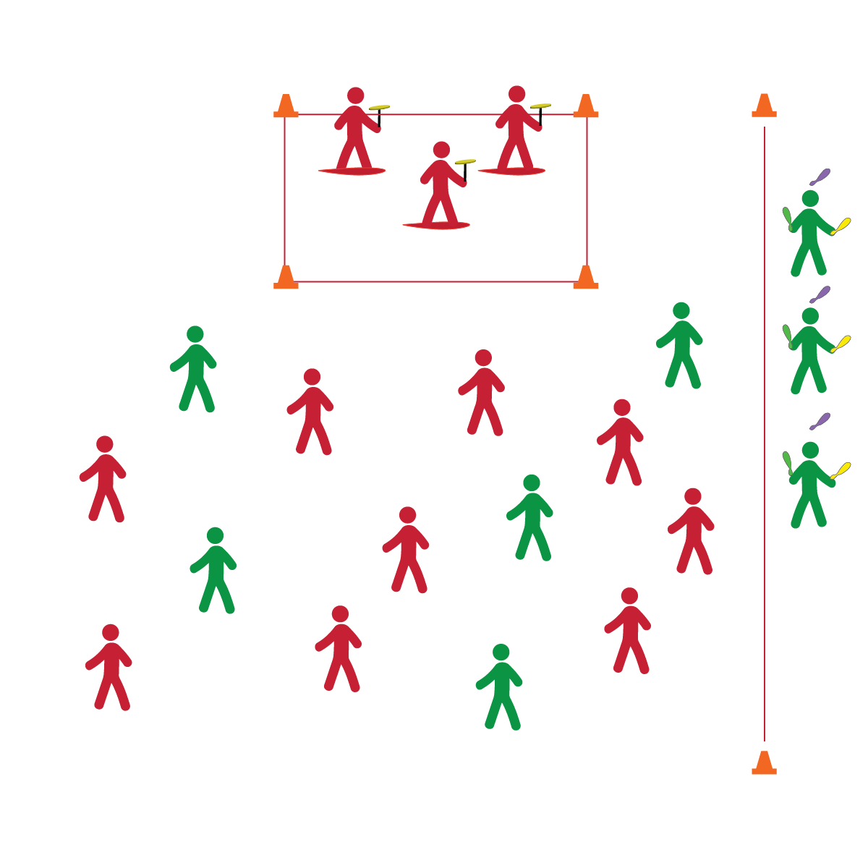

* **Skill:** I will perform a circus arts routine with a group, with a partner, or as a solo act.
* **Cognitive:** I will execute my planned routine following the choreographed moves.
* **Fitness:** I will focus on breathing and visualize successful participation just before performing my routine.
* **Personal & Social Responsibility:** I will demonstrate responsible and respectful behaviors during all circus arts performances.

**CIRCUS PERFORMANCE**

* Have Fun
* Follow the Format
* Stay in Control
* Keep Going

**Equipment:**

* A variety of circus arts equipment
* Show Line-Up Cards
* Music
* Cones to mark areas
* Seating for audience

**Set-Up:**

1. Using cones (or other organization solutions), create a stage area, a green room waiting area, and an audience seating area.
2. Post the show lineup card so students know the order of performances.

**Activity Procedures:**

1. It’s time to put all of our hard work in the circus spotlight!
2. You and your partner (or group, or solo act) will follow the show lineup. Enter the stage area from the green room waiting area when it’s your turn. You’ll perform your routine and then return to the audience.
3. Remember, I’m looking for skill performance, creativity, and fun! Do your very best, and if there are any hiccups or mistakes, just remember: the show must go on!

**Grade Level Progression:**

*See previous progressions and apply expectations to circus performance sessions.*

**CIRCUS PERFORMANCE**

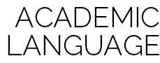

Focus, Visualize, Perform, Grit, Growth Mindset



* **Standard 1 [M25.6-8]** Demonstrates correct technique for basic skills in one self-selected individual-performance activity (6); Demonstrates correct technique for a variety of skills in one self-selected individual-performance activity (7); Demonstrates correct technique for basic skills in at least two self-selected individual-performance activities (8).
* **Standard 3 [M18.6-8]** Identifies positive and negative results of stress and appropriate ways of dealing with each (6); Practices strategies for dealing with stress, such as deep breathing, guided visualization, and aerobic exercise (7); Demonstrates basic movements used in other stress-reducing activities such as yoga and Tai Chi (8).
* **Standard 4 [M1.6-7]** Exhibits personal responsibility by using appropriate etiquette, demonstrating respect for facilities, and exhibiting safe behaviors (6); Exhibits responsible social behaviors by cooperating with classmates, demonstrating inclusive behaviors, and supporting classmates (7).



* **DOK 1:** How would you describe visualization as it relates to your circus arts performance?
* **DOK 2:** How can you apply what you know about visualization to develop a pre-performance routine?
* **DOK 3:** As you visualize your routine, can you describe the sequence of your performance? Provide as many details as possible.
* **DOK 4:** Practice and perform a circus arts routine using manipulative skills (e.g., juggling, plate spinning, etc.).

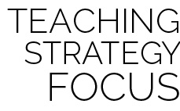

**Help students represent knowledge:** The creation and performance of a circus arts routine represents the highest level of student growth. It allows students to create their own interpretation of the content being presented. Truly rigorous teaching and learning will produce students who display active engagement, self-challenge, creative thinking, and a desire for excellence.

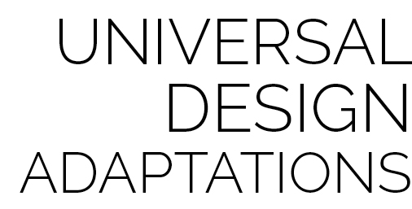

* Substitute rhythmic movements for complex tricks.
* Provide physical assistance when/where appropriate.