­­­

* Juggle
* Cascade
* Gravity
* Newton’s Laws of Motion

­

* **Skill:** I will perform cascade juggling with scarves.
* **Cognitive:** I will discuss and explain Newton’s first law of motion.
* **Fitness:** I will participate and actively engage in circus arts activities.
* **Personal & Social Responsibility:** I will remain focused, demonstrate grit, and work to overcome challenges related to circus arts skills and tricks.
* **Standard 2 [M12.6-8]** Varies application of force during dance or gymnastic activities (6); Identifies and applies Newton’s laws of motion to various dance or movement activities (7); Describes & applies mechanical advantage(s) for a variety of movement patterns (8).
* **Standard 5 [M3.6-8]** Recognizes individual challenges and copes in a positive way, such as extending effort, asking for help/feedback, and/or modifying the tasks (6); Generates positive strategies such as offering suggestions/assistance, leading/following others, and/or providing possible solutions when faced with a group challenge (7);Develops a plan of action and makes appropriate decisions based on that plan when faced with an individual challenge (8).
* Exit Slips

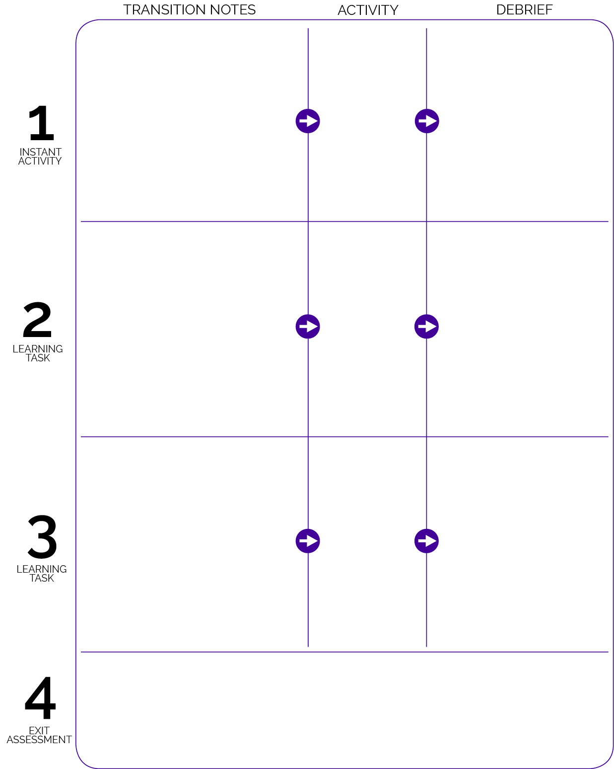

Advanced Juggling equipment is set up in stations at each corner of the activity area. Let students know they can continue with scarf juggling at the scarf station. Allow students to move freely to any station that they’d like to try for the remainder of the class period.

Students enter and begin Toss 3 activity using juggling bean balls. Level 2 progression: Students must toss from dominant hand to partner’s dominant hand. Level 3 progression: From non-dominant hand to partner’s non-dominant hand.

After short debrief, show the following juggling video: <https://youtu.be/xRSq-qZQLF4> Discuss the purpose of the Circus Arts Module. Then, students collect 3 scarves each and find on open space facing the front of the class.

* **DOK 1:** What is grit?
* **DOK 2:** How can grit help you learn how to juggle?
* **DOK 3:** How is grit related to goal setting and action planning?
* **DOK 1:** What is Newton’s first law of motion?
* **DOK 2:** How does gravity affects the inertia of objects being juggled?
* **DOK 3:** Elaborate on each aspect of juggling that is related to Newton’s first law of motion.
* **DOK 1:** What is gravity?
* **DOK 2:** Can you explain how tossing and catching is affected by gravity?

Toss 3 (OPEN Instant Activities)

Using Juggling Balls

Advanced Juggling

Basic Juggling

Exit slip using the debrief questions:

* **DOK 4:** If you were going to interview classmates about how grit helps them succeed in physical education class, what questions would you ask?