**SCARF JUGGLING**

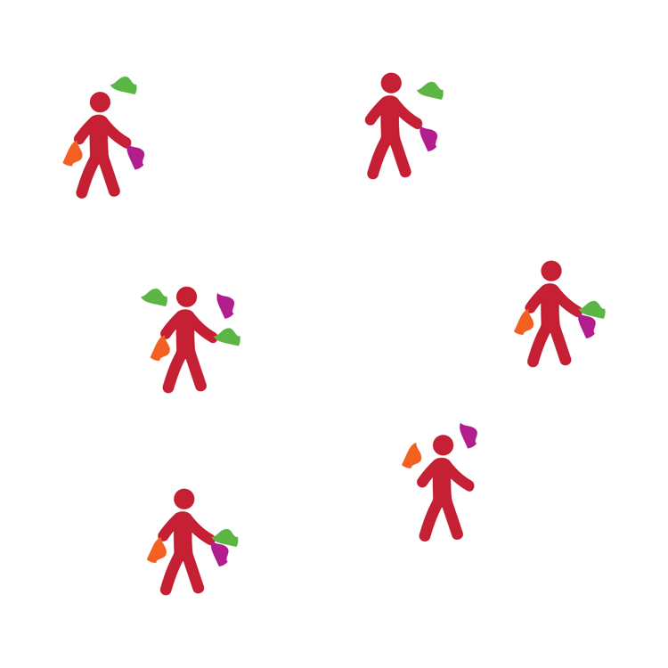

**2 Scarf Challenges**

* Crisscross
* 2 Columns (Right Hand Only)
* 2 Columns (Left Hand Only)

**3 Scarf Challenges**

* Cascade
* 3 Column (Left / Right / Center)

**4 Scarf Challenge**

* 4 Columns

**JUGGLING BALLS**

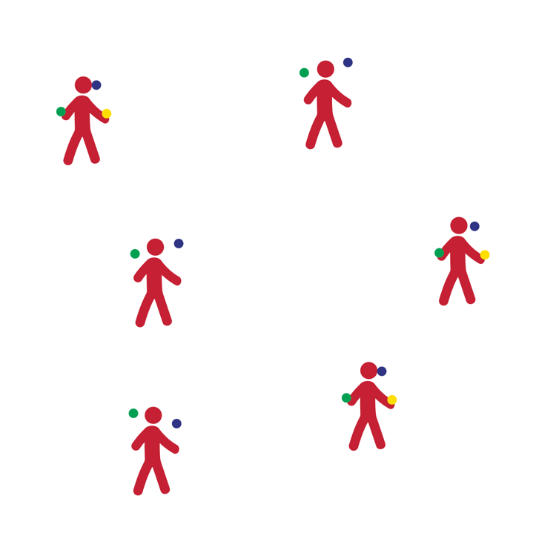

**2 Juggling Ball Challenges**

* Crisscross
* 2 Columns (Right Hand Only)
* 2 Columns (Left Hand Only)

**3 Juggling Ball Challenges**

* Cascade
* 3 Column (Left / Right / Center)

**4 Juggling Ball Challenges**

* 4 Columns

**JUGGLING RINGS**

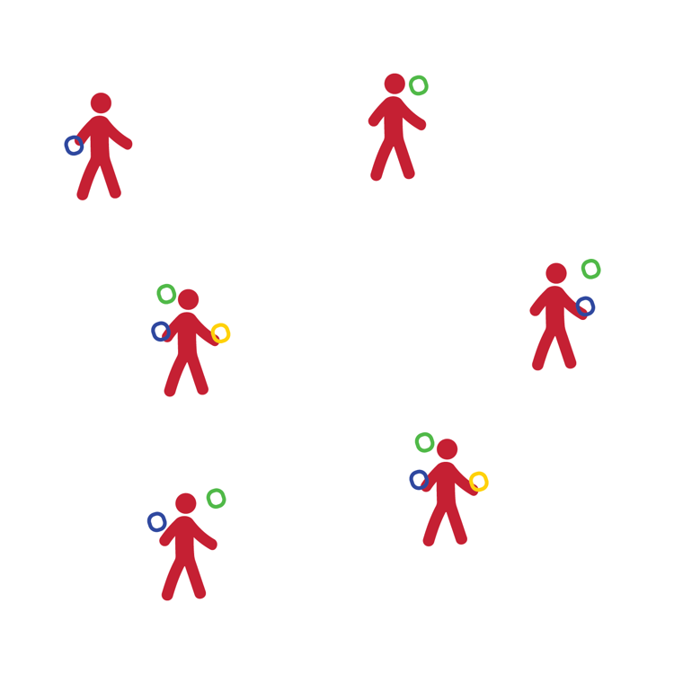

**1 Juggling Ring Challenges**

* Toss and Catch (1 hand)
* Toss and Catch (2 hands)

**2 Juggling Rings Challenges**

* Crisscross
* 2 Columns (Right Hand Only)
* 2 Columns (Left Hand Only)

**3 Juggling Rings Challenges**

* Cascade
* 3 Column (Left / Right / Center)

**4 Juggling Rings Challenges**

* 4 Columns

**JUGGLING CLUBS**

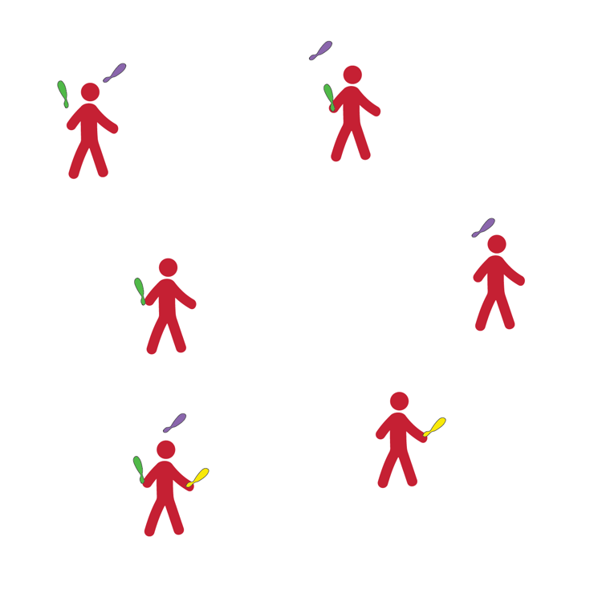

**1 Juggling Club Challenges**

* Toss and Catch (1 hand)
* Toss and Catch (2 hands)

**2 Juggling Clubs Challenges**

* Crisscross
* 2 Columns (Right Hand Only)
* 2 Columns (Left Hand Only)

**3 Juggling Clubs Challenges**

* Cascade
* 3 Column (Left / Right / Center)

**4 Juggling Clubs Challenges**

* 4 Columns