­­

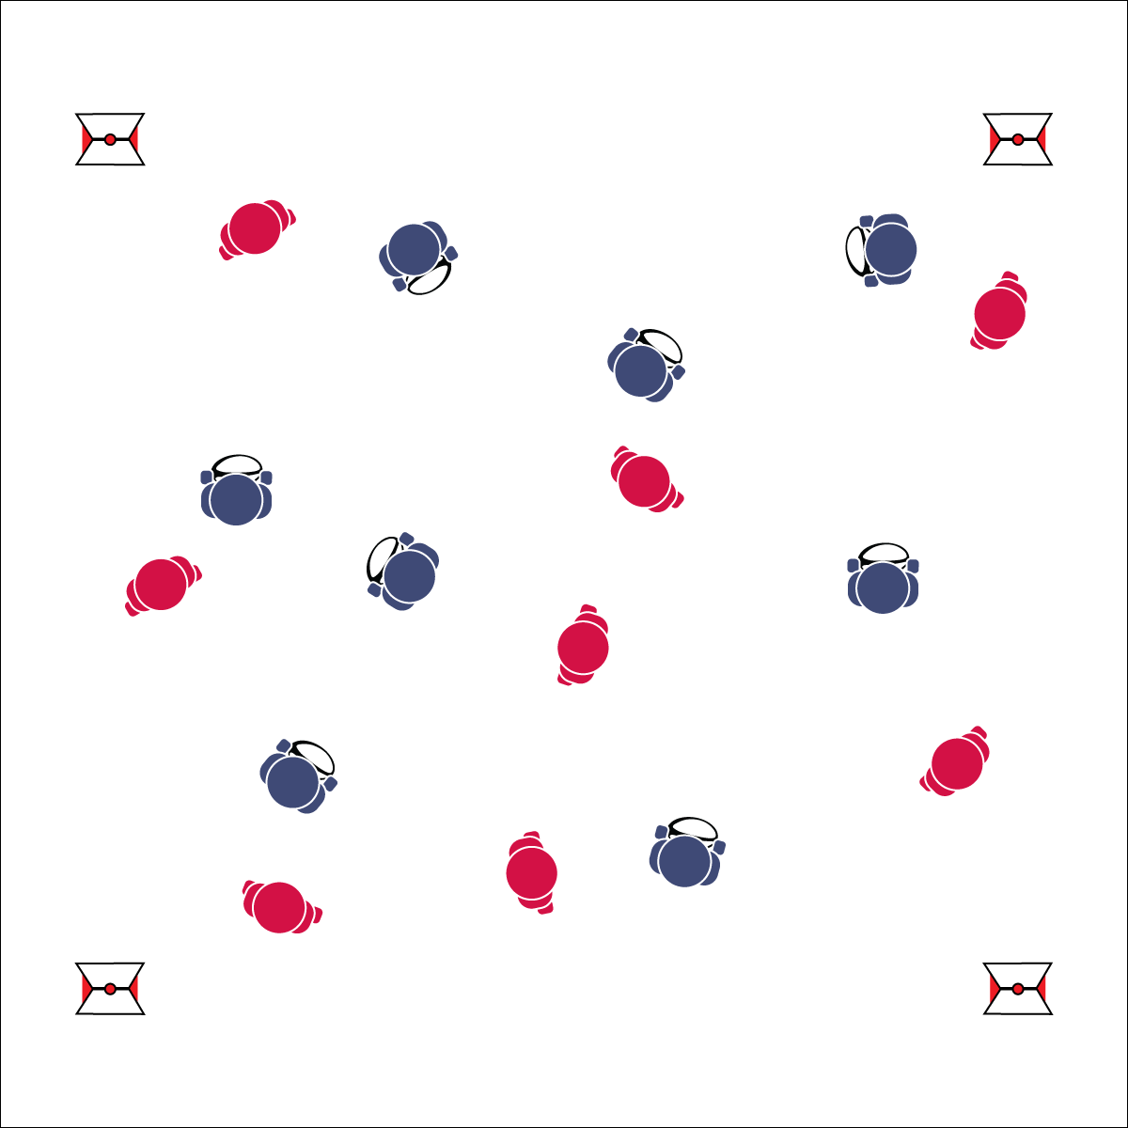

**Activity Procedures:**

1. Today’s activity is called Rugby Tag. The object of the activity is for:
   1. Students with a ball to avoid having their flag pulled. They can do this by faking, jabbing, cutting, and running to move to and create open space.
   2. Students without a ball to pull a ball carrier’s flag.
2. I’ll use a signal (whistle, starting the music, etc.) to start round 1 of Rugby Tag. If a ball carrier’s flag gets pulled by their opponent, s/he must freeze, put the flag back on, and hold the ball out in front of her/him using a cage grip.
3. Then a teammate needs to unfreeze the frozen player by touching her/his ball to the frozen player’s ball.
4. Stop when you hear the signal again (whistle, music stops, etc.).
5. Switch roles in Round 2: the flag pullers become ball carriers and the carriers become pullers.
6. Or, when a ball carrier’s flag is pulled, s/he must give the ball to the person that pulled the flag and players switch roles/teams. This eliminates the need for multiple rounds.

**Grade Level Progression:**

**6:** Implement the activity as described above.

**7 & 8:** Teach and prompt students to perform a minimum of 3 jab steps per round of play.

**RUGBY TAG**

* **Skill:** I will avoid taggers by using movement skills such as jab steps while using a cage grip.
* **Cognitive:** I will define and discuss the concept of open space.
* **Fitness:** I will activity participate and increase my heart rate.
* **Personal & Social Responsibility:** I will move safely, avoiding collisions.
* Cage Grip: Ball Parallel to the Ground, Thumbs on Top Seams, Fingers Spread On Bottom Seams, Create a Firm Cage Around the Ball

**Equipment:**

* 1 flag belt per student (2 colors for 2 even teams)
* 1 rugby ball per 2 students (can use footballs)
* Cones to mark playing area
* If playing inside, use lines on gym floor

**Set-Up:**

1. Create a large playing area to safely accommodate the entire class for tag (60’x60’).
2. Split the class in half by using belts of 2 different colors. Every student needs a flag belt, and the flag color represents which team they’re on.
3. Give each student on 1 team (half the class) a rugby or similarly shaped ball.
4. All students scatter throughout the playing area.

**RUGBY TAG**



* Allow students to use pool noodles for tagging.
* Set up mats in areas where students may fall.
* Slow the pace of the game.



Cage Grip, Fake, Jab Step, Open Space, Rugby



* **Standard 1 [M6.6-8]** Performs pivots, fakes, and jab steps designed to create open space during practice tasks (6); Executes at least one of the following designed to create open space during small-sided game play: pivots, fakes, jab steps (7); Executes at least two of the following to create open space during modified game play: pivots, fakes, jab steps, screens (8).
* **Standard 2 [M1.6-8]** Creates open space by using locomotor movements (e.g., walking, running, jumping & landing) in combination with movement (e.g., varying pathways; change of speed, direction, or pace) (6); Reduces open space by using locomotor movements (e.g., walking, running, jumping & landing, changing size and shape of the body) in combination with movement concepts (e.g., reducing the angle in the space, reducing distance between player and goal) (7); Opens and closes space during small-sided game play by combining locomotor movements with movement concepts (8).



* **DOK 1:** How would you describe open space?
* **DOK 2:** How would you summarize the importance of open space in rugby?
* **DOK 3:** As a defender, how is open space related to your success/failure?
* **DOK 1:** Can you recite the cues for a cage grip?
* **DOK 2:** How does grip affect your ability to carry the ball?
* **DOK 3:** After playing Rugby Tag and utilizing a cage grip, what facts would you select/identify to support the use of a proper grip? Why did you choose those facts?



**Preview new content:** Use the first lesson to introduce rugby in a fun and exciting way. There are amazing videos online to capture the essence of Flag Ruby. Go to YouTube.com, search “Flag Rugby Highlights,” and pick your favorite one!