­­

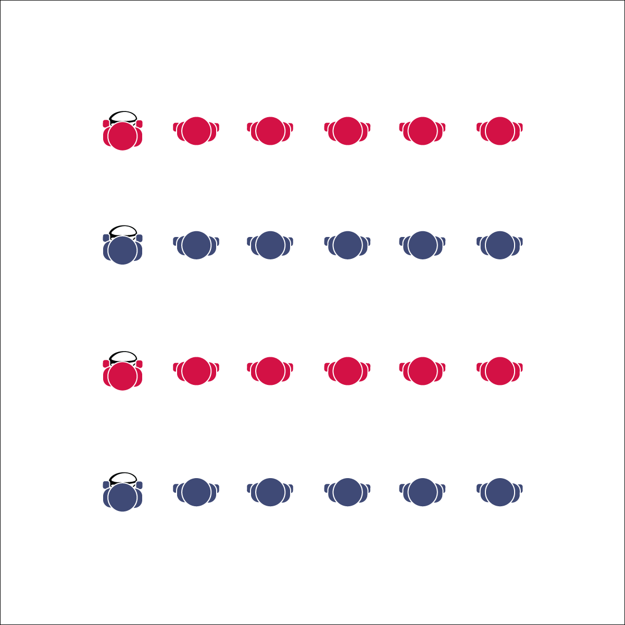

**Activity Procedures:**

1. Today’s activity is called Stationary Passing. The object of the activity is to learn and practice the basic rugby pass and the pop pass by using each skill to move the ball down the line and then back again.
2. Round 1: (Hand-offs only) Start the activity with the first person in line holding the ball with a cage grip. On the start signal, s/he will hand the ball off to the next person in line by side stepping toward the next player and using a pendulum motion to execute a hand off.
3. The receiving player grips the ball with a cage grip and executes this same hand off to the next player. This continues all the way down the line and then reverses all the way back to the first player. There should be no “flight” of the ball; hand-offs allow us to practice the cage grip and the pendulum motion.
4. Round 2: (Basic ruby pass) Spread out with about 2 arms’ lengths between each player. It’s time to practice the basic rugby pass. Now there will be flight! Same grip and step, same pendulum motion, but the next player will catch the pass instead of receiving a hand-off.
5. Round 3: (Pop pass) Same set-up and grip, but the ball is held in a position similar to a basketball chest pass. There should be enough elevation on the pass for the ball to clear a defensive player’s head.
6. Stop when you hear the signal (whistle, music stops, etc.).

**Grade Level Progression:**

**6:** Focus on handoffs and a basic pass. Revisit the activity in the next class with a focus on the pop pass.

**7 & 8:** Challenge students by adding a timed element to the activity. For example, can all teams move their ball down and back in less than 1 minute?

**Equipment:**

* 1 rugby ball per group of 5 or 6 students

**Set-Up:**

1. Create a large activity area (approx. 30’x30’).
2. Place 1 rugby ball on the ground where you want each line to start.
3. Create groups of 5 or 6 students in relay lines. Students are spaced arms-length away from the next teammate in line.

* Basic Pass: Cage Thumbs Down, Hip Level, Side to Target, Step Laterally, Pendulum Swing
* Pop Pass: Cage Thumbs Up, Chest Level, Chest to Target, Step and Push to Target
* **Skill:** I will perform a hand-off, a basic rugby pass, and a pop pass following all skill cues.
* **Cognitive:** I will discuss the importance of purposeful practice.
* **Fitness:** I will engage in an effort to build skill-related fitness.
* **Personal & Social Responsibility:** I will cooperate with my teammates by making accurate passes and focusing on clean catches.

**STATIONARY PASSING**

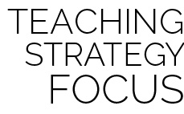

**Identify critical content:** Grip and passing techniques are the fundamentals needed for rugby success. Give students time to practice and become competent passers while providing fun, high-MVPA activities in which you can focus no grip technique. Define purposeful practice, and then create opportunities for students to experience it.



* **DOK 1:** What is purposeful practice?
* **DOK 2:** How would you compare and contrast purposeful practice with unfocused participation?
* **DOK 3:** How is purposeful practice related to skill development? How is it related to performance?
* **DOK 4:** Develop a purposeful practice plan that you can implement at home in order to improve your rugby skills.



* **Standard 1 [M3.6-7]** Catches with a mature pattern from a variety of trajectories using different objects in varying practice tasks (6); Catches with a mature pattern from a variety of trajectories using different objects in small-sided game play (7).
* **Standard 4 [M5.6-8]** Cooperates with a small group of classmates during adventure activities, game play, or team-building activities (6); Problem-solves with a small group of classmates during adventure activities, small-group initiatives, or game play (7); Cooperates with multiple classmates on problem-solving initiatives including adventure activities, large-group initiatives, and game play (8).

**STATIONARY PASSING**

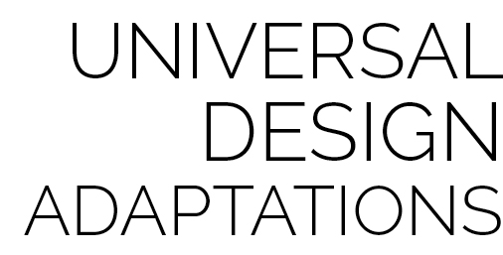

* Use larger balls of various shapes and construction.
* Use Velcro gloves and compatible balls.



Basic Ruby Pass, Cooperation, Hand-Off, Pendulum Motion, Pop Pass, Purposeful Practice, Skill-Related Fitness, Trajectory