­­

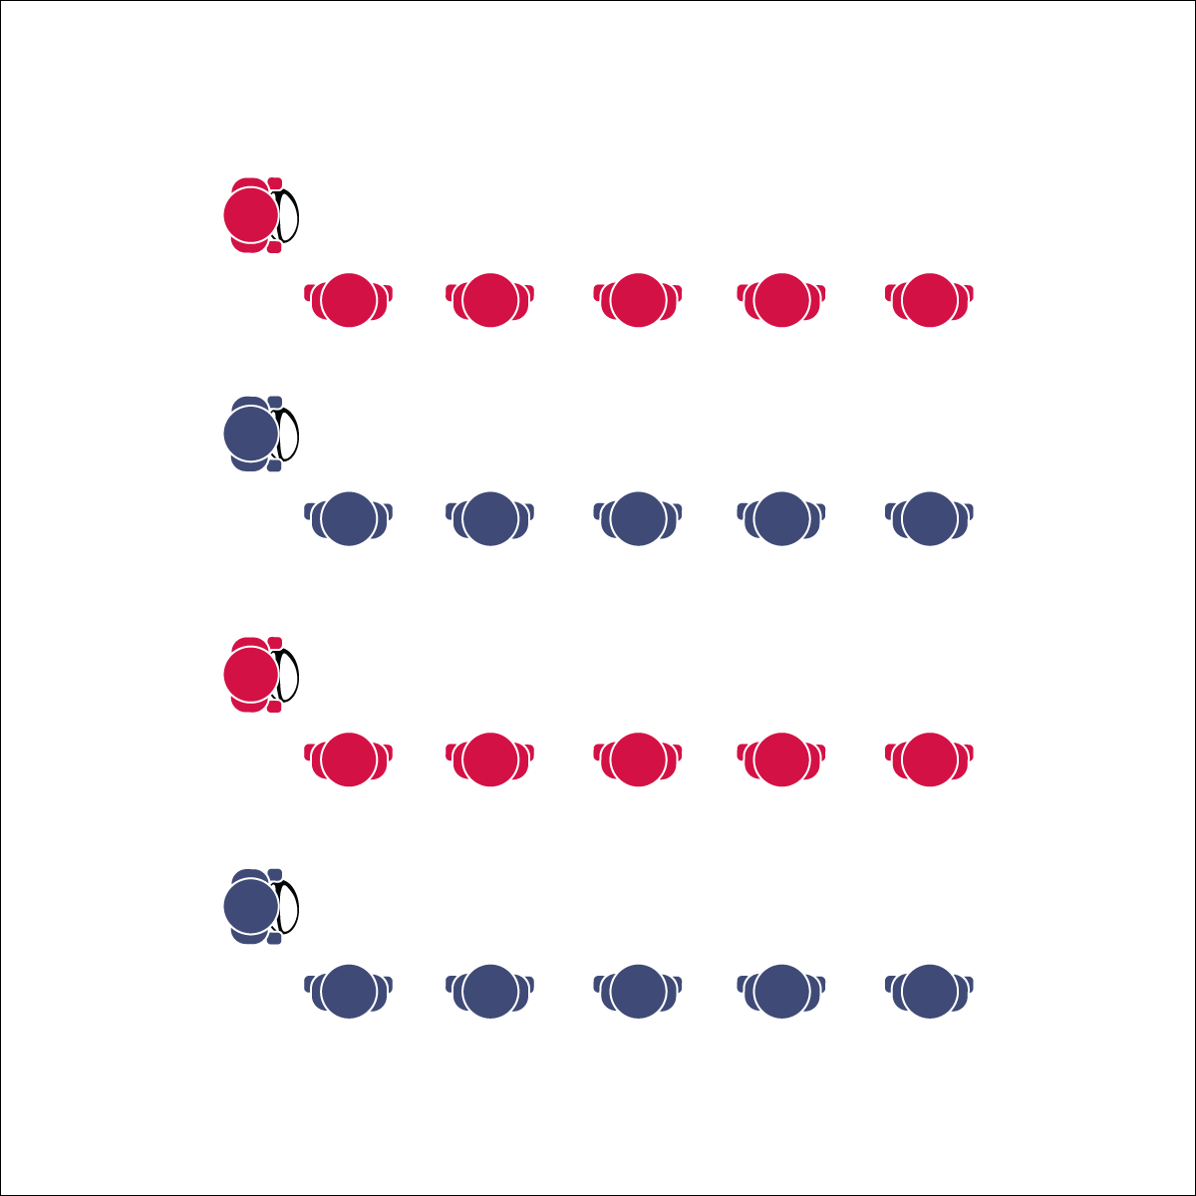

**LEADER BALL**

**Equipment:**

* 1 rugby ball per group of 5 or 6 students

**Set-Up:**

1. Create a large activity area (approx. 30’x30’).
2. Place 1 rugby ball on the floor/ground where you want each line to start.
3. Create groups of 5 or 6 students in relay lines. Students are spaced arms-length away from the next teammate in line.

**Activity Procedures:**

* Today’s activity is called Leader Ball. The object of the activity is to practice the basic rugby pass and the pop pass by using each skill to move the ball down the line as quickly as you can.
* Start the activity with the line leader holding the ball and the other group members in line, arms-length away from one another.
* On the start signal, the line leader executes a basic rugby pass (pendulum pass) to the first person in line. The person receiving the pass catches it, passes it back, and then begins doing jumping jacks. The line leader then moves to make a basic rugby pass to the second person in line. The receiver catches it, passes it back, and then begins doing jumping jacks with the first person.
* This pattern continues until everyone in line is doing jumping jacks. The line leader then goes to the end of the line and the next player moves up to be the new leader. The ball is quickly handed off down the line to the new leader. This continues until everyone in the group has been a line leader.
* When everyone has had a turn as the line leader, repeat the activity practicing the pop pass.
* Stop when you hear the signal (whistle, music stops, etc.).

**Grade Level Progression:**

**6:** Perform the activity with stationary receivers. Then challenge students to pass to a moving receiver.

**7 & 8:** Focus on leading passes and catching on the move.

* **Skill:** I will perform a leading pass to a moving teammate.
* **Cognitive:** I will define and discuss a leading pass.
* **Fitness:** I will engage in an effort to build skill-related fitness.
* **Personal & Social Responsibility:** I will use encouraging language in an effort to support my teammates.
* Lead Pass to Where Receiver is Going to Be – Not Where They Are



Encouragement, Lead Passing, Skill-Related Fitness



* Slow the pace of the activity.
* Use Velcro gloves and/or a variety of balls of various shapes and construction.
* Group students who work well together.



**Organize students to interact with content:** One essential component to a student-centered class is cooperative learning. Leader Ball provides a small-group structure for active participation as well as discussion. Use a “Turn and Talk” strategy during this activity’s debrief to allow groups to discuss, explore, and collaborate on answers.



* **DOK 1:** How can you recognize a leading pass?
* **DOK 2:** When would you apply/use a leading pass in rugby?
* **DOK 3:** Can you predict the outcome of a rugby game if a team cannot execute a leading pass?
* **DOK 4:** Create a choreographed rugby play that includes a lead pass beating a defender.

**LEADER BALL**



* **Standard** **1 [M4.6]** Passes and receives with hands in combination with locomotor patterns of running and change of direction & speed with competency in invasion games such as basketball, flag football, speedball, or team handball (6).
* **Standard 1 [M5.6-8]** Throws, while stationary, a leading pass to a moving receiver (6); Throws, while moving, a leading pass to a moving receiver (7); Throws a lead pass to a moving partner off a dribble or pass (8).
* **Standard 3 [M7.6-8]** Identifies the components of skill-related fitness (6); Distinguishes between health-related and skill-related fitness (7); Compares and contrasts health-related fitness components (8).
* **Standard 5 [M6.6-8]** Demonstrates respect for self and others in activities and games by following the rules, encouraging others, and playing within the spirit of the game or activity (6); Demonstrates the importance of social interaction by helping and encouraging others, avoiding trash talk, and providing support to classmates (7); Demonstrates respect for self by asking for help and helping others in various physical activities (8).